Saunders

County

Livestock & Ag

Association

P.O. Box 134

Wahoo, NE 68066

Dan Kellner, Weston

402-480-8778

Andrew “Pudge” Donahue, Ceresco

402-525-6262

Jordan Nelson, Ceresco

402-540-7556

Dave Vrana, Prague

402-840-0116

Brian Vech, Cedar Bluffs

402-480-3039

Chris Tvrdy, Wahoo

402-277-0902

Dennis Brabec, Wahoo

402-443-6580

Kevin Sladky, Wahoo

402-480-2468

Mike Heldt, Yutan

402-480-3798

Mike Hines, Prague

402-429-4268

Robert Meduna, Colon

402-480-1089

Tyler Sudik, Ceresco

402-443-8669

Jeff Brabec, Colon

402-277-6264

Dan Malousek, Prague (Associate Dir.)

402-443-9640

**SAUNDERS COUNTY LIVESTOCK & AG ASSOCATION**

**NOTICE OF ANNUAL MEETING – January 7, 2025**

**ANNUAL BANQUET – January 25, 2025**

Dear Members:

As we welcome the New Year, I extend my best wishes to each of you. I would like to take this opportunity to inform you about some important upcoming events.

We encourage all members to actively participate in the Association by attending our regular meetings, annual meeting and banquet. Membership dues for the upcoming year are as follows: $75 for local membership; $105 Nebraska Cattlemen; $170 for NCBA. Dues are payable now and are required to vote and participate as a member for 2025. You can also purchase raffle tickets for $20.00 from any of the Directors.

1. The Annual Business Meeting shall be held as follows:

**Tuesday January 7, 2025, *Saunders County 4 H Building, Wahoo, Nebraska***

**6:00 PM Social Hour**

**6:30 PM Dinner**

*Frontier Cooperative sponsor and presentation – Frontier is a full-service cooperative located primarily in Eastern Nebraska serving customers since 1915. Frontier prides itself on being a progressive leader in today’s agriculture world.*

**Annual Business Meeting Agenda**

Approval of 2024 Annual Meeting Minutes

2024 Treasurer’s Report

2025 Board of Directors Election

Adjourn

**RSVP is due on or before December 31, 2024**

**Dan Kellner – 402-480-8778**

**Pudge Donahue – 402-525-6262**

**Jordan Nelson – 402-540-7556**

**Dave Vrana – 402-840-0116**

This year, the annual meeting will be held in advance of the Annual Banquet to allow the Association to focus on recognition of our 4-H participants and their achievements and to enjoy the entertainment.

1. The Annual Banquet will be held as follows:

**January 25, 2025, at Starlight Event Center**

Entertainment – Cole Woita Band

5:30 p.m. Social Hour

6:30 p.m. Banquet

$35.00 advance tickets – Purchase from Directors

**NO TICKETS SOLD AT THE DOOR**

1. Scholarships are available to graduating seniors who are children, grandchildren or great-grandchildren of Association members. Applicates must be from Saunders County or bordering counties. Call Cheyenne Chromy at 402-547-7107 or email [Cheyenne.Chromy@gmail.com](mailto:Cheyenne.Chromy@gmail.com) for an application. Applications are due on or before March 1, 2025.

**REMINDER:** for further correspondence, especially dues, please DO NOT SEND to ENREC. Please mail Saunders County Livestock & Ag Association P.O. Box 134, Wahoo, NE 68066 or to Dave Vrana 2448 Co. Rd. 30, Prague, NE 68050

Please join us for both events!

Sincerely,

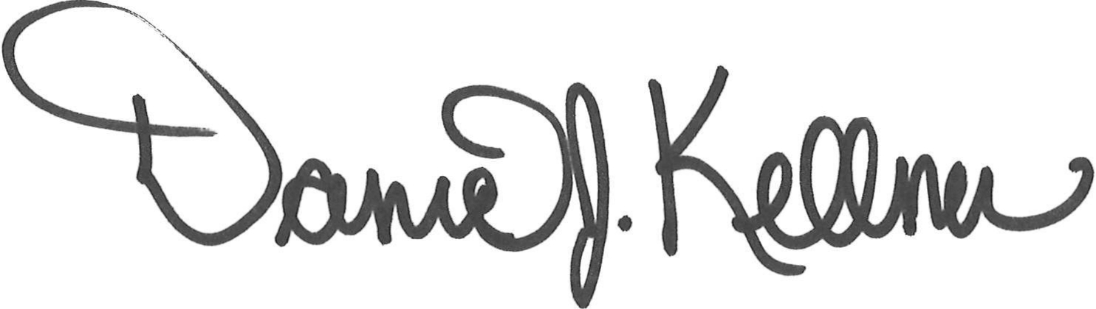

Dan Kellner

President, Saunders County Livestock & Ag Association