Saunders

County

Livestock & Ag

Association

P.O. Box 134

Wahoo, NE 68066

Dan Kellner, Weston

402-480-8778

Andrew “Pudge” Donahue, Ceresco

402-525-6262

Jordan Nelson, Ceresco

402-540-7556

Dave Vrana, Prague

402-840-0116

Brian Vech, Cedar Bluffs

402-480-3039

Chris Tvrdy, Wahoo

402-277-0902

Dennis Brabec, Wahoo

402-443-6580

Kevin Sladky, Wahoo

402-480-2468

Mike Heldt, Yutan

402-480-3798

Mike Hines, Prague

402-429-4268

Robert Meduna, Colon

402-480-1089

Tyler Sudik, Ceresco

402-443-8669

Jeff Brabec, Colon

402-277-6264

Dan Malousek, Prague (Assoc. Dir.)

402-443-9640

Dear Friends of Saunders County Livestock & Ag Association,

This letter is requesting your support for our upcoming banquet to be held on January 25, 2025, at the Starlight Event Center.

5:30 p.m. Social

6:30 p.m. Banquet

We are asking for sponsorship donations to help with our costs and to raise funds for our association. Please, **NO DOOR PRIZES!**

Throughout the year, funds are used for scholarships, county fair activities, as well as educational and livestock related programs, meetings, and other worthy causes.

Be assured, this is the only time of the year we ask for this type of donation.

These are our Sponsorship Categories:

* Gold Banquet Sponsor - $100 & up
* Platinum Sponsor - $500 (4 complimentary Banquet tickets & Reserve seating)
* Platinum Plus Sponsor - $1000 (8 complimentary Banquet tickets & Reserve seating)

Extra banquet tickets may be purchased from Directors.

We would appreciate anything you feel you could do to help keep our association strong.

The deadline to send in your donations is January 13, 2025.

Mail donations to:

Saunders County Livestock Association

% Dave Vrana

2448 County Road 30

Prague, NE 68050

Director Contact: ________________________

Cell Phone: ________________________

Sincerely,

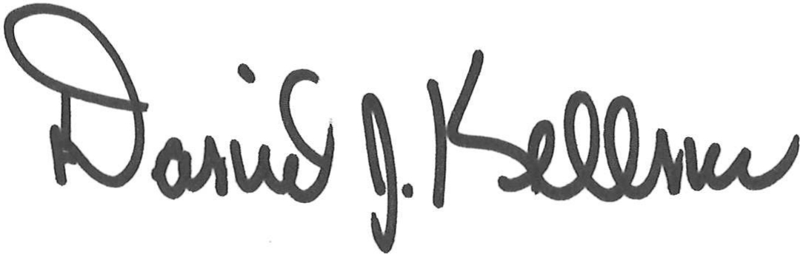

Dan Kellner

President, Saunders County Livestock & Ag Association