Saunders County
Livestock & Ag
Association

P.O. Box 134

Wahoo, NE 68066

Dan Kellner, Weston

Andrew “Pudge” Donahue, Ceresco

Jordan Nelson, Ceresco

Dave Vrana, Prague

Brian Vech, Cedar Bluffs

Chris Tvrdy, Wahoo

Dennis Brabec, Wahoo

Kevin Sladky, Wahoo

Mike Heldt, Yutan

Mike Hines, Prague

Robert Meduna, Colon

Tyler Sudik, Ceresco

Jeff Brabec, Colon

Dan Malousek, Prague (Associate Dir.)

February 1, 2025

Dear Saunders County Livestock & Ag Association Member:

Below is the information for your February meeting:

Wednesday, February 19, 2025
Colon Parish Hall, Colon
6:30 PM Social Time
7 PM Dinner
Business Meeting to follow

Your sponsors for the meeting will be Ron Kulwicki of Zoetis, Pioneer, and Todd Hoppe of All Metals.

for the less fortunate, bring a non-perishable food item for the Food Pantry.

Thank you for paying your 2025 Dues. If you have not paid, please contact one of your Association Directors.

We have scholarships available for 2025 graduating seniors who are children, grandchildren, or great grandchildren of Saunders County Livestock & Ag members for at least 3 years. You can do one of three things:

- Call Cheyenne Chromy at (402)547-7107
- Check website bit.ly/saunderscountylivestockag
- Email Cheyenne.Chromy@gmail.com for an application.

The Saunders County Livestock & Ag Association has launched an informative webpage where you can access details about upcoming and past events, monthly newsletters, scholarship applications, and a wealth of other essential resources. Be sure to visit https://bit.ly/saunderscountylivestockag for all the information you need!

Join us and support your Association.

Sincerely,
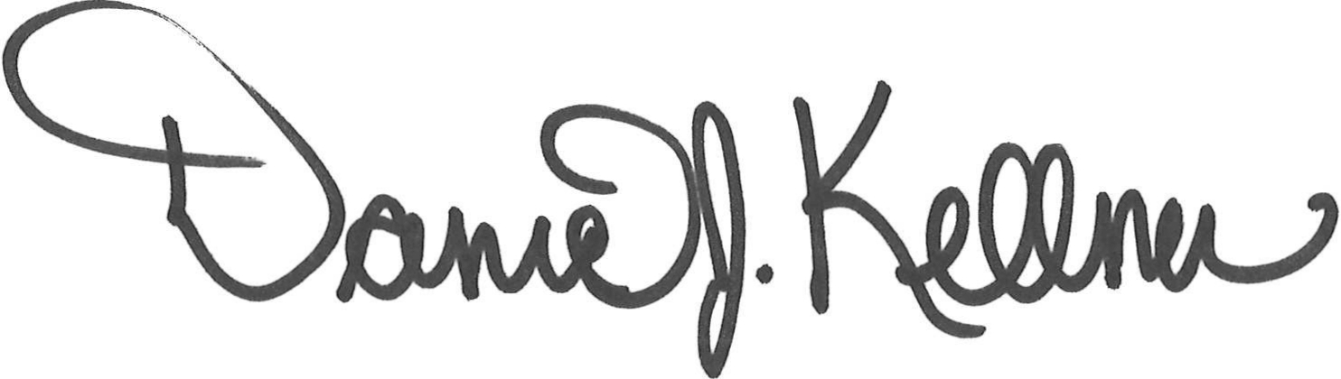

Dan Kellner
President, Saunders County Livestock & Ag Association

