Saunders County

Livestock & Ag

Association

P.O. Box 134

Wahoo, NE 68066

Dan Kellner, Weston

Andrew “Pudge” Donahue, Ceresco

Jordan Nelson, Ceresco

Dave Vrana, Prague

Brian Vech, Cedar Bluffs

Chris Tvrdy, Wahoo

Dennis Brabec, Wahoo

Kevin Sladky, Wahoo

Mike Heldt, Yutan

Mike Hines, Prague

Robert Meduna, Colon

Tyler Sudik, Ceresco

Jeff Brabec, Colon

Dan Malousek, Prague (Associate Dir.)

March 1, 2025

Dear Saunders County Livestock & Ag Association Member:

Below is the information for your March meeting

1.

**Annual Testical Festival**

**Wednesday March 12, 2025**

**Saunders County Fairgrounds**

**6:30 Social - 7 PM Dinner**

**Business meeting will follow**

We thank our sponsors: Novus Ag Colon, NE, Spicka Insurance, Steve Spicka, Cattle Reproduction Services- Tyler Mueller

2.

**Wednesday March 26, 2025**

**Woodcliff Community Center**

**980 County Road W, Woodcliff**

**Sponsors, FirstState Bank, Yutan**

**AgSmart, Cedar Bluffs**

**D.O.T.**

**Advanced Irrigation Solutions, Tyler Mensik**

The Saunders County Livestock & Ag Association has launched an informative webpage where you can access details about upcoming and past events, monthly newsletters, scholarship applications, and a wealth of other essential resources. Be sure to visit <https://bit.ly/saunderscountylivestockag> for all the information you need!

For those of you who have paid your annual dues, thank you! If you haven’t, please see one of your directors to get your dues paid up, or your name will be taken off the mailing list.

Hope you join us for an enjoyable evening!

Sincerely,

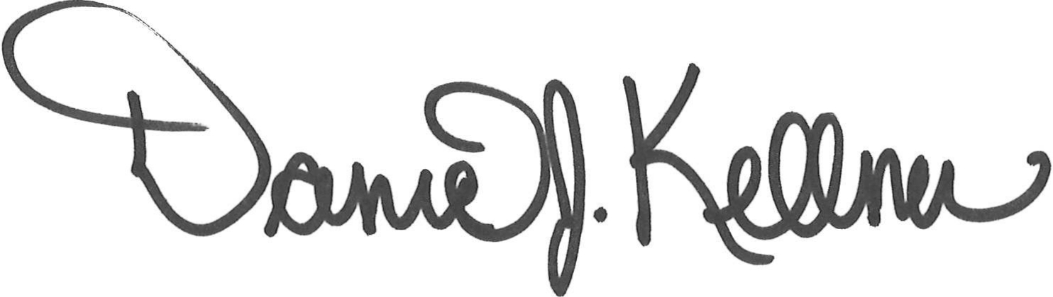

Dan Kellner

President, Saunders County Livestock & Ag Association