**Saunders**

**County**

**Livestock &Ag**

**Association**

PO Box 134

Wahoo, NE 66066

Dan Kellner, Weston

Andrew “Pudge” Donahue, Ceresco

Jordan Nelson, Ceresco

Dave Vrana, Prague

Brian Vech, Cedar Bluffs

Chris Tvrdy, Wahoo

Dennis Brabec, Wahoo

Kevin Sladky, Wahoo

Mike Heldt, Yutan

Mike Hines, Prague

Robert Meduna, Colon

Tyler Sudik, Ceresco

Jeff Brabec, Colon

Dan Malousek, Prague (Associate Dir.)

March 28, 2025

Dear Saunders County Livestock & Ag Association Member:

Spring is in the air, which means planting is just around the corner! Please join us for an informational meeting:

**Tuesday, April 8, 2025**

**Pre-Planting Meeting**

**Valparaiso Legion Hall**

**6:30 PM Social**

**7:00 PM Dinner**

Sponsors and speakers are:

**Booth Feed and Supply**

Beatrice, NE

**Mussmann Ag**

Jon Mussmann, Raymond, NE

**Ag-Technologies**

Tyler Rezac, Valparaiso, NE

Please help us recognize the 2025 Saunders County Livestock & Ag Association Scholarship winners, Erika Donahue, Jenna Sladky, Andrew Meduna, and Wyatt Palm.

There are a few who have not paid dues, please get a hold of one of your directors to get those paid.

The Saunders County Livestock & Ag Association Twilight Tour is being planned for June 30, 2025. Details to follow.

Sincerely,

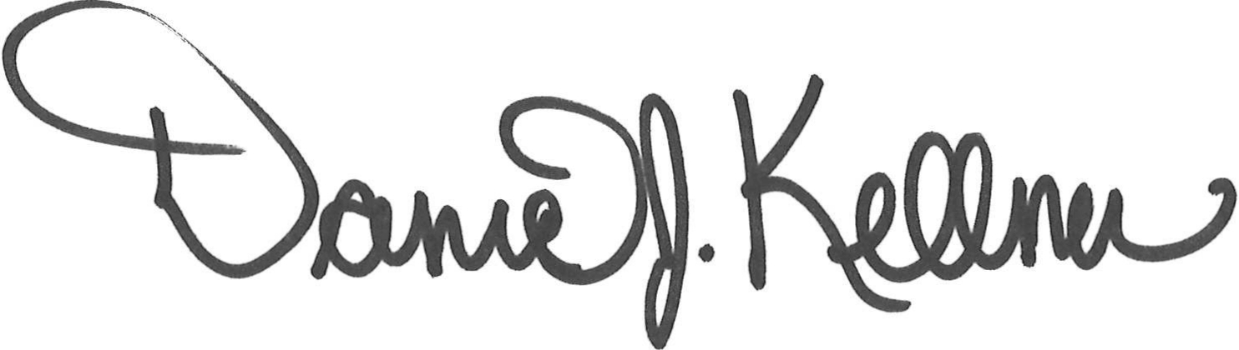

Dan Kellner

President, Saunders County Livestock & Ag Association