Saunders County

Livestock & Ag

Association

P.O. Box 134

Wahoo, NE 68066

Dan Kellner, Weston

Andrew “Pudge” Donahue, Ceresco

Jordan Nelson, Ceresco

Dave Vrana, Prague

Brian Vech, Cedar Bluffs

Chris Tvrdy, Wahoo

Dennis Brabec, Wahoo

Kevin Sladky, Wahoo

Mike Heldt, Yutan

Mike Hines, Prague

Robert Meduna, Colon

Tyler Sudik, Ceresco

Jeff Brabec, Colon

Dan Malousek, Prague (Assoc. Dir.)

Seth Johnson, Colon (Assoc. Dir.)

**Annual Twilight Tour – Monday, June 30, 2025**

Carpooling is encouraged!

This year’s Twilight Tour will take us to the Ithaca and Ashland areas.

**Start at 5:00 p.m. – SHARP!**

**Stop 1: Klosterman Feedlot Innovation Center**

**Hwy 66/County Road G and East of County Road 10, Southside**

Dr. Galen Erickson will lead a tour of the Klosterman Feedlot Center. **Ample parking is available in the highlighted area.**

Parking in highlighted area

*No alcohol is allowed on university property! *

**Stop 2: Treadway Ag**

**141 County Road 7, Ashland, NE**

Matt has lived in Ashland since he was 13 with a passion for farming. That passion turned into Treadway Ag-a full-service agronomy business based out of Ashland, NE.

**Stop 3: Country Drive Golf Course**

**951 County Road 4, Ashland, NE**

County Drive Golf Course was taken over in 2019 by Greg and Jerod Heldt and Chelsey Wenninghoff. We will be having supper at the events pavilion, which was added for concerts, weddings, and corporate events in 2023.

We want to thank all the hosts at the various stops for sharing their time and giving us an opportunity to see their operations. It should be an educational and enjoyable evening. We are looking forward to seeing you at the Twilight Tour!

Sincerely,

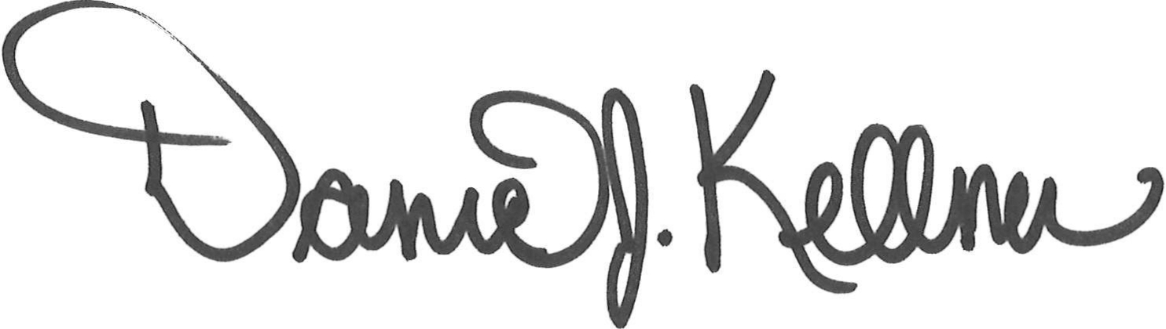

Dan Kellner

President, Saunders County Livestock & Ag Association

Stop 1

Stop 3

Stop 2

**Stop 1: Klosterman Feedlot**

**Hwy 66/County Road G and East of County Road 10, Southside**

Head north toward NE-66

Turn east onto NE-66 to Memphis

Go into Memphis

Turn left at Don’s Bar/4-way stop

Head South to County Road 8

Cross Ashland Road

Go 1 mile to Little Salt Road

Turn left to County Road 7

Turn right

Arrive at 141 County Road 7, Ashland, NE (Treadway Ag)

**Stop 2: Treadway Ag**

**141 County Road 7, Ashland, NE**

Leave Treadway Ag and go North to Ashland Road

Take Ashland Road to NE-66

Turn North on NE-66 out of Ashland

Continue on NE-66 until County Road 4

Turn East on County Road 4

At curve continue going straight North

Arrive at 951 County Road 4, Ashland, NE (County Drive Golf Course)

**Stop 3: Country Drive Golf Course**

**951 County Road 4, Ashland, NE**