Saunders
County
Livestock & Ag
Association

P.O. Box 134
Wahoo, NE
68066

Dan Kellner, Weston
Andrew “Pudge” Donahue, Ceresco
Jordan Nelson, Ceresco
Dave Vrana, Prague
Brian Vech, Cedar Bluffs
Chris Tvrdy, Wahoo
Dennis Brabec, Wahoo
Kevin Sladky, Wahoo
Mike Heldt, Yutan
Mike Hines, Prague
Robert Meduna, Colon
Tyler Sudik, Ceresco
Jeff Brabec, Colon
Dan Malousek, Prague (Assoc. Dir.)
Seth Johnson, Colon (Assoc. Dir.)

*Scholarship Recipients

Help Carry Meals/Clean Tables/Help as needed

Andrew Meduna
Erika Donahue
Jenna Sladky
Wyatt Palm

July 15, 2025

2025 BBQ Sandwich Meal for Saunders County Fair

Dear Saunders County Livestock & Ag Association Member:

This year’s Saunders County Fair is July 27th to August 3rd. The Saunders County Livestock & Ag Association will serve a BBQ Sandwich Meal on Thursday, July 31st from 5pm to 7:30pm This will be held at the Open Air Pavilion on the Saunders County Fairgrounds. We are planning to serve a lot of people, so we need everyone’s help and cooperation.

This year the Director’s will be handling the serving duties. If you are asked to help, we would be very grateful.

We appreciate anyone who can assist with cleaning up after serving once the BBQ is over. If you are unable to help, please contact one of your Director’s. Many Hands make Light Work.

This function is our big fundraiser for Your Association, to provide lunch or refreshments throughout the year. We hope you will all support your Saunders County Livestock & Ag Association by purchasing a dinner ticket whether you're working or not. Thank You.

Sincerely,

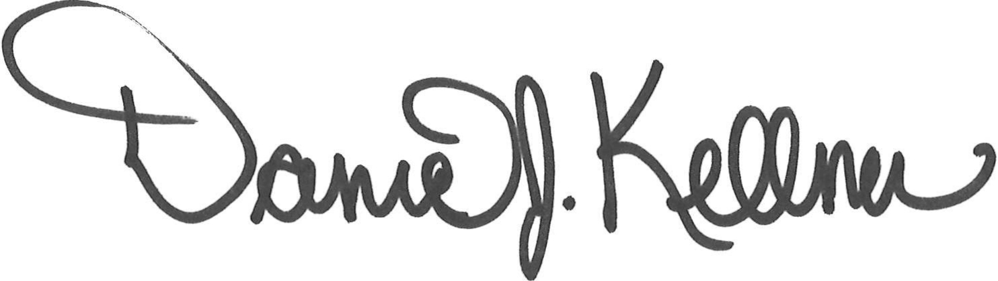

Dan Kellner
President, Saunders County Livestock & Ag Association

Directors – Please plan on setting up at the fairgrounds at 2 p.m. on July 31, 2025

