To | Person Person Dan Kellner
Cc | Person
Bcc | Person
Sbject
Saunders County
Livestock & Ag Association

P.O. Box 134
Wahoo, NE 68066

Dan Kellner, Weston
402-480-8778
Andrew “Pudge” Donahue, Ceresco
402-525-6262
Jordan Nelson, Ceresco
402-540-7556
Dave Vrana, Prague
402-840-0116
Brian Vech, Cedar Bluffs
402-480-3039
Chris Tvrdy, Wahoo
402-277-0902
Dennis Brabec, Wahoo
402-443-6580
Kevin Sladky, Wahoo
402-480-2468
Mike Heldt, Yutan
402-480-3798
Mike Hines, Prague
402-429-4268
Robert Meduna, Colon
402-480-1089
Tyler Sudik, Ceresco
402-443-8669
Jeff Brabec, Colon
402-277-6264
Dan Malousek, Prague (Associate Dir.)
402-443-9640
Seth Johnson, Colon (Associate Dir.)

SAUNDERS COUNTY LIVESTOCK & AG ASSOCIATION
NOTICE OF ANNUAL MEETING – January 5, 2026
ANNUAL BANQUET – January 26, 2026

Dear Members:

As we welcome the New Year, I extend my best wishes to each of you. I would like to take this opportunity to inform you about some important upcoming events.

We encourage all members to actively participate in the Association by attending our regular meetings, annual meeting and banquet. Membership dues for the upcoming year are as follows: $75 for local membership; $105 Nebraska Cattlemen; $180 for NCBA. Dues are payable now and are required to vote and participate as a member for 2026.

- The Annual Business Meeting shall be held as follows:

Monday January 5, 2026 Saunders County 4 H Building, Wahoo, Nebraska
6:00 PM Social Hour
6:30 PM Dinner
Frontier Cooperative sponsor and presentation – Frontier is a full-service cooperative located primarily in Eastern Nebraska serving customers since 1915. Frontier prides itself on being a progressive leader in today’s agriculture world.

Annual Business Meeting Agenda
Approval of 2025 Annual Meeting Minutes
2025 Treasurer’s Report
2026 Board of Directors Election
Adjourn
RSVP is due on or before December 31, 2026
Dan Kellner – 402-480-8778
Pudge Donahue – 402-525-6262
Jordan Nelson – 402-540-7556
Dave Vrana – 402-840-0116

This year, the annual meeting will be held in advance of the Annual Banquet to allow the Association to focus on recognition of our 4-H participants and their achievements and to enjoy the entertainment.

- The Annual Banquet will be held as follows:

January 26, 2026, at Starlight Event Center
Entertainment – US Veteran Col Tom Brewer
5:30 p.m. Social Hour
6:30 p.m. Banquet
$35.00 advance tickets – Purchase from Directors
NO TICKETS SOLD AT THE DOOR

- Scholarships are available to graduating seniors who are children, grandchildren or great-grandchildren of Association members. Applicants must be from Saunders County or bordering counties. Call Cheyenne Chromy at 402-547-7107 or email Cheyenne.Chromy@gmail.com for an application. Applications are due on or before March 1, 2025.

REMINDER: for further correspondence, especially dues, please DO NOT SEND to ENREC. Please mail Saunders County Livestock & Ag Association P.O. Box 134, Wahoo, NE 68066 or to Dave Vrana 2448 Co. Rd. 30, Prague, NE 68050

Please join us for both events!

Sincerely,
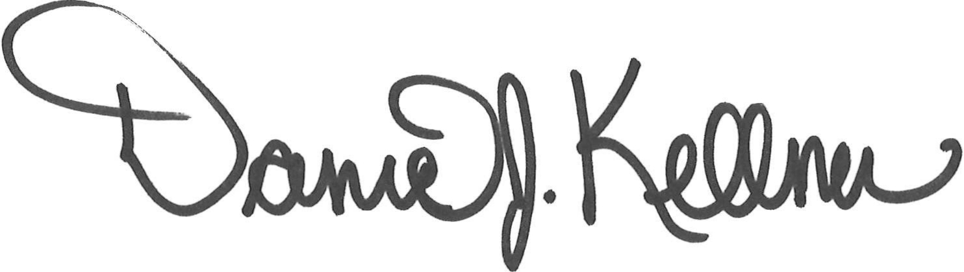

Dan Kellner
President, Saunders County Livestock & Ag Association

