Tentative Livestock & Ag Association Meetings for 2026

- Monday February 23, 2026
Food Pantry Drive
Colon Parish Hall

- Tuesday March 10, 2026
Testical Festival
Saunders County Fairgrounds

- Monday March 23, 2026
Scholarship/FFA
Valparaiso Legion Hall

- Monday April 6, 2026
Pre-Planning Meeting
Yutan Country Club

- Monday June 29, 2026
Twilight Tour

- Thursday July 30, 2026
Saunders County Fair Cookout

- Tuesday September 8, 2026
Outlook Meeting
Saunders County Fairgrounds

Letters to Follow

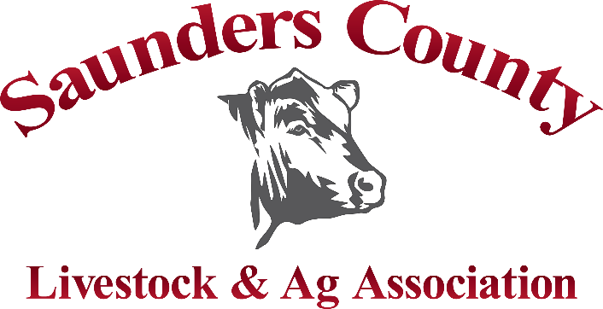

Tentative Livestock & Ag Association Meetings for 2026

- Monday February 23, 2026
Food Pantry Drive
Colon Parish Hall

- Tuesday March 10, 2026
Testical Festival
Saunders County Fairgrounds

- Monday March 23, 2026
Scholarship/FFA
Valparaiso Legion Hall

- Monday April 6, 2026
Pre-Planning Meeting
Yutan Country Club

- Monday June 29, 2026
Twilight Tour

- Thursday July 30, 2026
Saunders County Fair Cookout

- Tuesday September 8, 2026
Outlook Meeting
Saunders County Fairgrounds

Letters to Follow

Tentative Livestock & Ag Association Meetings for 2026

- Monday February 23, 2026
Food Pantry Drive
Colon Parish Hall

- Tuesday March 10, 2026
Testical Festival
Saunders County Fairgrounds

- Monday March 23, 2026
Scholarship/FFA
Valparaiso Legion Hall

- Monday April 6, 2026
Pre-Planning Meeting
Yutan Country Club

- Monday June 29, 2026
Twilight Tour

- Thursday July 30, 2026
Saunders County Fair Cookout

- Tuesday September 8, 2026
Outlook Meeting
Saunders County Fairgrounds

Letters to Follow

