Saunders County
Livestock & Ag
Association

P.O. Box 134
Wahoo, NE 68066

Dan Kellner, Weston

Andrew “Pudge” Donahue, Ceresco

Jordan Nelson, Ceresco

Dave Vrana, Prague

Brian Vech, Cedar Bluffs

Chris Tvrdy, Wahoo

Kevin Sladky, Wahoo

Mike Heldt, Yutan

Mike Hines, Prague

Robert Meduna, Colon

Tyler Sudik, Ceresco

Jeff Brabec, Colon

Dan Malousek, Prague

Seth Johnson, Colon (Assoc. Director)

Annual Twilight Tour – Monday, June 29, 2026
Carpooling is encouraged!

This year’s Twilight Tour will take us to the Columbus areas.

Start at 5:00 p.m. – SHARP!
Stop 1: 3D Designs Inc.
1520 25th Street, Columbus, NE 68601

3D Desings Inc. is a family-owned business that specializes in steel fabrication and manufacturing. They will show us a variety of machines that they use for metal working. 3D Designs is owned and operated by Dan and Andy Havlovic.

*Directions: Coming into Columbus, NE from the East, going West on Hwy 30, turn North on 16th Ave by the NAPA Store, go 2 block North and a little East, business will be on North side.

Stop 2: Duo Lift Manufacturing
2810 38th Street, Columbus, NE 68601

Duo Lift Manufacturing is 3rd generation family-owned business. Ben and David Hellbusch have run the company for the last 5 years. They build high-quality fertilizer and farm equipment.

*Directions: From 3D Designs, go West on Hwy 30, take a right on 18th Ave, go North, take a left on 38th Street, go West, Duo Lift is on the North side of 38th St.

Stop 3: Sidump’r Trailer, BatchBox, and Beaver Bearing
2500 23rd St. East, Columbus, NE 68601

The first Sidump’r Trailer was built in Plainview, NE in 2000. In 2010, Sidump’r was purchased by the Niewohner Brothers. With their expansion came a relocation to the current facility in Columbus, NE.

*Directions: From Duo Lift, go East to 18th Ave, then South to Hwy 30, take a left on Hwy 30, go to mile marker 383, if missed, then go to 29th St. and go South to the first entrance and follow the access road. Parking will be on both the East and West side of Sidump’r facility.

Lunch will be provided following the tour at Sidump’r facility.

We extend our sincere appreciation to all the hosts for generously sharing their time and providing us with the opportunity to tour their operations. We are confident the evening will be both educational and enjoyable. We look forward to seeing you at the Twilight Tour.

Sincerely,

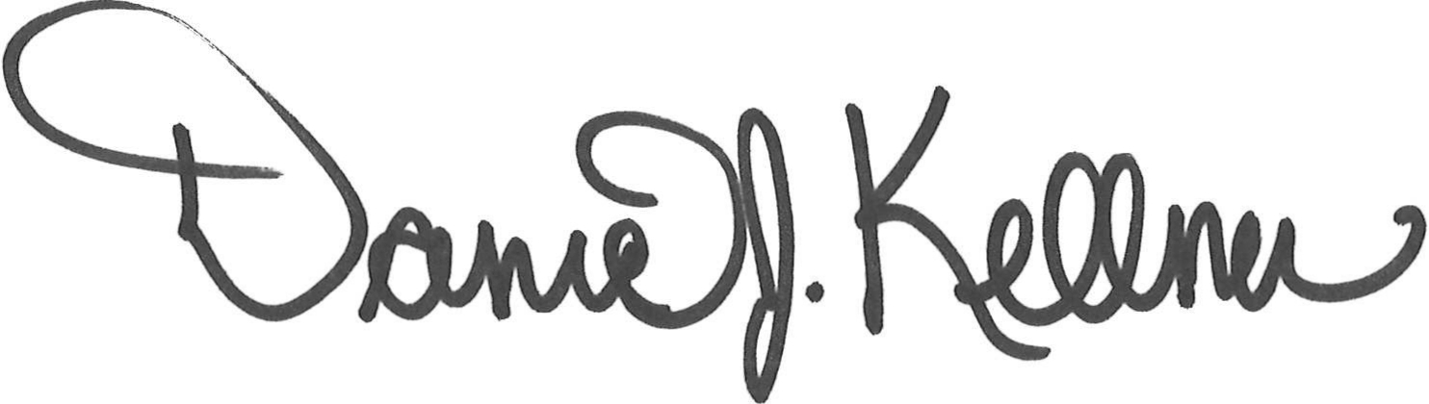
Dan Kellner
President, Saunders County Livestock & Ag Association

