De Vesci Lawn Tennis Club

Membership Management Handbook

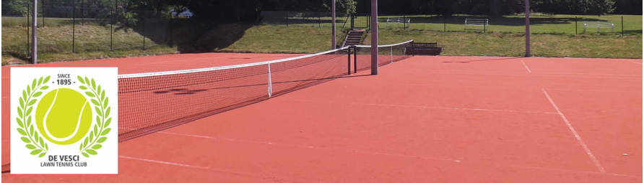

Developed by and for use of
De Vesci LTC Committee

1. Purpose of this document and document history 3
2. Process Flow Chart for New Members and Annual Renewal Process 4
3. New Joiner Application (Draft email) 5
4. Email to Welcome New Joiners to De Vesci LTC 6
5. De Vesci Court Booking System Details 7
6. Guest Players to the Club 8
7. De Vesci - Subscription Renewal: To be sent around mid-April of renewal year 8
8. Reminder Notice to Pay Membership 10
9. Final Notice to Pay Membership 11
10. Termination of De Vesci LTC Membership 12
11. New Membership Application Form 2025/2026 13
12. Membership Renewal Form 2025/2026 15

Purpose of this document and document history

The purpose of this document is to outline the process for new membership subscriptions in De Vesci Lawn Tennis Club and for membership renewal.

Draft communication emails are contained within for the purpose of distribution. These can be updated and amended as required.

This is a live document to aid the Membership Secretary in their role.

Developed | Date | Reviewer | Date | Comments
Ronan O’Sullivan | 20/01/2025 | Greta Hickey | 20/01/2025 | First Draft for comment
Ronan O’Sullivan | 24/01/2025 | Committee | XX/XX/2025 | Second Draft adding guest Section and Family membership payment using Acebook

Process Flow Chart for New Members and Annual Renewal Process

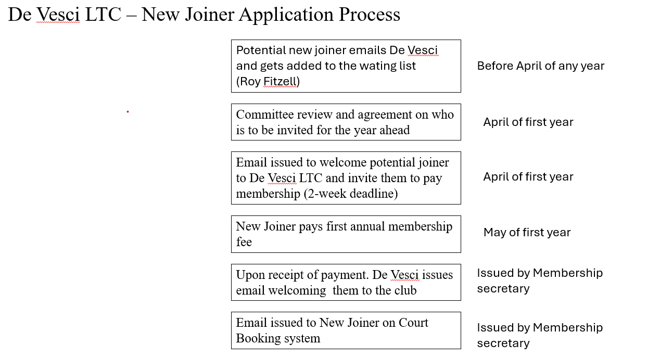

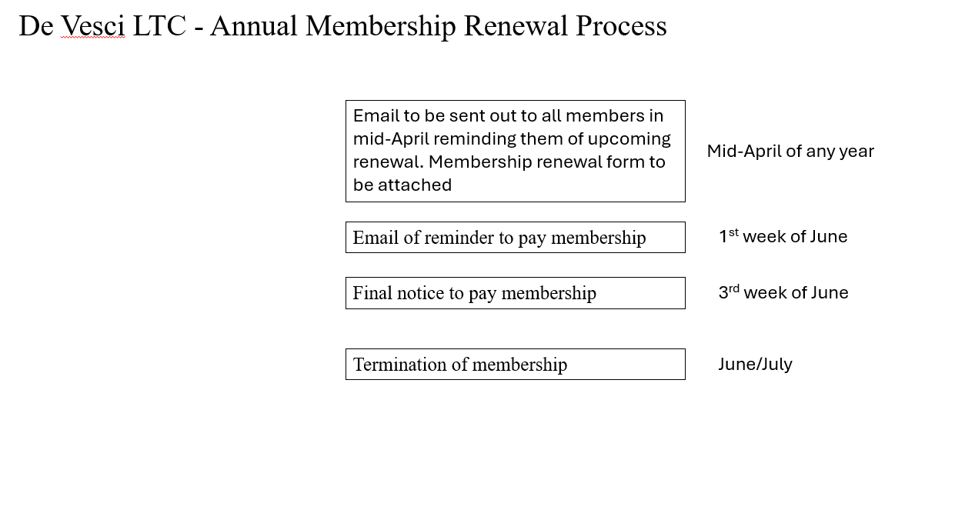

New Joiner Application (Draft email)

Email title: New Joiner Application

Hi there,
Thank you for your email and interest in joining De Vesci Lawn Tennis club. We would like to welcome you to join the club. I have included an application form which you can email back to me once complete.

Please include details of all family members (Name, Age and Gender), if offered a family membership.
Please pay your annual subscription (May to April) through the means suggested in the form. Please include your name or family name in reference while making online transfers.
When your membership fee is paid and filled form received, I will provide you more details regarding access, online court booking etc.
If we do not hear from you in 2 weeks’ time, we will offer the space to the next waiting in line.
For your information, men's tennis is on Monday evenings from 7:00pm onwards, and is open to all levels. Ladies’ tennis is on Tuesday evenings from 7:00pm, again for all levels.
Please also note, this club is mostly run by volunteers, your patience and cooperation will be highly appreciated.
Feel free to reach out in case you have any questions.
Many thanks,
Ronan
De Vesci Committee

Email to Welcome New Joiners to De Vesci LTC

Email title: Welcome new member of De Vesci LTC

Hi (New member name),

We formally welcome you to the De Vesci club. Thanks for paying membership fees.

I'll send you some details in a separate email regarding how to sign up to the court booking system. Please register every member (if applicable). Once you register, we will approve your registration. Court booking is not required by you for coaching.

We have men's tennis on Monday evenings from 7:00pm onwards open to all levels. Ladies’ tennis is on Tuesday evenings from 7:00pm again for all levels. No booking required for these nights.

We have a fob system for access and Roy Fitzell has all the fobs. You can contact him directly to arrange a collection, he is also cc'd on this email.
Roy Fitzell - 086 2517833 or refitzell@gmail.com

To open the outside gate (both in and out), place your fob in front of the keypad.

For access to the clubhouse
To open - place your fob in front of the keypad and then press 1234
To close - place the fob in front of the keypad and then press 4321

We have a coach Tadhg Johnston who organises individual sessions, kids coaching and Tennis camps.
You can contact him directly for more information and availability.
tadhgjohnston@gmail.com - 087 6301313

It is enormously beneficial if you are in the WhatsApp groups as there is plenty of information shared through that medium.
To join simply send a WhatsApp to a captain and they will add you in.
- Ladies Captain - Rimiko 086 608 6999
- Men’s Captain - Harry 086 328 2836

Just to note also that De Vesci Gardens is a private park for the residents only. Tennis club members, unless residents, only have access to and from the courts and are not permitted to walk in or around the park.
I'll also include you on the club mailing list.
Please also note that this club is run mostly by volunteers. Your patience and cooperation will be highly appreciated.
Many thanks,
Ronan
De Vesci Committee

De Vesci Court Booking System Details

Email title: Details on how to sign up and log in to the court booking system

Details on how to sign up and log in to the court booking system

Click on the link below for the De Vesci website

https://www.devesci.net/

Then click on 'Book a Court'

It will then ask you to select a Sports club - select De Vesci LTC

You will be brought to a Log In page - select 'Sign up'

For Username use your own email address

You then choose your own password, you'll need to enter it twice, and some other details

Press Save

You might then have to Log In with your Username and password

Your registration will have to be validated by an administrator from De Vesci before you can make court bookings. If there is a delay, please email devesciltc@gmail.com to let them know you are waiting to be validated.

Once registered, and up and running, courts can also be booked using the AceBook App, available from wherever you purchase your apps.

If there are any issues with the Court Booking system please contact
Roy Fitzell - 086 2517833 or refitzell@gmail.com

Many thanks,
Ronan
De Vesci Committee

Guest Players to the Club

Members are allowed to bring guests to play at the club at the following times

- Monday to Friday: All day until 4pm
- Saturday: After 4pm
- Sunday: After 1pm (except on days when there are league matches)

The cost of bringing guest members is €5/person, which is paid by an honor system of putting money in the collection box in the clubhouse.

De Vesci - Subscription Renewal: To be sent around mid-April of renewal year

Email title: De Vesci LTC annual membership renewal

Dear Member,

Thank you for being part of the De Vesci Tennis Club, and hope you are enjoying your tennis.

It is now time to renew your membership.
Membership runs from May to April. Please make the membership renewal payment for the new season - May-2024 to April-2025.

Annual membership payment can be made via the court booking system for all single memberships (senior, student, junior, under 7).
This is like any online payment process, using your debit/credit card.

For family membership please make the payment by bank transfer (details below).
Please include your name or family name for which you are making the payment in the payment reference.
For families, please fill in the form with all the family member names (and date of birth for Juniors).

For our club membership records we still require everyone complete and return the form attached to this email.

If you want to make any change in your current membership category (e.g. removing or adding any family members), please inform us before renewing the membership.

Also, every member of the family needs to be registered into the booking system, so a court can be booked in their name.

If you are making a payment for Student, please provide the student ID along with the form (still pay via online booking system).

If you are making a payment for a Junior membership or child below 7, please include Date of Birth on the form (still pay via online booking system).

There will be a small payment fees (Strip - the payment gateway) already added into the payment into the booking system.

Last day for paying the renewal fees is 31st May.
After that, access to the club and court booking system will be disabled, if renewal membership is not paid.

If you are not renewing your membership, we would really appreciate it if you could let us know by replying to this email.
This would assist us in starting to welcome new members, as we have a long waiting list.
We can then also remove your name from our membership mailing list.

Feel free to reach us in case there is any issue with making a payment, or any other query.

Thank you for your kind cooperation.

De Vesci Club.

Reminder Notice to Pay Membership

Email title: De Vesci LTC annual membership renewal reminder

Dear Member,

We are sending you this email, because it seems, from our records, that you have not yet paid your subscription.
We may have indeed missed your payment, and in this case, please come back to us with the payment details.

If you are not intending to renew your subscription, we would greatly appreciate it if you could let us know

If the subscription is not paid by 31st May, your access will be disabled.
If you still want to renew your subscription after the 31 May, you will need to pay a late fee of Euro 25 on top of the annual subscription.

All membership types can now be renewed via the system.

Please bear in mind that the club is run by volunteers, and we would like to close the renewal process as soon as possible, to allow new members to join the club. All this involves a lot of background work.

Feel free to reach out to us in case you have any questions or concerns.

Thanks,
De Vesci Committee

Final Notice to Pay Membership

Email title: Final notice - De Vesci LTC annual membership renewal

Dear Member,

We are sending you this email, because it seems, from our records, that you have not yet paid your subscription.
We may have indeed missed your payment, and in this case, please come back to us with the payment details.

If you are not intending to renew your subscription, we would greatly appreciate it if you could let us know

If the subscription is not paid by 31 May, your access will be disabled.
If you still want to renew your subscription after the 31 May, you will need to pay a late fee of Euro 25 on top of the annual subscription.

All membership types can now be renewed via the system.

Please bear in mind that the club is run by volunteers, and we would like to close the renewal process as soon as possible, to allow new members to join the club. As you can appreciate this involves a lot of background work.

Feel free to reach out to us in case you have any questions or concerns.

Thanks,
De Vesci Committee

Termination of De Vesci LTC Membership

Email title: Termination of De Vesci LTC membership

Dear Sir/Madam,

We are sending you this email, because it seems, from our records, that you have not yet paid your subscription. You would have received a notification email in April, a reminder and a final notice email. As you have not yet paid your membership fee for this year you are now removed from the club membership.

If you would like to rejoin the club, please let us know and you will be added to the waiting list.

Kind Regards
De Vesci Committee

New Membership Application Form 2025/2026

DE VESCI LAWN TENNIS CLUB
New Member Form - 1 May 2025 to 30 April 2026

Name:
Address:
Email: Phone / Mobile No:
Family Member Name (If applicable) | DOB (Mandatory for Juniors & Under 7’s) | Tennis experience (if any):
Please include every member’s detail who are joining the club.
Proposed by(if possible):
All applications subject to the approval of the Committee

Type | Details | Annual Fee
Family | 2 Seniors + all Juniors | €600
Senior | Over 18 yrs. on 1st May | €280
Student | Over 18 yrs. full-time student (ID Needed) | €120
Junior | 7 - 18 yrs, please provide DOB | €110
Pavilion | Only to follow the club, not allowed to play | €40
Under 7’s | Under 7 on 1st May, please provide DOB | €40

Please email to devesciltc@gmail.com

If paying by transfer please tick here [ X ]

Bank: Bank of Ireland BIC: BOFI IE 2D
Account name: De Vesci Lawn Tennis Club Account Number: 49090959
IBAN: IE32 BOFI 901116 49090959 Sort Code: 90-11-16

Please always reference your name or family name if paying by bank transfer

CHILD PROTECTION IN SPORT
By joining De Vesci LTC I formerly indicate my acceptance of Sport Irelands’ Ethics and Practices for Children in sport and to this end all members are expected to have read the guidelines contained in Sports Ireland's - Safeguarding Guidance for Children & Young People in Sport, a copy can be found on the noticeboard and website
https://www.sportireland.ie/sites/default/files/2020-01/safeguarding-guidance.pdf
For Data Protection and privacy statement please refer to club website www.devesci.net

Signature:
Date:

Membership Renewal Form 2025/2026

DE VESCI LAWN TENNIS CLUB
Subscription Renewal - 1 May 2025 to 30 April 2026

Name:
Address:
Email: Phone / Mobile No:
Family Member Name (If any) | DOB (Mandatory for Juniors and Under 7’s)
*Please also register every member of family in the booking system if not already.

Type | Details | Annual Fee
Family | 2 Seniors + all Juniors | €600
Senior | Over 18 yrs on 1st May | €280
Student | Over 18 yrs and full-time student (ID needed) | €120
Junior | 7 - 18 yrs, please provide DOB | €110
Pavilion | Not allowed to play | €40
Under 7’s | Under 7 on 1st May, please provide DOB | €40

if paying by bank transfer tick here [ yes ] (you can email back form to devesciltc@gmail.com)

Bank: Bank of Ireland
Account name: De Vesci Lawn Tennis Club
BIC: BOFI IE 2D
IBAN: IE32 BOFI 901116 49090959
Account Number: 49090959
Sort Code: 90-11-16

Please reference your name and email that payment was made to devesciltc@gmail.com

CHILD PROTECTION IN SPORT
By joining De Vesci LTC I formerly indicate my acceptance of Sport Irelands’ Ethics and Practices for Children in sport and to this end all members are expected to have read the guidelines contained in Sports Ireland's - Safeguarding Guidance for Children & Young People in Sport, a copy can be found on the noticeboard and website
https://www.sportireland.ie/sites/default/files/2020-01/safeguarding-guidance.pdf
For Data Protection and privacy statement please refer to club website www.devesci.net

Signature:
Date:

