

DIGITAL LEADERS

OF TODAY AND TOMORROW

01.10.2024-30.09.2026

DISCLAIMER

Funded by the European Union. Views and opinions expressed are however those of the author(s) only and do not necessarily reflect those of the European Union or the European Education and Culture Executive Agency (EACEA). Neither the European Union nor EACEA can be held responsible for them.

ROBLOX

ACTIVITY NO. 1

Lesson Project: “Math Obby” in Roblox Studio

Subject: Mathematics
Lesson project where students create a “math obby” (an obstacle course + math quiz) in Roblox Studio. The lesson combines mathematics, logical thinking, game design, and basic programming in Lua.

Learning Objectives
- Mathematical concepts: Review and apply arithmetic, fractions, proportions, simple equations:
[ 12 + 8,\quad \frac{3}{4} + \frac{1}{2},\quad 2x + 3 = 9 ]
- Digital skills: Using Roblox Studio, manipulating 3D objects, event logic, and basic Lua scripting.
- Critical thinking: Designing levels and calibrating difficulty; testing and iteration.
- Collaboration: Teamwork with roles (designer, programmer, item creator, QA).

Resources and Preparation
- Software: Roblox Studio installed; verified Roblox accounts.
- Templates: Objects like Part, SpawnLocation, Checkpoint, Decals/Textures for aesthetics.
- Materials: Worksheets with math items (per level), evaluation rubric, quick Lua guide.
- Organization: Teams of 3–4 students; total time 60–90 minutes.

Lesson Structure (60–90 min)

Introduction (10 min)
- Context: What an “obby” is, how we combine gaming with math learning.
- Objectives: What students will build and demonstrate at the end.
- Safety: Online behavior, appropriate language, no personal data.

Planning (10–15 min)
- Math theme: Choose per level (from arithmetic to equations).
- Storyboard: 4–6 levels, each with obstacles + quiz gate.
- Roles: Level designer, scripter, item author, tester.

Building in Roblox (25–40 min)
- Levels: Platforms, obstacles (lava, moving platforms), checkpoints.
- Quiz gates: Doors/blocks that open only with correct answers.
- UI: Screen with question + answer input, visual feedback.

Testing and Iteration (10–15 min)
- Bugfix: Collisions, spawn, scripts.
- Difficulty: Adjust timing, distances, variety of questions.
- Aesthetics: Colors, sounds, positive feedback.

Presentation (5–10 min)
- Demo: One team plays another’s level.
- Reflection: What worked, what to improve, what they learned.

Practical Steps in Roblox Studio

Project Setup
- Workspace: Create Baseplate; add SpawnLocation.
- Checkpoints: Colored parts; save “checkpoint index” in name.

Basic Obstacles
- Platforms: Raised Parts; Anchor; adjust Transparency/CanCollide.
- Hazard (“lava”): Red Part; on touch, respawn at last checkpoint.

Quiz Gate (door + trigger)
- Door: Part with CanCollide = true; named “QuizDoor”.
- Trigger: Invisible Part (“TouchTrigger”) before door; launches UI.

Interface (ScreenGui)
- Elements: TextLabel for question, TextBox for answer, TextButton “Submit”.
- Logic: On correct answer, door becomes CanCollide = false for a few seconds.

Essential Lua Scripts
- Respawn at “lava” and save checkpoint
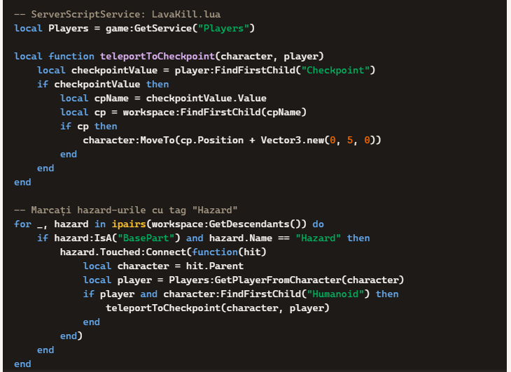
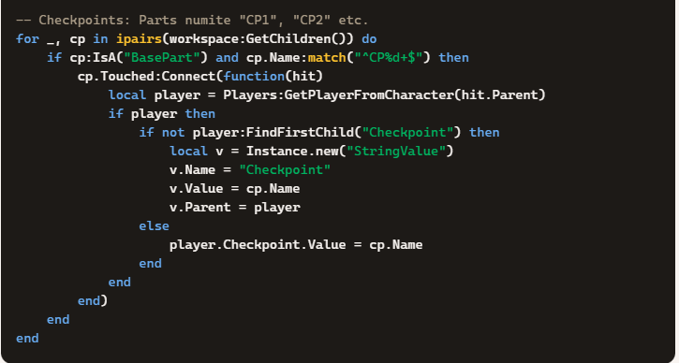

- Open door on correct answer (server + client)
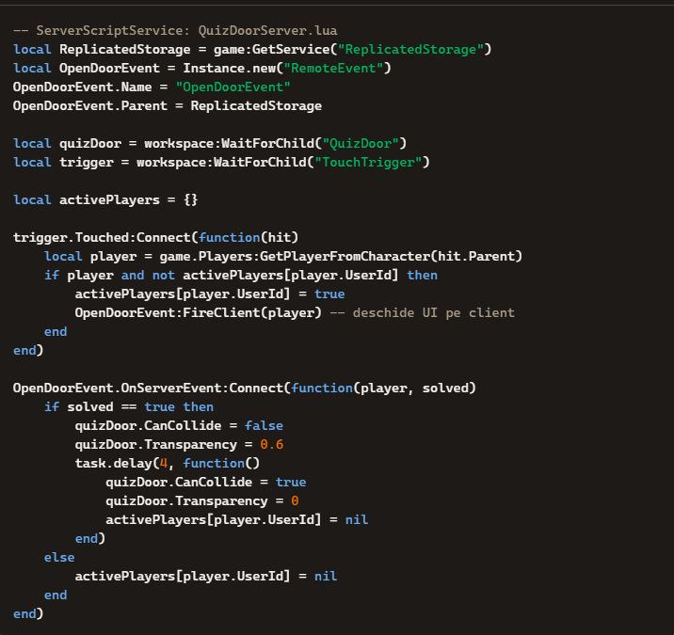
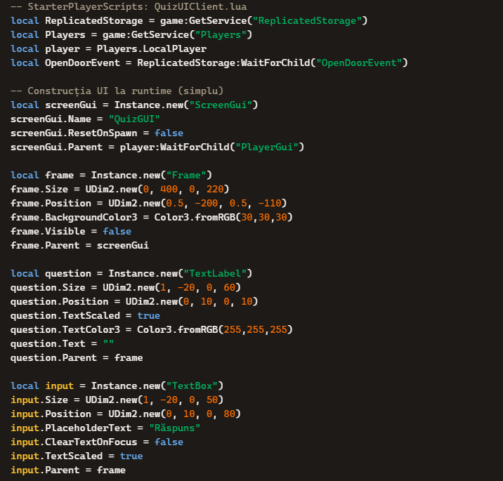
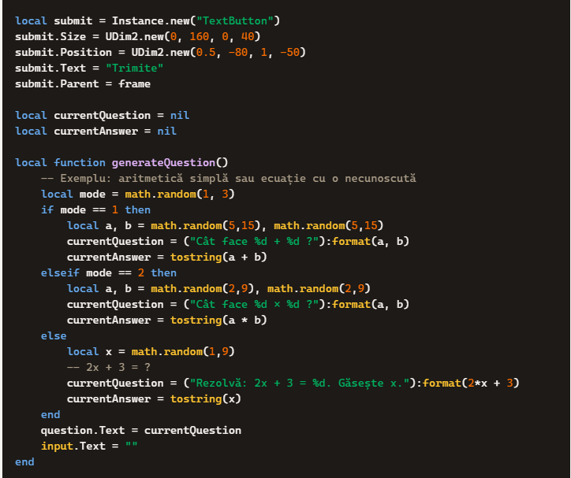
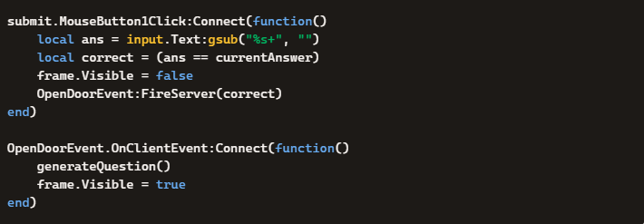
- Visual/audio feedback (optional)
-- ServerScriptService: Feedback.lua
local quizDoor = workspace:WaitForChild("QuizDoor")
local SoundService = game:GetService("SoundService")

local function playSound(id)
local s = Instance.new("Sound")
s.SoundId = "rbxassetid://"..id
s.Parent = SoundService
s:Play()
game.Debris:AddItem(s, 3)
end
-- Apelați playSound(123456789) la răspuns corect pentru un „success chime”

Math Content per Level (examples)
- Arithmetic: Sums/differences up to 100; single-digit products.
45-12, 7x3
- Fractions: Equivalences and additions with common denominators.
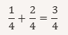
- Proportions: Rule of three in game situations (time/distance).
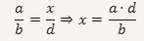
- Equations: Solve for (x) in simple linear equations.

Evaluation, Differentiation, and Extensions
- Rubric:
  - Math correctness: Varied questions, answer checking.
  - Level design: Clarity, progression, accessibility.
  - Functionality: No major bugs, correct checkpoints.
  - Collaboration: Contribution and communication in team.
- Differentiation:
  - Beginners: Arithmetic, single doors, simple UI.
  - Advanced: Randomized items, multiple doors, scores, timer, progress saving.
- Extensions:
  - Question database: Local table or ModuleScript with item lists.
  - Leaderboard: Score for fast correct answers.
  - Homework: Students add 2–3 new levels at home, with 5 questions each.

Safety and Ethics
- Content: No inappropriate language; only math and fair play.
- Personal data: No collection; don’t ask for real names or contacts.
- Publishing: Test first; set game “Private” until verified.

ACTIVITY NO. 2

Lesson Plan: Storytelling & Vocabulary Adventure in Roblox
Grade Level: 7th Grade
Subject: English Language
Duration: 60–90 minutes

Learning Objectives
- Reading comprehension: Translate short story elements into interactive Roblox scenes.
- Vocabulary development: Embed new words into in-game challenges and dialogues.
- Critical thinking: Show how character actions and choices affect the game’s outcome.
- Creative writing: Script alternative endings or branching storylines inside Roblox.

Materials
- Roblox Studio installed; student accounts ready.
- Short story excerpt (e.g., The Necklace or another age-appropriate text).
- Vocabulary list from the story.
- Teacher guide with sample scripts.
Lesson Flow

1. Warm-Up (10 min)
- Discussion: “How can we turn a story into a game?”
- Brainstorm: Students suggest how characters, conflicts, and settings could appear as Roblox levels.

2. Reading & Vocabulary (15 min)
- Read the short story excerpt.
- Identify 5–7 key vocabulary words.
- Challenge: Students must integrate these words into signs, NPC dialogues, or quiz gates in Roblox.

3. Roblox Build Activity (25–35 min)
- Scene design: Students recreate a setting from the story (e.g., a ballroom, a marketplace).
- Character representation: Add NPCs with dialogue boxes showing vocabulary words.
- Interactive quiz gates: Players answer comprehension questions to unlock doors or checkpoints.
- Branching endings: Students script simple choices (e.g., “Return the necklace” vs. “Hide the truth”) that lead to different paths.

4. Playtest & Reflection (10–15 min)
- Teams play each other’s games.
- Discussion: How did the game show character traits, conflict, and theme?
- Reflection: Students write one sentence about what they learned about storytelling

Assessment
- Correct integration of vocabulary in Roblox dialogues.
- Accuracy of comprehension questions embedded in quiz gates.
- Creativity in designing alternative endings.
- Participation in playtesting and discussion.

Differentiation
- Support: Provide pre-built templates (quiz gate, NPC dialogue) for beginners.
- Challenge: Advanced students add branching storylines or timed challenges tied to comprehension.

Extensions
- Create a “Vocabulary Obby” where each checkpoint requires defining or using a word.
- Build a “Choose Your Own Adventure” game where multiple endings reflect different interpretations of the story’s theme.
- Add a leaderboard for fastest completion with correct answers.

ACTIVITY NO. 3

Step-by-Step Roblox Scripting Guide for English Lesson

1. Setting up the Scene
- Open Roblox Studio → choose Baseplate.
- Add a SpawnLocation so players know where to start.
- Create Parts for platforms, doors, and checkpoints.
- Rename objects clearly: QuizDoor, TriggerPart, Checkpoint1.

2. Adding Vocabulary NPCs
Students can embed vocabulary words into NPC dialogue boxes.
-- StarterPlayerScripts: VocabularyNPC.lua
local npc = workspace:WaitForChild("VocabularyNPC")
local dialog = Instance.new("Dialog")
dialog.InitialPrompt = "Word of the day: 'Resilient'."
dialog.Parent = npc
Each NPC introduces a new word. Students must use the word in a sentence to pass the level (teacher checks during play).

3. Creating a Quiz Gate (Comprehension Questions)
Players must answer a reading comprehension question to open a door.
-- ServerScriptService: QuizDoor.lua
local ReplicatedStorage = game:GetService("ReplicatedStorage")
local QuizEvent = Instance.new("RemoteEvent")
QuizEvent.Name = "QuizEvent"
QuizEvent.Parent = ReplicatedStorage

local quizDoor = workspace:WaitForChild("QuizDoor")
local trigger = workspace:WaitForChild("TriggerPart")

trigger.Touched:Connect(function(hit)
local player = game.Players:GetPlayerFromCharacter(hit.Parent)
if player then
QuizEvent:FireClient(player) -- show question UI
end
end)

QuizEvent.OnServerEvent:Connect(function(player, correct)
if correct then
quizDoor.CanCollide = false
quizDoor.Transparency = 0.5
task.delay(5, function()
quizDoor.CanCollide = true
quizDoor.Transparency = 0
end)
end
end)

4. Building the Quiz UI (Client Side)
Students design comprehension questions based on the short story.
-- StarterPlayerScripts: QuizUI.lua
local ReplicatedStorage = game:GetService("ReplicatedStorage")
local QuizEvent = ReplicatedStorage:WaitForChild("QuizEvent")

local player = game.Players.LocalPlayer
local gui = Instance.new("ScreenGui", player.PlayerGui)
local frame = Instance.new("Frame", gui)
frame.Size = UDim2.new(0, 400, 0, 200)
frame.Position = UDim2.new(0.5, -200, 0.5, -100)
frame.Visible = false

local question = Instance.new("TextLabel", frame)
question.Size = UDim2.new(1, -20, 0, 60)
question.Position = UDim2.new(0, 10, 0, 10)
question.TextScaled = true

local input = Instance.new("TextBox", frame)
input.Size = UDim2.new(1, -20, 0, 50)
input.Position = UDim2.new(0, 10, 0, 80)
input.PlaceholderText = "Type your answer here"

local submit = Instance.new("TextButton", frame)
submit.Size = UDim2.new(0, 160, 0, 40)
submit.Position = UDim2.new(0.5, -80, 1, -50)
submit.Text = "Submit"

local currentAnswer = "Madame Loisel" -- Example answer

QuizEvent.OnClientEvent:Connect(function()
question.Text = "Who is the main character in 'The Necklace'?"
frame.Visible = true
end)

submit.MouseButton1Click:Connect(function()
local ans = input.Text
local correct = (ans == currentAnswer)
frame.Visible = false
QuizEvent:FireServer(correct)
end)

5. Creative Writing Extension
Students can script branching endings:
- If the player chooses “Return the necklace,” they unlock a happy ending room.
- If they choose “Hide the truth,” they unlock a tragic ending room.
-- Workspace: ChoiceButtons.lua
local ReplicatedStorage = game:GetService("ReplicatedStorage")
local EndingEvent = Instance.new("RemoteEvent")
EndingEvent.Name = "EndingEvent"
EndingEvent.Parent = ReplicatedStorage

-- Two buttons in the scene
local returnBtn = workspace:WaitForChild("ReturnButton")
local hideBtn = workspace:WaitForChild("HideButton")

local function teleportPlayer(player, destination)
local char = player.Character
if char then
char:MoveTo(destination.Position + Vector3.new(0,5,0))
end
end

returnBtn.Touched:Connect(function(hit)
local player = game.Players:GetPlayerFromCharacter(hit.Parent)
if player then
teleportPlayer(player, workspace:WaitForChild("HappyEndingRoom"))
end
end)

hideBtn.Touched:Connect(function(hit)
local player = game.Players:GetPlayerFromCharacter(hit.Parent)
if player then
teleportPlayer(player, workspace:WaitForChild("TragicEndingRoom"))
end
end)

6. Assessment in Roblox
- Vocabulary: NPC dialogues must use the target words.
- Comprehension: Quiz gates test understanding of the story.
- Creative writing: Branching endings show imagination and narrative skills.
- Collaboration: Students work in teams to design levels and scripts.

ACTIVITY NO. 4

Roblox Game Template Structure

Workspace
- SpawnLocation → where players start
- QuizDoor → locked door that opens after answering correctly
- TriggerPart → invisible part before the door to launch the quiz
- Checkpoint1, Checkpoint2, … → save progress points
- VocabularyNPCs → models with Dialog objects showing vocabulary words
- ReturnButton → choice button for “Return the necklace” ending
- HideButton → choice button for “Hide the truth” ending
- HappyEndingRoom → teleport destination for positive ending
- TragicEndingRoom → teleport destination for tragic ending

ServerScriptService
- QuizDoor.lua → handles server logic for quiz gates
- CheckpointSystem.lua → saves player progress at checkpoints
- ChoiceButtons.lua → teleports players to different endings based on their choice

StarterPlayerScripts
- QuizUI.lua → displays comprehension questions and checks answers
- VocabularyNPC.lua → shows vocabulary words in NPC dialogues

ReplicatedStorage
- QuizEvent (RemoteEvent) → communication between client UI and server door logic
- EndingEvent (RemoteEvent) → communication for branching endings

How Students Plug in Their Story
- Vocabulary Words
  - Edit VocabularyNPC.lua → replace "Resilient" with the target word.
  - Add definition and example sentence in the NPC’s dialog.
- Comprehension Questions
  - In QuizUI.lua, change question.Text to your chosen question.
  - Update currentAnswer with the correct answer.
- Alternative Endings
  - Rename HappyEndingRoom and TragicEndingRoom to match your story’s themes.
  - Students write short descriptions on signs or NPCs inside each room.
- Assessment
  - Teacher checks that vocabulary is used correctly in NPCs.
  - Quiz gates test comprehension of the short story.
  - Branching endings show creative writing skills.

Suggested Workflow for Students
- Read the short story excerpt.
- Pick 5–7 vocabulary words.
- Build the Roblox scene (setting + characters).
- Script quiz gates with comprehension questions.
- Add branching endings to show creative writing.
- Playtest each other’s games and reflect.

ACTIVITY NO. 5

Roblox English Adventure

– Student Checklist

1. Getting Started
- [ ] Open Roblox Studio and choose Baseplate.
- [ ] Add a SpawnLocation (where players start).
- [ ] Save your project with a clear name (e.g., EnglishAdventure).

2. Vocabulary NPCs
- [ ] Place an NPC (character model) in your world.
- [ ] Add a Dialog object to the NPC.
- [ ] Write one vocabulary word from today’s list in the dialog.
- [ ] Add a definition or example sentence.
(Example: “Word of the day: Resilient – able to recover quickly.”)

3. Comprehension Quiz Gate
- [ ] Insert a Part and rename it QuizDoor.
- [ ] Insert another Part before the door and rename it TriggerPart.
- [ ] Add the quiz script (teacher provides template).
- [ ] Change the question text to match your story.
- [ ] Update the correct answer.
(Example: Question: “Who is the main character?” Answer: “Madame Loisel”)

4. Checkpoints
- [ ] Add Checkpoint1, Checkpoint2, … (colored Parts).
- [ ] Make sure touching a checkpoint saves progress.

5. Creative Writing Endings
- [ ] Add two buttons: ReturnButton and HideButton.
- [ ] Create two rooms: HappyEndingRoom and TragicEndingRoom.
- [ ] Write a short description or dialogue in each room to show your alternative ending.
(Example: Happy Ending Room sign: “She returned the necklace and was forgiven.”)

6. Playtest
- [ ] Click Play in Roblox Studio.
- [ ] Walk through your level.
- [ ] Test the NPC vocabulary, quiz gate, checkpoints, and endings.
- [ ] Fix any errors (door not opening, wrong answer, etc.).

7. Share & Reflect
- [ ] Let another team play your game.
- [ ] Ask: Did they learn the vocabulary? Did they understand the story?
- [ ] Write one sentence in your notebook: “I learned that…”

✅ Success Criteria
- Vocabulary words are used correctly in NPCs.
- Quiz gate question matches the story.
- Alternative endings show creativity.
- Game runs without major bugs.

ACTIVITY NO. 6

Teacher’s Rubric

– Roblox English Adventure Project
Grade Level: 7th Grade English Language
Criteria | Excellent (4 pts) | Good (3 pts) | Fair (2 pts) | Needs Improvement (1 pt)
Vocabulary Integration | Vocabulary words are correctly embedded in NPC dialogues with definitions and examples; creative use in context. | Vocabulary words appear in dialogues with definitions; some examples missing. | Vocabulary words included but limited explanations or incorrect usage. | Few or no vocabulary words used; incorrect or missing definitions.
Comprehension Questions | Quiz gates ask clear, relevant questions tied directly to the short story; correct answers unlock smoothly. | Questions mostly relevant; minor issues with clarity or answer checking. | Questions loosely connected to the story; answers may not work consistently. | No meaningful comprehension questions; quiz gate broken or irrelevant.
Creative Writing (Alternative Endings) | Branching endings are imaginative, well-written, and clearly presented in game rooms/dialogues. | Endings show creativity but lack detail or polish. | Endings are simplistic or unclear; limited creativity. | No alternative endings or incomplete implementation.
Game Functionality | Game runs smoothly; checkpoints, doors, and scripts work without errors. | Minor bugs but overall playable. | Several bugs that affect gameplay; incomplete features. | Game is unplayable or missing major components.
Collaboration & Effort | Team worked effectively; roles clearly defined; strong participation from all members. | Team collaborated well; most members contributed. | Uneven collaboration; some members did most of the work. | Minimal collaboration; project incomplete due to lack of teamwork.

Scoring
- Total Points: 20
- Grade Conversion:
  - 18–20 = A (Excellent)
  - 15–17 = B (Good)
  - 12–14 = C (Fair)
  - 9–11 = D (Needs Improvement)
  - ≤8 = F (Incomplete)

Teacher Notes
- Encourage students to focus on storytelling quality as much as technical accuracy.
- Reward creativity in how they present vocabulary and endings.
- Use collaboration scores to highlight teamwork skills, not just technical ability.

ACTIVITY NO. 7

Student Self-Assessment – Roblox English Adventure

1. Vocabulary Integration
- [ ] Did I include at least 5–7 vocabulary words in my NPC dialogues?
- [ ] Did I write clear definitions or example sentences for each word?
- [ ] Did I use the words in a way that makes sense in the story/game?

2. Comprehension Questions
- [ ] Did I create at least one quiz gate with a question about the story?
- [ ] Is the question clear and connected to the short story we read?
- [ ] Does the correct answer unlock the door or checkpoint?

3. Creative Writing (Alternative Endings)
- [ ] Did I design two different endings (e.g., happy vs. tragic)?
- [ ] Did I write a short description or dialogue in each ending room?
- [ ] Do the endings show creativity and imagination?

4. Game Functionality
- [ ] Do my checkpoints save progress correctly?
- [ ] Does my QuizDoor open when the answer is correct?
- [ ] Do my choice buttons teleport players to the right ending rooms?
- [ ] Did I test my game to make sure it works without major bugs?

5. Collaboration & Effort
- [ ] Did I contribute fairly to my team’s project?
- [ ] Did I take on a role (designer, scripter, writer, tester)?
- [ ] Did I help my teammates and share ideas?

Reflection
Write one sentence:
“The part of my game I am most proud of is…”
Write one improvement:
“Next time, I would improve…”

Success Check: If you can check all boxes, your project is ready to submit!

ACTIVITY NO. 8

Student Self-Assessment – Roblox English Adventure

1. Vocabulary Integration
- [ ] Did I include at least 5–7 vocabulary words in my NPC dialogues?
- [ ] Did I write clear definitions or example sentences for each word?
- [ ] Did I use the words in a way that makes sense in the story/game?

2. Comprehension Questions
- [ ] Did I create at least one quiz gate with a question about the story?
- [ ] Is the question clear and connected to the short story we read?
- [ ] Does the correct answer unlock the door or checkpoint?

3. Creative Writing (Alternative Endings)
- [ ] Did I design two different endings (e.g., happy vs. tragic)?
- [ ] Did I write a short description or dialogue in each ending room?
- [ ] Do the endings show creativity and imagination?

4. Game Functionality
- [ ] Do my checkpoints save progress correctly?
- [ ] Does my QuizDoor open when the answer is correct?
- [ ] Do my choice buttons teleport players to the right ending rooms?
- [ ] Did I test my game to make sure it works without major bugs?

5. Collaboration & Effort
- [ ] Did I contribute fairly to my team’s project?
- [ ] Did I take on a role (designer, scripter, writer, tester)?
- [ ] Did I help my teammates and share ideas?

Reflection
Write one sentence:
“The part of my game I am most proud of is…”
Write one improvement:
“Next time, I would improve…”

Success Check: If you can check all boxes, your project is ready to submit!

ACTIVITY NO. 9

Peer-Review Feedback – Roblox English Adventure

Game Title: __________________________

Team Name: __________________________

1. Vocabulary NPCs
- Did the NPCs teach you new words?
☐ Yes, clearly explained
☐ Somewhat clear
☐ Not clear
Comment: _______________________________________

2. Comprehension Quiz Gate
- Was the quiz question connected to the story?
☐ Very clear and relevant
☐ Somewhat connected
☐ Not connected
- Did the correct answer unlock the door?
☐ Yes
☐ Sometimes
☐ No
Comment: _______________________________________

3. Creative Writing Endings
- Were the alternative endings imaginative?
☐ Very creative
☐ Somewhat creative
☐ Not creative
- Did the endings make sense with the story?
☐ Yes
☐ Somewhat
☐ No
Comment: _______________________________________

4. Game Functionality
- Did the game run smoothly (checkpoints, doors, buttons)?
☐ Yes, no problems
☐ Minor bugs
☐ Major bugs
Comment: _______________________________________

5. Overall Experience
- Did you enjoy playing the game?
☐ Yes, very much
☐ It was okay
☐ Not really
- Did you learn something about the story or vocabulary?
☐ Yes
☐ A little
☐ No
Comment: _______________________________________

Final Feedback
Write one positive thing about the game:

Write one suggestion for improvement:

