ST. NICHOLAS CCD SCHEDULE 2026-2027
Amy Schoen- Coordinator of Religious Education Stephanie Pohlman- Coordinator of Youth Ministry

Date |  |  | Liturgy/ Servers | Activity/Meetings
Sept. 2 | CCD Begins | John | Evening Prayer- 12th read/serve | Youth Ministry/ Blessing of the Books & Bibles
Sept. 9 |  | Father | Evening Prayer- 11th read/serve | 3rd gr. Confessions. EMHC/Lector Training
Sept. 16 |  |  | Senior Church Presentation
Sept. 23 |  | John | Evening Prayer- 10th read/serve | Parent First Reconciliation Meeting
Sept. 30 |  | Father | Evening Prayer- 8th gr read/serve | 4th gr. & 6th gr. Confessions  Activity Planning for Evening of Renewal
Oct. 7 |  |  | Rosary- 8th Grade | Evening of Renewal: Grades 9-12
Oct. 14 |  |  | Rosary- Teacher lead | World Youth/ EXALT: Grades 7-12
Oct. 21 |  |  | Rosary- Amy lead
Oct. 28 |  | Father | Adoration 7:00-8:15- 9th serve Chaplet- beginning at 7:45 p.m. | Confessions: 5th grade  High School walk to cemetery
Nov. 4 |  |  | 4th Grade Saint’s Program | H.S. boys- Pizza with the priests at St. Denis  H.S. girls- Activities at St. Nicholas
Nov. 11 |  | John | Evening Prayer- 7th read/serve
Nov. 18 |  | Father | Confessions: grades 7-12
Nov. 25 | Thanksgiving – No CCD
Dec. 2 |  |  | Jesse Tree: 6th grade | Hand out RTL Posters
Dec. 9 |  | John | Evening prayer- 12th read/serve
Dec. 16 |  | John | Evening prayer- 11th read/serve
Dec. 23 | Christmas Break- No CCD
Dec. 30 | New Year’s Break-No CCD
Jan. 6 | Teacher In-service: No CCD
Jan. 13 |  |  | Rosary: Pro-Life- Choir lead
Jan. 20 |  | Father | Adoration 7:00-8:15 10th serve  Rosary: Pro-Life | 3rd gr. Confessions
Jan. 27 |  | John | Evening Prayer- 9th read | Parent First Communion Meeting  ACRE Testing, Grade 5
Feb. 3 |  | Father | Evening Prayer- 8th read | 4th & 6th gr. Confessions
Feb. 10 | Ash Wednesday- No CCD
Feb. 17 |  | Father | Confessions: Grades 5th, 7-12
Feb. 24 |  | John | Stations of the Cross- 7th
March 3 |  | John | Stations of the Cross- 12th
March 10 |  |  | Chaplet of Divine Mercy
March 17 |  | John | Stations of The Cross- 11th
March 24 | Holy Week |  | Tenebrae Service- 12th
March 31 |  |  | Chaplet- beginning at 7:50
April 7 |  | John | Evening Prayer- 10th read/serve | Kindergarten Session
April 14 |  | Father | Evening Prayer- 9th read/serve | Kindergarten Session. Youth Ministry
April 21 |  | John | Evening Prayer- 8th read/serve | Kindergarten Session
April 28 | Last CCD class. | Father | May Crowning

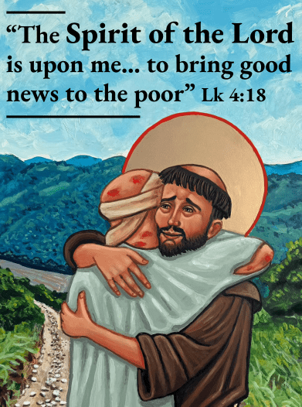
Catechetical Sunday: September 20, 2026
Sunday Preschool Classes:
Fall Oct. 4 thru Nov. 8, 2026
Winter Feb. 7 thru March 21, 2027
Parent First Reconciliation Meeting: Sept. 23, 2026
2nd Grade Dragon Slayer Retreat: October 4, 2026
Youth Ministry Breakfast: October 25, 2026
First Reconciliation: December 12, 2026
All Night Vigil for Life: January 15-16, 2027

Parent First Communion Meeting: January 27, 2027
Youth Sunday: February 7, 2027
Easter: March 28, 2027
First Communion: April 25, 2027
Graduation Mass: May 9, 2027
Vacation Bible School: June 7-10, 2027

