Religious Education
Handbook

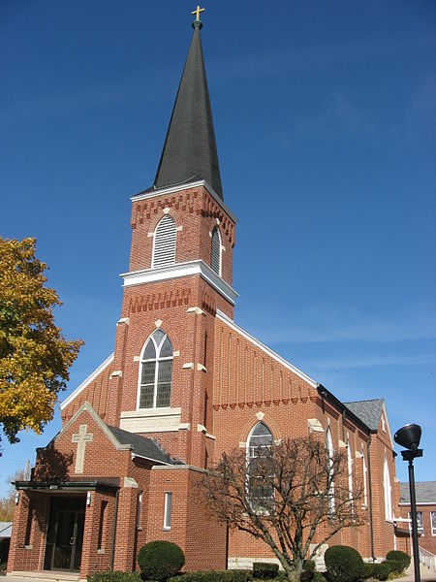

St. Nicholas Church, Osgood

Grades 1-12 will meet in their classrooms from 7:00-8:00 p.m. for CCD class. After class, all students will attend Evening prayer from 8:00-8:20 p.m. Students in grades 6-12 will be dismissed and may leave after evening prayer. Grades 1-5 will need to be accompanied by an older student or a parent.

Coordinator of Religious Education
Amy Schoen
stnicholasdre@gmail.com
419-582-2531- Religious Ed. Office
419-582-2150- Cell phone

OUR GOAL
Catechesis is oriented toward forming persons who get to know Jesus Christ and his Gospel of liberating salvation ever better; who live a profound encounter with him and who choose his own way of life and his very sentiments, striving to realize in the historical situations in which they live, the mission of Christ, which is the proclamation of the kingdom of God. (Directory for Catechesis, # 75, Vatican, 2020)

The tasks of Religious education are:
• to form children in the knowledge of our faith
• to prepare children for the Sacraments and initiation into the Mystery
• to foster a life in prayer
• to form children into a life in Christ and become missionary disciples

REGISTRATION
The student registration forms must be completed and on file for a child to attend the Parish Religious Education Program. Registration can be done by completing the family packet and returning to the office prior to CCD. Tuition is necessary and payment is expected. Fees are:
$75 one child
$120 two Children
$200 three Children
$250 four or more Children
*** Grades 9-12 are asked to pay an additional $10 to help cover the cost of the high school retreat. Please add this to your tuition fee.

If your family needs financial assistance please contact the pastor.

COMMUNICATION
To help keep you informed about Rel. Ed. activities or reminders, we use a program called Flocknote. Flocknote allows you to receive messages via texting and/or email. This is a free service but standard messaging data rates may apply. Flocknote will keep your phone number private, while making it easier to receive reminders for parent meetings or weather-related cancellations for Rel. Ed classes and other events. It is important that you provide an email and a cell phone number so that we can contact you when necessary.

Flocknote: https://stnicholaschurch45351.flocknote.com/dashboard

Other social media options are:
• the parish website: https://nwv.church
• the parish Facebook: StNicholas Church

CURRICULUM
• Grades 1-6 Word of Life by Augustine Institute
• 7th & 8th grade will use Chosen Your Journey Towards Confirmation by Ascension Press
• Grades 9th -12th will follow a curriculum based on the religious education guidelines set by the archdiocese called “Forming Young Disciples”

2nd GRADE
• First reconciliation will be on a Saturday morning. It is important at least one parent attend with their child(ren)
• Information regarding first communion will be sent home in the fall.
• One (1) student/parent retreat on 1st Communion
• Practice for 1st communion students will be on the Saturday morning before 1st communion and it is important at least one parent be present with their child(ren).

Confirmation will be the fall of 2027 for the 10th grade.
• One (1) parent & student retreat on confirmation. It is important at least one parent attend with their child(ren)

THE SACRAMENT OF RECONCILIATION
It is good practice for parents and children to take advantage of regularly scheduled Sacrament of Reconciliation. Please see the bulletin or website for the weekly scheduled times. All Rel. Ed students grades 3 – 12 will have 2 scheduled opportunities for reconciliation during Rel. Ed class time which will be during Advent and Lent. Second graders will have an opportunity for reconciliation during Lent as well.

CANCELLATIONS AND INCLEMENT WEATHER
Before calling the Office, please check Flocknote to find out if CCD classes are cancelled. All notifications regarding CCD cancellations will be sent by Flocknote and posted on Facebook. If CCD is cancelled, a Flocknote will be sent out. If the weather is inclement in your immediate area, please use your best judgment in coming to CCD

Flocknote:https://stnicholaschurch45351.flocknote.com/dashboard

ATTENDANCE
Attendance is taken at all CCD gatherings.
• All students are expected to attend each scheduled class
• Students enrolled in Sacrament preparation programs are expected to maintain consistent attendance. To ensure the integrity of their preparation, students should not exceed three absences within the program year.
• All students are is expected to attend special events
• If your child will be absent from class, please notify the CRE or your child’s teacher before the start of CCD class
• A Permission, Release, and Authorization to Seek Medical Treatment Form must be completed and kept on file to attend any off-site events

Records of attendance for past years are kept at the Rel. Ed Office.

MEDICAL CONDITIONS
In the event that your child has a medical concern, please notify the CRE or your child’s teacher so that we can follow any special instructions. A Permission, Release, and Authorization to Seek Medical Treatment Form must be completed and kept on file as noted under “Registration” above.
DISCIPLINE
Our children need to be models of good, Catholic behavior. They are expected to be respectful of each other, including teachers, guest speakers, the CRE and any other church employee. Examples of unacceptable behavior include bullying, name-calling, swearing, or harassment. Unacceptable behavior interferes with learning and teaching. Each case will be handled individually and these steps will be implemented as necessary:
• The catechist will attempt to deal with in the student(s) in the classroom
• If behavior continues, the catechist will notify the CRE
• The child will be sent to the CRE’s office for discipline
• If behavior continues, the CRE will notify the parents
• When further discipline is needed, the CRE will notify the pastor and the parents.
• If behavior does not end, the parents will be notified by the pastor of the child’s possible suspension, dismissal and/or expulsion. Parents will then be expected to home school religious education
• When the child resolves to no longer act in a disruptive manner, re-admittance will be considered

ELECTRONIC DEVICES
Students cannot have electronic devices out in class. Students are required to place their electronic devices in a designated area during class or keep them Off in their Pocket If the Teacher does not have a designated area. Violation of this policy while the student is under the supervision of their CCD teacher may result in disciplinary action and/or confiscation of the electronic device. In which case it will be the student’s responsibility to have the parents contact the CRE and make arrangements to pick up the electronic device.

In the event you need to contact your child during Rel. Ed, please contact the CRE. If the child has an immediate need or emergency to contact you, the CRE (or the teacher) will contact you.

All teachers, youth minister, and coordinators will have their cell phones with them and turned on during Rel. Ed classes. These are used for communication purposes when needed as part of our safety policy.

ARRIVING OR PARKING FOR CCD (DROPPING/PICKING UP STUDENTS)
- Students should not arrive at St. Nicholas before 6:45 p.m. Students should go straight to their classrooms.
- Parents and students old enough to drive must enter the parking lot by Church Street.

