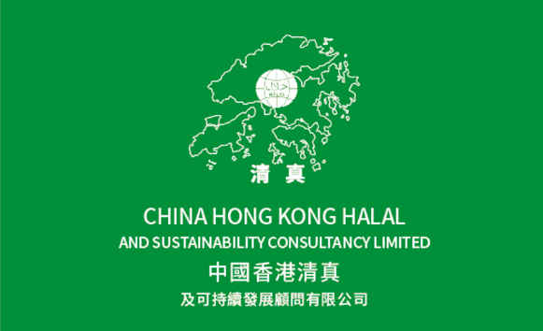
APPLICATION FOR HALAL CERTIFICATION
清真食品認證申請表

I/We hereby apply for a halal certificate and to join the fraternity of Halal Certificate holders and provide you with the following information and documents to assist you in assessing our request:
我/我們在此申請清真證書，並向貴公司提供以下資料及文件用以評估申請，希望得到貴公司的認證。

- Applicant / Company Name:
申請人 / 公司 名稱:
- Name of Contact Person:
聯絡人姓名:
- Address:
地址
- E-Mail:
電郵
- Tel: Fax: Mobile:
電話: 傳真號碼: 手提電話:
- Business Registration Certificate No.: (Please enclose a copy)
商業登記證號碼: (請提供副本)

- Certificate of Incorporation.: (Please enclose a copy)
公司註冊證書號碼: (請提供副本)

- Details of products to be certified Meat, Kind of Meat or others food products. (Please give detail in separate sheet if space is not enough):
申請清真食品認證之肉類, 肉類品種或其他食品之詳細資料: (如以下空白不
夠填寫，可自行另加紙張)

- Ingredients in the food products to be certified. (Please give details in separate sheet if space is not enough):
申請清真食品認證的詳細食品成份或配料: (如以下空白不夠填寫，可自行另
加紙張)

- Nature of Business (Please select one or more)
公司性質 (請選擇以下一項或多項)

Restaurants ◻ | Fast Food ◻ | Catering Service ◻
餐廳 | 快餐 | 餐飲服務
Bakery/Confectionery ◻ | Small Ice Cream Units◻ | Slaughterhouse◻
包點 / 糖果 | 雪糕製品 | 屠場
Poultry Supply ◻ | Meat Wholesaler ◻ | Food Processor ◻
家禽供應 | 肉類批發 | 食品加工
Manufacturing ◻ | Food ingredients ◻ | Other related ◻
製造業 | 食材 | 其他
- Purpose for Applying “Halal” Certificate
申請清真證書的原因

Import ◻ | Export◻ | Re-export◻ | Local Market◻
進口 | 出口 | 轉口 | 本地市場

- Number of Employees
職工/員工人數
1 – 5 6 – 10 20 – 50 Or More
◻ ◻ ◻ ◻
- Any Muslim Employee to handle Halal Department Yes / No
公司內是否有穆斯林專責清真事務/清真部門 有/ 無

(Signature)
簽署

Name:
姓名
Capacity (Duly Authorized)
職位 (正式授權)
Date:
日期:

NOTES TO FORM

Dear Client,
親愛的客戶,

Thank you for your enquiry/application for our “Halal” Certificate.
多謝您向本公司查詢 / 申請"清真”證書

We welcome you to obtain Halal Certification and join our esteemed fraternity of Halal Certificate holders.
我們歡迎您申請清真認證，並加入我們尊貴的清真證書持有人行列。

Please provide details of all chemicals, compounds, plant and meat products.
請提供申請認證的有關化學品，化合物，植物及肉類產品的詳細資料。

The certificate validity is specific to the matters stated on the certificate such as the Company/organization, the address, period of time and items specified and any change renders the certificate invalid and the certificate must be returned to the CHINA HONG KONG HALAL AND SUSTAINABILITY CONSULTANCY LIMITED.
清真證書的有效性是基於申請人所填寫的具體資料，如公司/機構名稱、 地址、
時效及其他項目而發出；申請人如有任何更改致使該證書無效，必須把證書歸還本公司。

Please provide the name and mobile number of a responsible person or a responsible alternate for the purpose of assisting with a random audit of halal certificate conditions.
(Name of Contact Person: Tel: )
本公司將公司在發出證書後安排抽查，以確保申請人能遵守所有條款及規章以保證清真證書之有效性；請提供負責人/ 相關聯絡人的姓名及手提電話以便本公司

進行抽查/跟進情況。
(聯絡人姓名: 電話: )

Sincerely yours,
此致

China Hong Kong Halal and Sustainability Consultancy Limited
中國香港清真及可持續發展顧問有限公司

