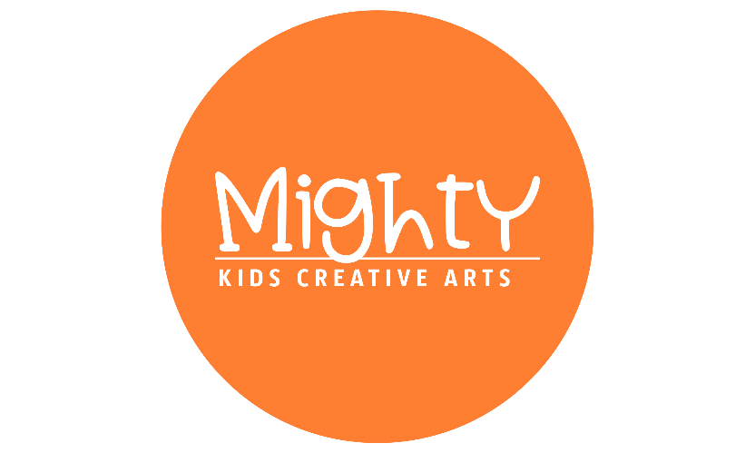
MIGHTY Kids Creative Arts LLC
“Where Creativity Meets Confidence”

Registration & Enrollment Form

Creator’s Name: ___________________________________ Start Date: _____________
Birth Date: _____________ Age: ________ Name of School Attending: _________________________
​Parent / Guardian Name: _____________________________________________________________
Home Phone: _______________________ Cell Phone: _______________________ Work Phone: _______________________
Email Address: ________________________________________________________________________
Home Address: _________________________________________________________________________
​Emergency Contact: _____________________________ Relationship to Creator: _____________________
Emergency Phone: ______________________________
Medical Conditions / Allergies / Notes: __________________________________________________________
​Policies and Procedures
​MIGHTY Kids Creative Arts LLC (MKCA) provides a fun, inspiring, and multidisciplinary creative arts curriculum that helps our students learn, grow, and advance through life. Our goal is to cultivate confidence through dance, self-expression, and creative discovery. As leaders in youth development, we continually update our programs to provide the highest quality experience for our Creators.
- ​Tuition, Automatic Billing & Late Fees
​Due Date: All tuition is due on the 1st day of each month and is processed via our automatic recurring payment system (Square).
​Late Fees: If tuition is not successfully processed by the 4th day of the month, a $25 late fee will be automatically assessed.
​Insufficient Funds: A $25 fee will be charged for any returned checks or insufficient funds, in addition to the standard tuition rate.
​Suspension: If tuition and associated fees remain unpaid by the last day of the current month, the student will not be permitted to return to class until the balance is paid in full.
​Session Consistency: Monthly tuition remains constant regardless of the number of classes in a specific month. It is calculated based on the full session/semester amount and divided into equal payments for your convenience. Therefore, tuition is not pro-rated for shorter months, missed classes, holidays, or inclement weather.
​Make-up Classes: Parents must request a make-up class for any missed sessions. Please stay updated via our Facebook page and the Band App, where all schedule updates and announcements are posted.
​Refunds: All fees, tuition, and deposits are final and non-refundable.
- ​Dropped Classes & Withdrawals
​A written 30-day notice must be submitted prior to withdrawing a student from a class. If notice is not received at least 30 days in advance, you will be automatically billed and responsible for the following month’s tuition.
- ​Trial Classes & Private Lessons
​Trial Classes: We offer one free trial class to prospective students. Because we maintain strict class size minimums and maximums to provide focused, one-on-one attention, trial spots must be reserved in advance.
​Private Lessons: Private lessons are available on a first-come, first-served basis and can be conducted either in-person or via Zoom.
- ​Attire, Hair & Electronics
​Dress Code: Creators should wear comfortable, appropriate athletic or studio attire. Hair must be securely pulled back off the face to prevent distractions during class.
​Electronic Devices: Cell phones and other electronic devices must be silenced and stored away during class time to maintain focus and respect for the learning environment.
- ​In-Class Conduct
​To ensure a positive, creative environment, we ask all Creators to follow these guidelines:
​No gum chewing.
​Show respect to peers, instructors, staff, and parents at all times.
​Creators are encouraged to remain in the studio for the duration of class rather than running back and forth to parents/guardians.
​Full participation and positive energy are key!
​Bring a water bottle to stay hydrated.
​Have fun!
​Note: Disciplinary dismissal from a class is a last resort. We are committed to working closely with parents to ensure every child succeeds.
- ​Arrival, Pick-Up & Program Structure
​Preschool & Homeschool Programs: Please follow the specific arrival, drop-off, and pick-up policies established by your child’s respective school or homeschool pod facility.
​Studio & Advanced Programs:
​In-Person Classes: Please arrive 15 minutes prior to class time to allow for proper stretching and warm-up. Creators must be picked up promptly; no student should be left waiting more than 10 minutes after class has concluded.
​Zoom / Virtual Classes: Please log in 5 minutes prior to the scheduled start time to allow the instructor to admit students to the digital classroom punctually.
- ​Health & Wellness
​Preschool & Homeschool Programs: If your child is sick, please strictly adhere to your school or homeschool pod’s health and exclusion guidelines.
​Studio Classes: Please use your best judgment and keep your child home if they are experiencing signs of illness. If you are unsure whether your child should attend, please reach out to studio leadership before arriving.
- ​Injury & Liability Waiver
​Creative arts, dance, and movement activities involve physical exertion and carry an inherent risk of minor injury. MIGHTY Kids Creative Arts LLC, its owners, and instructors are not liable for injuries sustained on the premises or during instruction.
​To help prevent injuries, instructors lead a mandatory 15–20 minute warm-up and stretch at the beginning of active classes. In the event of a minor injury, basic first aid will be administered by the instructor. In the event of a serious medical emergency, emergency medical services (an ambulance) will be called immediately, and the parent/guardian will be contacted right away. Instructors are required to document all incidents on an Injury/Accident Report, which must be signed by the instructor, a parent/guardian, and an owner for our permanent files.
​Acknowledgment & Consent
​By signing below, I certify that I am the parent or legal guardian of the enrolled Creator, and that I have read, fully understand, and agree to abide by all the policies, procedures, financial obligations, and liability waivers outlined by MIGHTY Kids Creative Arts LLC.
​Parent/Guardian Printed Name: ________________________________________________
​Parent/Guardian Signature: _______________________________ Date: _________________
​
WELCOME TO MIGHTY!

