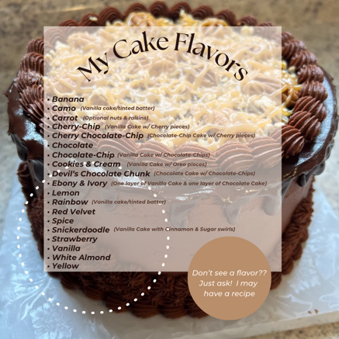
Cake Flavors:
Banana Cake ~ Camo Cake ~ Carrot Cake ~ Cherry-Chip Cake
Cherry Chocolate-Chip Cake ~ Chocolate Cake
Cookies & Cream Cake ~ Devil's Chocolate Chunk Cake
Ebony & Ivory Cake ~ Lemon Cake ~ Rainbow Cake
Red Velvet Cake ~ Spice Cake ~ Snickerdoodle Cake
Strawberry Cake ~ Vanilla Cake ~ White Almond Cake
Yellow Cake

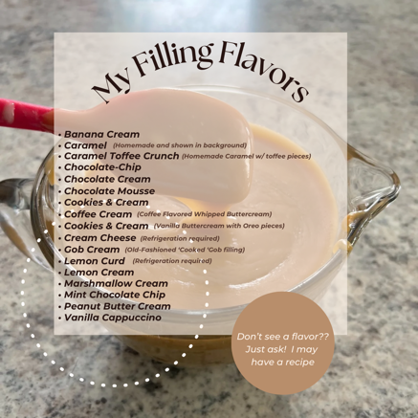
Cake Fillings:
Banana Cream ~ Caramel ~ Caramel Toffee-Crunch
Chocolate-Chip ~ Chocolate Cream ~ Chocolate Mousse
Coconut Cream ~ Cookies & Cream ~ Coffee Cream
Gob Cream ~ Lemon Curd Lemon Cream ~ Marshmallow Cream
Mint Chocolate-Chip Peanut Butter Cream ~ Raspberry Puree Strawberry Puree ~ Vanilla Cappuccino

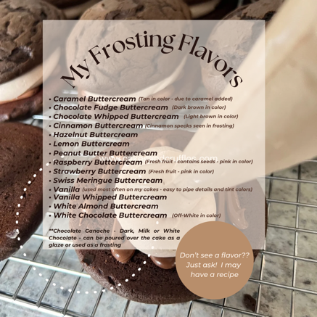
Cake Frostings/Icings:
Almond Buttercream ~ Caramel Buttercream*
Chocolate Fudge Buttercream*
Chocolate Whipped Buttercream* ~ Cinnamon Buttercream* Hazelnut Buttercream ~ Lemon Buttercream*
Peanut Butter Buttercream* ~ Raspberry Buttercream*
Strawberry Buttercream* ~ Swiss Meringue Buttercream**
Vanilla Buttercream ~ Vanilla Whipped Buttercream
White Almond Buttercream ~ White Chocolate Buttercream**
~Chocolate Ganache~ *upcharge of $5/per batch
Dark, Milk or White Chocolate Ganache (can be poured as a glaze or used as a frosting)

Vanilla Buttercream – my preferred “go-to” frosting that I use about 90% of the time to decorate both celebration and wedding cakes. If you look at my photo gallery – most cakes shown are iced with my standard Vanilla Buttercream.
*these icings are NOT WHITE due to ingredients added – some are not able to be tinted certain colors – and the fruit flavord buttercream contains chunks of the fruit listed (+ seeds in the Raspberry)
**these icings are more off-white/ivory due to ingredients added – these can be tinted most colors
CELEBRATION PRICES: A celebration cake is any cake NOT for a wedding: Birthday, Retirement, Anniversary, Graduation, Baby Shower, etc. – use this price guide for any party-style cake you may need.
CUPCAKES & CUPCAKE-CAKES:
Unfilled cupcakes are priced at $2/per cupcake – simple buttercream swirl and sprinkles.
Filled cupcakes are priced at $2.25/per cupcake – simple buttercream swirl and sprinkles.
Cupcakes-Cakes are individual cupcakes, arranged in a design or shape and are decorated to look like one large cake/item. They are “glued” together using buttercream but are able to be “pulled-apart” without any cutting. These work great for kid’s birthday parties – where you may not have kitchen utencils handy - and can be decorated to match any party theme.
CAKES:
Celebration Cakes  Single Tier | Cake Size | Serves | Price $3/serving
Single Tier Round | 6” | 12 | $36
Single Tier Round | 8” | 20 | $60
Single Tier Round | 10” | 28 | $84
Single Tier Round | 12” | 40 | $120
Single Tier Round | 14” | 63 | $189

Celebration Cakes  2-Tier | Cake Size | Serves | Price $3.50/serving
2-Tier Stacked Round | 6” & 8” | 32 | $112
2-Tier Stacked Round | 6” & 10” | 40 | $140
2-Tier Stacked Round | 8” & 10” | 48 | $168
2-Tier Stacked Round | 8” & 12” | 60 | $210
2-Tier Stacked Round | 10” & 12” | 68 | $238

Celebration Cakes  3-Tier | Cake Size | Serves | Price $3.50/serving
3-Tier Stacked Round | 6”, 8” & 10” | 60 | $210
3-Tier Stacked Round | 6”, 10” & 12” | 72 | $252
3-Tier Stacked Round | 6”, 10” & 12” | 80 | $280
3-Tier Stacked Round | 8”, 10” & 12” | 88 | $308

Sheetcakes | Cake Size | Serves | Price $2/serving
Celebration Sheetcake | 9x13” single | 24 | $48 ($2/serving)
Celebration Sheetcake | 11x15” single | 35 | $70 ($2/serving)
Celebration Sheetcake | 12x18” single | 54 | $108 ($2/serving)
Celebration Sheetcake | 9x13” double | 45 | $90 ($2/serving)
Celebration Sheetcake | 11x15” double | 60 | $120 ($2/serving)
 | 12x18” double |  | NOT AVAILABLE*
A single Layer sheetcake is a single layer of cake iced with frosting. The finished cake will be roughly 2” tall (no filling – just a regular sheetcake).
A double layer sheetcake will be two layers of cake – with your choice of a filling between the cake layers – iced with frosting. The finished cake will be roughly 4” tall (filling included).
*Too large to pick up and stack without breaking – I stopped offering my 12x18 size as a double-layer choice
- Usually a minimum of $15 is added to orders for my time hand-drawing buttercream details (ex: drawing kid’s cartoon characters)

‘Dessert-Style’ Single Layer Celebration Cakes  Single Layer (no filling) *Similar to a sheetcake but using round pans | Cake Size | Serves | Price
Single Layer Round | 6” | 6-8 | $15
Single Layer Round | 8” | 12-15 | $25
Single Layer Round | 10” | 20-22 | $35
Single Layer Round | 12” | 28-30 | $55

