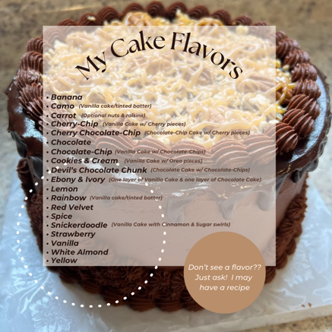
Cake Flavors:
Banana Cake ~ Camo Cake ~ Carrot Cake ~ Cherry-Chip Cake
Cherry Chocolate-Chip Cake ~ Chocolate Cake
Cookies & Cream Cake ~ Devil's Chocolate Chunk Cake
Ebony & Ivory Cake ~ Lemon Cake ~ Rainbow Cake
Red Velvet Cake ~ Spice Cake ~ Snickerdoodle Cake
Strawberry Cake ~ Vanilla Cake ~ White Almond Cake
Yellow Cake

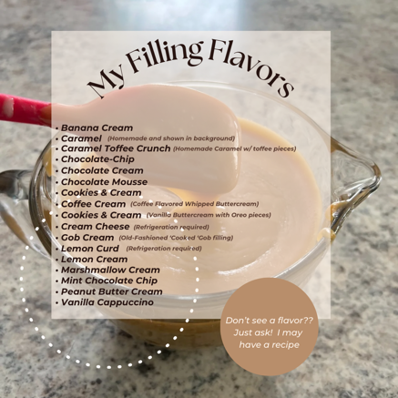
Cake Fillings:
Banana Cream ~ Caramel ~ Caramel Toffee-Crunch
Chocolate-Chip ~ Chocolate Cream ~ Chocolate Mousse
Coconut Cream ~ Cookies & Cream ~ Coffee Cream ~ Gob Cream Lemon Curd Lemon Cream ~ Marshmallow Cream
Mint Chocolate-Chip Peanut Butter Cream ~ Raspberry Puree Strawberry Puree ~ Vanilla Cappuccino

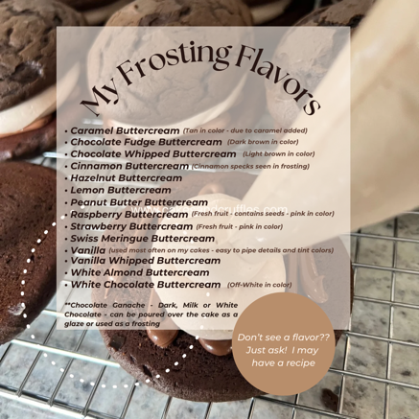
Cake Frostings/Icings:
Almond Buttercream ~ Caramel Buttercream*
Chocolate Fudge Buttercream*
Chocolate Whipped Buttercream* ~ Cinnamon Buttercream* Hazelnut Buttercream ~ Lemon Buttercream*
Peanut Butter Buttercream* ~ Raspberry Buttercream*
Strawberry Buttercream* ~ Swiss Meringue Buttercream**
Vanilla Buttercream ~ Vanilla Whipped Buttercream
White Almond Buttercream ~ White Chocolate Buttercream**
~Chocolate Ganache~
Dark, Milk or White Chocolate Ganache (can be poured as a glaze or used as a frosting)
Vanilla Buttercream – my preferred “go-to” frosting that I use about 90% of the time to decorate both celebration and wedding cakes. If you look at my photo gallery – most cakes shown are iced with my standard Vanilla Buttercream.
*these icings are NOT WHITE due to ingredients added – some are not able to be tinted certain colors – and the fruit flavord buttercream contains chunks of the fruit listed (+ seeds in the Raspberry)
**these icings are more off-white/ivory due to ingredients added – these can be tinted most colors
WEDDING PRICES:
A WEDDING cake is for ANY WEDDING CELEBRATION – from a back-yard celebration to a large venue. Use this price guide for any WEDDING cake you may need. Wedding cake servings are different than celebration cake servings. Venue’s cut wedding cakes according to the servings shown below. These are priced as BUTTERCREAM WEDDING designs – if you wish to have a FONDANT COVERED WEDDING CAKE – please message me. I rarely do these and may just refer you to other local bakers that works with fondant more often than I do.
Kitchen Cakes  (Kitchen Cake - simply iced in buttercream with a shell/bead border and NO DETAILS. These are ordered for extra guest servings – above what the display cake will serve. These will not be on display and kept in the kitchen to be cut and served.) | Cake Size | Serves | Price $3/serving
Single Tier Round | 6” | 12 | $36
Single Tier Round | 8” | 24 | $72
Single Tier Round | 10” | 38 | $114
Single Tier Round | 12” | 56 | $168

Single-Tier Wedding Cake  (Display Cake – decorated to be seen by guests and on display in the venue. Bride & Groom want it to be cut for photos so it will be designed and decorated to be on display at the venue on a cake table/stand.) | Cake Size | Serves | Price $3.50/serving
Single Tier Round | 6” | 12 | $42
Single Tier Round | 8” | 24 | $84
Single Tier Heart | 8” | 22 | $77
Single Tier Round | 10” | 38 | $133
Single Tier Round | 12” | 56 | $196
Naked Cakes start at $3.25/serving for 2-tiers and $3.50/serving for 3-tiers and larger

Wedding Cakes  2-Tier | Cake Size | Serves | Price $3.50/serving
2-Tier Stacked Round | 6” & 8” | 36 | $126
2-Tier Stacked Round | 6” & 10” | 50 | $175
2-Tier Stacked Round | 8” & 10” | 62 | $217
2-Tier Stacked Round | 8” & 12” | 80 | $280
2-Tier Stacked Round | 10” & 12” | 94 | $329

Wedding Cakes  3-Tier | Cake Size | Serves | Price $3.75/serving
3-Tier Stacked Round | 6”, 8” & 10” | 74 | $277.50
3-Tier Stacked Round | 6”, 8” & 12” | 92 | $345
3-Tier Stacked Round | 6”, 10” & 12” | 106 | $397.50
3-Tier Stacked Round | 8”, 10” & 12” | 118 | $442.50

Wedding Cakes  4-Tier | Cake Size | Serves | Price $3.75/serving
4-Tier Stacked Round | 6”, 8”, 10” & 12” | 130 | $487.50
4-Tier Stacked Round | 8”, 10”, 12” & 14” | 196 | $735
*ALL PRICES SHOWN are “base prices”. There are techniques, cake designs, details that may add extra costs to your bottom line - ribbons, pearls, gumpaste flowers, arranging fresh/silk flowers on the cake at the venue, intricate piping patterns that take extra time for me to do. These are all considered “extras” and will be quoted as a separate cost in your quotation email.

WEDDING CUPCAKES:
2 dozen minimum per cake/filling/frosting combination. Cupcakes must be purchased in addition to a wedding cake. All will be delivered together to the venue.
$2.50/each – basic cupcakes (buttercream swirl with sprinkles, sparkles, etc.)
$3/each - “Fancy” Cupcakes – buttercream with individual designs
“Deluxe” cupcakes – Cost determined per project/request.
Cupcakes prices shown are FILLED, check with me to see what flavors work best.

I can do UNFILLED cupcakes also – these start @ $2/each.

CAKE EXTRAS:
Fondant/Gumpaste accents:
Gumpaste flowers start @ $5 each
Other gumpaste accents vary in price.

Delivery/Set-Up Fee:
I charge $35 to deliver any wedding cake within 20 miles (“Mapquest” used to determine mileage). Anything over 20 miles, I charge $2/per mile.

ADDITIONAL REQUESTS:
$20 charge for heavy cake board used under any wedding cake 3-tiers or taller –
$20 REFUNDED when board is returned.

Wedding Cookies - Cruffles & Cake Pops – Gobs – can be found on a separate price list. Please ask.
With enough notice, I am able to provide wedding clients with wedding cookies also. Please check with me on availability FIRST . Due to not having any helpers, I am not able to bake last minute cookie orders. If you think you may want me to bake some wedding cookies, Cruffles/Cakepops or gobs – please mention it ASAP so I can check my schedule. If I am available, I will need to appropriately mark off “cookie baking” time on my cake calendar to fit in your cookies around other orders. I do have a cookie flavor list/prices per dozen on my website – under PRICING - or ask me for my COOKIE price list to be emailed to you.

