Awake, O Sleeper!
"For this reason it says, 'Awake, sleeper, And arise from the dead, And Christ will shine on you. (Ephesians 5:14, NASB).
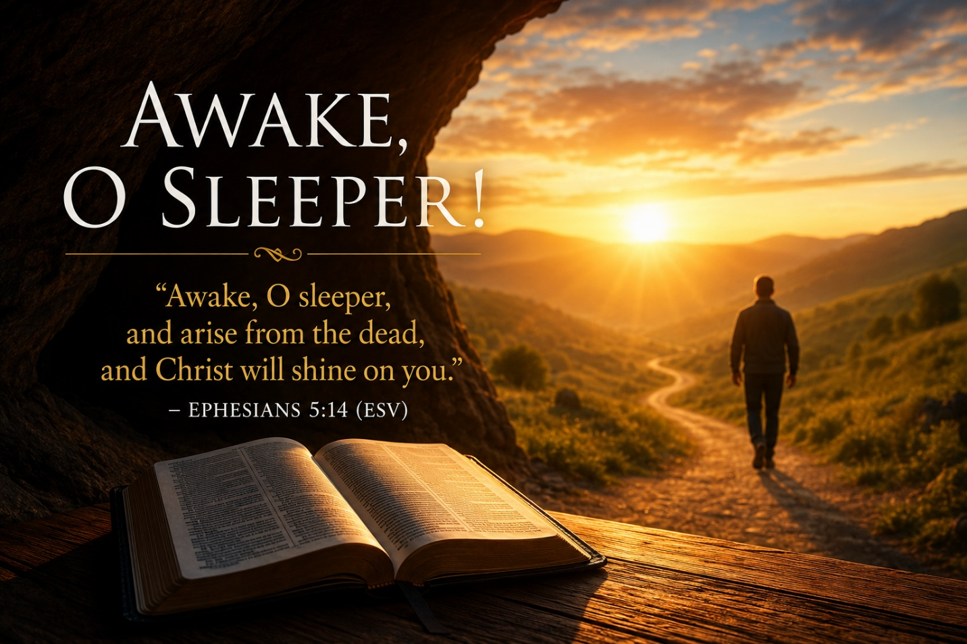
There are moments in life when a single sentence changes everything. A doctor says, "The surgery was successful." A soldier hears, "The war is over." A condemned prisoner is told, "You've been pardoned."
Ephesians 5:14 contains one of those life-changing statements. It is only eighteen English words, yet within those words God issues three commands and one magnificent promise. Every person who has ever lived fits somewhere within this verse. Either we are still asleep, or we have awakened. Either we remain spiritually dead, or we have risen with Christ. Either we continue in darkness, or His light now shines upon us.
Paul's words are not merely poetic; they are a divine invitation to transformation.
The Context of the Passage
To understand verse 14, we must first understand the surrounding verses.
Beginning in Ephesians 5:8, Paul reminds Christians:
"For you were formerly darkness, but now you are Light in the Lord; walk as children of Light."
Notice that Paul does not simply say they were in darkness. He says they were darkness. Sin was not merely the environment in which they lived; it had become their identity. But through Christ, everything changed.
The remainder of the chapter urges believers to live consistently with their new identity. They are to expose the works of darkness rather than participate in them. Christians are called to holiness because they now belong to the Light.
Verse 14 serves as Paul's dramatic appeal. It is the turning point of the discussion—a call to anyone still living in darkness to come into the light of Christ.
"For This Reason It Says..."
Paul introduces the quotation with the words, "For this reason it says."
It echoes several Old Testament passages, particularly Isaiah 26:19, Isaiah 51:17, Isaiah 52:1, and Isaiah 60:1, where God repeatedly calls His people to awake because His glory has come.
God has always called His people to wake up spiritually.
The call is timeless.
"Awake, Sleeper"
The first command is simple. Wake up. Sleep is one of the most fitting pictures of the sinner's condition.
- A sleeping person is unaware of danger.
- A sleeping person cannot accomplish anything.
- A sleeping person is unconscious of reality.
Likewise, the person separated from God often sees no urgency about eternity. Sin dulls the conscience. Pride blinds the heart. Satan convinces people they have plenty of time.
Jesus repeatedly warned against spiritual sleep, and the apostles did as well.
Paul himself wrote in Romans 13:11,
"It is already the hour for you to awaken from sleep."
Many today are asleep while believing they are fully awake. They are busy with careers, hobbies, entertainment, and financial pursuits, yet have given little thought to their eternal destiny.
God's first call is not, "Try harder."
It is, "Wake up!"
No genuine transformation begins until a person honestly recognizes his true spiritual condition.
"Arise From the Dead"
The second command reaches even deeper. The sleeper is not merely drowsy. He is spiritually dead.
Paul had already described mankind's condition earlier in the letter: "And you were dead in your trespasses and sins." (Ephesians 2:1).
Death is the Bible's description of separation from God. A corpse cannot revive itself. Neither can a sinner save himself through good works, morality, or religious activity.
Only Christ possesses the power to give life. When the gospel is believed and obeyed, God raises the sinner from spiritual death into newness of life. This explains why conversion is described throughout Scripture as:
- A new birth.
- A resurrection.
- A new creation.
- Passing from death into life.
Christianity is not merely self-improvement. It is a resurrection.
"And Christ Will Shine on You"
The third statement is not a command. It is a promise. The moment one comes to Christ, everything changes.
- His light exposes sin.
- His light removes guilt.
- His light gives direction.
- His light replaces fear with hope.
- His light reveals truth.
- His light transforms character.
Throughout Scripture, light represents God's presence, truth, holiness, and salvation.
Jesus declared,
"I am the Light of the world; he who follows Me will not walk in the darkness, but will have the Light of life." (John 8:12).
Without Christ, humanity walks in darkness. With Christ, life finally makes sense. His light not only shows us where we have been—it shows us where we are going.

Six Great Truths Found in Ephesians 5:14
1. From Sleep to Awake: God calls every person to spiritual alertness. Christianity begins when we stop drifting through life and begin seeking God with all our hearts.
2. From Death to Life: The gospel is God's power to bring spiritually dead people back to life. Only Christ can accomplish this miracle.
3. From Darkness to Light: Sin thrives in darkness. Truth flourishes in the light. The Christian no longer belongs to darkness but walks openly before God.
4. From Ignorance to Truth: The world offers countless opinions. Christ reveals eternal truth. His Word becomes the standard by which every decision is measured.
5. From Separation to Christ: Sin separates. Jesus reconciles. Those who were once far away are brought near through His sacrifice. Relationship replaces alienation. Hope replaces despair.
6. From Shame to Hope: Everyone carries regrets. Everyone has failures. The gospel does not erase the past, but it removes its condemnation. Through Christ, there is forgiveness, cleansing, and the promise of eternal life. His grace gives every believer a new beginning.

Living Awake
Paul did not intend these words merely to produce emotion. He intended them to change behavior. Immediately after verse 14, he writes,
"Therefore, be careful how you walk, not as unwise men but as wise." (Ephesians 5:15)
Those who have awakened should live differently. They value time because life is brief. They pursue wisdom because truth matters. They avoid sinful influences because holiness matters. They seek God's will because eternity matters.
Being awake means more than attending worship. It means living every day with heaven in view.

Questions for Personal Reflection
* Have I truly awakened to my need for Christ?
* Have I arisen from spiritual death through obedience to the gospel?
* Is Christ's light shining through my daily conduct?
* Am I exposing darkness or quietly participating in it?
* If others observed my life this week, would they recognize someone walking in the light?

Conclusion
God's invitation has never changed. He still calls the spiritually asleep to awaken. He still raises the spiritually dead to life. He still shines His glorious light upon those who come to His Son.
Perhaps the greatest tragedy is not physical death but living an entire lifetime asleep to eternal realities.
Today, hear God's voice:
- Awake.
- Arise.
- Come to Christ.
- Walk in His light.
Never return to the darkness from which He delivered you.
Garland Van Dyke
garland@tcmmail.online
www.thechristianministry.online

Schedule a 30-minute virtual Bible Study

