Health Education
Education Process
Second Semester 2023-2024 1
Intended Learning Outcomes:
On completion of this discussion, you will be able to:
1. Recognize the nurse educator’s role to enhance clients'
capability to function as self-directed learners. 2. Emphasize on the clients responsibility in the educational process
3. Identify the components of assessing the client learning status.
2
Intended Learning Outcomes:
On completion of this discussion, you will be able to: 4. Explain the meaning of the learning needs. 5. State types of readiness to learn (PEEK Model) 6. Clarify the importance of assessing the client's style of learning.
7. Outline the principles of learning style
8. Determine the client’s qualities that need to be assessed.
3
The Roles of the Nurse Educator when educating adults
The Roles of the Nurse Educator can be guided by the educational process (EP).
Advantages of EP:
1. Decrease the learners’ dependency on the educator.
2. Enhance the learners’ capability to function as self directed learners.
4
5
The First Role
of the Nurse Educator is: Assessment
Assessment
Includes the Client’s
Learning Needs
Readiness to Learn
Styles
_{of Learning} Qualities
6
1. Assessing the Client’s Learning Needs
• Learning Needs are defined as gaps in knowledge, attitudes, or skills that exist between a desired level of performance and the actual level of performance.
• The gap between what someone knows and what someone needs to know.
7
2. Assessing the Client’s Readiness to Learn
• Readiness to learn is defined as the time when the learner demonstrates an interest in learning necessary type or degree of information.
• Readiness to learn occurs when the client is: 1. Receptive to learning.
2. Has willing to learn.
3. Able to participate in the learning process.
8
Types of Readiness to Learn
Use “PEEK Model” (Lichtenthal, 1990)
Before learning can begin, the nurse educator must understand the four type of readiness to learn: P = Physical readiness
E = Emotional readiness
E = Experiential readiness
K = Knowledge readness
9
P = Physical Readiness
- Measures the client’s ability (such as physical; visual, auditory).
- Complexity of the learning task (difficulty level of the task, does it need special abilities).
10
P = Physical Readiness
- Environmental effects on the client (noise, suitability of the environment for type of learning such as lab for psychomotor learning).
- Gender of the client (women are more receptive to care, take less risk for health, women are the caregivers).
11
E = Emotional Readiness
- Anxiety level of the client.
- Support system for the client (they may attend some sessions to help a client at home) The client’s Motivation (A need must exist) The client’s developmental stage (subject must be suitable for the learner’s age; sex education in teenage).
12
E = Experiential Readiness
(refers to client’s past experience with learning) - Level of the client’s aspiration (how much the client is driven to learn)
- Past coping mechanisms of the client (are they effective for the new learning situation).
13
E = Experiential Readiness
- The client’s cultural background (Avoid encounters with cultural beliefs; language, and interpreter).
- The client’s locus of control (is readiness is internal or external).
- The client’s level of orientation (less experience with life, closed-minded, conservative, less willing to learn).
14
K = Knowledge Readiness
- Present knowledge base of the client. - The client’s cognitive ability. - The client’s learning disabilities. - The client’s Learning styles.
15
3. Assessing the Client’s Styles of Learning
• Learning style refers to “the ways individuals process information”.
• Each learner is unique and complex, with a distinct learning style preference that distinguishes one learner from another.
16
3. Assessing the Client’s Styles of Learning
• Certain learning style are biological in origin, whereas others are sociologically developed as a result of environmental influences.
17
LEARNING STYLES
Visual | Auditory | Physical
Learn best through seeing, need to see the teacher’s body language and facial expressions | Learn best through lectures &  discussions | Learn best through an active, hands-on approach
May prefer sitting at the front of the  classroom in order to see more clearly | Interpret the  underlying meanings of speech through listening to tone of voice, pitch, speed & other nuances | Do will in classes with a lab  component

18
LEARNING STYLES
Visual | Auditory | Physical
Learn best from  visual displays,  diagrams,  illustrations,  overhead  transparencies,  videos. | Often benefit from reading aloud | May find it hard to sit still for long  periods
Think in pictures | Written information may have little  meaning until heard | May become  distracted by need for activity &  exploration

19
The VAK Model: Three Types of Learning Styles
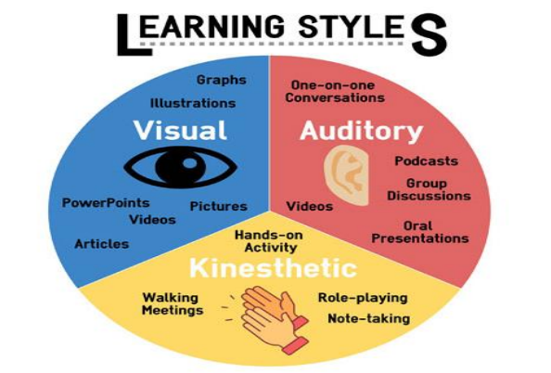20
The VARK Model: Four Types of Learning Styles
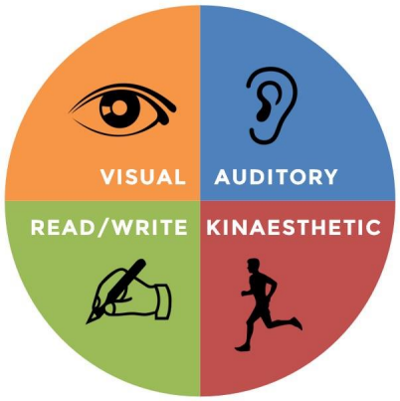
21
https://www.uow.edu.au/student/learning-co-op/effective
studying/identify-your-learning-style/
Visual
Learners learn by sight. Visual learners are better able to retain information when it’s presented to them in a graphic depiction, such as arrows, charts, diagrams, symbols, and more.
22
Visual
These learners benefit from: •Images and diagrams •Graphics and visuals •Charts
•Maps
•Mind-maps
• Flash cards
23
Auditory
Learners learn by hearing. Sometimes referred to as “aural” learners, auditory learners prefer listening to information that is presented to them vocally. These learners work well in group settings where vocal collaboration is present and may enjoy reading aloud to themselves, too.
24
Auditory
These learners benefit from: •Listening
•Speaking
•Group discussions
•Verbal repetition
•Sound recordings
•Mnemonic devices
25
Read/Write
Learners learn by reading and writing. Focusing on the written word, reading and writing learners succeed with written information on worksheets, presentations, and other text-heavy resources. These learners are note-takers and perform strongly when they can reference written text.
26
Read/Write
These learners benefit from: •Reading
•Writing
•Making detailed notes
•Re-writing notes to revise •Viewing information in word form
27
Kinaesthetic
Learners learn by touch. Taking a physically active role, kinesthetic learners are hands-on and thrive when engaging all of their senses during course work.
28
Kinaesthetic
These learners benefit from: •Movement
•Tactile representations •Models and materials •Physical interactions •Hands-on approaches •Experience and practice
29
What are the benefits of knowing the client’s learning style? Help to:
• Understand educational interests and needs for people with different learning styles.
• Create an atmosphere for learning that encourage each individual to reach potential.
• Matching the style with methods and strategies of Instruction.
• Making decisions about program development and instructional design.
30
Learning Style Principles
• Identify both the learner and the teacher learning style.
• Nurse educators must use the learner style. (It is much easier for the educator to change the teaching approach for the learner than to adapt to the teacher’s style).
• Clients should be encouraged to diversify their style preferences.
31
4. Assessing the Client’s Qualities
• It’s the learner’s own experiences, knowledge, skills, and motivations related to the learning experience
• The ability to organize new knowledge and skills with what he already knows.
32
4. Assessing the Client’s Qualities (Cont.
• The ability to recognize problems and use all available information to solve those problems.
• A sense of self-efficacy: the knowledge that he can solve those problems which face him
33

