Maternity preparation lab Lecturer:Eman Alqadi
Lab (1)
Pregnancy period is divided into 3 trimesters each trimester contains 13 weeks of gestation :
Firsttrimester : from the day of conception – 13 weeks ( dangerous period because organogenesis occur in this trimester )
Second trimester : 14-27 weak ( increase of size )
Third trimester ( 27- 38/42 ) weeks
Fulltermbaby:38-42GW
Pretermbaby:20-38GW
Post term : > 42 GW
Perinatal period : starts from 20 GW until 4 weak after delivery Why 20 weak ? because it is a time that baby can survive
Intra partum : labor / delivery :
4 stages >>>startfromstage of contraction until 4 hr post partum
Post partum : post natal :from the moment of
delivery till 6 week after delivery
Abortion/termination:lossofgestationbefore
viability (20weeks)
Viability : ability of baby to survive outside the uterus ( baby weight >500 g , GW > 20 )
Gravida : presence of pregnancy : the women who has been pregnant regardless the duration or outcome of pregnancy
عدد مرات الحمل بغض النظر عن نتيجة الحمل
Primi gravida : women who pregnant for first
time
Multi gravida : women who is pregnant more than one time
Nulli gravida : women who has never been pregnant
Grand multi gravida: women who is pregnant more than five time
Para : number of pregnancy that reached at least 20 GW at delivery either the fetus was alive or ( still born = dead )
عدد مرات الحمل التي يصل بها الحمل لعشرين اسبوع او اكثر
Primi para : women who has given birth to a fetus that reached at least 20 GW at delivery either the fetus was alive or ( still born = dead ) for the First time
Multi para : woman who has given births to more than one fetus that reached at least 20 GW at delivery either the fetus was alive or ( still born = dead ) for more than one time
Nuli para : women who has never sustain a pregnancy more than 20 GW
Obstetric history:
G T P A L
G : gravida
T : term
P : preterm
A : abortion
L : living children
Example :
Miss Khulood had been pregnant for 4, her times first pregnancy was a male delivered at 38 GW and , second one was terminated at 14 GW and the third wasa baby girl at 34 GW and finally the fourth was twins at 38 GW
Answer :
G4 T2 P1 A1 L4
*Ask about size of baby and weight
*Ask about type of delivery ( cesarean / normal/ instrumental)
Ask about complication any congenital anomaly
Ask about duration of labor
Ask about menstruation : first menses , duration , characteristics, amount , any complication Ask about LMP (last menstrual period ) and calculate EDD ( estimation date of delivery ) طريقهالحساب: :
من موعد اخر
دورة نحسب
موعد الوالدة
Nagles role
Add 7 to day
Subtract 3 from month
Add 1 to year
Example :
LMP = 7-9-2016
EDD = 14-6-2017
Ask about medical and surgical history :
- Previous surgical procedure
- Occupation
- Nutrition
- Life style ( smoking , exercise , type of food , hapit , sleeping pattern ) - Legal and illegal drug
- Recurrent infection ( STD, UTI )
- Family history ( inherited disease: G6PD , hemophilia , SCA, thalasemia ) - Partner history ( smoking , alcohol , drug addiction , Rh )
- BMI : to assess how many kg gain and decide if it appropriate or not - Support system + coping mechanism ( wanted or unwanted baby )
Physical exam :
Vital signs
increase pulse rate ~ 10-20 beat > normal range in second and third trimester
BP may decrease 10-15 mmHg in diastolic more than systolic in 24-32 GW or still same

Respiratory system : oxygen consumption increase about 20% >>>women breath more deeply although her RR unchanged
Gastrointestinal system :
Mouth : gingivitis and bleeding from hyperemia
Excessive salivation
Esophagus : pyrosis ;decrease muscle tone of sphincter causes reflux of acidic stomach into esophagus causes heartburn
Stomach and small intestine : decrease gastrointestinal tone and motility due to increase progestrone level
Nausea and vomiting during first trimester
Large intestine : constipation and hemorrhoids
Abnormal finding :
1- hyperemesis gravidarum (persistent vomiting )
2- diarrhea
Breast :
#Increase in size
#Highly vascular ( visible network of vein )
#Stria due to extensive increase in breast size
#Increase nipple size become more erected
#Areola ( larger and more pigment ) secondary areola may appear
#Tubercles of Montgomery : sebaceous glands secrete a substances that lubricates the nipples
Musculoskeletal
-Change in posture (lordosis)
-Low back pain

Endocrine slightly enlargement of thyroid gland, increase metabolic rate during pregnancy
- elevate HCG hormone that indicate pregnancy
Integumentary system : Skin
-Sweating, feeling of warm
-Hyperpigmentation due to increase MSH (melanocyte stimulating hormone)
-Chloasma: melasma: mask of pregnancy: brownish patches over forehead, cheeks and bridge of nose)
-Linea nigra "(pigment line extend from symphysis pubis to top of fundus)
-Darkening of areola and nipples
-Redness of palm and soles
-Vascular spider nevi (appear in face, neck, upper chest and arm) -Stria gravidarum: appear in abdomen, breast and buttocks) -Hair grow more rapidly and less hair fall during pregnancy
Estimation of GA depending on
the uterine size :
0-12 week : symphysis pupis
12-24week: umbilicus
24-36week: xiphoidal process
1- Leopold’s maneuver ( palpation of baby > 28 GW ) Preparation : - empty bladder , supine position , slight flexion of knee, pillow under head , towel under right side of abdomen
First maneuver: ( fundal )
If you palpate a regular , hard , circular then the presenting part is the head If it is smooth irregular then the presenting part is buttock
Head lower ( cephalic presentation )
Head upper ( breech presentation )
Second maneuver: ( lateral )
Assess size of uterus
If you palpate something ( convex , smooth , firm ) it is back ( nodular part , movable ) it is extremities
Third maneuver : pawlicks
Determine if head engaged or floating
Fourth maneuvers : pelvic
Determine position of fetus and assess degree of engagement ROA , LOP ……etc )
Second lab
Labor /delivery
Baby outside uterus
It is normal physiological process need 24 hr / birth weight (2.5-4 kg ) / duration full term period (38-42GW) / onset spontaneously
During labor the women have increase production of prostaglandin that increase estrogen level and decrease progesterone
Cervical change during labor :
Effacement : thinning and shortening fully thin cervix is 100% effaced Dilation : opening of cervix full dilation is 10 cm
duration : : the length of each contraction from the beginning to the end, expressed in seconds
Interval : the period from the end of one contraction till the beginning of the next
Frequency : : it is the period from the beginning of one uterine contraction to the beginning of the next, expressed in minute and fractions of minute
Intensity : : the strength of the contraction (mild, moderate, strong) - - Mild contraction feels like the tip of the nose
- Moderate contractions like the chin
- Strong contraction like the forehead
In 10 min if uterine contraction 5 and more it called Tachysystole and it emergent we should notify doctor
Critical factor affect labor :
∙ A _ power
1- Primary ( involuntary ) due to uterine contraction and hormonal interaction
2- Secondary ( voluntary ) due to bearing down of mother
∙ Passage : maternal pelvis and soft tissue the best type of pelvis is gynecoid for vaginal delivery
Android pelvis birth is C/S
∙ Passenger : fetus and placenta
Variation in the passenger :
1- Fetal lie
2- Attitude
3- Presentation
4- Position
Fetal lie : it is the relation between long axis of the fetus to the long axis of the woman ( longitudinal normal ) abnormal ( transverse , oblique )
Attitude : is the relation of fetal body parts to each others.
The normal fetal attitude is (flexion)
Presentation : Fetal part that enters the pelvis first
Normal fetal presentation ( cephalic )
Complete flexion : vertex presentation
Neutral : military
Complete extension : face presentation
Not complete extension : brow presentation

Position : the relationship between the fetal presenting part and the maternal pelvis.
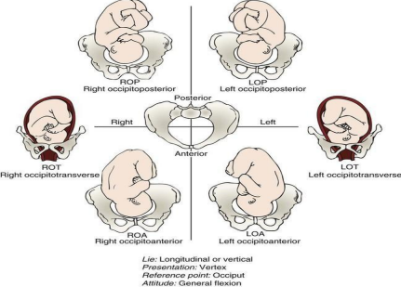
Station : the descent of the fetal presenting part in relation to the level of the ischial spines
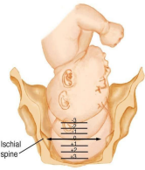
Premonitory sign of labor :
1- Braxton Hicks contraction ( false contraction )
False contraction : irregular , not progressive , not effect cervix )
True contraction : involuntary , progressive , effect cervix , associated with effacement and dilation )
2- Lightening ( drop , descend )
3- Increased clear and nonirritating vaginal secretion
4- ( bloody show : thick mucus with dark blood discoloration) 5- An energy spurt (nesting )
6- Small weight loss up to 1.3 kg
Stages oflabor:
@First Stage : from true labor pain until full dilation of cervix , effacement 100 % -Latent phase : dilation 0-3 cm , UC mild , Q5min , duration 20-30 sec -Active phase : dilation 4-7 cm , UC moderate , Q 2-3 min , duration 40-50 sec -Transition phase : dilation 8-10 cm , UC strong , Q1.5-2 min , duration 60-90 sec
@Second Stage : stage of delivery of fetus to be newborn , duration maximum 3 hr , from fully dilation to complete dilation , uterine contraction strong
@Third Stage : delivery of placenta and membranes
@Fourth Stage : recovery 1-4 hr after delivery of placenta (after pain most common in this stage
Important medications
MgSo4 : muscle relaxant and anticonvulsant
Antidote : calcium gluconate
Misoprostol : induction of labor
Methergine : to stop bleeding, contraindication if women have HTN , varicose vein
Oxytocin : to stop bleeding
Anti d : if women blood group negative and fetus positive
Third lab
Post partum
The period that begins from the delivery of placenta until 6 week after birth
Normal state : during this period the reproductive organ return to the normal non pregnant state
Assessment :
1- Type of labor : NVD , C/S , forceps and vacuum used
2- Type of anesthesia : - general , spinal in subarachnoid , epidural in the end of spinal cord )
3- Skin color
4- Urinary output
5- Abdominal incision if present
6- Feeling level and ability to move
7- V/S : temp change // first 24 hr 38.0 it is normal physiological change Cause that elevate temp :
- Dehydration during labor (NPO )
-
WBC 30.000 / unit / chills and fever source of infection
How to assess temperature :
First hr ---Q 15 min
Second hr ---Q 30 min
Next hr--- Q 1 hr
Rest of 24 hr ---Q 4 hr
Second day--- Q 8 hr
Pulse : average 60-90 beat / min ------50-60 beat / min in first weak after birth
Blood volume increase
Tachycardia : causes :
1- dehydration
2- excitement
3- pain (severe )
4- stress
5- fatigue
6- infection
7- anemia
BP : SHOULD be within normal …… in case of hypotension ( elevate mother leg )
RR within normal , unchanged <12 cycle / min
Physical exam for lung is necessary if mother have URTI , smokers , have asthma
- pain assessment ( OPQRST )
BUBBLE
B: BREAST
U : UTERUS
B B : BOWEL AND BLADDER
L : LOCHIA /LEG
E: EPISITOMY
@Breast: Inspection (size, shape, symmetry, nipple and skin) ❑ The first two days the breast is soft and nontender
❑ The Nipple should be inspected for retraction or flatness which affects breast feeding
❑ Signs of nipple trauma such as redness and fissures
❑ Palpation: for firmness and tenderness, the breast may feel lumpy
❑ Anterior pituitary gland increase production of prolactin it initiate milk production
❑ Posterior pituitary gland release oxytocin it influence : ( contraction milk duct to enhance milk to reach to baby / contraction of uterus to prevent and stop bleeding )
❑ Nipple sucking by baby enhance APG to release prolactin
❑ Encourage breast feeding after birth to stop bleeding
❑ First milk called colostrums
❑ During first two days : breast soft & non tender
❑ Breast engorgement intervention :
- Early breast feeding
- Use warm compress before feeding (15-30 min )
- Breast massage
- Suction
- Manual empty of the breast
- Fold back between feeding
- Avoid wearing tight bra
** avoid nipple stimulation if baby die
***medication : prolactin / bromocriptine to suppress milk production if baby die
@UTERUS :
-consistency( firm / contracted ),
-location,
- position (midline not deviated …if it is deviated meaning that bladder is fully )
-shape (grapefruit shape )
- tenderness,
❑ If the uterus is above the expected level or shifted from midline the bladder may be distended: may cause PPI , PPH
❑ If the fundus is difficult to locate or is soft (boggy), stimulate it by gentle massage
***Descend of uterine fundus :
- Immediately after delivery : weight about 1000g and found between umbilicus and symphysis pubis
- Within 12 hr : at level of umbilicus
- By the second day : descend 1 cm or 1 finger each day
- By 14 day : in pelvic cavity not palpable abdominally
- 6 week need the uterus to return in normal place / if uterus palpable mean there is clot
BLADDER ELIMINATION :
Examine signs of distended bladder Which include
1. Location of fundus above baseline level
2. Fundus displaced from midline
3. Excessive lochia
4. Bladder discomfort
5. Bulge of bladder above symphysis pubis
6. Frequent voiding of less than 150 ml of urine , which may indicate retention
❑ Voiding at least 300-400ml indicate that bladder is empty ❑ urgency, frequency and dysuria suggest infection
❑ Intervention to promote bladder elimination :
- Ask mother to urinate Q2-3 hr
- Drink 2-3 L of fluid
- Medicating women for perineal pain
- Running water , place hand in water , pouring water over vulva - Encourage urination in shower
- Hot tea or other fluid
- Ask mother to blow a bubble through straw
- Apply foley’s catheter if women failes to urinate
Perineal hygiene :
- Wipe From front to back
- Dry from front to back
- Change pad Q2-3 hr \
- Wear cotton underwear not tight
@ Lochia:
amount ,color and odor
❑ A constant trickle or dribble of lochia indicates excessive bleeding and requires immediate interventions
❑ Excessive lochia in the presence of contracted uterus suggest laceration of birth canal
❑ The odor of lochia is usually described as fleshy or earthy , a foul odor suggest infection
❑ Absence of lochia may also suggest infection. Or a significant clot sealed the cervix
❑ If the birth is C/S lochia may be scant
❑ Type of lochia :
rubra bright red
serosa --- pink to brown
alba ----- yellowish to white ( creamy )
Amount of lochia :
- Scant : less than 2.5 cm stain on pad ]
- Light : 2.5-10 cm
- Large : saturated peri pad in 1 hr
- Excessive : saturated pad in 15 min
***Abnormal lochia : ( large clot , excessive amount , foul smell , continue or recurrent reddish color , persistent lochia serosa ;return to lochia rubra , foul odor )
@Leg : rest **)
check for :(pain assessment
, warm in touch ….keep mother bed
@Bowel :
- Decrease bowel motility after birth
- Due to progesterone
- Due to trauma in perineal area ( episitomy )
- Decrease food and fluid intake during labor
- First stool : delivered until 2-3 day post partum
- Normal pattern of bowel movement day 8-14 day post partum - Don’t give laxative in pregnancy ( preterm labor )
@EPISITOMY : Incision done by doctor to facilitate birth o baby Two type : midline , mediolateral /
Intervention :
perineal hygiene
before 24 hr apply cold dry packs
after 24 hr apply war dry packs
change pad Q2-3 hrs
take protein diet
use mirror to check sign of infection :
: REEDA
R: Redness
E: Edema
E: Ecchymosis
D: Discharge
A: Approximation
Nervous system : headache if bilateral or frontal inform Dr >>headache mean fluid and electrolyte imbalance '
Vascular system : increase clotting factor , increase WBC , HB + RBC – need 6 weak to return to normal
After pain :
Is more sever in certain cases :
1- Multipara
2- Over distended uterus such as multifetal , polyhydrominous 3- Retained blood clot
4- During breast feeding
Nursing consideration for after pain :
- Lying in prone position with a pillow or blanket under abdomen - Analgesics taken before breast feeding
- Is self limiting decrease after 48 hr
Fourth lab
Newborn assessment
8-10 : normal ( dry baby and warm )
5-7 : nervous system depression ( need wrapping ) 0-4 : severe depression require CPR sent to NICU
Caring newborn :
- Drying and warming
- Apgar score
- Cord care
- Vit k ( dose according to baby weight : each kg give 1 mg vit k ) - Measurement : ( height , weight , head & chest circumference ) - Foot stump
- ID band
- Clothing
- Initiate breast feeding as possible
Newborn assessment :
- Weight 2.5-4 kg
- Length : 48-53cm
- Head circumference : 33-35 cm
- Chest circumference : less than H.C 1-2 cm
- Low birth weight < 2.5 kg
- Respiratory rate : 30-60 cycle / min use accessory muscle / abdominally - Temp : axillaries or rectally if baby passed meconium to avoid perforation ( 37.2 c) average
- Baby passed meconium after 24 hr ( green and thick stool ) - Pulse apex ( 120-160 beat / min )
Baby appearance :
- Look red or cyanotic
- Well flex
- Skin color completely pink
- Jaundice pathological first 24 hr / physiological after 24 hr - Lanugo hair : fine hair , shoulder , back
- White spot in tip of nose ( milia )
- Mongolian spot ( bluish discoloration in back )
- Vernix caseosa ( whitish creamy material concentrated in inguinal , axillary , skin fold
Head :
1- Caput succedum : fluid between skull and skin
2- Cephalo hematoma : accumulate of blood resulting from using of vacuum / ( instrumental delivery )
3- Hydrocephalus
4- Size appropriate to baby body / shape circular
Eye : edematous , no tear , no secretion , no redness , buffy eye Nose : large than face , nares , breathing patent
Mouth : intact gum and palate
Ear : no deformity no secretion …above imaginary line / if less baby down syndrome
Neck : small , short , fold ( if neck bulk baby down syndrome because present of fat )
Chest: parallel , retraction , nipple symmetry
Abdomen : rounded , umbilicus midline no inflammation no redness , cord intact, cord care using normal saline , bowel sound below umbilicus , assess for masses when baby crying
Anus : passing meconium , male abnormalities ( undescending testis , hypospadius or epispadius ) , female abnormalities ( swollen vulva , white secretion , menstrual secretion )
Back : convex shape , palpate from upper to lower , assess for spina bifida
Limb : length , ROM free movement , posture , level of alertness and muscle tone , number of finger and creases
Reflex :
- Rooting
- Sucking
- Moro
- Babiniski
- Grasp
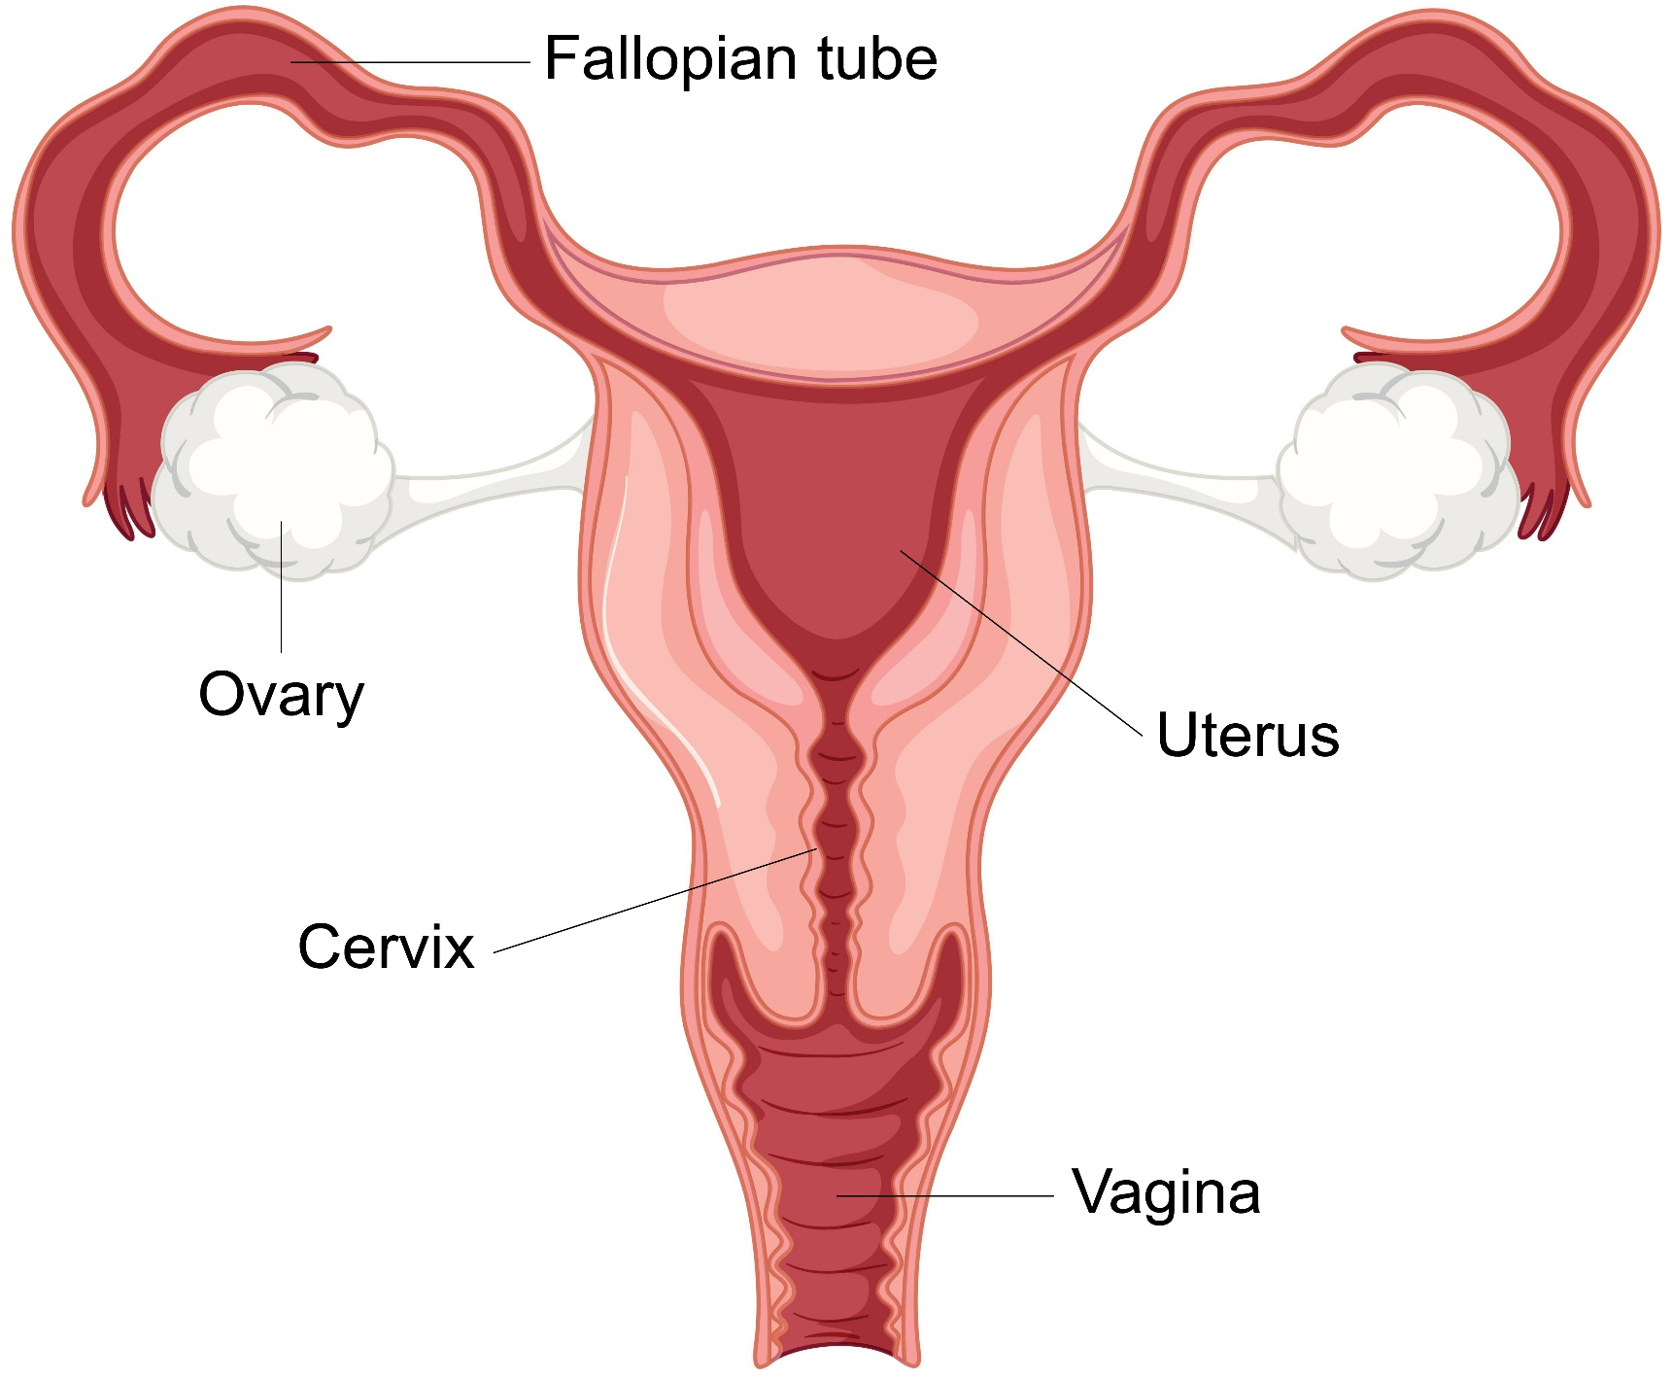- Tonic neck

