The Official Rules of BrendanWorld® Croquet (BWC)

Rule 1: BB’s decision is always final. Any player disputing His decisions will be cast out from BrendanWorld® to live in the Land of Nod (which apparently isn’t as nice as it sounds).
Rule 2: BB is incapable of error, and thus infallible on matters of croquet etiquette, the offside rule, and metaphysics. In the unlikely event of any player disputing this proposition, they will be expelled from BrendanWorld® to live in the East of Eden where there is weeping, and gnashing of teeth, and Very Bad Things.
Rule 3: The BWC sides are Gold and Brown versus Pink and Red (or Green and Black versus Yellow and Orange). In Singles the player plays both balls of that side in alternate turns; in Doubles each player plays one ball only. BB is always a member of the winning team, whether playing a) Singles; b) Doubles; or c) ‘Bad BB’ vs. ‘Good BB’ (N.B. ‘Bad BB’ customarily wins by cheating, but not invariably).
Play progresses in order of colour and player age: Gold, Pink, Brown, Red (the order of colours on the peg). If second colour balls are used, the sequence is Green, Yellow, Black, Orange. The Gold Ball is exclusively for the use of BB. If He is not playing, then the Gold Ball and BB’s golden mallet should be removed (with all appropriate ceremony) and a Persian pomegranate should be used as a substitute, together with any common or garden mallet.
Each turn consists of one stroke only. Roquets are not permitted. When any ball leaves the court, it is placed on the boundary where it went off. Any ball striking either peg is instantly disqualified, and must be removed from the court (along with its owner).
The game starts by playing the balls in order from a peg placed within one yard of the first wicket.
All players try in successive turns to run wicket 1. As soon as any player completes the running of wicket 1, then the point is scored for that side. All players then move on (in order) from where their balls currently are to contest wicket 2, and so on around the court. So each wicket is scored only once, for one side or the other.
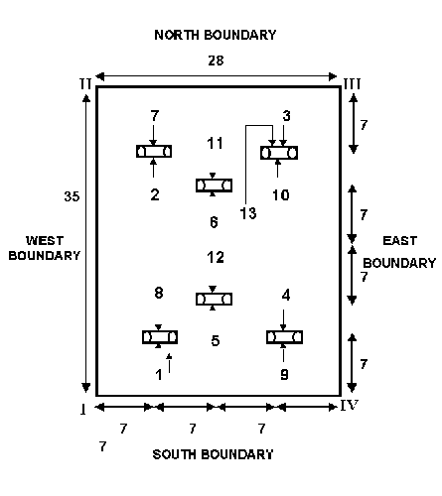
The wickets are run in the order and direction shown in Diagram 1. The BrendanWorld® croquet version is played as a "best of 13 point" game, and stops as soon as one player or team has scored 7. If the points are level after running the 12th wicket, the game is decided by contesting wicket 3 again from the starting place.
A ball scores a point by passing through the next wicket in the order and direction shown in Diagram 1.
If a ball other than the striker's ball is knocked through the next wicket in order, then that wicket is scored for the side owning that ball. If more than one ball runs a wicket in the same stroke, then the ball which was closest to the wicket at the start of the stroke is deemed to have scored the point.
If a ball runs two wickets in the same stroke, then both points are scored.
By Order

Brendan BRUCE
Sole Proprietor & General Manager, BrendanWorld®

BrendanWorld®

BrendanWorld®

BrendanWorld®

