SynchroScore
Quick Start:
Download and install the Java Runtime (Windows only)
- For an install while connected to the internet, go to http://www.java.com and click the big red button.
- To install later on another computer, go to http://java.com/en/download/manual.jsp and click the link for “Windows Offline.”
- Run this install program and accept all the defaults.

Download SynchroScoreXXX.exe from shared drive where XXX is a number, higher numbers are more recent versions.

SynchoScore needs no install, just save it some place convenient and run it from there. If all goes well, you should see the window below when it starts up:
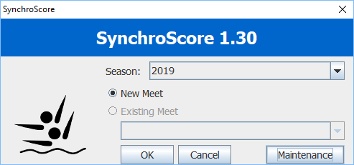

The program is almost ready to use, but it doesn't have the list of VFCAL swimmers and other season information. You should have an Excel file that was sent to you called (current year)synchroscore(one, two, three, etc).xlsx. To load this, click the Maintenance button and the window below will open:
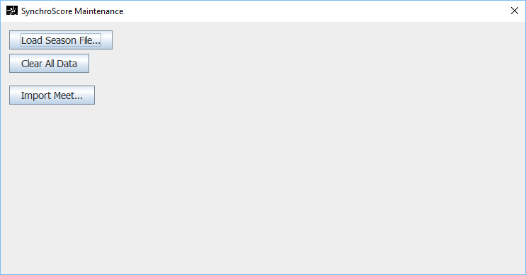
If this is before the season begins, click Clear All Data. Then click Load Season File and select the Excel file you were provided. Then close the Maintenance window by clicking the X in upper right.

If you are loading an updated Excel file, only click the Load Season File and the season information will be updated.

Scoring a Meet:

Start SynchroScore:

Select an existing meet or start a new one and press OK.

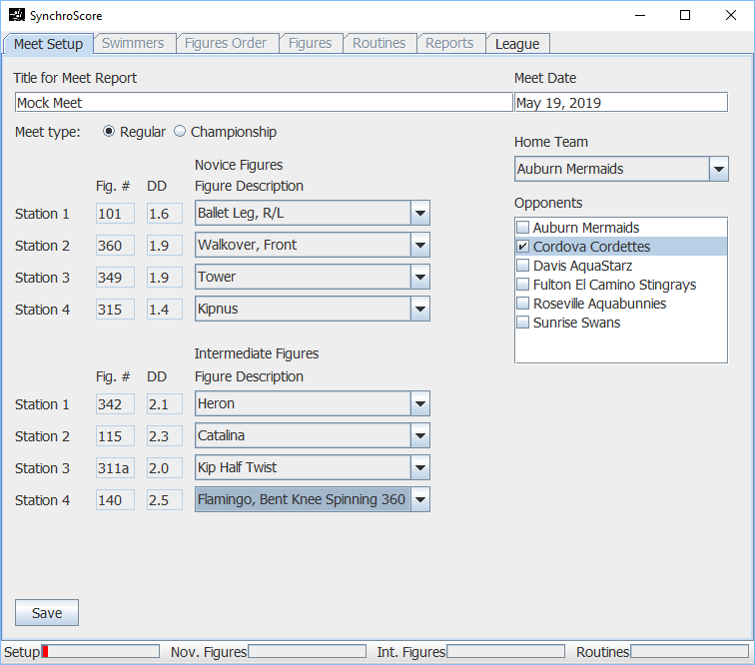
Give the meet a title. Select the home team, and put a check next to the opponent team. Set the figures being performed (station numbering is up to you for your convenience). Press Save, click Swimmers tab.

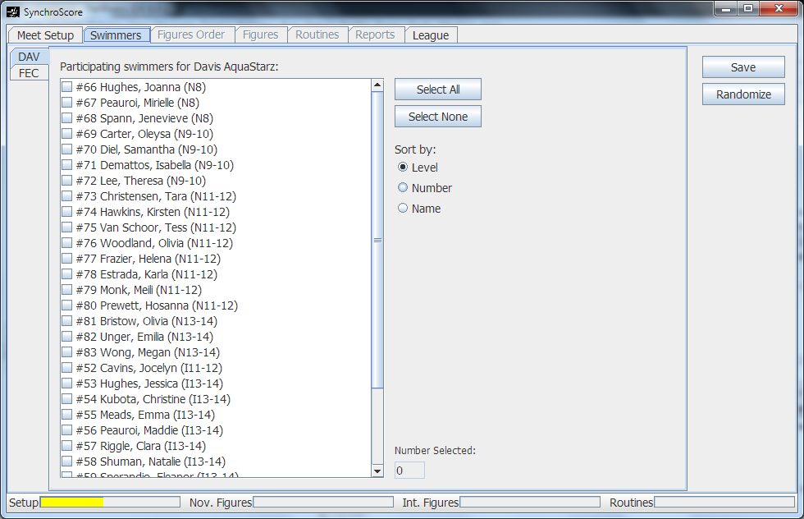

Click a check next to each participating swimmer for both teams. Each team has its own tab to the left. When done, click Save. Then click Randomize, and you will automatically move to the Figures Order tab.

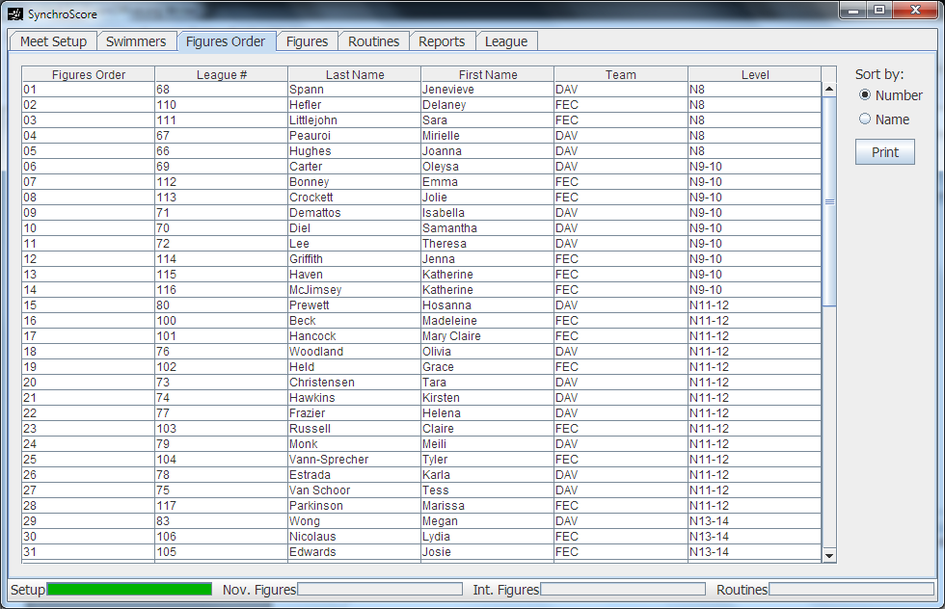

Here you can view the list of figures swimmers. Click the Print button to print the Meet List. You should print 5 copies at a dual meet and 10 copies at champs.

If there are any changes to swimmer names or level, you need to exit the program and restart to get to the Maintenance window where you can make the corrections, restart, and reopen the meet. A change in level will require that you either re-randomize or that you remove the swimmer from the meet, save, add the swimmer back, and save again. This process will give the swimmer a new number at the end of other swimmers of the same level.

Once the Meet List is done, you are ready to enter figures scores. Click on the Figures tab.
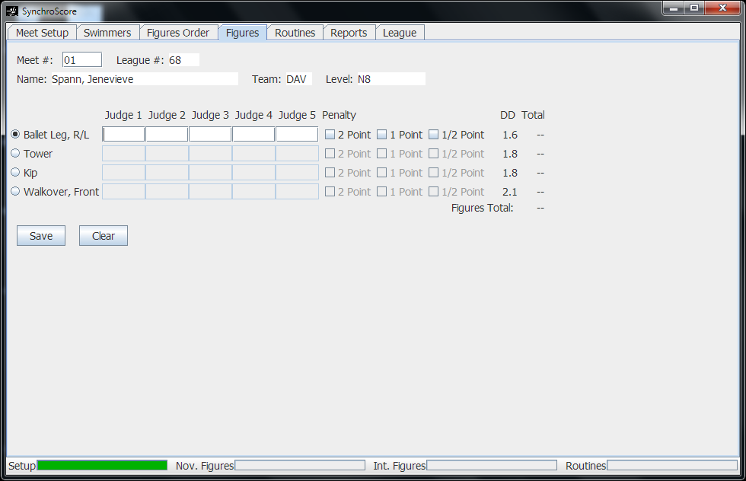

Enter the meet number of the swimmer at the top and press enter. Then click on the correct figure from the list. Now you can begin entering scores. Enter just the two numbers in each box pressing enter between each. After the last one, the Save button will be highlighted, and pressing enter once more will save the score.

Hot keys:
Period will take you directly to the Meet # box to look up a new swimmer.
Slash “/” will move to the next figure.

Along the bottom of the window, there are progress meters. When Nov. Figures or Int. Figures are completely dark green, then you have entered all scores for that group, and it's time to print results (see below).

To enter routines, click on the Routines tab. Press Add for a new routine, enter all the information, and enter the scores similar to how they are entered for figures. The Penalty box will accept a decimal for penalties (e.g. “1.5”)
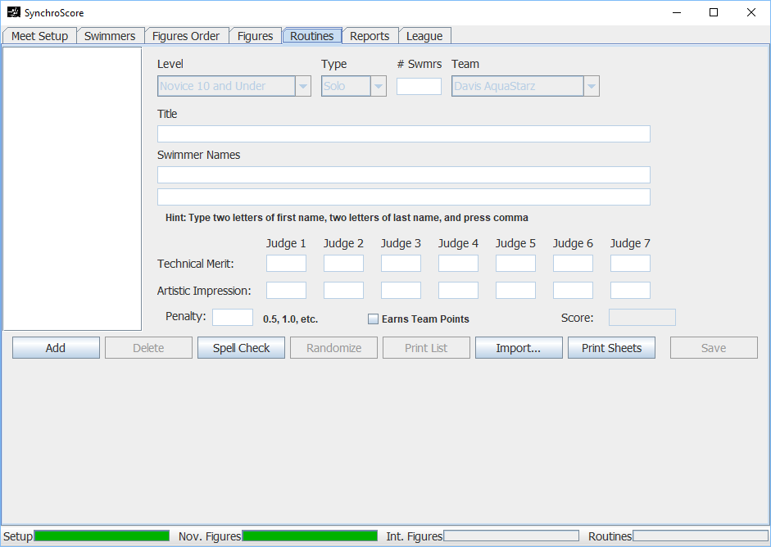

To print results, click on the Reports tab. Hover the mouse over buttons to get hints on what reports need to be printed.
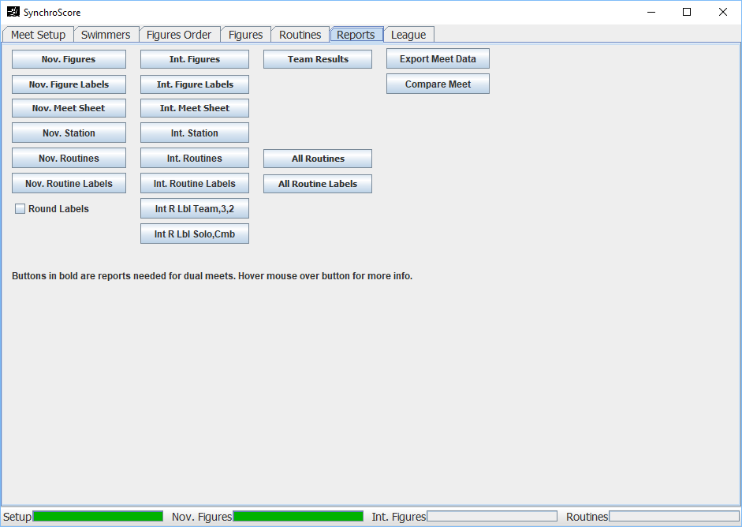
Print one copy of “Nov Figures” and “Int Figures” per team. Print one copy of labels and one copy of meet sheets.

Use the Round Labels checkbox at Champs if round labels will be used for medals. Reports will be split into one for the round labels and another for the regular address labels.

Export Meet – write a .csv file of the meet. This file can be used to compare between two computers (when running two duplicates at Champs) and to load in later (using Maintenance window).

If you need to view or print a list of swimmers for the league or a team, you can do this on the League tab.
