
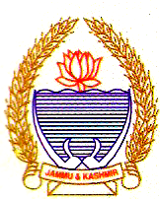
GOVT. POLYTECHNIC COLLEGE GANDERBAL
Govt. Polytechnic College
Ganderbal. Kashmir
KASHMIR
G.P.C.G.KMR

- Name of the Student: ____________________________
- Department: ____________________________

No Objection Certificate

- H.O.D: ____________________________
- I/C Civil Engineering Deptt: ____________________________
- I/C Electrical Engineering Deptt: ____________________________
- I/C Library: ____________________________
- Workshop: ____________________________
- Foreman Workshop: ____________________________
- I/C Store: ____________________________
- I/C Computer Lab: ____________________________
- Account Section: ____________________________
- Establishment Section: ____________________________
- Fee Receipt Details 1st Year ____________________________
2nd Year _____________________________
3rd Year _____________________________

Principal

GPC Ganderbal

