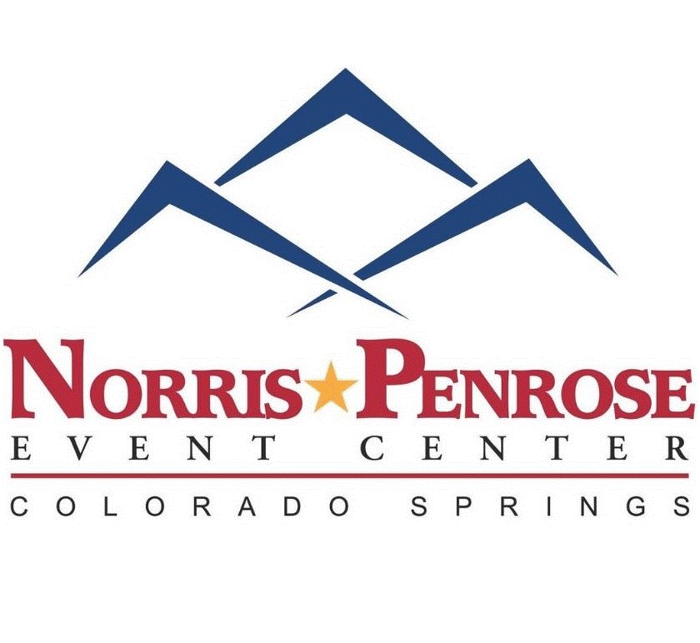

**Site Number:_______**

**NORRIS PENROSE EVENT CENTER**

CAMPGROUND AND BOARDING

1045 Lower Gold Camp Rd.

Colorado Springs, CO 80905

Business Office Ph: (719) 635-1101 Campground Host Ph: (719) 425-0468

**Camp Site/Service Agreement**

**Guest Name: ________________________________ Date: ______________________**

**Camping Equipment: Motorhome / Trailer / Van or Bus Conversion**

**Number of Vehicles: _____ (including carts, and ATVs)**

**License Plate #/State (vehicle and trailer): #____________/____ #____________/____**

**Up to 2 pets allowed per campsite. Pets must be on a leash and you are responsible for picking up after your pet.**

**Do you have a Pet(s)?: Yes / No Number of pets: _______**

**Number in camping party: (18+) _________**

Norris Penrose Event Center will not tolerate any onerous, noxious or offensive activity of any sort that could interrupt and/or adversely affect the enjoyment of other parties utilizing our facilities. In the event of such activity, in the judgment of management, parties may be asked to leave the park immediately without a refund.

Colorado Revised Statute, Title 18, Section 18-4-401, provides that a person commits theft when he or she knowingly obtains, retains or exercises control over anything of value of another without authorization . . . or procures food or accommodations from a public establishment without making payment therefore . . . .” Any guest who leaves without paying for site services or who refuses to pay for site services when due is subject to criminal prosecution. We require full payment on arrival and will prosecute any theft violations for unpaid goods or services acquired thereafter.

As a guest of Norris Penrose Event Center I FULLY ACCEPT THESE RULES AND ANY OTHERS POSTED.

This agreement does not constitute a landlord/tenant agreement. Payment for sites is entirely for services rendered under a Host/Guest arrangement.

**Facility Rates:**

**$35/night for RV/Trailer site w/hookups (Water & Electric)** No sewer, but dumpstation on site.

*Extended Stay Rate is $200/week - 28 day max stay

**$20/night for dry camping (no hookups)**

**Horse Stall Rental:**

**$20/night - each**

Stalls are “self-care” and YOU are responsible for the care and cleanup of your animal.

If you would like to purchase shavings, we have some available for **$20/bale**

**GUEST LIABILITY RELEASE AND INDEMNIFICATION AGREEMENT**

GUEST has been given permission to come upon the Norris Penrose Event Center, (hereinafter referred to as the “Owners' Premises”) and any or all other properties managed or operated by Norris Penrose Legacy Foundation, located in Colorado Springs, Colorado (hereinafter referred to as "Owner"). GUEST acknowledges and understands that no warranty, either express or implied, is made by the OWNER as to the condition of the Owner's Premises. This document is to warn GUEST that dangerous conditions and hazards do exist on the owner's premises that can result in injury or property damage to the person/persons involved in these activities. These conditions, risks and hazards, including but not limited to: severe sunburn, dehydration, heat stroke, exhaustion, hypothermia, frost bite, ice fall, rock fall, avalanches, high-altitude illness, lightning strike, adverse weather conditions, animal attack, drowning, and injuries caused by terrain, facilities, equipment, or other people. The many possibilities and sources of injury are acknowledged by GUEST.

I hereby state that I expressly assume all such dangers, risks, and hazards for all parties staying in property and myself. In consideration for the right to enter the premises, I hereby release and agree to protect, indemnify and hold harmless the Owner, its members or officers and their respective heirs, agents, employees and assigns from and against any and all claims, demands, causes of action and damages, including attorney's fees, resulting from any accident, incident, or occurrence arising out of, incidental to or in any way resulting from the use of the premises and all improvements thereon, whether or not caused by the Owner's negligence or gross negligence. This release shall be binding on my heirs, successors and assigns. As used in this release, the terms include all parties in/on the property and minors in my care while on the premises. The Guest who brings minors onto the Owner's premises assumes the responsibility for watching and caring for minors’ safety and guarding against hazards at all times.

**Additional Charges**: Owner reserves the right to charge to GUEST directly, or by the credit card on file, or by legal action not limited to a lien against personal property, or any additional services needed to return the property to the state it was in upon your arrival. For example: excess garbage or broken/damaged or missing items.

BY YOUR SIGNATURE BELOW, OWNER IS AUTHORIZED TO CHARGE THE CREDIT CARD ON FILE FOR THE DAMAGES/MISTREATMENT OF PROPERTY.

I expressly agree that this Waiver and Release of Liability is intended to be broad and inclusive as permitted by the laws of the State of Colorado and shall be governed by and interpreted in accordance with the laws of the State of Colorado. I agree that in the event that any clause or provision of this Waiver and Release of Liability is deemed invalid, the enforceability of the remaining provisions of this Waiver and Release of Liability shall not be affected.

**CERTIFICATION**: I have read each paragraph above and understand the obligations, release, waiver of rights, and legal consequences contained in each paragraph. I have been afforded the opportunity to ask for clarification of any of the statements contained above which I did not understand. I have initialed and signed this document without duress and of my own free will and accord.

____________________________________________ ___________________

SIGNATURE OF RESPONSIBLE PARTY DATE