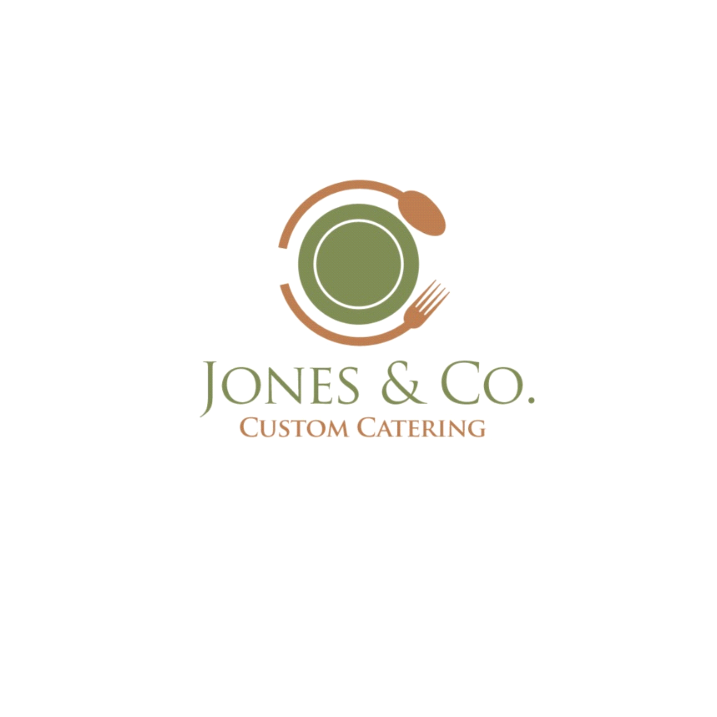

**Chateau Briand:** Peeled tenderloin of beef, hand trimmed, cut to into medallions and roasted to a medium center and served with a house reduced demi-glaze. **$34.99**

**Prime Rib of Beef:**  This holiday favorite is hand seasoned and slow roasted to a medium rare center. This selection is hand carved and served with au jus and a sour cream horseradish sauce. **$31.99**

**Slow Roasted Sirloin of Beef:** Aged top sirloin trimmed and seasoned then slow roasted for 8 hours to ensure flavor and tenderness. Sliced and served with au jus and a sour cream horseradish sauce. **$26.99**

**Roasted New York Strip:** This Choice strip loin is aged 30 days. Prepared with a selection of house seasonings and slow roasted to medium rare. This entrée is similar to prime rib but is a leaner cut. We hand carve and serve it with horseradish. **$28.99**

**Roasted Flat Round of Beef:** This U.S.D.A. choice round is hand seasoned and slow roasted it to a medium rare center. It is hand carved and served with a sour cream horseradish sauce. **$24.99**

**Prime Rib of Pork:** This non beef entrée is slow roasted and served with the bone in to maximize flavor and tenderness. It is hand carved and served with either an apple horseradish or apricot glaze on the side. **$28.99**

**Carved Beef Tenders:** This beef tender strip that is hand seasoned, oven roasted and carved into medallions. It is full of natural juices, flavor and is extremely tender. It smothered with mushroom leek compote. **$27.99**

**Pan Seared Sirloin Steak:** Top sirloin of beef aged for 30 days, hand cut and then aged again. Seared and served with a medium center, accompanied w/ sautéed mushrooms, A-1 and Heinz 57 steak sauce. **$25.99**

**Brown Butter New York Strip Steak:** Strip loin of beef, hand trimmed and cut to a 10 oz portion and then grilled in seasoned brown butter and served with sliced sautéed mushrooms. **$27.99**

**PICO BEEF:** Sliced, marinated, and grilled sirloin steak, served with a fresh Pico de gallo. This is best served over a rice pilaf. **$24.99**

**Chicken Cordon Bleu:** 8 oz chicken breast hand rolled with Swiss cheese and thin sliced pit ham, basted with butter, breaded with corn flakes and topped with a chicken hollandaise sauce. **$25.99**

**Chicken Alfredo with Penne Pasta** Skinless, boneless chicken tenders, pan seared and folded together with penne pasta, fresh herbs, select seasoning in a reduced whole cream with fresh shredded parmesan cheese. Not like any other Alfredo you have ever had. **$24.99**

**(NEW) Vodka Pasta Italian:** Grilled Italian sausage, onions and peppers, mixed with a Vodka pasta sauce served with a penne pasta. **$24.99**

**Pork Tenderloin:** 8oz of roasted pork tenderloin served w/ your choice of an Italian Balsamic glaze or Apricot Glaze. **$24.99**

* **Price shown is price per person based upon one selection from each category and does not include gratuity or tax.**

Second Protein Options

Choose one of the following to accompany

your center plate option.

**Grilled Chicken Mushroom Melt:** This is a skinless, boneless breast of chicken

seasoned and flat grilled. It is topped with sliced sautéed mushrooms and melted provolone cheese.

**Chipotle Chicken:** This is a boneless skinless breast of chicken, grilled and served with our house southwest chipotle sauce and topped with sautéed onions and peppers.

**Smokey Mountain Chicken:** This is a skinless, boneless breast of chicken

that is seasoned and flat grilled. It is topped with a spiced barbeque sauce, apple fired bacon bits and a shredded cheddar cheese.

**Smothered Basil Pesto Chicken:** 6oz skinless, boneless chicken breast, grilled, topped with a fresh basil pesto and smothered with sliced sautéed mushrooms and mozzarella cheese.

**Grilled Chicken Marinara:** 4 oz chicken breast served with grilled onions and peppers baked in a homemade marinara sauce with mozzarella cheese.

**Roasted Pork Loin:** This entrée is hand seasoned and slow roasted. It is extremely lean, tender and flavorful. It is hand carved and served with an apricot glaze.

**Wild Berry Chicken:** This is a skinless, boneless breast of chicken

that is seasoned and flat grilled. We top it with a reduced sauce of cherries, cranberries, blueberries and raspberries. This is an outstanding accompaniment to center entrée.

**Jumbo Fried Shrimp:** Large count shrimp lightly breaded and fried to a golden brown perfection. This item is served with a house cocktail sauce.

**Glazed Pit Ham:** This is a roasted pit ham that is hand carved and served with a cinnamon cherry sauce. This is a great holiday protein.

**Roasted Breast of Turkey:** This is an oven roasted breast and wing section of turkey. It is extremely moist and has an excellent flavor profile. This entrée is served with cranberry

sauce.

**Chicken Pesto Cavatappi Pasta:** Grilled chicken breast, served with corkscrew pasta with creamy pesto alfredo, garnished with freshly grated parmigiana cheese and fresh basil.

**Three Cheese Tortellini:** Tri colored tortellini tossed in a light cream sauce, diced tomato and parmesan cheese. Chicken or Shrimp can be added for an additional charge.

Potato Choices

Please choose one of the following

**Baby Red Garlic Potato:** This is a new red potato that is quartered, and par steamed. It is finished on a flat grill. It is sautéed with butter, fresh minced garlic and parsley.

**Garlic Mashed Potato:** Steamed new potatoes, mashed and mixed with cream, butter, minced garlic and fresh parsley.

**Mashed Potato and Gravy:** Peeled Idaho russets, steamed and mashed with cream, white pepper, salt and butter. This is served with a choice of white, poultry or beef gravy.

**Cajun Red Potato:** This is a new red potato that is quartered and par steamed. It is finished on a flat grill. It is sautéed with butter, salt, pepper and a light Cajun seasoning.

**Dutch Oven Style Potato:** This is a new red potato that is quartered, and par steamed. It is finished on a flat grill. It is sautéed with seasoning salt, onion, peppers and topped with shredded cheddar cheese.

**Oven Roasted Rosemary Potato:** Baby red potato bathed in extra virgin olive oil and seasoned with kosher salt, course ground pepper and rosemary and oven roasted to a golden brown.

**Baked Potato:** Idaho russet oven fired potato served with sour cream and butter.

**Funeral Potatoes:** Traditional scalloped potatoes, if you like good old fashioned comfort food these are for you and are a definite crowd pleaser.

Vegetable Choices

Please choose one of the following

**Green Beans with Baby Carrots:** Clipped long green beans with baby carrots, steamed and sautéed with butter, salt and pepper.

**Fresh blend of Green and Yellow Beans:** This blend is par steamed and sautéed on the flat grill with sliced almonds.

**Kernel Corn with Pimento:** Succulent sweet yellow corn steamed and served in butter and diced red pimento.

**Sautéed Squash Medley:** This is a blend of baby zucchini and yellow squash steamed and sautéed on a flat grill with red onion, butter and seasoning salts.

**Southern Style Green Bean:** These green beans are pot simmered in ham hawks, white pepper and salt.

**Rainbow Vegetable Medley:** Purple, white and orange cauliflower, baby carrots, green and yellow beans and sweet red peppers steamed and pan sautéed.

Salads

Please Choose One of the Following

**Garden Tossed Salad:** This is an iceberg, romaine lettuce blend, tossed with tomatoes, sliced cucumbers, green peppers and onions. Served with ranch and 1000 island dressing.

**Hand Tossed Caesar:** Fresh trimmed and cut romaine lettuce hand tossed with parmesan cheese, seasoned croutons and our house Caesar dressing.

All meals include fresh baked

Yeast Roll w/ honey margarine.

Beverage Selection

Please choose one.

**Raspberry Lemonade**

**Assorted Canned Soda**

**Assorted Gourmet Soda (Minimal additional cost)**

**Appetizer Menu Available**

**Upon Request**

Dessert Choices

Please choose one of the following

**Strawberry or Lemon Layer Cake:** Layers of moist sponge cake separated by a fruit puree filling and topped with a cream dream whip.

**Cheese Cake with Carmel Sauce:** Cream cheese cake with a honey gram cracker crust drizzled with a reduced Carmel sauce.

**Turtle Cheesecake:** NY style cheesecake served with chocolate and caramel sauce, topped with chopped walnuts.

**Mixed Berry Cheesecake:** Blueberries, raspberries and strawberries in a cane sugar glaze, served on top of NY style cheesecake.

**Peach Cobbler Cheesecake:** Peach pie filling with crumb topping, served on top of NY style cheesecake.

**Assorted Cheesecakes:** A colorful assortment of flavored cheesecakes**.**

**(Note, separate dessert table is needed and requires guest to make their own selection. This may not be appropriate for parties with.)**

**Assorted Berry Tart:** Blueberries, raspberries and strawberries in a cane sugar glaze and topped with a heavy whipped cream.

**NEW**

**PREMIUM DESSERT MENU**

Up charge is required for these premium dessert options.

**Chocolate Tuxedo Layer Cake** Moist layer cake separated by a chocolate cream filling and finished with a firm chocolate topping.

**Mango Mousse Vanilla Layer Cake:** Three layers of vanilla sponge cake enhanced with a hint of coconut, and nestled in a fresh mango puree with a essence of passion fruit, and topped with a fresh mango puree with mango chunks.

**Tiramisu:** Traditional Italian dessert made of mascarpone cheese and lady fingers soaked in espresso with a touch of liquor. Lightly dusted with cocoa powder. ($1.00 upcharge)

**S’mores Chocolate Lava Cake:** Graham cracker cake, with smoked chocolate ganache center, drizzled with chocolate topped with toasted marshmallows. ($2.00 up charge)

Catering Agreement

Please review, sign, and return with menu.

* Service fee 18% for buffet style and 20% for full service
* Menu must be submitted 10 days before event. 20% fee will be added if submitted late to cover cost of product being purchased locally.
* Guest count must be submitted 7 days before event. Any additional guest adjustment within 6 days of event may result in additional cost to order extra product locally.
* Service time will be allotted per number of guests as follows:

0-150 60 min

150-300 90 min

300+ 120 min

Any additional requested time will result in a $100 fee per hour. ( Not applicable to Christmas Events)

* If we obtain and place linen for your event $1.50 per person will be added to cover linen cost.
* Any extra place settings above the agreed upon number of guests will result in a $1.50 charge per setting.

X_____________________________________________ Date_____________

Signature of Event Coordinator

**If there is something that you would like that you do not see please let us know. Chances are we can prepare it for you.**

McKenzie McNamara 435-790-5139

Dane Jones 435-828-0513

jonescustomcatering@gmail.com