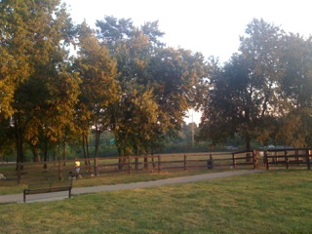


Front view of school – Work has begun on the gymnasium and cafeteria
Wellington Park is within walking distance to the school, providing additional learning opportunities for students.

Recommendation:
The Naming Committee for the New School on Keithshire Way would like to recommend the name Wellington Elementary School to the Fayette County Board of Education. The name reflects the geographical proximity to the Wellington neighborhood and park.
Rationale:
The name defines the geographical location.
The school is in walking distance to Wellington Park.
In addition to the school being in close proximity to the Wellington Subdivision, the recently developed Wellington Park presents itself as a teaching tool. Native gardens, wildlife and walking trails would provide additional learning opportunities for students, keeping in mind the vision of the school.
In Closing:
The Naming Committee experience has been a very positive one. All involved worked to reach consensus and were in unanimous agreement with the decision. I appreciate the work of the committee and their commitment to the goal. I am extremely proud of their work.

