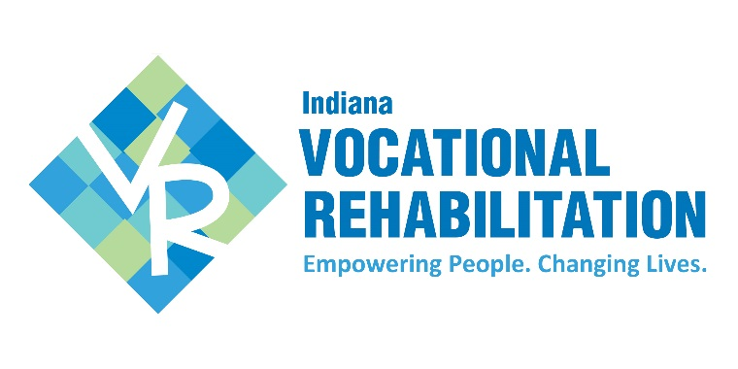Vocational Rehabilitation Area Offices

Vocational Rehabilitation (VR) is a program of the Division of Disability & Rehabilitative Services, a division of the   
Indiana Family & Social Services Administration.

**Area 1**

110 W. Ridge Road

Gary, IN 46408

(219) 981-5326

**Area 3**

2602 Chicago St.

Suite 200

Valparaiso, IN 46383

(219) 462-0521

**Area 4**

401 E. Colfax Ave.

Suite 270

South Bend, IN 46601

(574) 232-4861

**Area 5**

1659 Mishawaka St.

Suite A

Elkhart, IN 46514

(574) 262-2086

**Area 6**

615 N. 18th St.

Suite 103

Lafayette, IN 47904

(765) 449-4278

**Area 7 & 8**

201 E. Rudisill Blvd.

Suite 300

Fort Wayne, IN 46806

(260) 424-1595

**Area 9**

1914 S. Dixon Road

Kokomo, IN 46902

(765) 455-5020

**Area 10**

840 N. Miller Ave.

Suite C

Marion, IN 46952

(765) 662-9961

**Area 11 & 12**

201 E. Charles St.

Suite 130

Muncie, IN 47305

(765) 282-9863

**Area 13 & 14**

2620 Kessler Blvd. East Drive

Suite 105

Indianapolis, IN 46220

(317) 205-0100

**Area 15 & 16**

6640 Parkdale Place

Suite L

Indianapolis, IN 46254

(317) 270-1005

**Area 17**

30 N. 8th St.

Terre Haute, IN 47801

(812) 232-7864

**Area 18**

1600 Willow St.

Suite B

Vincennes, IN 47591

****(812) 882-7208

**www.VRS.IN.gov**

**(800) 545-7763**

**Area 19**

125 E. 37th St.

Suite A

Jasper, IN 47546

(812) 827-5179

**Area 20**

700 E. Walnut St.

Evansville, IN 47713

(812) 425-1367

**Area 21**

1531 S. Curry Pike

Suite 300

Bloomington, IN 47403

(812) 332-7331

**Area 22 & 24**

1248 Washington St.

Columbus, IN 47201

(812) 376-9935

**Area 23**

52 S. 2nd St.

Richmond, IN 47374

(765) 966-0932

**Area 25 & 26**

1452 Vaxter Ave.

Clarksville, IN 47129

(812) 288-8261

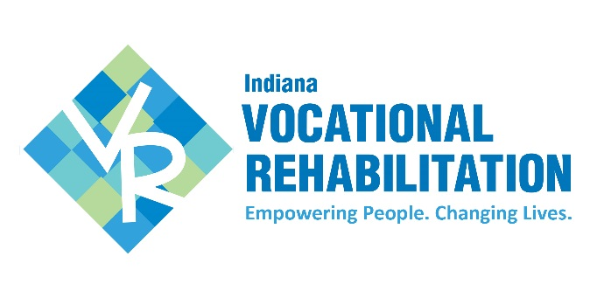

Vocational Rehabilitation (VR) provides quality individualized services to enhance and support people with disabilities to prepare for, obtain or retain employment. The individual will work closely with a VR counselor throughout the process. Through active participation in their rehabilitation, people with disabilities achieve a greater level of independence in their work place and living environments.

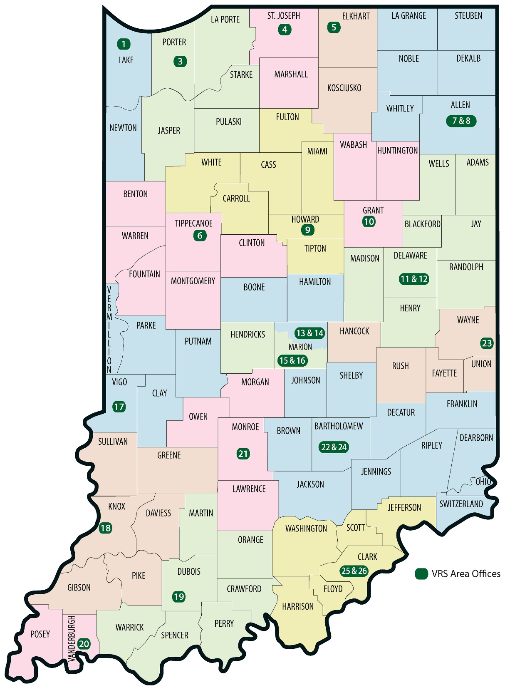

If you have a disability and are interested in applying for VR services in order to obtain or maintain employment, please call the office closest to you to schedule an application appointment.

Updated: 09/11/2019