**Sponsor’s Information**

Please provide the following information in **Arabic for item 1/2/3/4/9.**

1. First Name – in Arabic
2. Father Name - in Arabic
3. Grandfather Name – in Arabic
4. Surname - in Arabic
5. Nationality： Iraqi
6. Gender： male/female
7. Birth Date：dd/mm/yyyy
8. Marital Status： Married /Single/ Divorced / Widow
9. Mother Name – in Arabic
10. Email:
11. Phone Number:
12. National CARD:
13. National Number: dd/mm/yyyy
14. Issuance Date: dd/mm/yyyy
15. Current address inside Iraq:
16. Accommodation type(choose one from the list):

1. Governorate:

1. Residence card form number:
2. Residence Card Number:
3. Issuance Date: if known
4. Residence Card Information Office (choose one from the list):

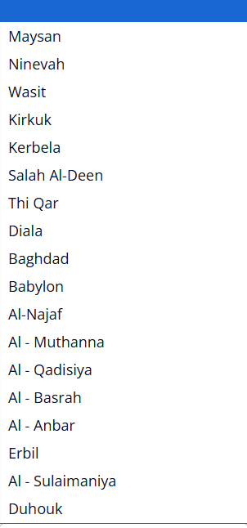

1. Please provide photos of these documents below:
2. Nationality Card: （please put photos of both side here）
3. Residence Card: （please put photos of both side here）

We provide the following screen shortcut for your better understanding about the questions above:



