Northern Berkshire: NBSWMD recycling holiday light strands
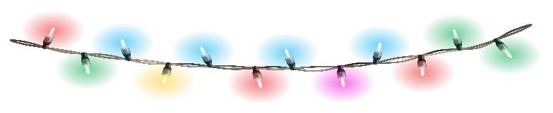
This Photo by Unknown Author is licensed under CC BY-NC

November 24, 2025

This time of year, countless strands of holiday lights are thrown away because a single bulb goes out or breaks.
Broken or unwanted holiday lights can be placed in the scrap metal recycling containers located at all Northern Berkshire Solid Waste Management District transfer stations. This program is open All year long.
Northern Berkshire Solid Waste Management District is working with Sayers Scrap Metal to offer this recycling program free of charge to the district's 14 member towns. Please place in the scrap metal recycling container.
Information regarding recycling programs on page 11 of the Reduce, Reuse, Recycle Guide https://tinyurl.com/RRRW-2025
Direct questions to Northern Berkshire Solid Waste Management Director Linda Cernik at 413-743-8208 or lcernik@nbswmd.com

