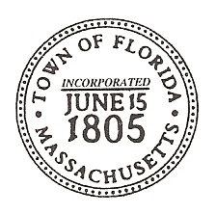
Joan Lewis
Town Administrator
379 Mohawk Trail
Drury, MA 01343
413-662-2448 Extension 0
TownAdmin@TownOfFlorida.org

MAY 1, 2026

ATTENTION:

ALL NATIONAL GRID CUSTOMERS, FLORIDA RESIDENT HOMEOWNERS WILL BE RECEIVING NEW REPLACEMENT ELECTRIC METERS FROM NATIONAL GRID WITHIN THE NEXT FEW MONTHS.

LISTED BELOW IS THE STATEMENT FROM THE NATIONAL GRID COMMUNITY MANAGER.

ANY QUESTIONS, PLEASE FEEL FREE TO THE FLORIDA TOWN HALL AT 413-662-2448 EXTENTION 0.

National Grid will be sending information to the residents, our customers, to familiarize them with the smart meter program. We will be highlighting three key benefits of the new meter:
- Transparency – secure access to how and when you use energy
- Speed - near real-time data available to you
- Outage Identification – real-time awareness of outage to restore your service

We anticipate that smart meters will be installed within one to three months.

Customers receive two notifications:
- Approximately 60 days prior to their installation.
- Approximately 30 days prior to their installation.
For your reference, included photos of our ‘customer communications’ and included a link to view them on the National Grid Smart Meter page.

National Grid Smart Meter Program Customer Engagement and Communication Approach:
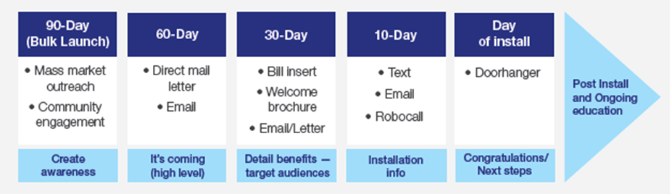
Examples of National Grid Smart Meter customer marketing communications:
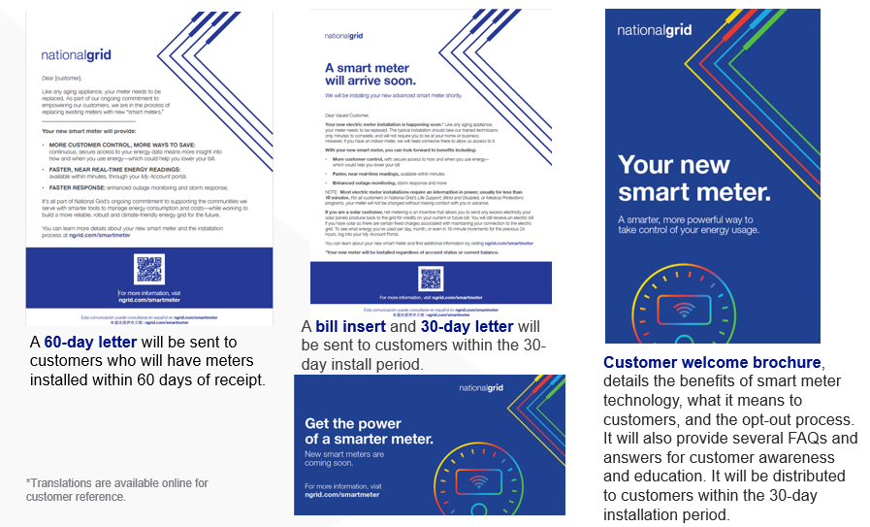

Link to: National Grid Smart Meter Customer Communications

