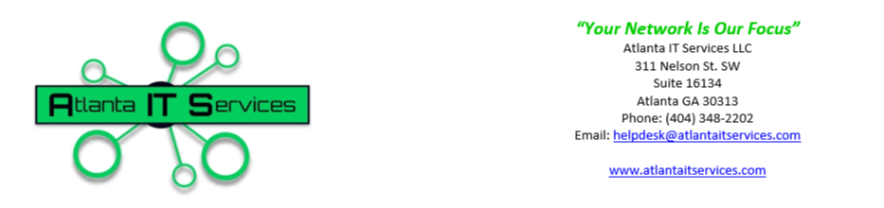
Terms and Conditions
Last Updated: September 22, 2025

By using Atlanta IT Services LLC’s services, including signing up for text message communications, you expressly consent to collecting, using, and sharing your personal information as outlined in our Privacy Policy. You acknowledge that you have read, understood, and agree to our Terms of Service and Privacy Policy, including the terms related to data collection, communication, and security.
You further consent to receive text messages from Atlanta IT Services LLC, including transactional and promotional messages. You may opt out of receiving promotional messages at any time by following the opt-out instructions provided in the messages. Your continued use of our services constitutes your ongoing consent to these terms.
You may choose to stop receiving promotional text messages from Atlanta IT Services LLC at any time. To opt out, simply reply to any text message you receive from us with the word ‘STOP’ or ‘UNSUBSCRIBE.’ Once we receive your opt-out request, we will promptly remove your number from our promotional messaging list. Please note that opting out of promotional messages will not affect your ability to receive important service-related communications.
Atlanta IT Services LLC is not responsible for any delays, failures in delivery, or any other issues related to the transmission or receipt of text messages. Delivery of text messages is subject to effective transmission by your mobile carrier and is not guaranteed by Atlanta IT Services LLC.
By subscribing to our SMS services, you acknowledge and agree that Atlanta IT Services LLC will not be liable for any damages, losses, or injuries arising from or related to the use or failure to receive any text messages, including but not limited to, delays, non-delivery, or technical issues. Your use of our SMS services is at your own risk, and we provide our services on an ‘as-is’ basis without any warranties of any kind, express or implied.
Atlanta IT Services LLC is committed to protecting the security of your personal information. We implement industry-standard security measures to safeguard your data against unauthorized access, use, or disclosure. However, it is also your responsibility to protect the confidentiality of your account information and any passwords associated with your use of our services.
You agree to notify Atlanta IT Services LLC immediately of any unauthorized use of your account or any other security breach. Atlanta IT Services LLC will not be liable for any loss or damage arising from your failure to protect your account or personal information adequately. By using our services, you acknowledge and accept that no data transmission over the Internet or mobile networks can be guaranteed to be 100% secure, and therefore, you use our services at your own risk.

Atlanta IT Services LLC collects personal information from you when you interact with our services, including when you sign up, make purchases, or communicate with us via text messages. The types of information we collect may include your name, contact details, payment information, and any other information you voluntarily provide.
We use this information to provide, maintain, and improve our services, process transactions, communicate with you, and comply with legal obligations. Your information may be shared with trusted third-party service providers solely for the purpose of operating our business and fulfilling our commitments to you. We do not sell, rent, or share your personal data with third parties for marketing purposes without your explicit consent.
You have the right to access, correct, or delete your personal information at any time, and we are committed to handling your data in a secure and transparent manner.
Atlanta IT Services LLC takes the security of your personal information very seriously. We employ industry-standard security measures, including encryption and secure servers, to protect your data from unauthorized access, alteration, disclosure, or destruction. We continuously monitor our systems to ensure your information is safe and secure, and we are committed to maintaining the highest levels of data protection to safeguard your privacy.
Atlanta IT Services LLC is committed to upholding the highest standards of privacy for all personal information collected through our text messaging services. We do not sell, rent, distribute, or trade your personal data to third parties without your explicit consent unless legally required to do so. Any information shared with third parties is exclusively for the purpose of delivering our services to you. We assure you that your data will never be shared with third parties for marketing purposes.

If you no longer wish to receive text messages from us, you can opt out at any time by replying with the word ‘STOP’ or ‘UNSUBSCRIBE’ to the number from which you received the message. Upon receiving your request, we will promptly remove you from our messaging list, and you will no longer receive further text communications from us.

Atlanta IT Services LLC may update this Privacy Policy from time to time to reflect changes in our practices or legal requirements. When we make changes, we will notify you by updating the “Last Updated” date at the top of this policy. In the event of significant changes, we will provide a more prominent notice, such as sending an email notification or displaying a notice on our website.
By continuing to use our services after these changes, you agree to the revised Privacy Policy. We encourage you to periodically review this policy for the latest information on our privacy practices.

