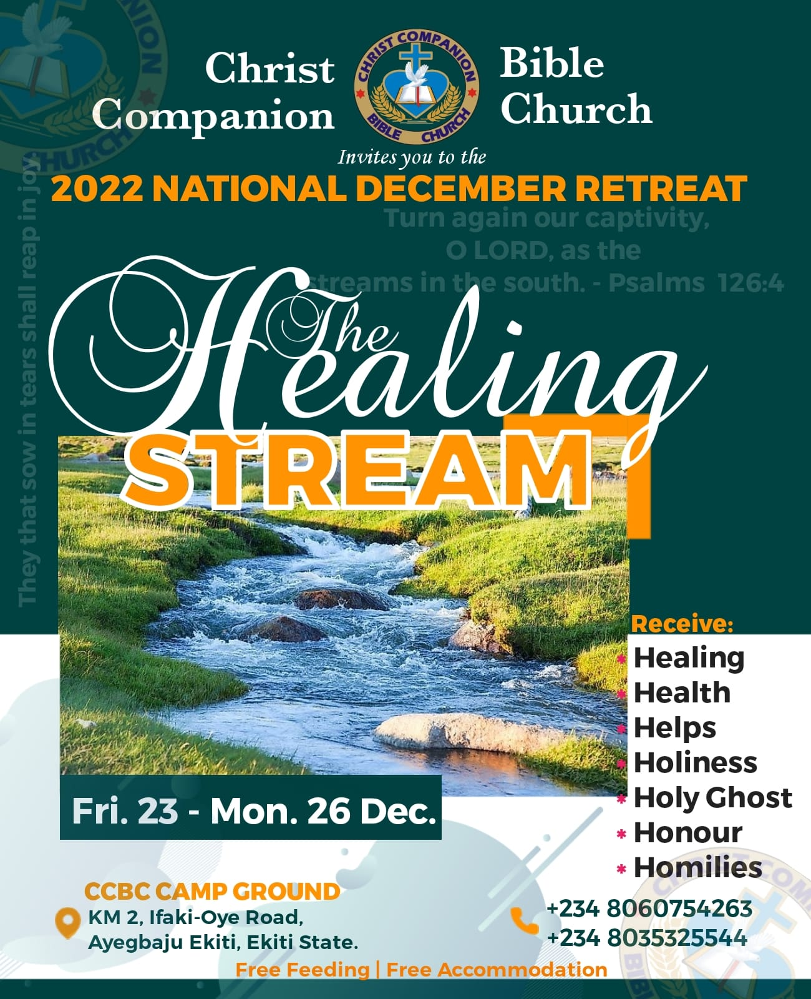
BIBLE STUDY- II
Study Texts: Psalm 126:1-6; Isaiah 49:24-26; Nehemiah 1:1-4.
‘When the Lord turned the captivity of Zion’. This statement talks about the appointed time when the Lord looked upon the people of Zion, stepped into their situation and delivered them out of their captivity. May your appointed time of deliverance come speedily in Jesus Name. And when He did so, it was a pleasant surprise to them; they would not understand the way the whole event took place. In fact, all that they could say was that they were like those who were dreaming. I pray for you today, in all your challenges being in your ministry, family, finances, education, health, work etc may you experience the supernatural touch of the most- high God for wonder in Jesus name. Acts 12:5-16.
However, suffering saints are often in tears; they share the calamities of human life and commonly have a greater share than the other. But they sow in tears: weeping must not hinder sowing; and they that sow in the tears of godly sorrow to the spirit kind of severe affliction shall of the Spirit reap life everlasting and that will be a joyful harvest indeed. Psalm 30:5b, Galatians 6; 7-9.
Believers are enjoin to look unto Jesus as an author, the fountain of living water and finisher of our faith; who for the joy before him endured the cross, despised the shame, Hebrews 12:2. We are to preoccupy and invest on soul winning which is the sole desire and heart beat of the master. Daniel 12:3; John 4:34-38; Proverbs 11:30. The day is coming when they shall reap in joy, plentiful shall be thy harvest, and great shall be thy joy in the Lord in Jesus name.

- THE PROMISE OF HOPE OF RESTORATION:
Jeremiah 30:15-21, 31:1-5,7-17,28,33,34; Job 14:7-9,14; Isaiah 35;10, 41:10-18, 42:11, 43:1-5, Psalm 37:23-25, 30:5; Jeremiah 29:1,4-6,10,11,30:8 ’15.
Why criest thou for the affliction? Thy sorrow is incurable for the multitude of thine iniquity; because thy sins were increased, I have done these things unto thee. …..18 Thus saith the Lord: Behold I will bring again the captivity of Jacob’s tents, and have mercy on his dwelling places;…’Jeremiah 30:15-18.
God has promised, His promises is yea and Amen 2 Corinthians 1:20. His word is infinite, it cannot lie, every good word he ever spoke concerning you he will bring it to pass, Numbers 23:19, I Kings 8:56. When one is sick to the point of death or suffering from any other kind of severe affliction or oppression that makes one to be despised or rejected, one is likely to be hopeless especially when there is no ray of hope from the other side of the tunnel in that precarious situation. Surely, hope will come when someone of power and influence promises healing and deliverance. From the passage, the Israelite captives suffered justly for their sins and could not help themselves Psalm 119:67. The Lord promised to appear for them, punish their oppressors and heal their wounds. Also, like the Israelites in the passage, every self effort for healing or deliverance will prove futile for as long as we neglect the heavenly Advocate. God has promised to heal the sick Isaiah 58:8, Jeremiah 30;17, deliver the oppressed and to be an enemy to our enemies. He has promised to fight our battles for us 2 Chronicles 20:15-17, our dwelling places will be rebuilt and the Lord will increase us once again. He will be our God; we will be truly His people with unprecedented joy. We need to make our ways right with God through repentance and turning to Christ as our Lord and savior so that we will be healed and delivered of all infirmities and afflictions. God is ready to heal and bring joy back to the humble 2 Chronicles 7: 13-15. There is also hope of restoration for the backsliders who will retrace their steps back to the Lord Jeremiah 3:11-14. There might be situation you are battling with that has cause tears in the secret and no one to console you. Your ministry is being confronted with strange force and you are at the point of given up to fate. God is asking me to tell you don’t lose hope, wait, there is hope in the end, Job 14:7-9, 14, 22:29, Psalm 42:5,11. Weeping may endure for a night, but joy cometh in the morning Psalm 30:5, 126:5,6. God is faithful; He will surely reward your labour of love here on earth and in eternity if you continue in faith and in the service of the Lord unmovable till the end I Corinthians 15:58, Mathew 24:13.

- THE PRAYER OF RESTORATION: Psalm 126:4, I Chronicles 17:9,10,12-14,23, Daniel 9:1-11,13,14,17-22, Mathew 7:7, Nehemiah 1:3-9, Psalm 18:2-6,16-19, 34:4-6, Act 12:5-16. ‘Turn again our captivity oh Lord as the stream in the south, Psalm 126:4. This is the heart cry, desires and prayer of Psalmist in their excruciating pain of oppression and captivity. It is the prayer of remembrance and total turnaround from all difficulties and captivity of the enemy like a stream of water to the dry and thirsty grounds. They prayed for refreshment as the river of the south gladden, fructify and replenish their dry and thirsty soil. This prayer is passionate and definite. Everyone is expected to emulate this and seek redress to their situation. Sinners should acknowledge the cause of their captivity, humble themselves, confess their sins and turn from their evil ways, Isaiah 55:6,7, Ezekiel 18;30,31. Though the promise has been given and is sure, yea and Amen. God expectation from us is to ask and pray in faith. God sees, feels, knows our needs and the pains we go through but he demands that we should ask Him to do it for us; 1 Chronicles 17:9,10,13,14,23-24, Dan 9:1-6. Many are praying today but their prayers remains unanswered as a result of secret sins, double mind, unbelief, unforgiveness etc that silent their prayers Proverbs 28:13, Ps 66:18, 17:1-3. For our prayers to go unhindered, we must do away with all encumbrances and impediments Psalm 18:20,21, Mathew 15:25,26 Ask and it shall be given; seek and ye shall find; knock and it shall be opened unto you; For every one that asketh receiveth and he that seeketh findeth; and to him that knocketh it shall be opened, Mathew 7:7-11. For verily I say unto you, That whosoever shall say unto this mountain, Be thou removed, and be thou cast into the sea; and shall not doubt in his heart, but shall believe that those things which he saith shall come to pass; he shall have whatsoever he saith. Mark 11:23 Prayer is a command. God command us to ask, seek and knock, he has promised an undeny answers to prayer to all who ask according to his will. It is left for you! NOTE: Prayer is the key that unlocks all the storehouses of God’s infinite grace and power. All that God is, and all that God has, is at the disposal of prayer; but we must use the key. Prayer can do anything that God can do, and since God can do anything, prayer is omnipotent. No one can stand against the person who knows how to pray, who meets all the conditions of prevailing prayer, and who really prays, and if they are willing to pay the price. The price is prayer, much prayer, much real prayer; prayer in the Holy Spirit.

C. THEY THAT SOW IN TEARS Psalm 126:5; Hosea 10:12; 2Corinthians 9:6; the act of sowing is natural phenomenon is applicable world over, it is certain that you cannot reap when you have not sowed. Many are wary of sowing and sit waiting for an harvest that will never come. Our daily lives is an act of sowing, your today is the harvest of what you lived for yesterday. Many at times, sowing comes with sorrow, sacrifices and sufferings but enduring such will give birth to unprecedented joy at the end John 16:21; never be afraid to sow Ecclesiastes 11:4; be constant in sowing Ecclesiastes 11:6; be wise not to sow in a fallow ground Jeremiah 4:3; never be tired of sowing Ecclesiastes 11:1;
THE PRECIOUS SEED WHICH WE ARE EXPECTED TO BEAR.
1. The seed of Repentance.
2. The seed of genuine holiness.
3. The seed of patient perseverance.
4. The seed of perfect submission to the will of God.
5. The seed of cheerful self-denial.
6. Seed of obedience.
7. Seed of allegiance and loyal service unto the lord.
8. Seed of love towards God and our fellow brethren.
D. IT IS YOUR SEASON OF JOY: Psalm 126:5b, 6; 1Chronicles 29: 5,9; Esther 8:16-17; 9:22; Psalm 51:12; Say to them that are of a fearful heart….. He will come and save you. Isaiah 35:4; let it sink into your heart that your healing, deliverance, liberty, joy Glory has come, it will no longer be delay, your disappointment are come to end. The power of God is here to deliver. Key into this revelation, because it is your season. Desist from seeing the devil, see God as the great and mighty deliverer that has arisen for you. Today will mark a total 360 degree turn around from every unpalatable experiences you’ve had, from sorrow to joy, from sowing to reaping, from trouble to peace, from darkness to light. Amen

