**CHRIST COMPANION BIBLE CHURCH**

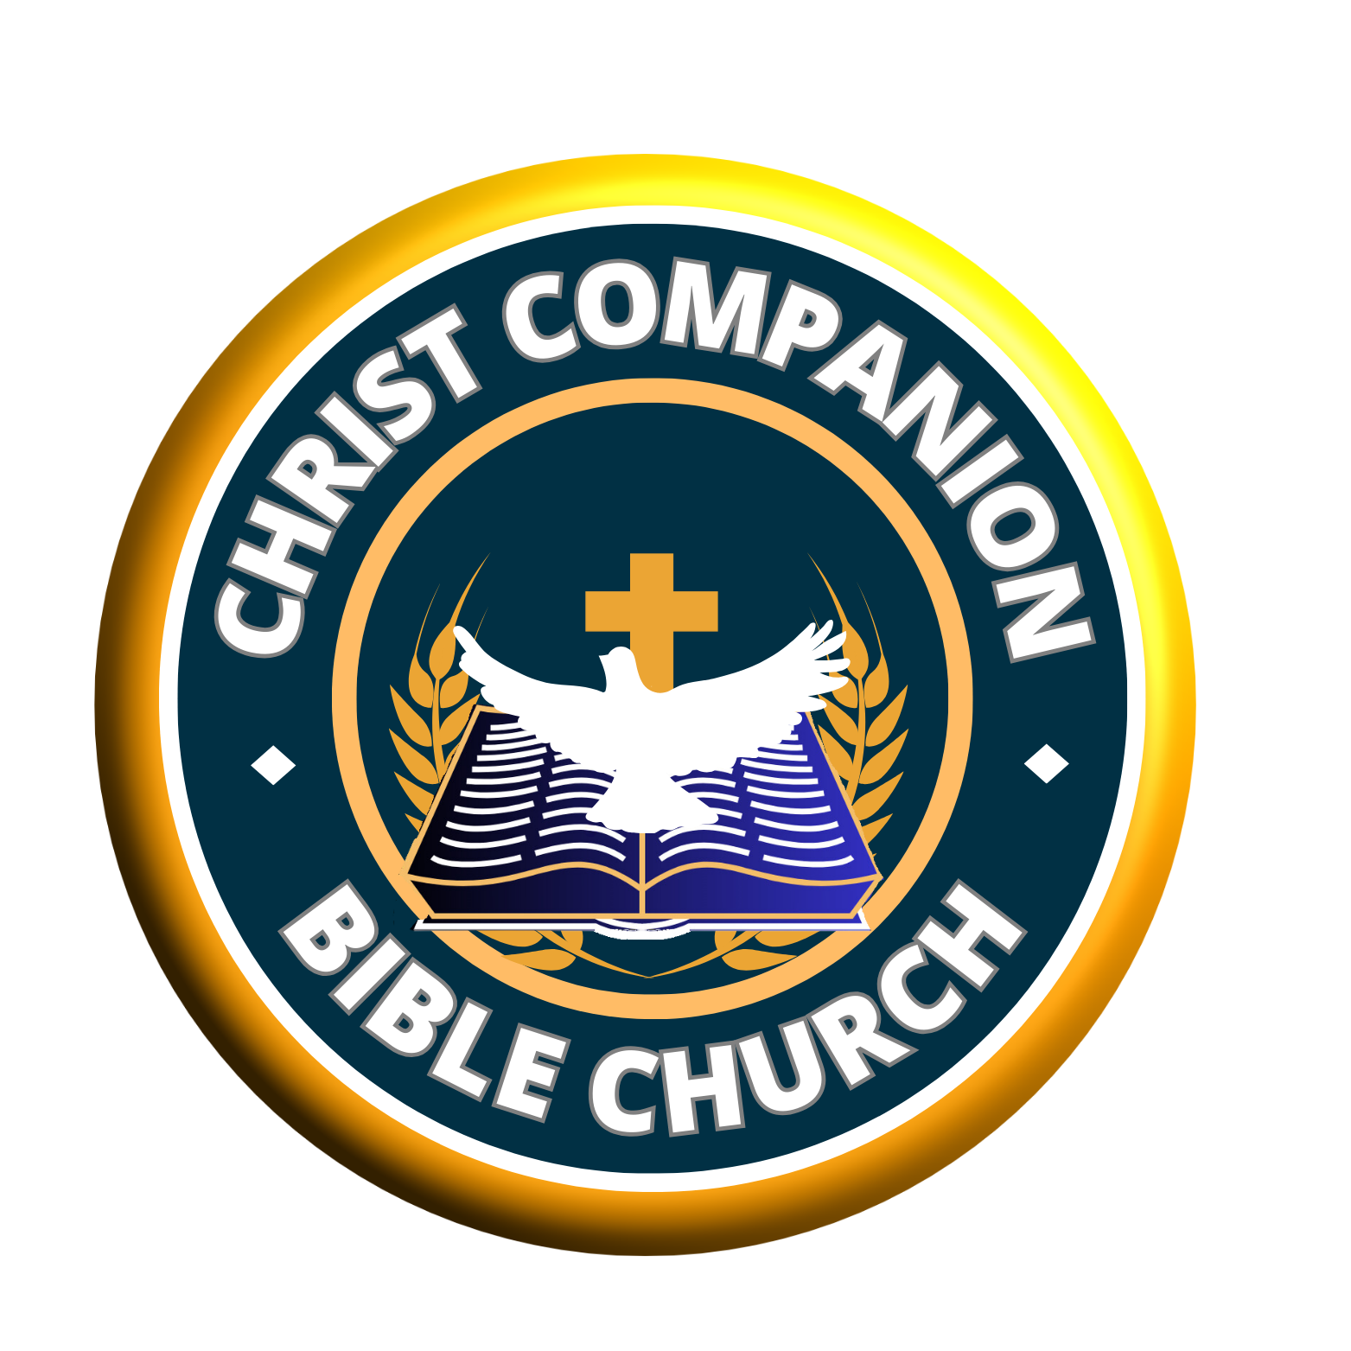

**Weekly Bible Study**

***Branch: headquarters Date: 21/05/2024***

**THE BIBLE: THE MINES OF GREAT TREASURES (Part 3) Study 16**

**TEXT:** Psalm 19: 7-14

**MEMORY VERSE:Psalm 19: 7-8**

God, having been so passionate to make His word available to man, It is incumbent on everyone to dig up the treasures that the Bible is loaded with.

Today, we will look at these treasures of life and how to tap them for personal and corporate profit.

**THE RICH TREASURES OF THE BIBLE. PSALM 19:7-14.**

It is not enough to have money, the most important thing is to be conversant with what money can do or made to achieve. Ordinary men labour to get money, only to spend it, whereas, the wise men obtain money and invest it to become rich, prominent and powerful! The word of God when digested, understood, and applied can make God's riches available so much that your life will experience great transformation and turn arround!

Let us dig a little into these riches of the word of God (the Bible):

**1. The word of God is light! Psalm 119:105; 2 Peter 1:19.** Imagine the world without light, it means the eye will be useless! It equally means there will be great limitations to possibilities and progress. That was the state of the world in the beginning Genesis 1:2, until God proffered light as the only possible solution. Genesis 1:3 (KJV) ***"And God said, Let there be light: and there was light"***. The light of God is your powerful resource for purposeful living and fulfillment in life.

**2. The word of God is fire! Psalm 148:8; Jeremiah 23:29.** This fire is pure and hot! This is why it purifies or consumes whatever it comes in contact with! Fire is loaded with power! The fire can come in different forms: wooden kitchen matches, electricity and dynamite, open flame etc. When it works for you, it can bring you comfort, convenience, productivity, riches and fulfillment. But when fire works against you, your experience can be so saddened! When your life aligns with the word of God, it is victory and joy all the way.

**3. The word of God is the bread of life! John 6:33, 48. Job 34:3.** Your body needs food daily to sustain you, just as Israelites ate the heavenly manna in the wilderness.Your spirit must feed on the word of God to be spiritually alive and sound. The Bible is the answer.

**4. The word of God is an embodiment of knowledge and wisdom! Colossians 3:16; Genesis 41:39.** Revelation of God's word to Daniel set him above all the wise men of Babylon and likewise Joseph in Egypt. The written word of God is wisdom to those who are given to its injunctions. It is your best resource and treasures of winning and reigning in life.

**5. The word of God is alive forever! It saves and delivers! John 6:63; 16:7-13.** It is the Holy Ghost resource for working conviction, repentance, conversion and salvation! The Holy Spirit works through the word of God to do the work of regeneration whenever it is released by faith. The word of God delivers from satanic bondages and oppression. Psalm 107:20; 119:154.

**6. The word of God is pure! Psalm 12:6; 119:40; Proverb 30:5.** Those who try to add or remove from the word of God are simply playing with fire! Revelation 22:18. It purifies and sanctifies those that meditate and obey it to fit in such for heaven.

**7. The word of God is a living seed! Luke 8:11; I Peter 1:23.** The word of God carries the seed of a glorious future and eternal life. Imagine the word that came to Abraham and the fruits of blessings to the nations of the world ever since! You can as well locate a great and fruitful future by taking heed to the word of God. Isaiah 55:10-11.

**8. The word of God brings about supernatural manifestations of signs, miracles and wonders! Matthew 16:20; Hebrew 4:12**. To experience the wonders of God's word, believe it, act on it and expect your miracles like Hannah. It will always work.

Faith in God's word will produce results. This is what makes God's word unique:

*i. Its promises are true and reliable;*

*ii. Its prophecies come to pass;*

*iii. Its testimonies are sure; and*

*iv. Its judgments are true and righteous altogether.*

Trusting God's word brings power, peace, hope, joy and rewarding end. John 15:2-7.

May you have the grace to receive, believe and abide in the Bible's invaluable treasures forever. Amen.

**HYMN: JESUS ONLY IS OUR MESSAGE (CHS 121)**

1. Jesus only is our message,  
   Jesus all our theme shall be;  
   We will lift up Jesus ever,  
   Jesus only will we see.

*Jesus only, Jesus ever,  
Jesus all in all we sing,  
Savior, Sanctifier, and Healer,  
Glorious Lord and coming King.*

1. Jesus only is our Savior,  
   All our guilt He bore away,  
   All our righteousness He gives us,  
   All our strength from day to day.
2. Jesus is our Sanctifier,  
   Cleansing us from self and sin,  
   And with all His Spirit’s fullness,  
   Filling all our hearts within.
3. Jesus only is our Healer,  
   All our sicknesses He bare,  
   And His risen life and fullness,  
   All His members still may share.
4. Jesus only is our Power,  
   He the Gift of Pentecost,  
   Jesus, breathe Thy pow’r upon us,  
   Fill us with the Holy Ghost.
5. And for Jesus we are waiting,  
   List’ning for the advent call;  
   But ’twill still be Jesus only,  
   Jesus ever, all in all.