**Lesson 7**

**READING**

**At the supermarket**

I have to go to the supermarket.

****I need to buy some food.

I need some meat and some vegetables.

I need one kilo of tomatoes and two kilos of oranges.

I also need a box of matches and 3 bottles of mineral water.

I always go to the same place.

They have good prices and it's near my home.

I usually pay by credit card.

**Comprehension Questions**

1. ¿Qué comidas necesita comprar?

2. ¿Cuántas botellas de agua mineral va a comprar?

3. ¿Es cerca de su casa el supermercado?

4. ¿Cómo paga generalmente?

**NEW WORDS AND EXPRESSIONS**

**Shopping - Ir de compras**

**I have to buy...** Tengo que comprar...

**I need...** Necesito...

**Do you have fresh tomatoes?** ¿Tiene tomates frescos?

**How much is this?** ¿Cuánto cuesta esto?

**How are you paying?** ¿Cómo va a pagar?

**By credit card. / By cheque.** Con tarjeta de crédito. / Con cheque.

**Cash.** En efectivo.

**It's twenty dollars and 45 cents.** Son veinte dólares con 45 centavos.

**Here's your change.** Aquí tiene su cambio.

**I'm hungry.** Tengo hambre.  
**I'm thirsty.** Tengo sed.  
**to eat  C**omer  
**to drink  B**eber

**breakfast  D**esayuno  
**lunch  A**lmuerzo  
**tea  M**erienda  
**dinner  C**ena

|  |  |
| --- | --- |
| **Money - Dinero** | |
| **one dollar** | un dólar |
| **one quarter** | 25 centavos |
| **one dime** | 10 centavos |
| **one cent** | un centavo |
| **five dollars and thirty cents** | cinco dólares con treinta centavos |
| **one pound** | una libra esterlina |
| **one penny** | un centavo de libra |
| **two pence** | dos centavos de libra |
| **five pounds and thirty pence** | cinco libras con treinta centavos |

|  |  |
| --- | --- |
| **Food - Alimentos** | |
| **Apple** | Onion |
| **Peach** | Tomato |
| **Orange** | Carrot |
| **Banana** | Lemon |
| **Cherries** | Milk |
| **Pear** | Cheese |
| **Strawberry** | Meat |
| **Grapes** | Butter |
| **Biscuits** | Wine |
| **Icecream** | Egg |
| **Potato** | Lamb |
| **Fish** | Juice |
| **Beer** | Water |
| **Turkey** | Chiken |
| **Ham** | Pork |
| **Lettuce** | Bread |



|  |  |
| --- | --- |
|  |  |

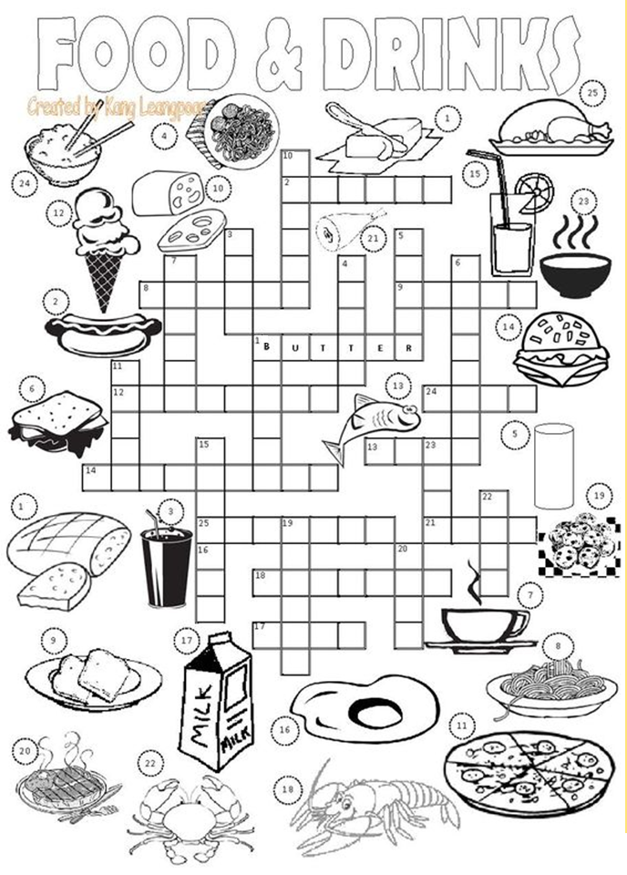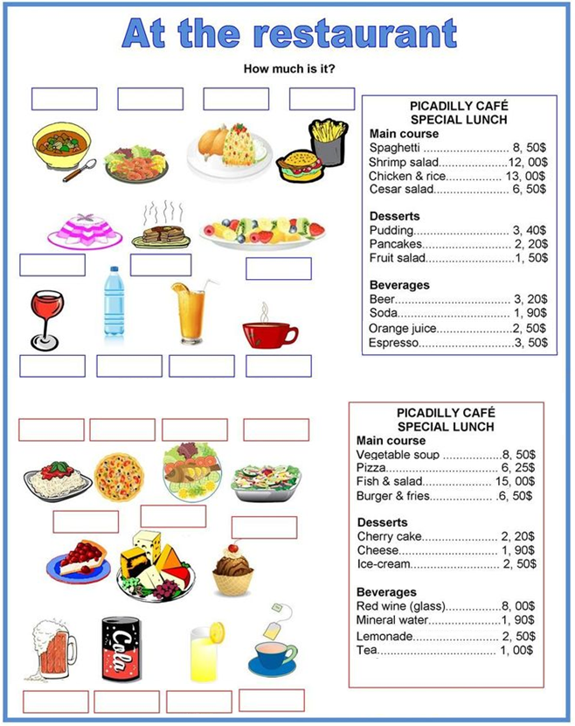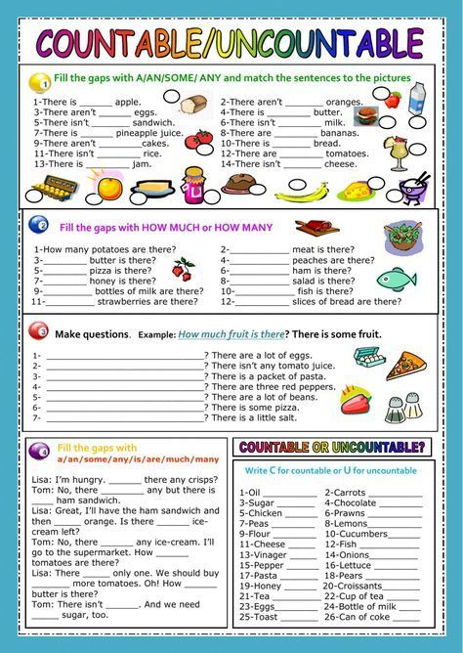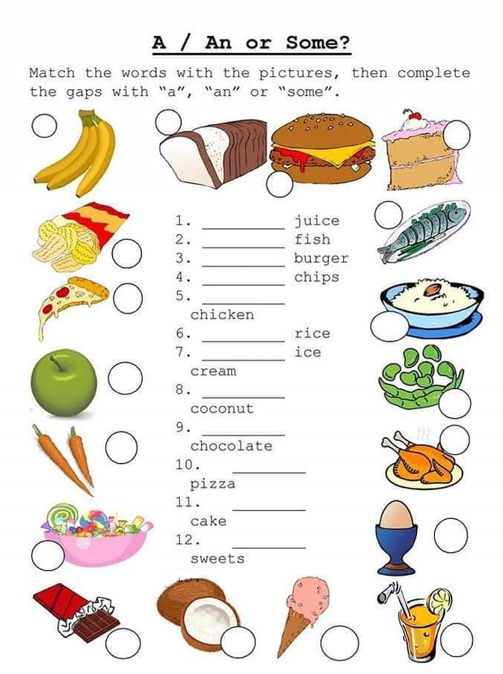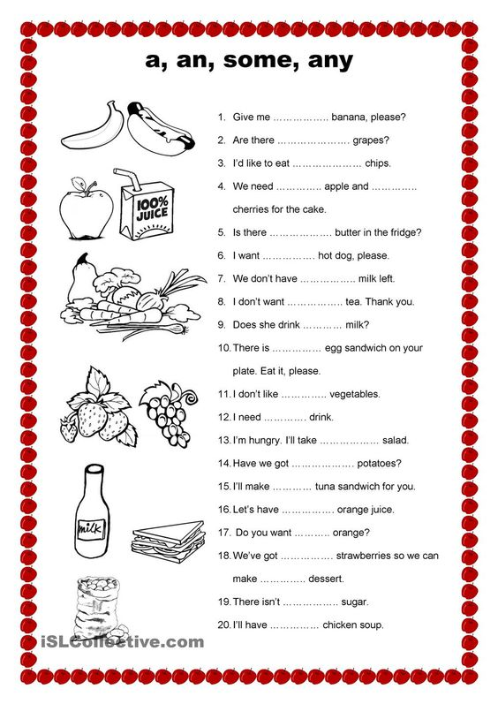

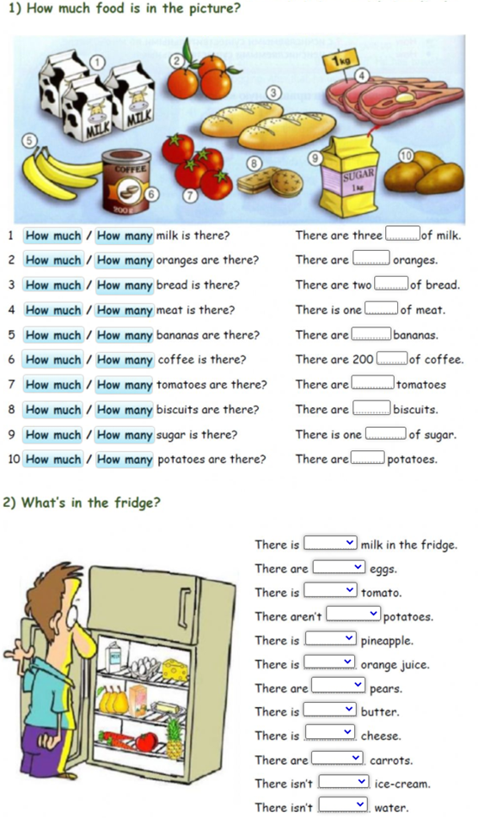

**USE A/AN/SOME/ANY****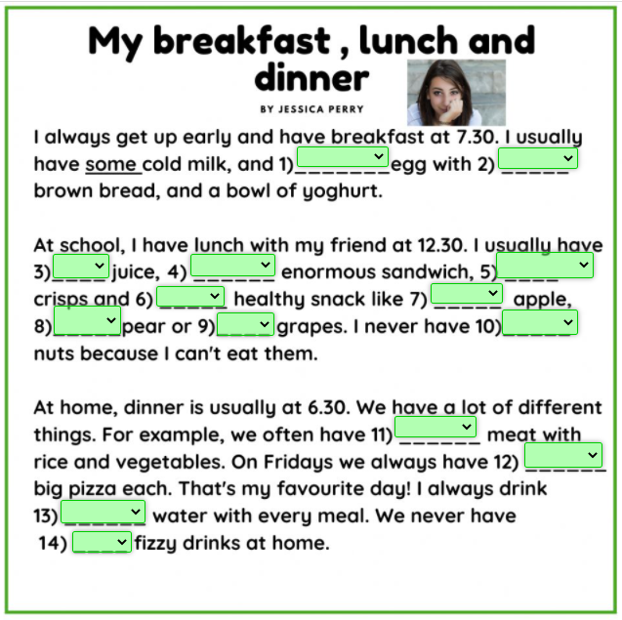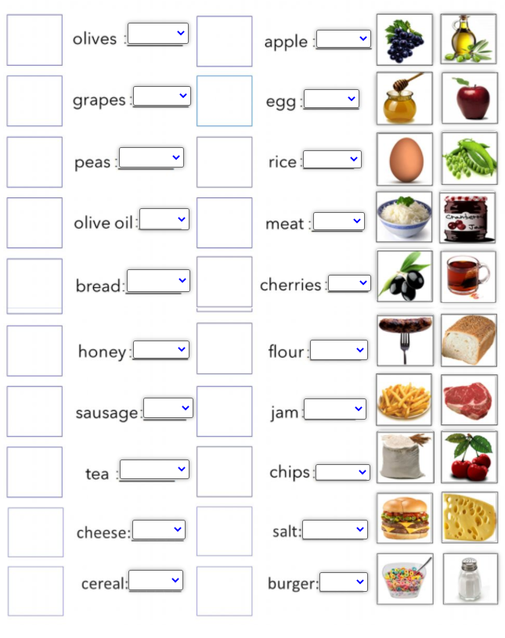**

**SOME / ANY**



