**LESSON 12**

**READING**

**A hotel room**

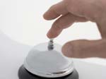

**Hotel clerk:** Good morning. May I help you?

**Rob:** Yes, I need a room for three nights.

**Hotel clerk:** Certainly. We have standard and deluxe rooms.

**Rob:** What's the difference?

**Hotel clerk:** Standard rooms are smaller than deluxe rooms.

The beds in the deluxe rooms are bigger.

**Rob:** I guess the deluxe rooms are more expensive than the

standard rooms.

**Hotel clerk:** Yes, of course.

**Rob:** The standard is fine for me. I don't have much money,

so give me the cheapest room you have.

**Comprehension Questions**

1. How long is Rob going to stay at the hotel?

2. What's the difference between standard and deluxe rooms?

3. How are the beds in the deluxe rooms?

4. What kind of room does Rob choose?

**NEW WORDS AND EXPRESSIONS**

**At a hotel - En un hotel**

**I need a room, please.** Necesito una habitación, por favor.

**I'd like to book a room, please.** Desearía reservar una habitación, por favor.

**When for?** ¿Para cuando?

**How many nights?** ¿Cuántas noches?

**When are you checking in?** ¿Cuándo se va a registrar?

**When are you checking out?** ¿Cuándo va a dejar el hotel?

**Check-in time is 3 p.m. P**uede ingresar a la habitación a las 3 pm.

**Check-out time is 10 a.m. D**ebe dejar la habitación antes de las 10 am.

**Hello. I have a booking** Hola. Tengo una reserva

**What kind of room do you prefer?** ¿Qué tipo de habitación prefiere?

**Is breakfast included in the rate?** ¿El desayuno está incluido en la tarifa?

**Where is the lift?** ¿Dónde está el elevador?

**Your room is on the first / second / third floor.**Su habitación está en el primer / segundo / tercer piso.

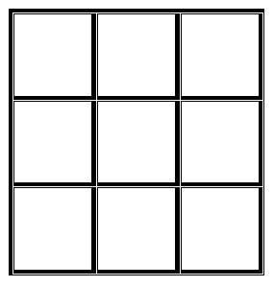**NEW WORDS AND EXPRESSIONS**

**At a hotel - En un hotel**

|  |  |  |
| --- | --- | --- |
| **front office** | **to check in** | **bed** |
| **bellboy** | **room service** | **lobby** |
| **housekeeping** | **laundry** | **shower** |
| **single room** | **key** | **gym** |
| **double room** | **safe** | **ice-dispenser** |
| **room service** | **breakfast area** | **swimming pool** |



|  |  |
| --- | --- |
|  | |
| HAPPY  SAD  ANGRY  SCARED  LONELY  BRAVE  ANNOYED  DISAPPOINTED  WORRIED  SHY | CALM  BORED  UNCOMFORTABLE  SILLY  GRUMPY  EMBARRASSED  JEALOUS  ANXIOUS  EXCITED  CONFIDENT |



