Christmas Lights

# 

# Introduction

This article is about a simple capacitor-charging Christmas Light circuit. The capacitors charge over time until the LEDs are ON and at full brightness.

Similar circuits can be applied to light bulbs. However, you will need higher-value capacitors. In the circuit presented in this article, the capacitor Farad values are high, thus increasing the cost of the circuit.

# Step 1: Design the Circuit

This is my PSpice simulation software drawing:

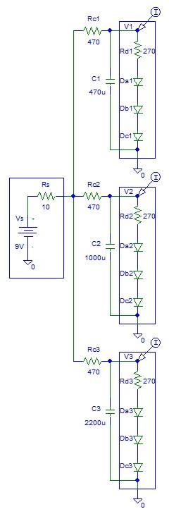

**Figure 1:** Circuit Design.

# Step 2: Simulations

Simulations of LED current versus time:

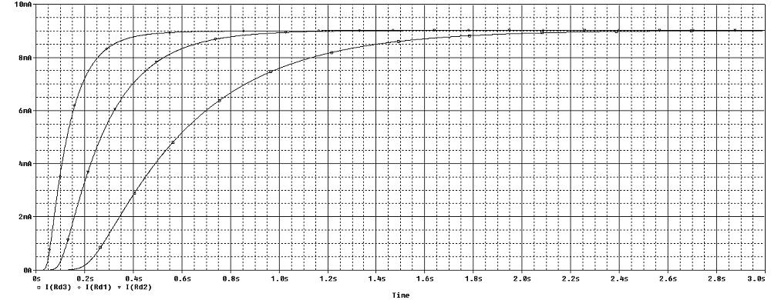

**Figure 2:** Simulations.

You can see that the LEDs are fully charged after about 3 seconds.

The maximum current is about 9 mA.

# 

# Conclusion

There is also an option of connecting the circuit to a square or sine wave oscillator that you can purchase on the internet.