Crazy Motor Driver

# Introduction

This a simple resistor motor driver circuit:

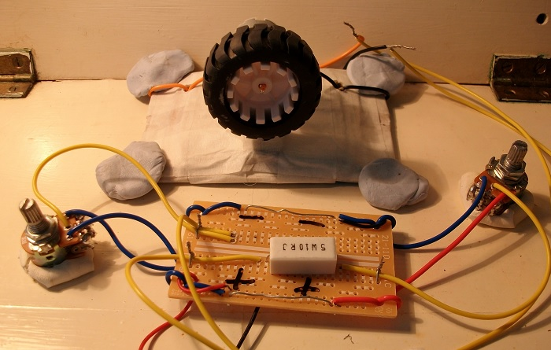

**Figure 1:** Device.

You can see the low-current motor with the wheel attached in the photo.

This circuit is not the most optimum motor driver design. Do NOT connect this circuit to the USB or mains powered power supply.

# 2. Step 1: Design the Circuit

I drew the circuit via PSpice simulation software, student edition version 9.1:

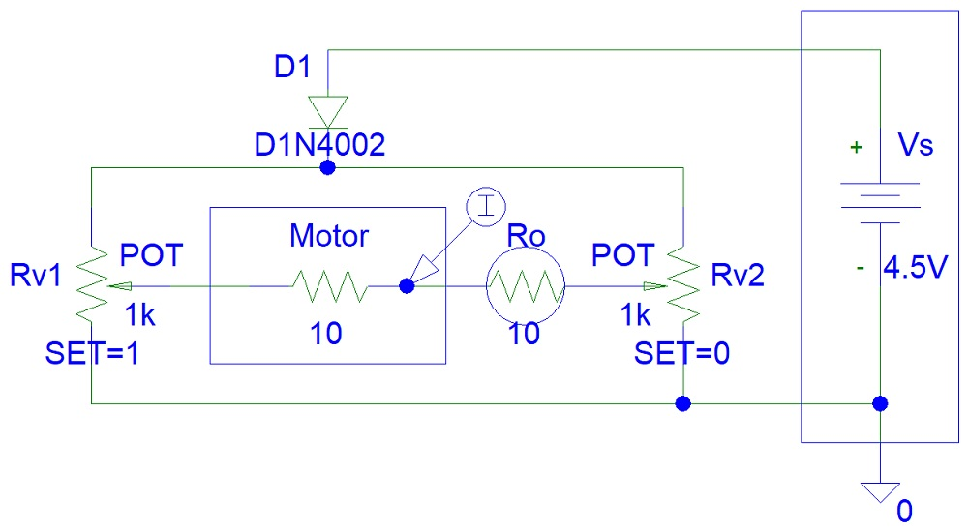

**Figure 2:** PSpice Drawing.

The diode is used to protect the power supply from the discharging currents of the motor. This can occur when the motor is spinning very fast due to external mechanical force applied to the wheel.

# 3. Step 2: Simulations

PSpice simulations show a high current output.

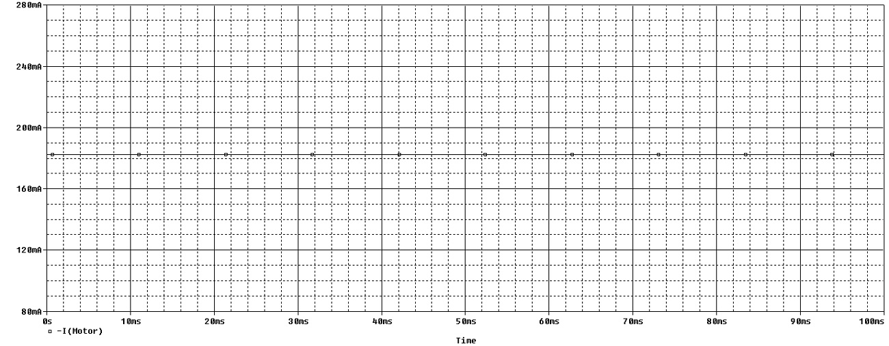

**Figure 3:** PSpice Simulations.

# 4. Step 3: Make the Circuit

I did not include the diode in my circuit.

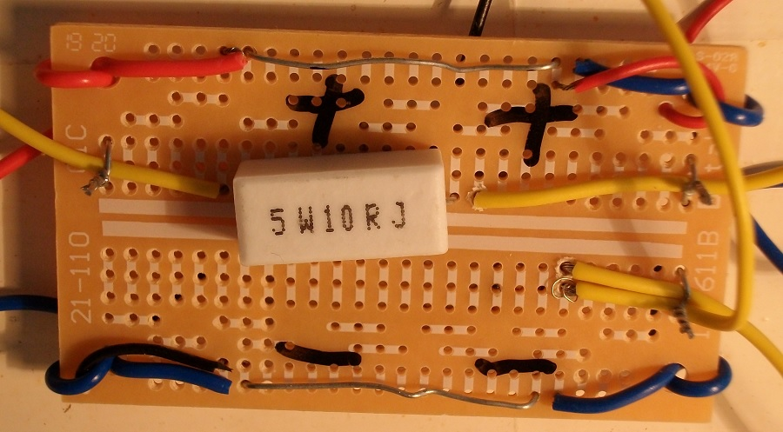

**Figure 4:** Circuit Construction.

I could have used 2 Watt or even 1 Watt resistor instead of the expensive 5 Watt resistor that I used.

You can see from other photos of this article that I used dual gang potentiometers to reduce the small chance of burning my potentiometer.

# 

# 5. Step 4: Testing

You can see the motor spinning fast when connected to 4.5 V, three AA rechargeable battery power supply, in the photo below.

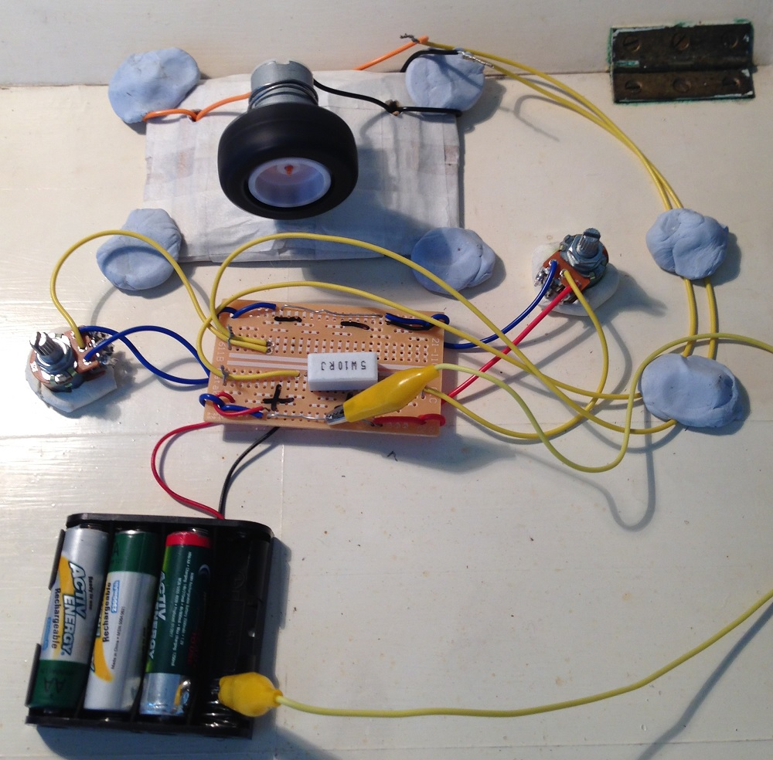

**Figure 5:** Testing.

You can watch this YouTube video:

<https://www.youtube.com/shorts/PDCgrMecxUQ>

# 6. Conclusion

This circuit worked well and I did not burn my potentiometers. I did not implement the diode protection feature because my motor is a low-current motor.

Adam, Weird Circuits Project