**COMPUTER**

**KNOWLEDGE**

**WORKBOOK**

**Internal Computer Hardware**

**Introduction**

Computer Hardware is the physical part of a computer, as distinguished from the [computer software](http://en.wikipedia.org/wiki/Computer_software) that executes or runs on the hardware. The hardware of a computer is infrequently changed, while software and data are modified frequently. The term soft refers to readily created, modified, or erased. These are unlike the physical components within the computer which are hard.

When you think of the term computer hardware you probably think of the guts inside your personal computer at home or the one in your classroom. However, computer hardware does not specifically refer to personal computers. Instead, it is all types of computer systems. Computer hardware is in embedded systems in automobiles, microwave ovens, CD players, DVD players, and many more devices. In 2003, only 0.2% of all microprocessors sold were for personal computers. How many other things in your house or your classroom use computer hardware?

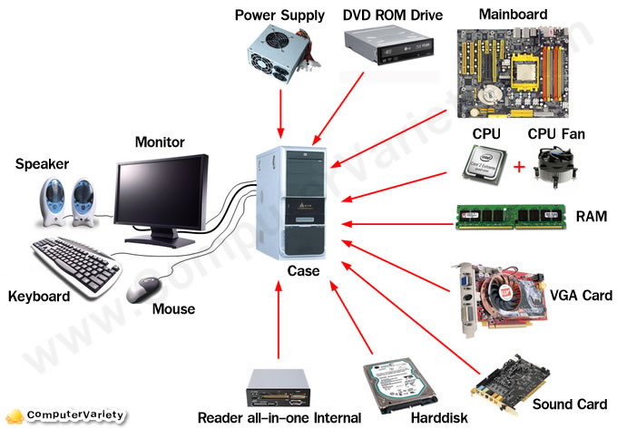

Inside Computer

**Motherboard**

The motherboard is the body or mainframe of the computer, through which all other components [interface](http://en.wiktionary.org/wiki/interface). It is the central circuit board making up a complex electronic system. A motherboard provides the electrical connections by which the other components of the system communicate. The mother board includes many components such as: central processing unit (CPU), random access memory (RAM), firmware, and internal and external buses.

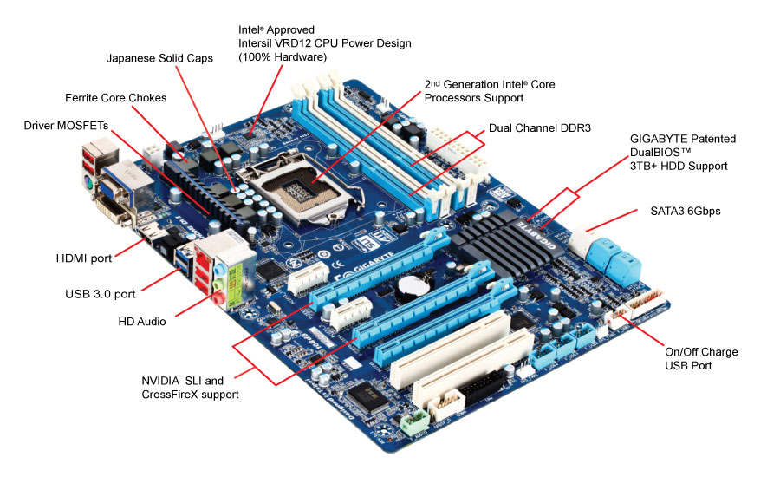

Motherboard

**Central Processing Unit**

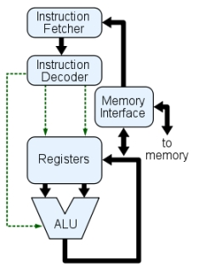The Central Processing Unit (**CPU**; sometimes just called processor) is a machine that can execute [computer programs](http://en.wikipedia.org/wiki/Computer_program). It is sometimes referred to as the brain of the computer. There are four steps that nearly all CPUs use in their operation: *fetch*, *decode*, *execute*, and *writeback*. The first step, fetch, involves retrieving an instruction from program memory. In the decode step, the instruction is broken up into parts that have significance to other portions of the CPU. During the execute step various portions of the CPU, such as the [arithmetic logic unit](http://en.wikipedia.org/wiki/Arithmetic_logic_unit) (ALU) and the [floating point unit](http://en.wikipedia.org/wiki/Floating_point_unit) (FPU) are connected so they can perform the desired operation. The final step, writeback, simply writes back the results of the execute step to some form of memory.

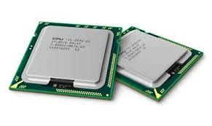

CPU Diagram

**Random Access Memory**

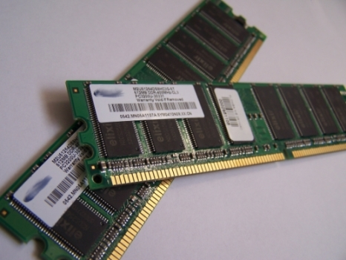Random access memory (RAM) is fast-access memory that is cleared when the computer is power-down. RAM attaches directly to the motherboard, and is used to store programs that are currently running. RAM is a set of integrated circuits that allow the stored data to be accessed in any order (why it is called random). There are many different types of RAM. Distinctions between these different types include: writable vs. read-only, static vs. dynamic, volatile vs. non-volatile, etc.

RAM

**Firmware**

Firmware is loaded from the Read only memory (ROM) run from the Basic Input-Output System (BIOS). It is a computer program that is embedded in a hardware device, for example a microcontroller. As it name suggests, firmware is somewhere between hardware and software. Like software, it is a computer program which is executed by a microprocessor or a microcontroller. But it is also tightly linked to a piece of hardware, and has little meaning outside of it. Most devices attached to modern systems are special-purpose computers in their own right, running their own software. Some of these devices store that software (“firmware”) in a ROM within the device itself

**Power Supply**

The power supply as its name might suggest is the device that supplies power to all the components in the computer. Its case holds a transformer, voltage control, and (usually) a cooling fan. The power supply converts about 100-120 volts of AC power to low-voltage DC power for the internal components to use. The most common computer power supplies are built to conform with the ATX form factor. This enables different power supplies to be interchangable with different components inside the computer. ATX power supplies also are designed to turn on and off using a signal from the motherboard, and provide support for modern functions such as standby mode.

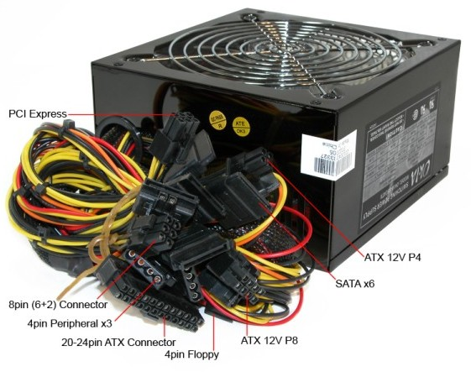

**Removable Media Devices**

If your putting something in your computer and taking it out is most likely a form of removable media. There are many different removable media devices. The most popular are probably CD and DVD drives which almost every computer these days has at least one of. There are some new disc drives such as Blu-ray which can hold a much larger amount of information then normal CDs or DVDs. One type of removable media which is becoming less popular is floppy disk.

**CD**

CDs are the most common type of removable media. They are inexpensive but also have short life-span. There are a few different kinds of CDs. CD-ROM which stands for Compact Disc read-only memory are popularly used to distribute computer software although any type of data can be stored on them. CD-R is another variation which can only be written to once but can be read many times. CD-RW (rewritable) can be written to more than once as well as read more than once. Some other types of CDs which are not as popular include Super Audio CD (SACD), Video Compact Discs (VCD), Super Video Compact Discs (SVCD), PhotoCD, PictureCD, CD-i, and Enhanced CD.

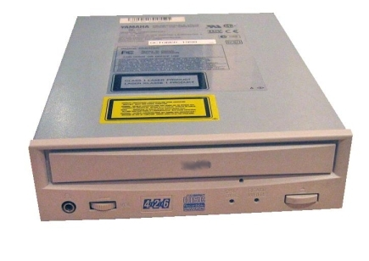

CD-ROM Drive

There are two types of devices in a computer that use CDs: CD-ROM drive and a CD writer. The CD-ROM drive used for reading a CD. The CD writer drive can read and write a CD. CD writers are much more popular are new computers than a CD-ROM drive. Both kinds of CD drives are called optical disc drives because the use a laser light or electromagnetic waves to read or write data to or from a CD.

**DVD**

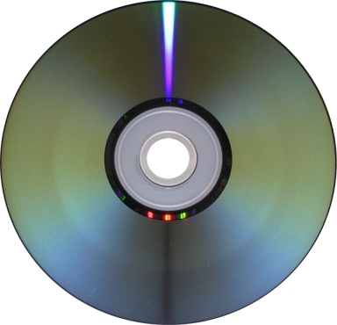DVDs (digital versatile discs) are another popular optical disc storage media format. The main uses for DVDs are video and data storage. Most DVDs are of the same dimensions as compact discs. Just like CDs there are many different variations. DVD-ROM has data which can only be read and not written. DVD-R and DVD+R can be written once and then function as a DVD-ROM. DVD-RAM, DVD-RW, or DVD+RW hold data that can be erased and re-written multiple times. DVD-Video and DVD-Audio discs respectively refer to properly formatted and structured video and audio content. The devices that use DVDs are very similar to the devices that use CDs. There is a DVD-ROM drive as well as a DVD writer that work the same way as a CD-ROM drive and CD writer. There is also a DVD-RAM drive that reads and writes to the DVD-RAM variation of DVD.

DVD

**Blu-ray**

Blu-ray is a newer optical disc storage media format. Its main uses are high-definition video and data storage. The disc has the same dimensions as a CD or DVD. The term “Blu-ray” comes from the blue laser used to read and write to the disc. The Blu-ray discs can store much more data then CDs or DVDs. A dual layer Blu-ray disc can store up to 50GB, almost six times thecapacity of a dual layer DVD (WOW!). Blu-ray discs have similar devices used to read them and write to them as CDs have. A BD-ROM drive can only read a Blu-ray disc and a BD writer can read and write a Blu-ray disc.

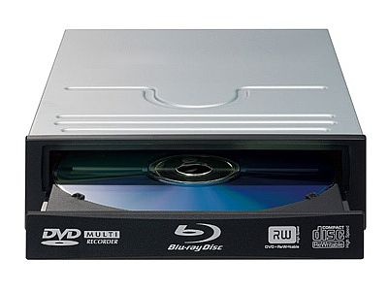

**Internal Storage**

Internal storage is hardware that keeps data inside the computer for later use and remains persistent even when the computer has no power. There are a few different types of internal storage. Hard disks are the most popular type of internal storage. Solid-state drives have grown in popularity slowly. A disk array controller is popular when you need more storage then a single har disk can hold.

**Hard Disk Drive**

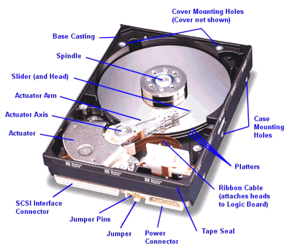A hard disk drive (HDD) is a non-volatile storage device which stores digitally encoded data on rapidly rotating platters with magnetic surfaces. Just about every new computer comes with a hard disk these days unless it comes with a new solid-state drive. Typical desktop hard disk drives store between 120 and 400GB, rotate at 7,200 rpm, and have a madia transfer rate of 1 Gbit/s or higher. Hard disk drives are accessed over one of a number of bus types, including parallel ATA(also called IDE), Serial ATA (SATA), SCSI, Serial Attached SCSI, and Fibre Channel.

Hard Drive

**Solid-State Drive**

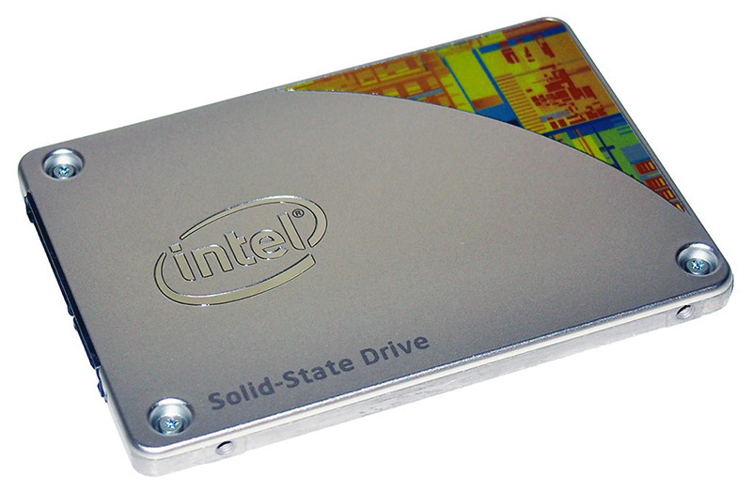A solid-state drive (SSD) is a data storage device that uses solid-state memory to store persistent data. An SSD emulates a hard disk drive, thus easily replacing it in any application. SSDs have begun to appear in laptops because they can be smaller than HDDs. SSDs are currently more expensive per unit of capacity than HDDs which is why they have not caught on so quickly.

**Disk Array Controller**

A disk array controller is a device which manage the physical disk drives and presents them to the computer as logical units. It almost always implements hardware RAID. RAID (Redundant Array of Independent Drives) is a technology that employs the simultaneous use of two or more hard disk drives to achieve greater levels of performance, reliability, and/or larger data volume sizes. A disk array controller also provides additional disk cache.

**Computer Hardware Peripherals**

**Introduction**

A peripheral is a piece of computer hardware that is added to a computer in order to expand its abilities. The term peripheral is used to describe those devices that are optional in nature, as opposed to hardware that is either demanded or always required in principle. There are all different kinds of peripherals you can add your computer. The main distinction among peripherals is the way they are connected to your computer. They can be connected internally or externally.

**Buses**

A bus is a subsystem that transfers data between computer components inside a computer or between computers. Unlike a point-to-point connection, a bus can logically connect several peripherals over the same set of wires. Each bus defines its set of connectors to physically plug devices, cards or cables together. There are two types of buses: internal and external. Internal buses are connections to various internal components. External buses are connections to various external components. There are different kinds of slots that internal and external devices can connect to.

**Internal**

**Types of Slots**

There are many different kinds of internal buses, but only a handful of popular ones. Different computers come with different kinds and number of slots. It is important to know what kind and number of slots you have on your computer before you go out and by a card that matches up to a slot you don’t have.

**PCI**

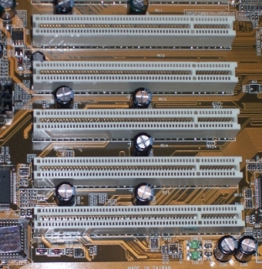PCI (Peripheral Component Interconnect) is common in modern PCs. This kind of bus is being succeeded by PCI Express. Typical PCI cards used in PCs include: network cards, sound cards, modems, extra ports such as USB or serial, TV tuner cards and disk controllers. Video cards have outgrown the capabilities of PCI because of their higher bandwidth requirements.

PCI Slots

**PCI Express**

PCI Express was introduced by Intel in 2004. It was designed to replace the general-purpose PCI expansion bus and the AGP graphics card interface. PCI express is not a bus but instead a point-to-point conection of serial links called lanes. PCI Express cards have faster bandwidth then PCI cards which make them more ideal for high-end video cards.

**PCMCIA**

PCMCIA (also referred to as PC Card) is the type of bus used for laptop computers. The name PCMCIA comes from the group who developed the standard: Personal Computer Memory Card International Association. PCMCIA was originally designed for computer memory expansion, but the existence of a usable general standard for notbeook peripherals led to many kinds of devices being made available in this form. Typical devices include network cards, modems, and hard disks.

**AGP**

AGP (Accelerated Graphics Port) is a high-speed point-to-point channel for attaching a graphics card to a computer’s motherboard, primarily to assist in the acceleration of 3D computer graphics. AGP has been replaced over the past couple years by PCI Express. AGP cards and motherboards are still available to buy, but they are becoming less common.

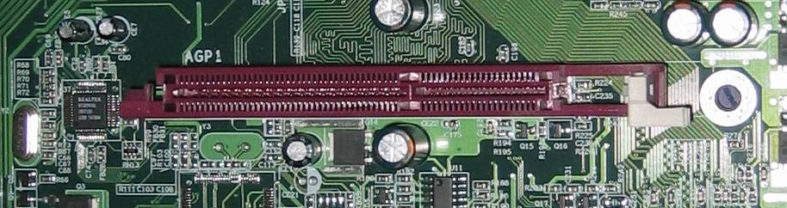

AGP Slot

**Types Of Cards**

**Video Card**

A video card (also known as graphics card) is an expansion card whose function is to generate and output images to a display. Some video cards offer added functions, such as video capture, TV tuner adapter, ability to connect multiple monitors, and others. Most video cards all share similar components. They include a graphics processing unit (GPU) which is a dedicated microprocessor optimized for 3D graphics rendering. It also includes a video BIOS that contains the basic program that governs the video card’s operations and provides the instructions that allow the computer and software to interface with the card. If the video card is integrated in the motherboard, it may use the computer RAM memory. If it is not it will have its own video memory called Video RAM. This kind of memory can range from 128MB to 16GB or more. A video card also has a RAMDAC (Random Access Memory Digital-to-Analog Converter) which takes responsibility for turning the digital signals produced by the computer processor into an analog signal which can be understood by the computer display. Lastly, they all have outputs such as an HD-15 connector (standard monitor cable), DVI connector, S-Video, composite video or component video.

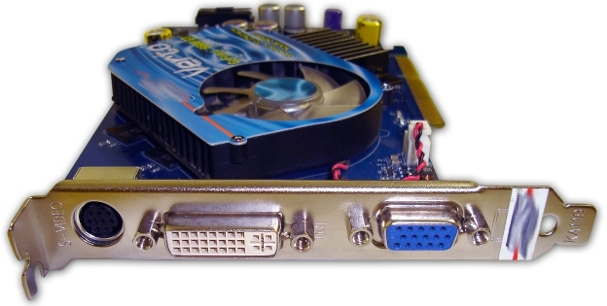

Graphics Card

**Sound Card**

A sound card is an expansion card that facilitates the input and output of audio signals to/from a computer under control of computer programs. Typical uses for sound cards include providing the audio component for multimedia applications such as music composition, editing video or audio, presentation/education, and entertainment. Many computers have sound capabilities built in,, while others require additional expansion cards to provide for audio capability.

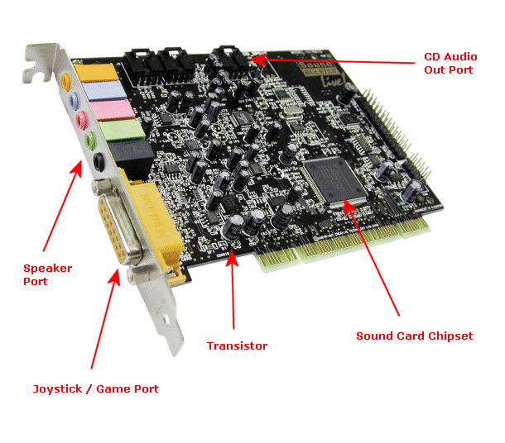

**Network Card**

A network card is an expansion card that allows computers to communicate over a computer network. It allows users to connect to each other either by using cables or wirelessly. Although other network technologies exist, Ethernet has achieved near-ubiquity for a while now. Every Ethernet network card has a unique 48-bit serial number called a MAC address, which is stored in ROM carried on the card. You can learn more about networking in the introduction to networking lesson.

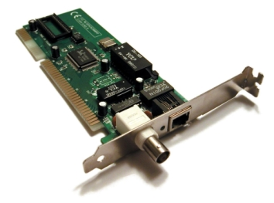

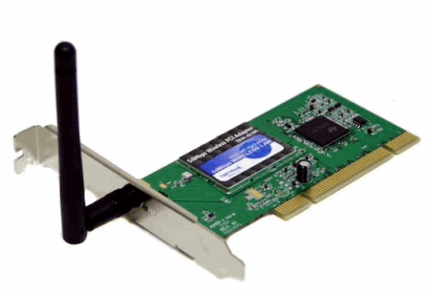LAN Network Card

WirelessNetwork Card

**External**

**Types of Connections**

**USB**

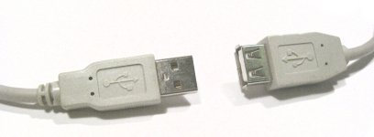USB (Universal Serial Bus) is a serial bus standard to interface devices. USB was designed to allow many peripherals to be connected using a single standardized interface socket and to improve the plug-and-play capabilities by allowing devices to be connected and disconnected without rebooting the computer. Other convient features include providing power to low-consumption devices without the need for an external power supply and allowing many devices to be used without requiring manufacturer specific, individual device drivers to be installed. USB is by far the dominating bus for connecting external devices to your computer.

USB Connectors

**Firewire**

Firewire (technically known as IEEE 1394 and also known as i.LINK for Sony) is a serial bus interface standard for high-speed communications and isochronous real-time data transfer, frequently used in a personal computer. Firewire has replaced Parallel ports in many applications. It has been adopted as the High Definition Audio-Video Network Alliance (HANA) standard connection interface for A/V (audio/visual) component communication and control. Almost all modern digital camcorders have included this connection.

Firewire Cable

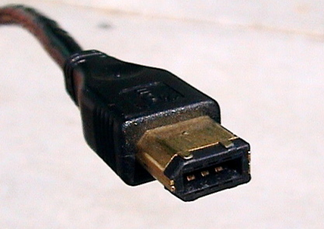

**PS/2**

The PS/2 connector is used for connecting some keyboards and mice to a PC compatible computer system. The keyboard and mouse interfaces are electrically similar with the main difference being that open collector outputs are required on both ends of the keyboard interface to allow bidirectional communication. If a PS/2 mouse is connected to a PS/2 keyboard port, the mouse may not be recognized by the computer depending on configuration.

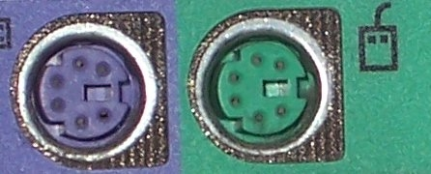

PS/2 Ports

**Devices**

**Removable Storage**

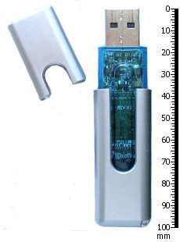The same kinds of CD and DVD drives that could come built-in on your computer can also be attached externally. You might only have a CD-ROM drive built-in to your computer but you need a CD writer to burn CDs. You can buy an external CD writer that connects to your USB port and acts the same way as if it was built-in to your computer. The same is true for DVD writers, Blu-ray drives, and floppy drives. Flash drives have become very popular forms of removable storage especially as the price of flash drives decreases and the possible size for them increases. Flash drives are usually USB ones either in the form USB sticks or very small, portable devices. USB flash drives are small, fast, removable, rewritable, and long-lasting. Storage capacities range from 64MB to 32GB or more. A flash drive does not have any mechanically driven parts so as opposed to a hard drive which makes it more durable and smaller usually.

USB Flash Drive

**Non-removable Storage**

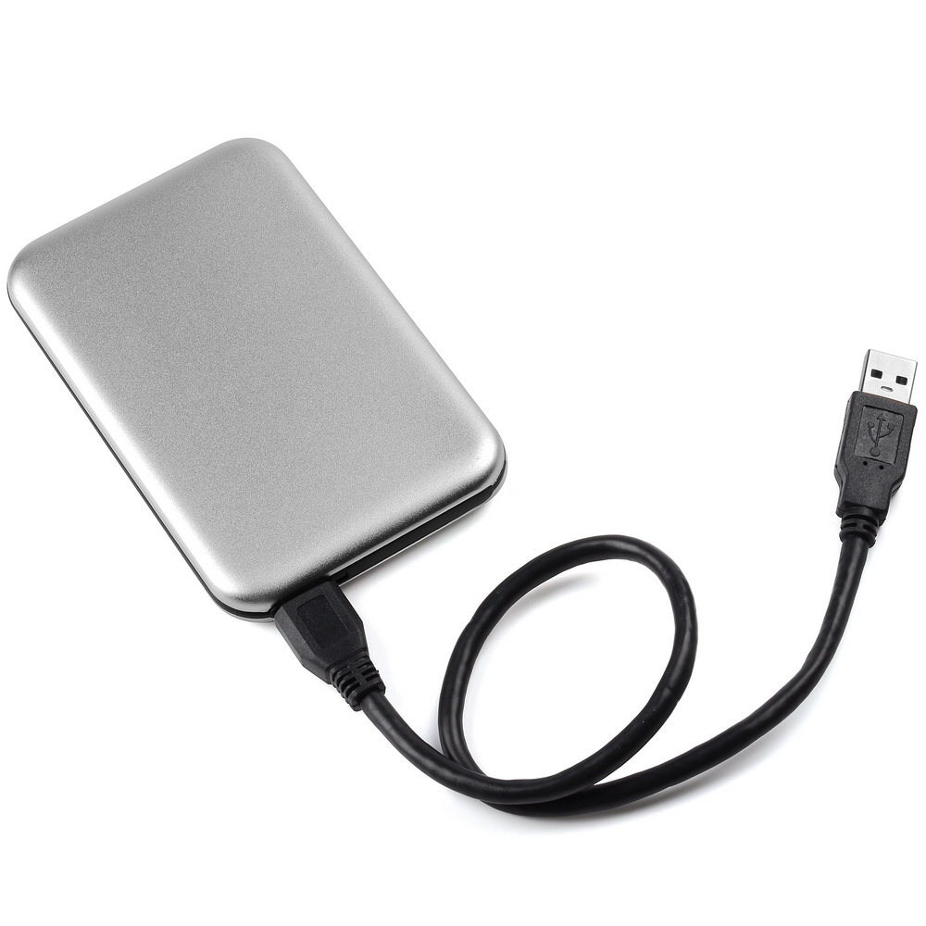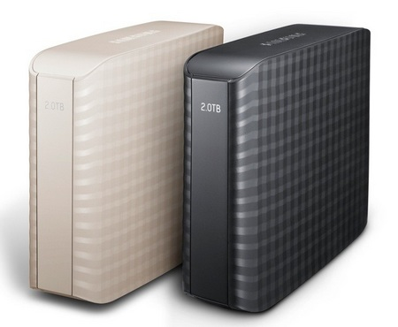Non-removable storage can be a hard drive that is connected externally. External hard drives have become very popular for backups, shared drives among many computers, and simply expanding the amount of hard drive space you have from your internal hard drive. External hard drives come in many shapes and sizes like flash drives do. An external hard drive is usually connected by USB but you can also have a networked hardrive which will connect to your network which allows all computers on that network to access that hard drive.

**Input**

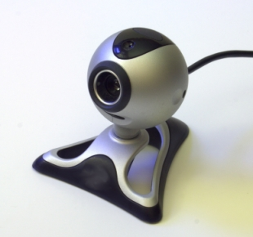Input devices are absolutely crucial to computers. The most common input devices are mice and keyboards which barely every computer has. A new popular pointing device that may eventually replace the mouse is touch screen which you can get on some tablet notebooks. Other popular input devices include microphones, webcams, and fingerprint readers which can also be built in to modern laptops and desktops. A scanner is another popular input device that might be built-in to your printer.

Webcam

**Output**

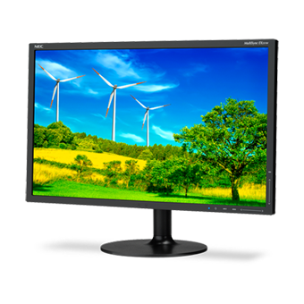There are lots of different kinds of output devices that you can get for your computer. The absolute most common external output device is a monitor. Other very popular output devices are printers and speakers. There are lots of different kinds of printers and different sizes of speakers for your computer. Monitors are connected usually through the HD-15 connector on your video card. Printers are usually connected through a USB port. Speakers have their own audio out port built-in to the sound card.

Monitor

**Software**

Software is the collection of programs written to enable the computer to carry out all of it’s tasks. These are divided into the following;

* Operating Systems

This is a collection of programs that enable all the functionality of the computer like user interface, file management, running applications and operating peripheral devices.

Examples are;

Windows ME, Windows 7, Windows 8, Windows 10, UNIX, Linux a version of UNIX

* Programming Languages

These are languages that allow the creation of programs to perform specific tasks. Examples are;

Cobol, Fortran, Basic, Visual Basic, C and C++, and Java.

* Application Programs

These are the programs written to perform a specific task and are varied and very numerous. Common applications include;

Word processors AmiPro, Word

Spreadsheets Lotus 123, Excel

Databases Access

Graphics Paint, Adobe PhotoShop

Communications Modem drivers

**How to sit at a computer**

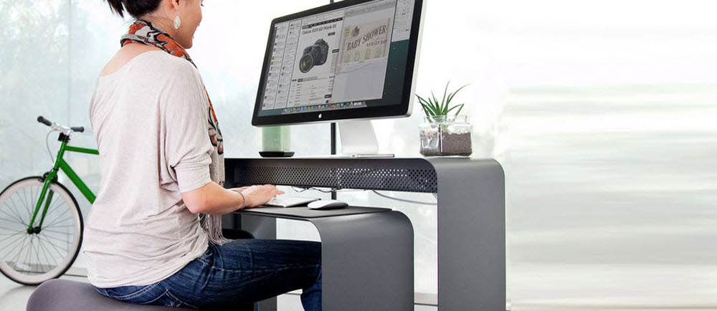

We see too many workplace injuries that could be avoided. And prevention is better than cure. Here is a four-step checklist that you can carry out at your workstation, to make sure you’re comfortable, safe and productive at the office.

**STEP 1: Your Chair**

* Push your hips as far back as they can go in the chair.
* Adjust the seat height so your feet are flat on the floor and your knees equal to, or slightly lower than, your hips.
* Adjust the back of the chair to a 100°-110° reclined angle. Make sure your upper and lower back are supported. Use inflatable cushions or small pillows if necessary. If you have an active back mechanism on your chair, use it to make frequent position changes.
* Adjust the armrests (if fitted) so that your shoulders are relaxed. If your armrests are in the way, remove them.

**STEP 2: Your Keyboard**

An articulating keyboard tray can provide optimal positioning of input devices. However, it should accommodate the mouse, enable leg clearance, and have an adjustable height and tilt mechanism. The tray should not push you too far away from other work materials, such as your telephone.

* Pull up close to your keyboard.
* Position the keyboard directly in front of your body.
* Determine what section of the keyboard you use most frequently, and readjust the keyboard so that section is centred with your body.
* Adjust the keyboard height so that your shoulders are relaxed, your elbows are in a slightly open position (100° to 110°), and your wrists and hands are straight.
* The tilt of your keyboard is dependent upon your sitting position. Use the keyboard tray mechanism, or keyboard feet, to adjust the tilt. If you sit in a forward or upright position, try tilting your keyboard away from you at a negative angle. If you are reclined, a slight positive tilt will help maintain a straight wrist position.
* Wristrests can help to maintain neutral postures and pad hard surfaces. However, the wristrest should only be used to rest the palms of the hands between keystrokes. Resting on the wristrest while typing is not recommended. Avoid using excessively wide wristrests, or wristrests that are higher than the space bar of your keyboard.
* Place the pointer as close as possible to the keyboard. Placing it on a slightly inclined surface, or using it on a mousebridge placed over the 10-keypad, can help to bring it closer.

If you do not have a fully adjustable keyboard tray, you may need to adjust your workstation height, the height of your chair, or use a seat cushion to get into a comfortable position. Remember to use a footrest if your feet dangle.

**STEP 3: Screen, Document, and Telephone**

Incorrect positioning of the screen and source documents can result in awkward postures. Adjust the screen and source documents so that your neck is in a neutral, relaxed position.

* Centre the screen directly in front of you, above your keyboard.
* Position the top of the screen approximately 2-3” above seated eye level. (If you wear bifocals, lower the screen to a comfortable reading level.)
* Sit at least an arm’s length away from the screenand then adjust the distance for your vision.
* Reduce glare by careful positioning of the screen.Position source documents directly in front of you, between the screen and the keyboard, using an in-line copy stand. If there is insufficient space, place source documents on a document holder positioned adjacent to the screen.
  + Place screen at right angles to windows
  + Adjust curtains or blinds as needed
  + Adjust the vertical screen angle and screen controls to minimize glare from overhead lights
  + Other techniques to reduce glare include use of optical glass glare filters, light filters, or secondary task lights
* Place your telephone within easy reach. Telephone stands or arms can help.
* Use headsets and speaker phone to eliminate cradling the handset.

**STEP 4: Pauses and Breaks**

Once you have correctly set up your computer workstation use good work habits. No matter how perfect the environment, prolonged, static postures will inhibit blood circulation and take a toll on your body.

* Take short 1-2 minute stretch breaks every 20-30 minutes. After each hour of work, take a break or change tasks for at least 5-10 minutes. Always try to get away from your computer during lunch breaks.
* Avoid eye fatigue by resting and refocusing your eyes periodically. Look away from the monitor and focus on something in the distance.
* Rest your eyes by covering them with your palms for 10-15 seconds.
* Use correct posture when working. Keep moving as much as possible.*Information supplied by UCLA Ergonomics

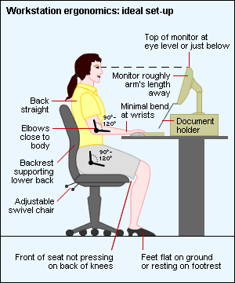

**References**

* [**https://www.google.com.au/search/images**](https://www.google.com.au/search/images)
* [**http://openbookproject.net/courses/intro2ict/hardware/internal.html**](http://openbookproject.net/courses/intro2ict/hardware/internal.html)
* **\*Information supplied by UCLA Ergonomics**