**RESISTOR COLOUR CODE**

**PROBLEMS**

1. Determine the resistance and tolerance for the following resistor colour code bands

(a) blue, green, yellow, silver

(b) brown, green, grey, black, brown

(c) white, red, brown, gold

(d) red, yellow, orange, gold

(e) orange, yellow, green, red, red

(f) violet, red, orange, gold

(g) grey, white, blue green, brown

2. What are the colour bands associated with the following resistors

(a) 2k9, +/- 5%

(b) 4R7, +/- 10%

(c) 395R, +/- 2%

(d) 1M2, +/- 5%

(e) 470k, +/- 1%

(f) 568k, +/- 1%

(g) 6R8, +/- 10%

(h) 0R82, +/- 5%

(I) 3R3, +/- 2%

(j) 12k2, +/- 1%

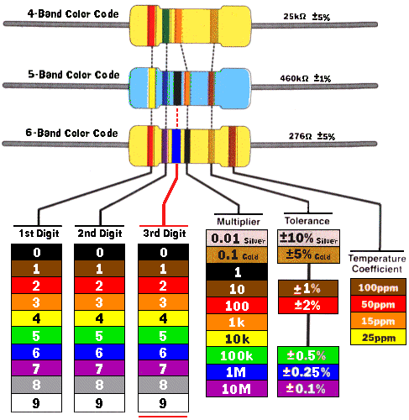

**BB ROY Great Britain has Very Good Wife**

**"Bad boys race our young girls, but Violet generally wins,**

**"Bad boys rape our young girls but Violet gives willingly. Get some now."**

**"Batman blanks* Robin on yonder Gotham bridge. Very good work. Get**

**Superman next." (GSN for Gold, Silver & None Tolerance)**