FAULT

FINDING

TECHNIQUES

Introduction
The most valuable asset in fault finding is the application of common sense when analysing a control problem. Coupled with this the maintenance person should have a sound knowledge of the circuit operation which may be gained by careful study of the circuit diagram and by observation of the equipment in operation.
It can also be of use to listen to equipment operator's description of the problem. However, take into account whether or not the operator is keen to get the equipment to operate again quickly. Sometimes you may also be led up the garden path by a false lead supplied by a well meaning operator. A good maintenance person will be able to tell fact from fiction.

Using your senses
Time may be saved when fault finding by applying the following senses:
`
Look: a visual inspection may reveal broken wires, blown fuses, signs of overheating, contacts stuck or mechanical jamming.

Smell: a varnish smell could indicate burnt out or over heated coils, solenoids or motors. plastic or rubber smell could indicate wiring which is overheating.

Listen: listen for buzzing (chattering) relays or contactors, noisy motor bearings, laboring motors or other noises that may give an indication of the fault.

Touch: overheating or vibration may be sensed by touching, but take care to avoid hand injury or electric shock.

In many situations, a few or all of the above mentioned symptoms may be present in some form or other and yet not be an indicator to the actual problem. The maintenance person must make judgments, all with a view to efficiently and effectively locating the actual fault.

Fault diagnosis
By using a logical process of elimination in checking all the probable fault, the problem can be located. To locate faults in faulty equipment, a maintenance person must be aware of the types of faults that can occur and the symptoms of each. The following table shows a list of symptoms, faults & causes.

Fault | Symptom | Cause
Open circuit relay coil | Relay or contactor won't pick up | Over voltage, moisture, high ambient temperature, mechanical binding, dirt between pole faces
Short circuit relay coil | Fuse blows
Relay failure | Relay won't pick up | Low voltage, open circuit coil, mech binding, incorrect coil
 | Relay won't dropout | Mech binding, pole faces stuck together, contacts welded together, voltage not removed from coil
 | Relay chattering | Dirt between pole faces, broken shading ring
Short circuit in wiring | Fuse blows | Moisture, dust build-up, loose connections, insulation failure due to effect of vibration/chemicals/heat
Open circuit in wiring | A particular part of the circuit will not operate | Loose connection, broken wire
Motor overheating | overload relay tripping | Mech load too large
 | Varnish smell | Dirt clogged air vents, high ambient temperature, too frequent starting and stopping
Insulation breakdown | Fuse blows, perhaps intermittently | Moisture, overheating, accumulation of dirt on surfaces, acid fumes

Troubleshooting

Troubleshooting is the process of analyzing the behavior or operation of a faulty circuit to determine hat is wrong with the circuit. It then involves identifying the defective component(s) and repairing the circuit.
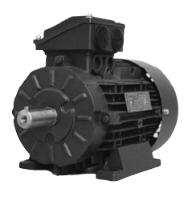
Depending on the type of equipment, troubleshooting can be a very challenging task. Sometimes problems are easily diagnosed and the problem component easily visible. Other times the symptoms as well as the faulty component can be difficult to diagnose.

A defective relay with visual signs of burning should be easy to spot, whereas an intermittent problem caused by a high resistance connection can be much more difficult to find.

One trait of expert troubleshooters is that hey are able to find virtually any fault in a reasonable amount of time. Easy faults, complicated faults, they find them all. Another trait is that they typically replace only the components that are defective.

They seem to have a knack for finding out exactly what is wrong. No trial and error here. So what is their secret?

You might think that a person who has a very good understanding of how the equipment works, should be able to troubleshoot it effectively. Being a good at troubleshooting requires more than this.

Expert troubleshooters have a good understanding of the operation of electrical components that are used in circuits they are familiar with, and even ones they are not. They use a system or approach that allows them to logically and systematically analyze a circuit and determine exactly what is wrong.

Understand how the circuit works

This consists of understanding the operation of all the components that are used in the circuit. This could include such components as: push buttons, contactors, various types of switches, relays, sensors, motors, etc.

Electrical circuits typically control or operate mechanical systems and components. You also need to understand how these mechanical aspects of the equipment operate to carry out the work.

You need to be able to determine how the circuit works under normal conditions and what effect changing one of the circuit inputs has on the circuit operation. For example, what happens to the overall circuit operation when a push button is pressed; which relays energize, which lights illuminate, does the pump start or stop, etc. You also need to be able to determine what effect a faulty component may have on the circuit operation.
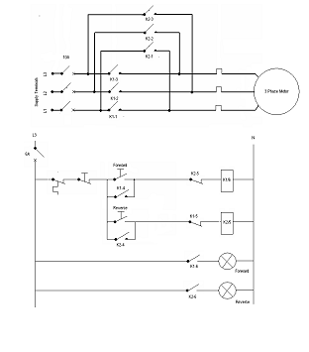

Use a logical, systematic approach to analyze the circuit’s behavior

This is critical. There are several approaches that troubleshooters use. They may have different steps or processes but they have the following in common: They all approach problems systematically and logically thus minimizing the steps and ruling out trial and error. One such approach used to teach troubleshooting is called the “5 Step Approach”. A summary of the key steps are:

  - Observation: Most faults provide clues as to their cause. There could be visual clues such as signs of damage or improper operation. Don’t forget to use your other senses; sounds and smells can also provide valuable clues. Through careful observation and a some reasoning, most faults can be identified to the actual component with very little testing.

  - Define Problem Area: At this stage you apply logic and reasoning to your observations to determine the problem area of the malfunctioning equipment.

  - Identify Possible Causes: Once you have the problem area(s) defined it is necessary to identify all the possible causes of the malfunction.

  - Determine Most Probable Cause: Once the list of possible causes has been made it is necessary to prioritize the items as to the possibility of them being the actual cause of the malfunction.

  - Test and Repair: Once you have determined the most probable cause, you must test it to prove it to be the problem or not.

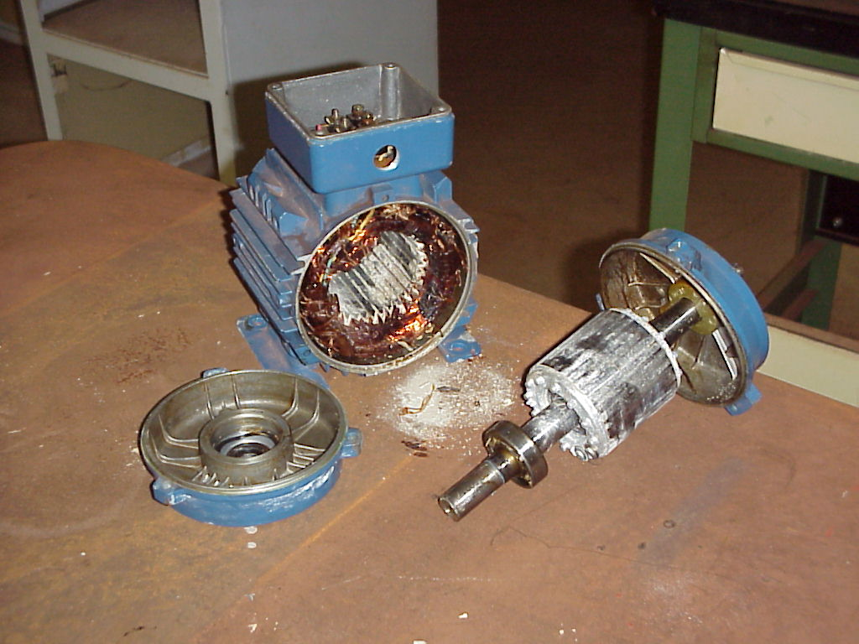

Let’s take a look at these in more detail.

Before you begin to troubleshoot any piece of equipment, you must be familiar with your organization’s safety rules and procedures for working on electrical equipment.

These rules and procedures govern the methods you can use to troubleshoot electrical equipment (including your lockout/tagout procedures, testing procedures etc.) and must be followed while troubleshooting.

Next, you need to gather information regarding the equipment and the problem. Be sure you understand how the equipment is designed to operate.

It is much easier to analyze faulty operation when you know how it should operate. Operation or equipment manuals and drawings are great sources of information and are helpful to have available.

If there are equipment history records, you should review them to see if there are any recurring problems.

You should also have on-hand any documentation describing the problem. (i.e., a work order, trouble report, or even your notes taken from a discussion with a customer.)

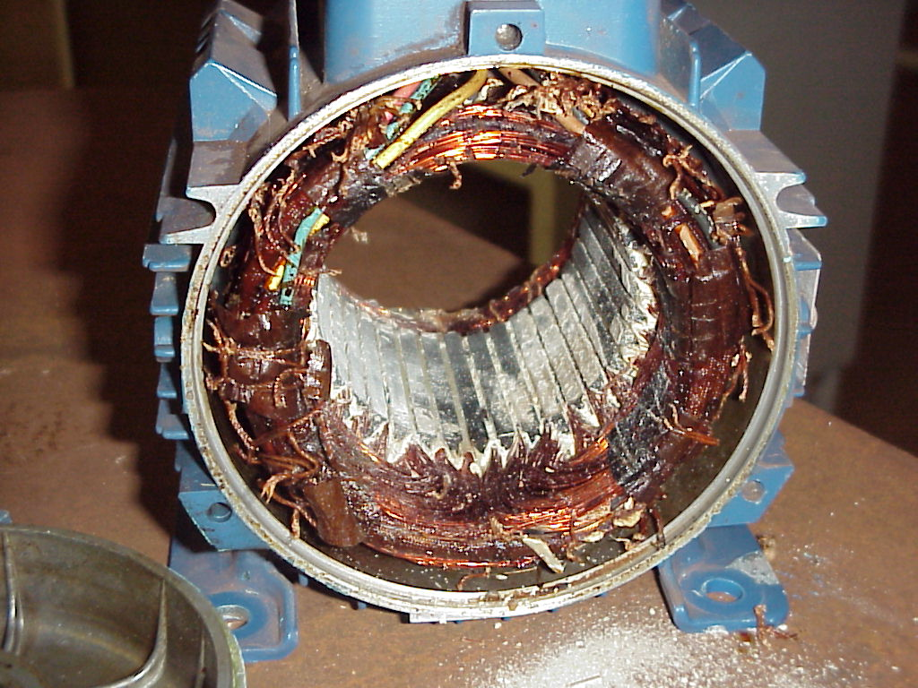
Step 1 – Observation

Most faults provide obvious clues as to their cause. Through careful observation and a little bit of reasoning, most faults can be identified as to the actual component with very little testing.

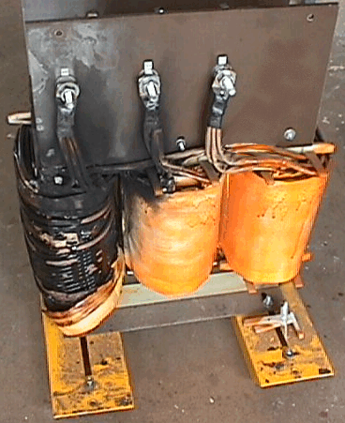
When observing malfunctioning equipment, look for visual signs of mechanical damage such as indications of impact, chafed wires, loose components or parts laying in the bottom of the cabinet.
Look for signs of overheating, especially on wiring, relay coils, and printed circuit boards.

Don't forget to use your other senses when inspecting equipment. The smell of burnt insulation is something you won't miss. Listening to the sound of the equipment operating may give you a clue to where the problem is located.

Checking the temperature of components can also help find problems but be careful while doing this, some components may be alive or hot enough to burn you.

When faced with equipment which is not functioning properly you should:

- Be sure you understand how the equipment is designed to operate. It makes it much easier to analyze faulty operation when you know how it should operate;

- Note the condition of the equipment as found. You should look at the state of the relays (energized or not), which lamps are lit, which auxiliary equipment is energized or running etc. This is the best time to give the equipment a thorough inspection (using all your senses). Look for signs of mechanical damage, overheating, unusual sounds, smells etc.;

- Test the operation of the equipment including all of its features. Make note of any feature that is not operating properly. Make sure you observe these operations very carefully. This can give you a lot of valuable information regarding all parts of the equipment.

Step 2 – Define Problem Area

It is at this stage that you apply logic and reasoning to your observations to determine the problem area of the malfunctioning equipment.

Often times when equipment malfunctions, certain parts of the equipment will work properly while others not.

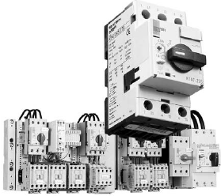
The key is to use your observations (from step 1) to rule out parts of the equipment or circuitry that are operating properly and not contributing to the cause of the malfunction.

You should continue to do this until you are left with only the part(s) that if faulty, could cause the symptoms that the equipment is experiencing.

To help you define the problem area you should have a schematic diagram of the circuit in addition to your noted observations.

Starting with the whole circuit as the problem area, take each noted observation and ask yourself "what does this tell me about the circuit operation?"

If an observation indicates that a section of the circuit appears to be operating properly, you can then eliminate it from the problem area.

As you eliminate each part of the circuit from the problem area, make sure to identify them on your schematic. This will help you keep track of all your information.

Step 3 – Identify Possible Causes

Once the problem area(s) have been defined, it is necessary to identify all the possible causes of the malfunction.

This typically involves every component in the problem area(s).

It is necessary to list (actually write down) every fault which could cause the problem no matter how remote the possibility of it occurring.

Use your initial observations to help you do this.

During the next step you will eliminate those which are not likely to happen.

Step 4 – Determine Most Probable Cause

Once the list of possible causes has been made, it is then necessary to prioritize each item as to the probability of it being the cause of the malfunction.

The following are some rules of thumb when prioritizing possible causes.

Although it could be possible for two components to fail at the same time, it is not very likely. Start by looking for one faulty component as the culprit.

The following list shows the order in which you should check components based on the probability of them being defective:

- First look for components which burn out or have a tendency to wear out, i.e. mechanical switches, fuses , relay contacts, or light bulbs. (Remember, that in the case of fuses, they burn out for a reason. You should find out why before replacing them.)

- The next most likely cause of failure are coils, motors, transformers and other devices with windings. These usually generate heat and, with time, can malfunction.

- Connections should be your third choice, especially screw type or bolted type. Over time these can loosen and cause a high resistance. In some cases this resistance will cause overheating and eventually will burn open. Connections on equipment that is subject to vibration are especially prone to coming loose.
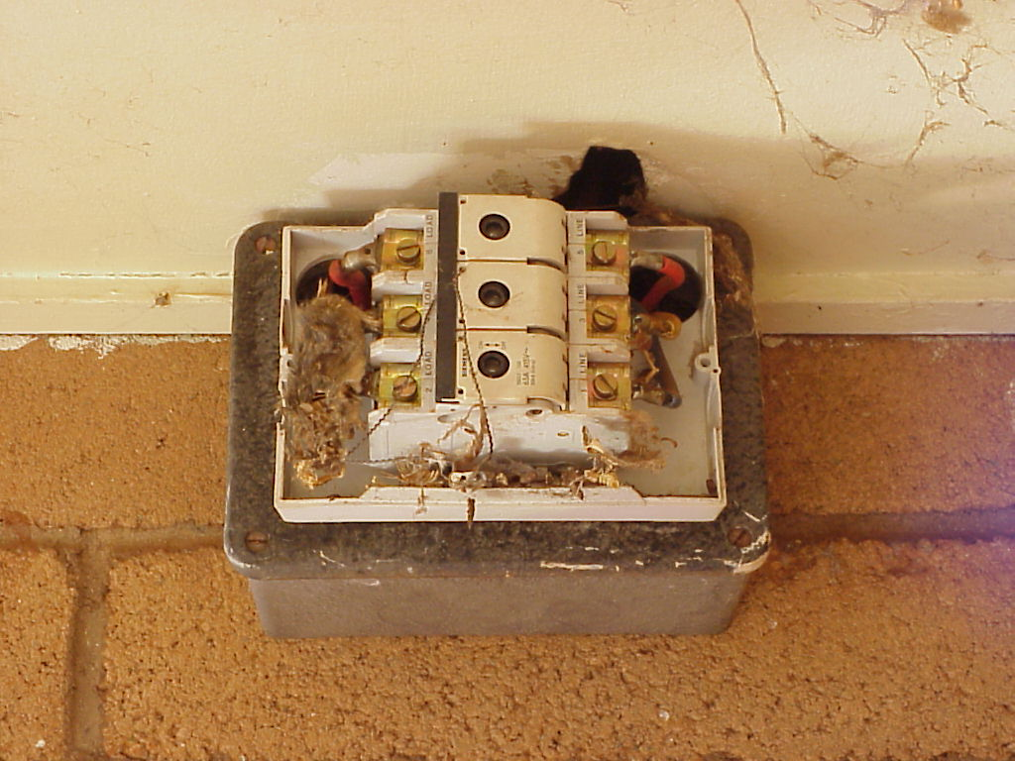
- Finally, you should look for is defective wiring. Pay particular attention to areas where the wire insulation could be damaged causing short circuits. Don't rule out incorrect wiring, especially on a new piece of equipment.

Step 5 – Test and Repair

Testing electrical equipment can be hazardous. The electrical energy contained in many circuits can be enough to injure or kill. Make sure you follow all your companies safety precautions, rules and procedures while troubleshooting.

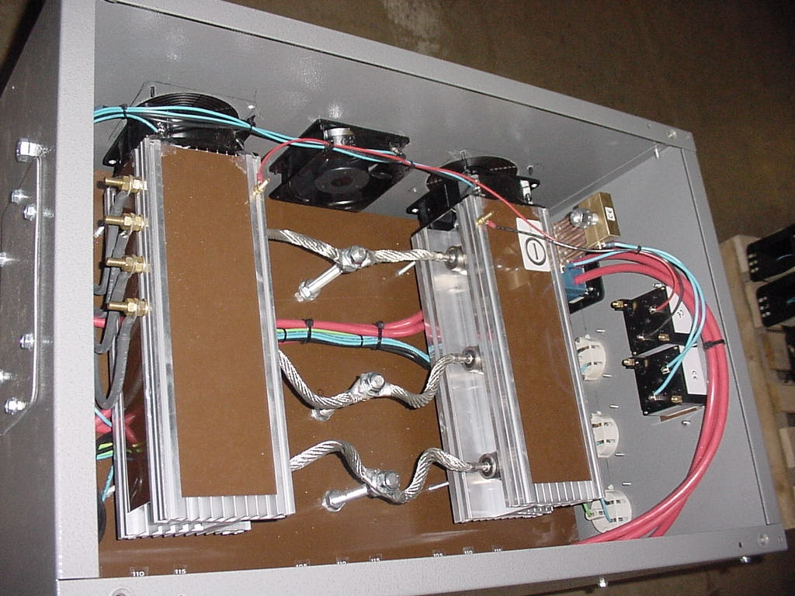
Once you have determined the most probable cause, you must either prove it to be the problem or rule it out. This can sometimes be done by careful inspection however, in many cases the fault will be such that you cannot identify the problem component by observation and analysis alone.

A very important rule when taking meter readings is to predict what the meter will read before taking the reading. Use the circuit schematic to determine what the meter will read if the circuit is operating normally. If the reading is anything other than your predicted value, you know that this part of the circuit is being affected by the fault.

Depending on the circuit and type of fault, the problem area as defined by your observations, can include a large area of the circuit creating a very large list of possible and probable causes.

Under such circumstances, you could use a “divide and eliminate” testing approach to eliminate parts of the circuit from the problem area. The results of each test provides information to help you reduce the size of the problem area until the defective component is identified.

Once you have determined the cause of the faulty operation of the circuit you can proceed to replace the defective component. Be sure the circuit is locked out and you follow all safety procedures before disconnecting the component or any wires.

After replacing the component, you must test operate all features of the circuit to be sure you have replaced the proper component and that there are no other faults in the circuit.

It can be very embarrassing to tell the customer that you have repaired the problem only to have him find another problem with the equipment just after you leave.

Follow up
Although this is not an official step of the troubleshooting process it nevertheless should be done once the equipment has been repaired and put back in service. You should try to determine the reason for the malfunction.

- Did the component fail due to age?
- Did the environment the equipment operates in cause excessive corrosion?
- Are there wear points that caused the wiring to short out?
- Did it fail due to improper use?
- Is there a design flaw that causes the same component to fail repeatedly?
- Through this process further failures can be minimized. Many organizations have their own follow-up documentation and processes. Make sure you check your organization’s procedures.

Understand how to use tools such as drawings, circuit diagrams and test instruments to identify defective components.

Let’s first look at drawings and diagrams. Some of the key things you should be able to determine from these are:

- how the circuit should operate
- what kind of features the circuit has
- what voltages you should expect at various points on the circuit
- where components are physically located
- how the components are actually wired together

You must be able to determine what type of test instrument to use, when and where to use it, and how to safely take readings with it.

Practice!

Troubleshooting, like any skill, requires practice to become proficient. Practice can be difficult to get. Depending on your job, you may not have the opportunity for enough troubleshooting practice. And even if you do, your employer may not want you to practice troubleshooting on equipment they depend on. .

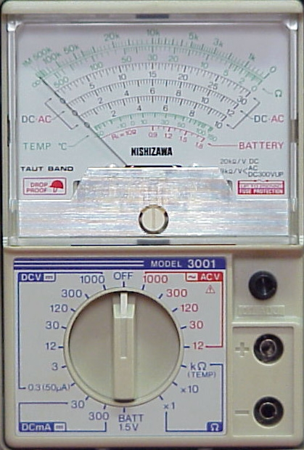
Test equipment
The appropriate test equipment should be used when fault finding, such as:
A voltmeter to measure voltage at the supply, at the load side of the fuses, across a coil or at the load terminals.
A clip-on ammeter to measure load current, when testing to see if a motor is being overloaded or to test for earth leaks.
An ohmmeter to measure the continuity of fuses, coils, closed contacts or wires.
The supply must be isolated before an ohmmeter is used !

An insulation resistance tester to measure the insulation resistance of a circuit or a load. This should be carried out if circuit fuses have blown.
The supply must be isolated before using this instrument !

Expected test equipment readings
When using test equipment a maintenance person must be able to tell when the reading indicates a normal or fault situation.

For example:
Supply voltage should usually be within 10% of the nominal voltage. Three phase line to line voltages should be within 5% otherwise the supply is unbalanced. Low voltage readings may be due to high resistance connections or contacts. Low value supply voltages may be caused by excessive loading on the supply conductors. Voltage imbalance could be due to single phase loads connected to a three phase supply.
Load currents should not be excessive. Check the name plate details. three phase motor currents should be similar for each line but in practice, they are almost never identical.
The resistance of components will depend on their rating although relay coils should have resistances between 100 Ohms and 500 Ohms. Note that this indicates only that the coil is not open circuited.
A better indication is to compare the coil resistance with another similar coil which is known to be good. The resistance of fuses, closed contacts and wiring should be close to zero.
Insulation resistance of wiring should exceed 1M Ohm. Motor windings may be somewhat less than this value. Heating elements can have readings as low as 10 000 Ohms.

