

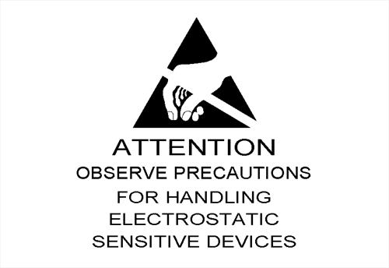

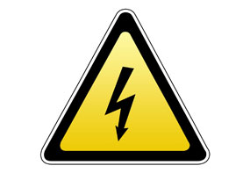

Electrostatic Discharge – Risks and Prevention

What Is Static Electricity?
It's the accumulation of positive or negative charges on insulators or conductors. These charges can vary, based on the stored capacitance of certain items with respect to an object having a corresponding opposite charge. The word static simply means the charge cannot be equalized or transferred through electromotive force until there is a decrease in the capacitance between two objects. An example of this can be your hand (which may hold a negative charge) as it approaches a doorknob (which may hold a positive charge). As your hand moves closer to the doorknob, the capacitance between the object and your hand will decrease. This results in a flow of current between your hand and the doorknob. This transfer is known as electrostatic discharge, or ESD.
Electrostatic discharge (ESD) has been around since the beginning of time. However, this natural phenomenon has only become an issue with the widespread use of solid-state electronics.
Sources of ESD.
All materials (insulators and conductors alike) are sources of ESD. Positive charges accumulate predominantly on human skin or animal fur. Negative charges are more common to synthetic materials such as Styrofoam or plastic cups. The amount of electrostatic charge that can accumulate on any item is dependent on its capacity to store a charge. For example, the human body can store a charge that can be as high as 25,000V.
How does ESD damage electronic circuitry?
ESD is a tiny version of lightning. As the current dissipates through an object, it's seeking a low impedance path to ground to equalize potentials. In most cases, ESD currents will travel to ground via the metal chassis frame of a device. However, it's well known that current will travel on every available path. In some cases, one path may be between the PN junctions on integrated circuits to reach ground. This current flow will burn holes visible to the naked eye in an integrated circuit, with evidence of heat damage to the surrounding area. One ESD event will not disrupt equipment operation. However, repeated events will degrade equipment's internal components over time.
How does ESD occur?
ESD can occur in a variety of forms. One of the most common is through human contact with sensitive devices. Human touch is only sensitive on ESD levels that exceed 4,000V.
A recent investigation found the human body and its clothing capable of storing between 500V and 2,500V electrostatic during the normal workday. This is far above the level that damages circuits yet below the human perception threshold. Other sources of ESD damage to equipment include:
Troubleshooting electronic equipment or handling of printed circuit boards without using an electrostatic wrist strap;
Placement of synthetic materials (i.e. plastic, Styrofoam, etc.) on or near electronic equipment; and
Rapid movement of air near electronic equipment (including using compressed air to blow dirt off printed circuit boards, circulating fans blowing on electronic equipment, or using an electronic device close to an air handling system).In all of these scenarios, the accumulation of static charges may occur, but you may never know. Furthermore, a charged object does not necessarily have to contact the item for an ESD event to occur.
How do you measure electrostatic voltage?
One of the most effective ways to identify potential ESD problem areas is to make measurements using an electrostatic voltmeter. This meter will effectively measure electrostatic voltage up to 30,000V on all conductors and insulators. It also will display whether the charge is negative or positive. This may help you determine the source of the electrostatic accumulation.
How can you prevent ESD?
It's unlikely you can eliminate ESD completely from any site. However, experience has shown that the following guidelines are helpful:
Keep all synthetic materials at least 100mm. away from electronic equipment.
When cleaning printed circuit boards, use a spray labeled as non-static forming.
When troubleshooting electronic equipment, always wear a static wrist strap that's grounded to the frame of the device. Also, wear the wrist strap when handling printed circuit boards.
Treat carpets and floors with compounds that reduce the buildup of static charges.
Use static floor mats where necessary.
Make sure the grounding system for equipment has a low impedance for ESD currents to dissipate to an earthing reference.
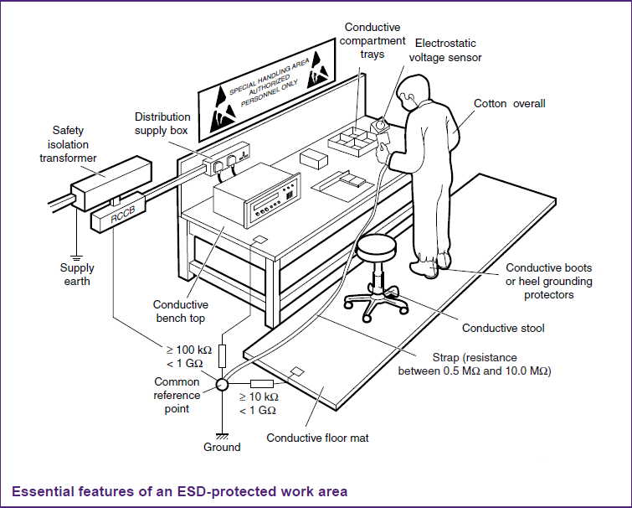

Device type | ESD withstand voltage sensitivity (V) HBM
Power MOSFETs, laser diodes | 100 - 300V
Pre - 1990 VLSI | 400 - 1000V
Modern VLSI | 1000 - 3000V
HCMOS | 1500 - 3000V
CMOS B Series | 2000 - 5000 V
Linear MOS | 800 - 4000 V
Older signal bipolar transistor | 600 - 6000 V
Modern signal bipolar transistor | 2000 - 8000 V
Power bipolar transistor | 7000 - 25000 V
Metal film resistor | 1000 - 5000 V

HBM Model
As the human body was originally the most common and damaging source of electrostatic discharge, the most common measurement of ESD sensitivity is by Human Body Model (HBM) electrostatic discharge. In this test a charged 100pF capacitor is discharged into the device via a 1500Ω resistor. The 100pF capacitor simulates charged stored on the average human body, and the resistor simulates the resistance of the human body and skin. This is then used to establish the range in which a device is considered safe from ESD.
In the table above there are various devices listed such as Metal Oxide Semiconductor Field Effect Transistors (MOSFET), Very Large Scale Integrated circuits (VLSI), Complementary Metal Oxide Semiconductors (CMOS), Metal film resistors etc.
Summary
As electrical workers you are very unlikely to come into contact with these devices as they are generally internal working components integrated as part of an electrical appliance or control system.
If you do find yourself in an area of electrical work where you are required to change these devices your employer will need to ensure you are properly trained in the use of ESD sensitive devices and protection systems.
http://www.cisco.com/web/learning/le31/esd/WelcomeP.html (Static screens as per PPT)
https://www.youtube.com/watch?v=ZAyBxPtYwOA (Video demo of grounding mat)

