

UEE11 Training Package Support Material

(Non-Endorsed Component)

Based on:

National Electrotechnology Industry Standards

**Resource Book**

UEENEEA102A

**Select electronic components for assembly**

AQF Level:

Certificate II in Electrotechnology Electrician

(Career Start)



Compiled by R. Elvidge December 2015

© North Metropolitan TAFE 2017

Version 2 – 12/2018

Acknowledgements

This Unit Guide has been prepared by North Metropolitan TAFE Lecturers.

It is intended for North Metropolitan TAFE students only.

COPYRIGHT STATEMENT

This unit outline has been created by North Metropolitan TAFE for educational purposes.

Any third party content contained in the unit outline is copied with permission of the copyright owner or under Statutory License VB of the Copyright Act 1968.

Text and pictures in this document are reproduced by North Metropolitan TAFE with permission of McGraw Hill.

ALL RIGHTS RESERVED

Apart from any use as permitted under the Copyright Act 1968, no part may be reproduced without the prior written permission of North Metropolitan TAFE.

Requests and inquiries concerning other reproduction and rights should be directed in the first instance to the Manager Publications and Distributions.

Manager Publications and Distributions

North Metropolitan North

Locked Bag 6, Northbridge

Telephone: +61 1300 300 822

[www.northmetrotafe.wa.edu.au](http://www.northmetrotafe.wa.edu.au)

Disclaimer:

While every effort has been made to ensure the accuracy of the information contained in this publication, no guarantee can be given that all errors and omissions have been excluded. No responsibility for loss occasioned to any person acting or refraining from action as a result of the material in this publication can be accepted by North Metropolitan TAFE.

**Pre-Requisites**

| **Prerequisite Unit(s)** | **4)** | |
| --- | --- | --- |
| **Competencies** | **4.1)** | |
|  | Granting competency in this unit shall be made only after competency in the following unit(s) has/have been confirmed. | |
|  | UEENEEE101A | Apply Occupational Health Safety regulations, codes and practices in the workplace |

|  |  |  |  |  |  |  |
| --- | --- | --- | --- | --- | --- | --- |
| **Literacy and numeracy skills** | **4.2)** | | | | | |
|  | Participants are best equipped to achieve competency in this unit if they have reading, writing and Numeracy skills indicated by the following scales. Description of each scale is given in Volume 2, Part 3 ‘Literacy and Numeracy’ | | | | | |
|  | Reading | 3 | Writing | 3 | Numeracy | 3 |

**Employability Skills Information**

| **Employability Skills** | **5)** |
| --- | --- |
|  | The required outcomes described in this unit of competency contain applicable facets of Employability Skills. The Employability Skills Summary of the qualification in which this unit of competency is packaged will assist in identifying Employability Skill requirements. |

**Elements and Performance Criteria Pre-Content**

|  |  |
| --- | --- |
| **6)** Elements describe the essential outcomes of a competency standard unit | Performance Criteria describe the required performance needed to demonstrate achievement of the element. Assessment of performance is to be consistent with the Evidence Guide. |

**Elements and Performance Criteria**

| **ELEMENT** | | **PERFORMANCE CRITERIA** | |
| --- | --- | --- | --- |
| 1 | Prepare to select electronic components. | 1.1 | OHS procedures for a given work area are identified, obtained and understood. |
|  |  | 1.2 | Established OHS risk control measures for work preparation are followed. |
|  |  | 1.3 | Work instructions are obtained and understood. |
|  |  | 1.4 | Advice is sought from the work supervisor to ensure the work is coordinated effectively with others. |
|  |  | 1.5 | Materials required for the work are obtained in accordance with established routines and procedures. |
|  |  | 1.6 | Tools, equipment and testing devices needed to carry out the work are obtained and checked for correct operation and safety. |
| 2 | Select electronic components. | 2.1 | Established OHS risk control work measures are followed. |
|  |  | 2.2 | Electronic components are selected, sorted and placed in accordance with work instructions and established routines. |
|  |  | 2.3 | Prescribed solutions are used to resolve issues with supply of component. |
|  |  | 2.4 | Routine quality checks are conducted to ensure components comply with enterprise / industry standards. |
|  |  | 2.5 | Work is completed in acceptable timeframe given environment and workplace conditions. |
| 3 | Complete work report. | 3.1 | Established OHS risk control measures for work completion are followed. |
|  |  | 3.2 | Work report forms/data sheets on components are completed accurately. |

**Required Skills and Knowledge**

| **REQUIRED SKILLS AND KNOWLEDGE** |
| --- |
| **8)** This describes the essential skills and knowledge and their level, required for this unit. |
| Evidence must show that knowledge has been acquired of safe working practices and the selection of electronic components.  All knowledge and skills detailed in this unit should be contextualised to current industry practices and technologies.  **KS01-EA102A Electronic component basics and selection**  Evidence shall show an understanding of selecting electronic components, applying safe working practices and relevant Standards, Codes and Regulations to an extent indicated by the following aspects:  T1. Types of components encompassing:  resistors, inductors, capacitors, diodes, transistor, integrated circuits, printed circuit boards, sub-assemblies, and mounting/enclosing, connection and termination hardware.  T2. The physical features and primary characteristic of components encompassing:  features include shape, size and connections  characteristics include parameter and power ratings and polarity.  methods of identifying and marking of component ratings.  identifying and handling static sensitive components.  selection of components |

|  |  |
| --- | --- |
| **Critical aspects of evidence required to demonstrate competency in this unit** | **9.2)** |

|  |
| --- |
| A Following job specifications  B Identifying and selecting components  C Handling components without damaging them  D Adhering to quality procedures  E Dealing with unplanned events by drawing on essential knowledge and skills to  provide appropriate solutions incorporated in the holistic assessment with the  above listed items. |

**UEENEEA102A – Select electronic components for assembly**

**Learning and Assessment Plan**

Name of Lecturer: ______________________________________________________________

Contact Details: ______________________________________________________________

Delivery Mode/s: □ Face to Face □ On-Line □ Blended Delivery □ Other

Using: UEENEEA102A –Select electronic components for assembly Resource Book

|  |  |  |  |
| --- | --- | --- | --- |
| **Session** | **Nominal**  **Duration** | **Program of Work**  **(Topics to be covered)** | **Primary Reference** |
| 1 | 2 hrs | Introduction to UEENEEA102A | Resource Book |
| 2 | 2 Hrs | Component identification | Parts catalogues |
| 3 | 4 Hrs | Worksheet 1 Activity 1 | Resource Book |
| 4 | 4 Hrs | Worksheet 2 Activity 2 | Resource Book |
| 5 | 2 Hrs | Knowledge Assessment |  |
| 6 | 4 Hrs | Skills Assessment |  |

|  |  |  |
| --- | --- | --- |
| **I acknowledge that I have received and read this Delivery and Assessment Plan**  Student Name:___________________________ Signature: _______________________ Date: _________ | | |
| Lecturer Name | Lecturer Signature | Date |

**Assessment Strategy**

Conditions of Assessment:

Normally learning and assessment will take place in an integrated classroom/ laboratory environment.

It is essential to work through the worksheets and activities in this workbook and follow the guidance of your lecturer. The worksheets and practical activities will provide the required skills and knowledge outlined in this Unit and assists you in achieving competency.

Assessment Methods:

Resource Book - The satisfactory completion of all worksheets and practical activities is required.

Written Theory Assessment – based on the REQUIRED SKILLS AND KNOWLEDGE. You must achieve a mark of 75% or more in this assessment.

Observed Practical Assessment – based on the Elements and Performance Criteria of this Competency Unit UEENEEA102A. You must achieve a mark of 100% in this assessment.

Sufficiency of Evidence:

In all instances competency is to be attributed on evidence sufficient to show that a person has the necessary skills required for the scope of work. These include:

• Task skills - performing individual tasks

• Task management skills - managing a number of different tasks

• Contingency management skills - responding to irregularities and breakdowns in routines

• Job/role environment skills - dealing with the responsibilities and expectations of the work environment including working with others.

Evidence must demonstrate that an individual can perform competently across the specified range of activities and has the essential knowledge, understanding and associated skills underpinning the competency.

**DANGER TAG PROCEDURE for ELECTRICAL TRADE LABORATORIES**

**THE FOLLOWING PROCEDURE IS COMPULSORY**

1. The student is to attach a DANGER TAG on to the plug top of the project lead before proceeding with the allocated project. A danger tag must be attached to the plug top at all times, when the lead is NOT plugged into the supply outlet. Plug tops or leads are not to be connected to the supply outlet WHILE A DANGER TAG is attached.

2. The student is to assemble the project according to project instruction procedure and lecturer’s directions in its isolated and de-energised state and report to the lecturer as necessary and on completion.

3. The lecturer is to:-

a. Check the project for safety and

b. Ensure that the student has performed a safety check, including **short circuit test** using the recommended procedure.

4. When the lecturer is satisfied that the project is safe to connect and energise, the lecturer is to instruct the student to REMOVE the DANGER TAG from the plug top.

5. The student is to plug in the project and switch it on in the presence of the lecturer.

6. The lecturer is to determine whether or not the project is operating satisfactorily.

7. If the project operates satisfactorily the student may take measurements using correct meters with regard to the safety risks associated with using the particular item of test equipment including;

1. Selecting correct meter function,
2. Holding meter probes correctly during measuring with fingers behind knurls (finger guards) at all times.

This is to be done under general supervision of lecturer. The student is NOT to modify, disassemble or carry out ANY unsafe act.

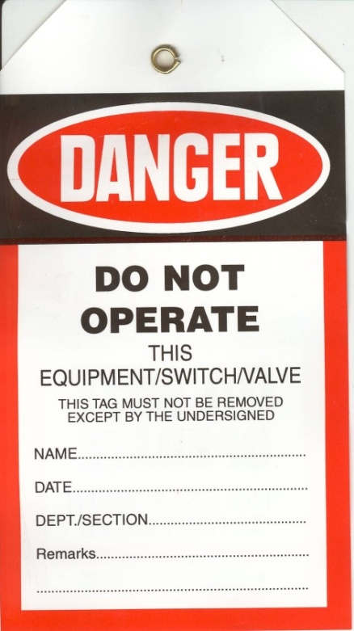

8. If the circuit is to be modified the student must:

a. Switch the circuit off,

b. Disconnect the project from the supply,

c. Attach the DANGER TAG to the plug top,

d. Report to the lecturer for instructions,

In the lecturer's presence the student is to:-

e. TEST and VERIFY for ZERO VOLTAGE.

f. Restart the DANGER TAG procedure from step 2 above.

9. When the student is satisfied that the project has been completed the student is to:-

a. Switch the project off,

b. Remove the plug,

c. Replace the DANGER TAG on the plug top,

d. Report to the lecturer for instructions,

In the lecturer's presence the student is to:-

e. TEST and VERIFY for ZERO VOLTAGE.

The lecturer is then to instruct the student to:-

f. Disassemble the project

g. Remove the DANGER TAG and store the equipment in its designated place.

**LABORATORY SAFETY**

Students working in laboratories at NMTAFE West Balga Campus do so, on condition that they agree to abide by the following safety instructions. Failure to observe the safety instructions will result in **IMMEDIATE SUSPENSION.**

1. No circuit is to be plugged in or switched on without the specific permission of the lecturer in charge of the class. A circuit must be switched off and tested for **ZERO VOLTS** before any supply leads are removed. The **DANGER TAG PROCEDURE** must be used at all times.
2. Do not leave any circuit switched on any longer than necessary for testing. Do not leave any circuit switched on unattended.
3. Check each item of equipment before using. Report any broken, damaged or unserviceable equipment to your Lecturer.
4. All wiring must be disconnected at the end of each practical class or as each project is completed.
5. Make all connections in a safe manner with an appropriate connecting device. Unshielded 4mm banana plugs are not to be used for wiring.
6. Switch off, remove the plug from the socket and attach your **DANGER TAG** to the plug top before working on any project. It is not sufficient to simply turn the switch off.
7. When disconnecting your wiring from a connection made under a screw, undo the screw to remove the wiring, do not cut the wire off.
8. Observe the correct colour code for all wiring projects.
9. Test your circuit for short circuits with your multimeter before asking your Lecturer to switch circuit on. Test the Tester before and after **EACH** test.
10. Skylarking and horseplay is not permitted at any time.
11. Proper clothing and safety footwear must be worn at all times. Thongs, sandals and singlets are not permitted. Hard capped safety boots or safety shoes **MUST** be worn **AT ALL TIMES** at Polytechnic West Balga Campus.
12. Where an activity sheet is issued for a project, complete each step in the Procedure before moving to the next step. Advise your Lecturer when you have completed the activity.
13. Draw **ALL DIAGRAMS** in **PENCIL** so that they can be easily changed or corrected. Mark off each connection on your diagram as it is made.
14. Check the range before taking a reading with a multimeter.
15. Make sure that it is **YOUR** plug before inserting plug into an outlet.
16. Always switch multimeter **OFF**, or to the highest possible **AC VOLTS** range when you have finished using it.
17. Report any unexpected situations or events to your Lecturer.

**Student’s Signature :___________________ Date :___/___/_____**

**UEENEEA102A - Select electronic components for assembly**

**Types of Components**

**Task:**

Describe the general characteristics of various types of electronic components and assemblies including the following.

* Resistors
* Capacitors
* Inductors
* Diodes
* Transistors
* Integrated Circuits
* Printed Circuit Boards/Sub-Assemblies
* Connection and Termination Hardware

**Why:**

Electronic devices are used in virtually all areas of modern industry. Knowledge of the basic function and system of rating such components is essential, along with the ability to physically identify devices and interpret markings to determine specifications.

**To Pass:**

1. You must correctly answer the questions on the Work Sheets provided and achieve a mark of 75% or more in a competency test for each Required Skills and Knowledge (RSAK) topic.

2. You must satisfactorily complete the set activities and laboratory tasks.

3. You must achieve 100% in a final practical competency test.

**Equipment:**

Selection of various components and circuit boards.

Soldering equipment.

**References:**

* Altronics catalogue both hard copy and on line.
* Cisco Ltd. Web site

Internet references as presented by lecturer. You tube etc

**Types of components:**

Passive types:

* Resistors – these devices are used to limit current flow and to form voltage dividers.

Fixed value

Power resistor – larger to safely dissipate heat generated.

Construction - Generally constructed from resistance wire wound onto a heat

resistant former and can be covered in a ceramic housing.

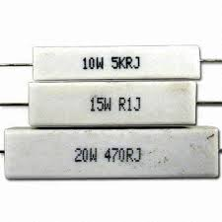

General purpose resistor – smaller and generally used in low power

applications in electronic control circuitry etc.

Construction – Various types generally resistive material bonded to a ceramic

former and coated with a protective material. Generally identified by coloured

bands to indicate resistive value.

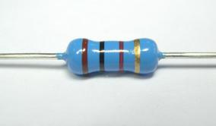

SIP or DIP resistor network – array of resistors in one package generally of a

very low power rating such as 1/8W or less.

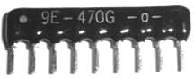

Variable resistor

Rheostat – two-terminal variable resistor (often for high power)

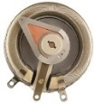

Potentiometer – three-terminal variable resistor (variable voltage divider)

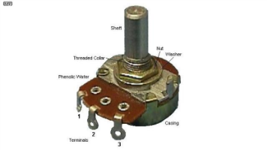

Trim pot – Small potentiometer, usually for internal adjustments

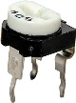

Thermistor – thermally sensitive resistor whose prime function is to exhibit a large, predictable and precise change in electrical resistance when subjected to a corresponding change in temperature.

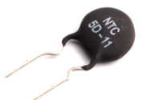

Photoresistor - photo sensitive resistor whose prime function is to exhibit a

large, predictable and precise change in electrical resistance when subjected

to a corresponding change in light level striking the surface.

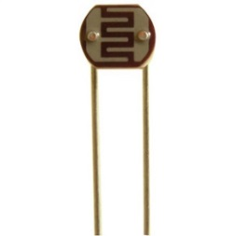

Varistor, Voltage Dependent Resistor, MOV – Passes current when excessive

voltage is present

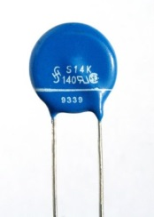

Resistance wire, Nichrome wire – wire of high-resistance material, often used as a heating element

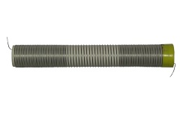

* Capacitors – these devices are used to store an electric charge and can be used for filtering.

Fixed value.

These come in many types depending upon the application. The dielectric material, between the plates, is how capacitors are primarily categorized.

These materials are things such as mica, polyester, paper, glass and ceramic to name a few. They also come in polarized and non-polarized depending upon the application. Generally DC circuits use polarized capacitors and AC circuits use non-polarized. So rating of capacitors is usually determined by the dielectric type, the voltage rating and whether or not they are polarized.

Polyester – Non-polarized general purpose in electronic circuits for high reliability, low cost and low voltage applications. Capacitance rarely exceeds 0.5uF.



Value in pF = 68 (1st 2 digits) and 3 zeros

Thus the value of this is 68000pF or 0.068uF

Ceramic - Non-polarized general purpose in electronic circuits for high reliability, low cost and low and high voltage applications. Capacitance rarely exceeds 0.5uF.

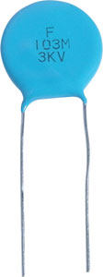

Value in pF = 10 (1st 2 digits) and 3 zeros thus the value of this is 10000pF or 0.01uF.

Note the voltage rating of this device is 3kV

Electrolytic – Non polarized for general use in AC circuits.

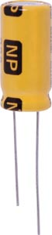

Value is written on the component.

Electrolytic – Polarized for use in DC circuits. Generally used for filtering. Values can range from 0.1uF up to above one Farad. Voltage ratings generally low voltage for electronic circuits up to 400V is typical.

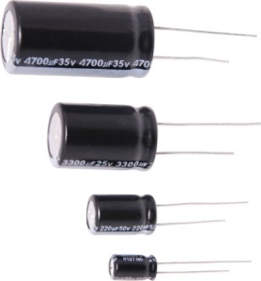

Value is written on the component.

Trimmer capacitor – Very low value variable capacitor used for tuning adjustments in electronic circuits. Typical values between 2pF and 70pF.

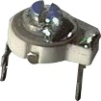

* Diodes – These devices are used to convert AC to DC and for protection against reverse polarization. Can also be used for back EMF suppression and many other applications. They are polarized and must be correctly inserted into circuit.

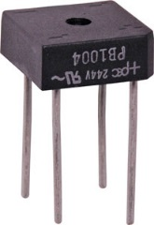

Bridge rectifier package has 4 diodes in one package and is used to convert AC to DC.

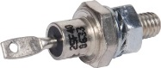

Typical power diode able to be bolted to a metal chassis to assist with heat sinking. Rated by voltage and current typically in this format 15A/400V (example)

http://images.altronics.com.au/prod/z/Z0030.jpg

Typical low power rectifier diode generally PCB mounted and typical ratings up to around 5A/1000V.

* Transistors – These devices are used for many purposes such as amplifying signals, voltage regulation circuits, switching circuits and filter circuits. They range from small low powered devices up to large devices typically used for switching functions. Generally rated in voltage, current and operating frequency range. Three legged device must be correctly inserted to ensure correct operation.

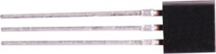

Typical small signal type transistor used for amplification of low level signals and switching small devices such as LED’s etc.

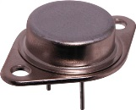 http://images.altronics.com.au/prod/z/Z1128.jpg

Typical power transistors in chassis mount and flat pack styles.

* Inductors – Generally a length if insulated copper wire wound onto a former to create a coil shaped device. Core material may vary depending upon the application and frequency range. Generally used in tuning circuits and for filtering applications. Inductors are also an integral part of a transformer and can be used to step voltages up or down and to provide isolation. Transformers are generally rated in V/A (Volt/Amps).

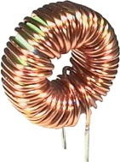

Typical inductor as used in a filter circuit. Insulated copper wire wound on to a toroidal core of ferrite

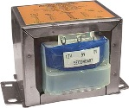

Typical low power mains transformer used to step 230V mains down to ELV levels typically in the 3V – 24V range.

* Integrated circuits – These devices are a package containing many transistors, diodes and other components integrated into one package. Modern IC’s are generally designed for a particular function and can range from amplifiers to switching devices to timers, counters and many other functions.

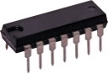

Typical low power integrated circuit. This device may be a timer or a counter or low power amplifier.

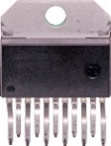

Typical power amplifier IC. Can be bolted to a heat sink to facilitate cooling. This type of device would be typically found in a car staereo amplifier circuit.

Electrostatic Discharge – Risks and Prevention

**What Is Static Electricity?**

It's the accumulation of positive or negative charges on insulators or conductors. These charges can vary, based on the stored capacitance of certain items with respect to an object having a corresponding opposite charge. The word static simply means the charge cannot be equalized or transferred through electromotive force until there is a decrease in the capacitance between two objects. An example of this can be your hand (which may hold a negative charge) as it approaches a doorknob (which may hold a positive charge). As your hand moves closer to the doorknob, the capacitance between the object and your hand will decrease. This results in a flow of current between your hand and the doorknob. This transfer is known as electrostatic discharge, or ESD.

Electrostatic discharge (ESD) has been around since the beginning of time. However, this natural phenomenon has only become an issue with the widespread use of solid-state electronics.

**Sources of ESD.**

All materials (insulators and conductors alike) are sources of ESD. Positive charges accumulate predominantly on human skin or animal fur. Negative charges are more common to synthetic materials such as Styrofoam or plastic cups. The amount of electrostatic charge that can accumulate on any item is dependent on its capacity to store a charge. For example, the human body can store a charge that can be as high as 25,000V.

**How does ESD damage electronic circuitry?**

ESD is a tiny version of lightning. As the current dissipates through an object, it's seeking a low impedance path to ground to equalize potentials. In most cases, ESD currents will travel to ground via the metal chassis frame of a device. However, it's well known that current will travel on every available path. In some cases, one path may be between the PN junctions on integrated circuits to reach ground. This current flow will burn holes visible to the naked eye in an integrated circuit, with evidence of heat damage to the surrounding area. One ESD event will not disrupt equipment operation. However, repeated events will degrade equipment's internal components over time.

**How does ESD occur?**

ESD can occur in a variety of forms. One of the most common is through human contact with sensitive devices. Human touch is only sensitive on ESD levels that exceed 4,000V.

A recent investigation found the human body and its clothing capable of storing between 500V and 2,500V electrostatic during the normal workday. This is far above the level that damages circuits yet below the human perception threshold. Other sources of ESD damage to equipment include:

Troubleshooting electronic equipment or handling of printed circuit boards without using an electrostatic wrist strap;

Placement of synthetic materials (i.e. plastic, Styrofoam, etc.) on or near electronic equipment; and

Rapid movement of air near electronic equipment (including using compressed air to blow dirt off printed circuit boards, circulating fans blowing on electronic equipment, or using an electronic device close to an air handling system).In all of these scenarios, the accumulation of static charges may occur, but you may never know. Furthermore, a charged object does not necessarily have to contact the item for an ESD event to occur.

**How do you measure electrostatic voltage?**

One of the most effective ways to identify potential ESD problem areas is to make measurements using an electrostatic voltmeter. This meter will effectively measure electrostatic voltage up to 30,000V on all conductors and insulators. It also will display whether the charge is negative or positive. This may help you determine the source of the electrostatic accumulation.

**How can you prevent ESD?**

It's unlikely you can eliminate ESD completely from any site. However, experience has shown that the following guidelines are helpful:

Keep all synthetic materials at least 100mm. away from electronic equipment.

When cleaning printed circuit boards, use a spray labeled as non-static forming.

When troubleshooting electronic equipment, always wear a static wrist strap that's grounded to the frame of the device. Also, wear the wrist strap when handling printed circuit boards.

Treat carpets and floors with compounds that reduce the buildup of static charges.

Use static floor mats where necessary.

Make sure the grounding system for equipment has a low impedance for ESD currents to dissipate to an earthing reference.

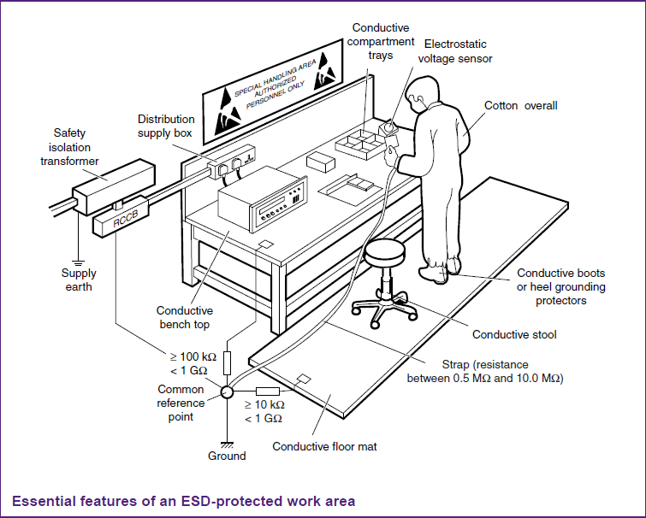

|  |  |
| --- | --- |
| **Device type** | **ESD withstand voltage sensitivity (V)** **HBM** |
| Power MOSFETs, laser diodes | 100 - 300V |
| Pre - 1990 VLSI | 400 - 1000V |
| Modern VLSI | 1000 - 3000V |
| HCMOS | 1500 - 3000V |
| CMOS B Series | 2000 - 5000 V |
| Linear MOS | 800 - 4000 V |
| Older signal bipolar transistor | 600 - 6000 V |
| Modern signal bipolar transistor | 2000 - 8000 V |
| Power bipolar transistor | 7000 - 25000 V |
| Metal film resistor | 1000 - 5000 V |

**HBM Model**

As the human body was originally the most common and damaging source of electrostatic discharge, the most common measurement of ESD sensitivity is by Human Body Model (HBM) electrostatic discharge. In this test a charged 100pF capacitor is discharged into the device via a 1500Ω resistor. The 100pF capacitor simulates charged stored on the average human body, and the resistor simulates the resistance of the human body and skin. This is then used to establish the range in which a device is considered safe from ESD.

In the table above there are various devices listed such as Metal Oxide Semiconductor Field Effect Transistors (MOSFET), Very Large Scale Integrated circuits (VLSI), Complementary Metal Oxide Semiconductors (CMOS), Metal film resistors etc.

**Summary**

As electrical workers you are very unlikely to come into contact with these devices as they are generally internal working components integrated as part of an electrical appliance or control system.

If you do find yourself in an area of electrical work where you are required to change these devices your employer will need to ensure you are properly trained in the use of ESD sensitive devices and protection systems.

For more information regarding ESD, it’s effects and methods of prevention follow the link below.

<http://www.cisco.com/web/learning/le31/esd/WelcomeP.html>

Soldering Components on to a PCB.

**First a few safety precautions:**

* **Never touch the element or tip of the soldering iron.**   
  They are very hot and will give you a nasty burn.
* If you are unlucky (or careless!) enough to burn yourself please see the first aid officer allocated to your work area.
* **Take great care to avoid touching the mains flex with the tip of the iron.**   
  The iron should have a heatproof flex for extra protection. An ordinary plastic flex will melt immediately if touched by a hot iron and there is a serious risk of burns and electric shock.
* **Always return the soldering iron to its stand when not in use.**   
  Never put it down on your workbench, even for a moment!
* **Work in a well ventilated area.**   
  The smoke formed as you melt solder is mostly from the flux and quite irritating. Avoid breathing it by keeping your head to the side of, not above, your work. Use a fume extraction device where possible.
* **Wash your hands after using solder.**   
  Solder can contain lead which is a poisonous metal.

**Preparing the soldering iron:**

* **Place the soldering iron in its stand and plug in.**   
  The iron will take a few minutes to reach its operating temperature.
* **Dampen the sponge in the stand.**   
  The best way to do this is to lift it out the stand and hold it under a cold tap for a moment, then squeeze to remove excess water. It should be damp, not dripping wet. Some soldering stations utilise a swarf type cleaner which gives better results and does not have a cooling effect on the tip of the iron.
* **Wait a few minutes for the soldering iron to warm up.**   
  You can check if it is ready by melting some solder on the tip.
* **Wipe the tip of the iron on the damp sponge or in swarf tray.**   
  This will clean the tip.
* **Melt a little solder on the tip of the iron.**   
  This is called 'tinning' and it will help the heat to flow from the iron's tip to the joint. It only needs to be done when you plug in the iron, and occasionally while soldering if you need to wipe the tip clean on the sponge. Keeping the tip “wet” will create a heat bridge and good heat transfer from tip to work. Thus preventing an unreliable connection.
* **Tip cleaner compound.**   
  This will clean a badly tarnished tip. A small tin containing a mixture of flux and powdered lead free solder is available in the workshop. Simply insert the tip of the iron into this compound and rotate for about 4-5 seconds. Clean tip again on swarf or sponge, re-wet tip ready for use.

**You are now ready to start soldering:**

* 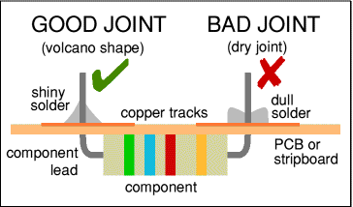**Hold the soldering iron like a pen, near the base of the handle.**   
  Remember to never touch the hot element or tip.
* **Touch the soldering iron onto the joint to be made.**   
  Make sure it touches both the component lead and the track. Hold for a second or so to pre-heat the joint before solder is applied.
* **Feed a little solder onto the joint touching iron tip first.** This action is necessary to melt solder and form a heat bridge between the iron and the joint   
  Apply the solder to the joint. It should flow smoothly onto the lead and track to form a volcano shape as shown in the diagram.
* **Remove the solder, then the iron, while keeping the joint still.**   
  Allow the joint a few seconds to cool before you move the circuit board.
* **Inspect the joint closely.**   
  It should look shiny and have a 'volcano' shape. If not, you will need to reheat it and feed in a little more solder. This time ensure that **both** the lead and track are heated fully before applying solder.

|  |
| --- |
| Crocodile clip, photograph © Rapid Electronics |
| Crocodile clip |

**Using a heat sink**

Some components, such as transistors, can be damaged by heat when soldering so if you are not an expert it is wise to use a heat sink clipped to the lead between the joint and the component body. You can buy a special tool, but a standard crocodile clip works just as well.

**Soldering Advice for Components**

It is very tempting to start soldering components onto the circuit board straight away, but please take time to identify all the parts first. You are much less likely to make a mistake if you do this!

1. **Identify each component** **prior to commencement.** Place in groups of like components if there are more than one of each type.
2. **Order of installation** there are no hard and fast rules but it is best to start with any wire links and IC sockets followed by resistors, capacitors, diodes, transistors, IC’s and finally any external connections such as battery holders or interconnecting wires.
3. Some components require special care when soldering. Many must be placed the correct way round and a few are easily damaged by the heat from soldering. Appropriate warnings are given in the table below.

|  |  |  |  |
| --- | --- | --- | --- |
|  | **Components** | **Pictures** | **Reminders and Warnings** |
| 1 | IC Socket | IC holder | Connect the correct way round by making sure the notch is at the correct end.  Do NOT put the ICs (chips) in yet. |
| 2 | Wire links | single core wire  single core wire | Use single core wire, this is one solid wire.  If there is no danger of touching other parts you can use tinned copper wire, this has no plastic coating and looks just like solder but it is stiffer. |
| 3 | Resistor | resistor | No special precautions are needed with resistors. |
| 4 | Small Capacitors | small value capacitors | These may be connected either way round.  Take care with polystyrene capacitors because they are easily damaged by heat. |
| 5 | Electrolytic Capacitors | electrolytic capacitor | Connect the correct way round. They will be marked with a + or - near one lead. |
| 6 | Diodes | diodes | Connect the correct way round. |
| 7 | LED’s | LED | Connect the correct way round.  The diagram may be labelled a or + for anode and k or - for cathode; The cathode is the short lead and there may be a slight flat on the body of round LEDs. |
| 8 | Transistors | transistors | Connect the correct way round.  Transistors have 3 'legs' (leads) so extra care is needed to ensure the connections are correct.  Easily damaged by heat. |
| 9 | Interconnecting wires | stranded wire  stranded wire | You should use stranded wire which is flexible and plastic-coated.  Do not use single core wire because this will break when it is repeatedly flexed. |
| 10 | IC’s | 555 timer IC | Connect the correct way round.  Many ICs are static sensitive.  Leave ICs in their antistatic packaging until you need them, then use an anti static mat and wrist strap as precaution. |

**What is solder?**

|  |
| --- |
| http://www.kpsec.freeuk.com/photos/rapid/solder.jpg |
| Reels of solder |

Solder is an alloy (mixture) of tin and lead, typically 60% tin and 40% lead. It melts at a temperature of about 200°C. Lead free solder is now the preferred method as the reduction of lead in electronic products has been a requirement since July 1st, 2006. The alloy used is typically approximately 95% Tin, 4% Silver and 1% Copper with a melting point around 220°C. Due to the unproven long term reliability of lead free alternatives we will still find lead based solders in use in aviation and medical equipment. Coating a surface with solder is called 'tinning' because of the tin content of solder. Lead is poisonous and you should always wash your hands after using lead based solder.

Solder for electronics use contains tiny cores of flux, like the wires inside a mains flex. The flux is corrosive, like an acid, and it cleans the metal surfaces as the solder melts. This is why you must melt the solder actually on the joint, not on the iron tip. Without flux most joints would fail because metals quickly oxidise and the solder itself will not flow properly onto a dirty, oxidised, metal surface.

**Desoldering**

At some stage you will probably need to desolder a joint to remove or re-position a wire or component. There are a few ways to remove the solder:

|  |
| --- |
| http://www.kpsec.freeuk.com/photos/desolder.jpg |
|  |

**1.  With a manual solder sucker**

* Set the pump by pushing the spring-loaded plunger down until it locks.
* Apply both the pump nozzle and the tip of your soldering iron to the joint.
* Wait a second or two for the solder to melt.
* Then press the button on the pump to release the plunger and suck the molten solder into the tool.
* Repeat if necessary to remove as much solder as possible.
* The pump will need emptying occasionally by unscrewing the nozzle.

|  |
| --- |
| http://www.kpsec.freeuk.com/photos/rapid/wick.jpg |
| Solder remover wick |

**2.  With solder remover wick (copper braid)**

* Apply both the end of the wick and the tip of your soldering iron to the joint. This works best if the iron is placed directly over the wick.
* As the solder melts most of it will flow onto the wick, away from the joint.
* Remove the wick and iron together.
* Cut off and discard the end of the wick coated with solder.

After removing most of the solder from the joint(s) you may be able to remove the wire or component lead straight away (allow a few seconds for it to cool). If the joint will not come apart easily apply your soldering iron to melt the remaining traces of solder at the same time as pulling the joint apart, taking care to avoid burning yourself.

**\*\*Not recommended for use with boards where copper layer is very thin as excessive heat may damage this material.**

**3. With an electronic vacuum pump.**

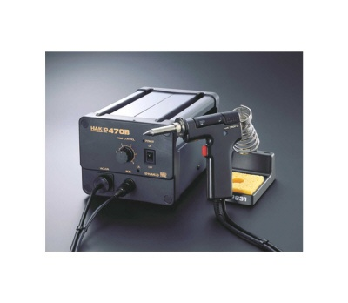

* Generally hollow tipped soldering iron with a vacuum hose attached to the base station.
* Operate by placing over the solder joint to be desoldered, allow to heat and melt solder for a few seconds then when solder is molten press the trigger to operate vacuum pump and remove solder.
* Will require solder reservoir to be emptied from time to time and also hollow in tip to be cleared usually with tool supplied. Generally this will be a simple length of very stiff wire used to clear any solder from the hollow section of the tip.

**Worksheet – 1**

1. State three safety precautions that should be observed whilst soldering?

|  |
| --- |
|  |
|  |
|  |

1. State three actions required to prepare a soldering iron for use?

|  |
| --- |
|  |
|  |
|  |

1. Describe the best method to use in order to create a reliable solder joint?

|  |
| --- |
|  |
|  |
|  |

1. In what order would you typically mount the following components when constructing a PCB?

|  |  |
| --- | --- |
| Capacitor |  |
| Wire Link |  |
| Diode |  |
| IC |  |
| IC Socket |  |
| Interconnecting Wires |  |
| Resistor |  |

1. What precautions need to be observed when mounting the following components?

|  |
| --- |
| IC |
|  |
| Diode |
|  |
| Resistor |
|  |
| Transistor |
|  |

1. State three methods of de-soldering and give a brief description of each?

|  |
| --- |
|  |
|  |
|  |
|  |
|  |
|  |
|  |

1. Describe the composition of both lead type and lead free solder. Give quantities of different metals and approximately melting temperatures?

|  |  |  |
| --- | --- | --- |
| Solder Type | Lead Free | Leaded |
| Composition |  |  |
| Melting Temp |  |  |

**Worksheet 2**

1) State three of the hazardous components as specified on the product MSDS?

|  |
| --- |
|  |
|  |
|  |

2) Are there any risk phrases for this substance?

|  |
| --- |
|  |

3) Are there any safety phrases listed for this substance? Please state number and definition.

|  |
| --- |
|  |

4) State three potential health effects associated with this product.

|  |
| --- |
|  |
|  |
|  |

5) What are the first aid measures recommended for the following exposures to this material?

|  |
| --- |
| Inhalation: |
| Skin contact: |
| Eye contact: |
| Ingestion: |

6) Is this product considered to be flammable?

|  |
| --- |
|  |

7) State three of the hazardous products as a result of combustion of this substance.

|  |
| --- |
|  |
|  |
|  |

8) What environmental precautions should be taken following an accidental release of this product?

|  |
| --- |
|  |
|  |
|  |
|  |

9) What are the handling and storage recommendations for this product?

|  |
| --- |
|  |
|  |
|  |

10) What are the recommended disposal considerations for this sub-stance.

|  |
| --- |
|  |
|  |

11) What PPE is recommended to be worn whilst using this product?

|  |
| --- |
|  |
|  |
|  |

**Activity – 1**

Using the Altronics catalogue fill out the parts order below.

|  |  |  |  |  |  |
| --- | --- | --- | --- | --- | --- |
| **Component** | **Altronics**  **Stock Code** | **Qty in Package** | **Qty required** | **Price per unit** | **Total** |
| 1KΩ, 0.6-watt resistor |  |  |  |  |  |
| 10KΩ, 0.6-watt resistor |  |  |  |  |  |
| 390 Ω 0.6-watt Resistor |  |  |  |  |  |
| 470µf, 16 volt capacitors |  |  |  |  |  |
| Transistor BC548 |  |  |  |  |  |
| 10k 5mm Top Adjust Trimpot |  |  |  |  |  |
| Red 3mm LED |  |  |  |  |  |
| Green 3mm LED |  |  |  |  |  |
| Diode IN 4004 |  |  |  |  |  |
| 9V battery snap clip |  |  |  |  |  |



**Activity – 2**

Soldering practice –

Using tinned copper wire cut and bend neat wire links to insert into the PCB in the rigid, clinch and double clinch positions. Your lecturer will demonstrate soldering technique and how to solder using rigid and clinched joints. Fill all of the holes being 5 rigid links, 5 clinch links and 4 double clinch links. Keep your PCB as you will need it to complete your practical assessment.



Student successfully produced links and soldered in to PCB

__________________________

Signed : Lecturer



**SAFETY DATA SHEET**

**ISSUED SEPTEMBER 2014 (VALID 5 YEARS FROM DATE OF ISSUE)**

**TC1 MILD STRENGTH TIP THINNERS**

**SECTION 1 - IDENTIFICATION OF THE MATERIAL**

Chemtools Pty Ltd Phone: 1300 738 250 (business hours) Unit 2/14-16 Lee Holm Road Fax: 02 9623 3670

St Marys NSW 2760 [www.chemtools.com.au](http://www.chemtools.com.au/)

**PRODUCT NAME** Mild Strength Tip Thinners

**PRODUCT TYPE** Tinning and cleaning aid for soldering irons

**PART NUMBER** CT-TC-1

**AVAILABLE SIZES** 20g

**SECTION 2 - COMPOSITION/INFORMATION ON INGREDIENT HAZARDOUS COMPONENTS CAS # % TWA HSIS STEL HSIS**

|  |  |  |  |  |
| --- | --- | --- | --- | --- |
| Tin | 7440-31-5 | <60 | 2mg/m3 | N/A |
| Ammonium phosphate | 7783-28-0 | <60 |  |  |
| Alcohol ethoxylate | 68439-46-3 | <10 |  |  |
| Non-hazardous ingredients | N/A | <10 |  |  |
| **SECTION 3 - HAZARDS IDENTIFICATION** |  |  |  |  |

**Hazard Classification:** Not classified as a Hazardous Substance according to the criteria of SafeWork Australia.

**Risk Phrases:**

**Safety Phrases:** S2 – Keep out of reach of children

**Relevant routes of exposure:** Ingestion.

**Potential Health Effects**

**Inhalation:** The fumes produced during use will irritate the nose and throat.

**Skin contact:** Skin irritation may result from prolonged contact.

**Eye contact:** Fumes produced during use may irritate the eyes.

**Ingestion:** Will irritate the digestive tract.

|  |
| --- |
| **SECTION 4 – FIRST AID MEASURES** |

**Inhalation:** Remove the source of contamination or move the victim to fresh air. Ensure airways are clear. Administer oxygen if breathing is difficult. If symptoms develop and persist, seek medical attention

**Skin contact:** Wash the affected area with plenty of cold or lukewarm running water. If symptoms develop and persist, seek medical attention.

**Eye contact:** Flush immediately with copious amounts of water holding eyelid(s) open. Take care not to rinse contaminated water into the non-affected eye. If symptoms develop and persist seek medical attention.

**Ingestion:** Do NOT induce vomiting. Wash out mouth with water. If symptoms develop and persist, seek medical attention

|  |
| --- |
| **SECTION 5 – FIRE FIGHTING MEASURES** |

**Flash point:** >200ºC (Closed Cup)

**Autoignition temperature:** Non Flammable

**Flammable/Explosive limits-lower %:** N/A

**Flammable/Explosive limits-upper %:** N/A

**Extinguishing media:** N/A

**Special fire fighting procedures:** N/A

**Unusual fire or explosion hazards:** None

**Hazardous combustion products:** Under fire conditions this product may emit toxic and/or irritating fumes including carbon monoxide, carbon dioxide, oxides of nitrogen, and organic substances

|  |
| --- |
| **SECTION 6 – ACCIDENTAL RELEASE MEASURES** |

**Environmental precautions:** Dispose of waste according to federal, Environmental Protection Authority and state regulations. If large spillages of this material enters the waterways contact the Environmental Protection Authority, or your local Waste Management Authority.

**Clean-up methods:** Use appropriate personal protective equipment during clean-up

**SECTION 7 – HANDLING AND STORAGE**

**Handling:** No special handling procedures are required. Wash hands thoroughly after handling

Store in a cool, dry well-ventilated area away from heat, oxidising agents and out of direct sunlight. Keep out of reach of children and away from foodstuffs.

**Incompatible products:** Refer to Section 10.

|  |
| --- |
| **SECTION 8 – EXPOSURE CONTROLS/PERSOANL PROTECTION** |

**Engineering controls:** No exposure standards have been established for this material by HSIS. However, as with all chemicals, exposure should be kept to the lowest possible levels.

**Respiratory protection:** Not normally required. However if engineering controls are not effective in

controlling airborne exposure then respiratory protective equipment should be used suitable for protecting against fume. Reference should be made to

Australian Standards AS/NZS 1715, Selection, Use and maintenance of

Respiratory Protective Devices; and AS/NZS 1716, Respiratory Protective Devices

**Skin protection:** Gloves are recommended as good industrial practice

**Eye/face protection:** Safety glasses are recommended as good industrial practice.

**See Section 2 for exposure limits.**

|  |
| --- |
| **SECTION 9 – PHYSICAL AND CHEMICAL PROPERTIES** |

**Physical state:** Solid (tablet).

**Colour:** Grey

**Odour:** None. **pH:** N/A **Boiling point/range:** >500C. **Melting point/range:** >200C

**Specific gravity:** Approx. 4 g/cm³

**Vapour density:** N/A

**Evaporation rate:** N/A

**Solubility in water:** Partially soluble.

|  |
| --- |
| **SECTION 10 – STABILITY AND REACTIVITY** |

**Stability:** Stable at normal temperatures and conditions.

**Hazardous polymerization:** Will not occur.

**Hazardous decomposition products:** In case of incomplete combustion and/or thermal decomposition carbon monoxide, carbon dioxide may be released. Molten tin may be formed.

**Incompatibility:** Strong oxidising agents.

**Conditions to avoid:** See "Handling & Storage" (Section 7) and "Incompatibility" (Section 10).

|  |
| --- |
| **SECTION 11 – TOXICOLOGICAL INFORMATION** |

**Product toxicity data:** Not determined.

|  |
| --- |
| **SECTION 12 – ECOLOGICAL INFORMATION** |

**Ecological information:** The product is not readily biodegradable but inherently biodegradable.

|  |
| --- |
| **SECTION 13 – DISPOSAL CONSIDERATIONS** |

**Recommended method of disposal:**

Recover or recycle if possible. Dispose of according to Federal, State and local governmental regulations.

|  |
| --- |
| **SECTION 14 – TRANSPORT INFORMATION** |

Not classified as a Dangerous Good, according to the Australian Code for the Transport of Dangerous Goods by

Road and Rail (6th Edition).

**Domestic (Land):**

**Proper shipping name:** No information found

**UN No.**:

**Hazard class or division:**

**Packing group:**

**International Air Transportation (ICAO/IATA):**

**Proper shipping name:** No information found

**UN No.**:

**Hazard class or division: Packing group:**

|  |
| --- |
| **SECTION 15 -** |

**Poisons Schedule (SUSDP):** Not Listed.

**ADG Code:** No information found.

**NOHSC:** Not Listed.

|  |
| --- |
| **SECTION 16 – OTHER INFORMATION** |

**Abbreviations/Acronyms:** ADG – Australian Dangerous Goods.

AICS – Australian Inventory of Chemical Substances. HSIS - Hazardous Substances Information System. IARC – International Agency for Research on Cancer.

NIOSH – National Institute of Occupational Health and Safety. NOS – Not Otherwise Specified.

PEL – Permissible Exposure Limit. STEL – Short Term Exposure Limit.

SWA – SafeWork Australia, formally ASCC and NOHSC.

SUSDP – Standard for the Uniform Scheduling of Drugs and Poisons. TLV – Threshold Limit Value.

TWA – Time Weighted Average.

|  |
| --- |
| **DISCLAIMER** |

The information contained within this MSDS applies only to the Chemtools product to which the sheet relates. The information provided is based on our best knowledge at the time of issue.

The information contained within this MSDS is believed to be accurate and is given in good faith. However, no warranty is made, either expressed or implied, regarding its accuracy or any liability arising out of the use of the information herein or the product supplied.

When used in other preparations, formulations, or in mixtures, it is necessary to ascertain whether the classifications of the hazards have changed. The attention of the user is drawn to the possibility of creating other hazards when the product is used for purposes other than that for which it was recommended. In such cases, a reassessment may be necessary and should be made by the user.

This safety data sheet should only be used and reproduced in order that the necessary measures are taken relating to the protection of health and safety at work.

It is the responsibility of the handlers to pass on the totality of the information contained within this document to any subsequent person(s) who will come in to contact with, handle or use this product in any way.

They should check the adequacy of the information provided within this MSDS before passing it on to their customers/staff.