
UEE11 Training Package Support Material
(Non-Endorsed Component)
Based on:
National Electrotechnology Industry Standards

Resource Book

UEENEEP024A

Version 3

© North Metropolitan TAFE
ACKNOWLEDGEMENTS

This Resource Book is intended for use by North Metropolitan TAFE students only.
COPYRIGHT DISCLAIMER
Some of the material and graphics in this workbook may have been reproduced from the following published material by North Metropolitan TAFE for educational purposes under Part VB of the Copyright Act 1968.
- AS/NZS 3760:2010 In service safety inspection and testing of electrical equipment.
- AS/NZS 3000:2007 Wiring Rules (current edition)
- AS/NZS 4836:2011 Safe working on or near low-voltage electrical installations and equipment.

Safety Sign images reproduced from www.safetysignswa.com.au
Drawings courtesy of North Metropolitan TAFE Lecturing Staff.
All rights reserved. Apart from any use as permitted under the Copyright Act 1968, no part
may be reproduced without the prior written permission of North Metropolitan TAFE.
This permission does not extend to the making of copies for use outside the immediate training environment for which they are made, nor the making of copies for hire or resale to third parties.
Requests and enquiries concerning other reproduction and rights should be directed in the first instance to the Manager Publications and Distributions.
Manager Publications and Distributions North Metropolitan TAFE
Locked Bag 6
Northbridge WA 6865
Disclaimer:
Whilst every effort has been made to ensure the accuracy of the information contained in this publication, no guarantee can be given that all errors and omissions have been excluded. No responsibility for loss occasioned to any person acting or refraining from action as a result of the material in this publication can be accepted by North Metropolitan TAFE.

C O N T E N T S
Competency Standard Unit Elements and Performance Criteria UEENEEP024A
Delivery Plan
Assessment Strategy
Danger Tag Procedure
Laboratory and Workshop Safety Instructions

UEENEEP024A - Training Achievement Record
Name: | Student No: | Apprenticeship No
Employer: |  | College:

P | Topic | Date | Lecturer
Worksheet 1 | Practical electrical circuits and protection.
Worksheet 2 | Ohm’s law
Worksheet 3 | Electrical power.
Activity 1 | Removing the Insulation from a Flexible Cord
Worksheet 4 | Resistance measurements.
Worksheet 5 | Selection of flexible cords.
Activity 2 | Fitting a plug to a flexible cord
Activity 3 | Identify various plug and socket patterns
Worksheet 6 | Documentation.

References:

- AS/NZS 3760:2010 In service safety inspection and testing of electrical equipment.
- AS/NZS 3000:2007 Wiring Rules (current edition)
- AS/NZS 4836:2011 Safe working on or near low-voltage electrical installations and equipment.
UEENEEP024A - Attach cords and plugs to electrical equipment for connection to a single phase 230 Volt supply

Unit Descriptor
Unit Descriptor | Descriptor
 | This unit covers attaching flexible cords and plugs to electrical equipment for connection to supplies up to 230V a.c. This may be incidental to or a primary and regular function of work related to a principle function in the workplace. It encompasses working safely, identifying plug configurations, selecting and using testing and measuring devices, terminating and connecting cords/plugs and conductors, safety testing and reporting.

Application of the Unit
Application of the Unit | This unit applies to any formal recognition for this standard at the aligned AQF 2 level or higher.

Licensing/Regulatory Information
1.2) License to practice
The skills and knowledge described in this unit may require a license to practice in the workplace. However, practice in this unit is subject to regulations directly related to occupational health and safety and where applicable contracts of training such as apprenticeships.
Note:
Candidates are to meet regulator eligibility requirements by providing formal confirmation from the relevant state/territory regulator for the respective work class and scope of work prior to developing and being conferred competent.

Pre-Requisites
Prerequisite Unit(s) | 2.1) Competencies
 | Granting competency in this unit shall be made only after competency in the following unit(s) has/have been confirmed.
 | UEENEEE101A | Apply Occupational Health and Safety regulations, codes and practices in the workplace

Elements and Performance Criteria Pre-Content
6) Elements describe the essential outcomes of a unit of competency |  | Performance criteria describe the required performance needed to demonstrate achievement of the Element. Assessment of performance is to be consistent with the evidence guide.
ELEMENT | PERFORMANCE CRITERIA
1 | Plan and prepare to attach flexible cord(s) and plug(s). |  | 1.1 | Work is planned and prepared to ensure OHS policies and procedures are followed, and the work is appropriately sequenced in accordance with requirements.
 |  |  | 1.2 | Condition and ratings under which the flexible cords and plugs are to operate is determined from requirements and in consultation with appropriate personnel followed by written instruction.
 |  |  | 1.3 | Flexible cords and plugs are selected to comply with standards and requirements for the condition and rating to be determined.
 |  |  | 1.4 | Materials necessary to complete the work are obtained in accordance with established procedures and checked against job requirements.
 |  |  | 1.5 | Tools, equipment and testing devices needed to carry out the work are obtained in accordance with established procedures and checked for correct operation and safety.
 |  |  | 1.6 | Flexible cord(s) is prepared without damage to insulation and conductors and in accordance with requirements.
2 | Attach flexible cord(s) and plug(s). |  | 2.1 | OHS policies and procedures are followed.
 |  |  | 2.2 | Single insulated metal framed equipment is earthed in accordance with requirements.
 |  |  | 2.3 | The integrity of double insulated equipment is maintained in accordance with requirements.
 |  |  | 2.4 | Conductors are connected to terminals in accordance with requirements to ensure the required polarity is affected.
3 | Test equipment for operation and safety. |  | 3.1 | Appropriate tests of the cord(s) and plug(s) connected to the electrical equipment are conducted in accordance with requirements and to established procedures to ensure safe installation and operation.
 |  |  | 3.2 | Ongoing checks of the quality of work are undertaken in accordance with established procedures.
4 | Locate and repair fault(s) in attached flexible cord(s) and plug(s). |  | 4.1 | Electrical equipment and attached flexible cord(s) and plug(s) are isolated, where necessary, in accordance with established procedures.
 |  |  | 4.2 | Other OHS policies and procedures are followed.
 |  |  | 4.3 | Visual checks of the attached flexible cord(s) and plug(s) are carried out in accordance with established procedures to detect any abnormal or obvious damage or fault.
 |  |  | 4.4 | Fault(s) in attached flexible cord(s) and plug(s) are confirmed and components to be replaced are determined and details recorded in accordance with established procedures.
 |  |  | 4.5 | Fault(s) in attached flexible cord(s) and plug(s) are repaired in accordance with established procedures, where necessary.
 |  |  | 4.6 | Approval is obtained in accordance with established procedures from appropriate personnel, before any contingencies are implemented.
5 | Provide status report(s). |  | 5.1 | Status report(s) are completed and notified in accordance with established procedures.

Required Skills and Knowledge
REQUIRED SKILLS AND KNOWLEDGE
7) This describes the essential skills and knowledge and their level, required for this unit.
Evidence shall show that knowledge has been acquired of safe working practices and attaching cords and plugs to electrical equipment for connection to a single phase 230 Volt supply.
All knowledge and skills detailed in this unit should be contextualised to current industry practices and technologies.
KS01-EP024A | Flexible cords and plugs to 230 V
Evidence shall show an understanding of flexible cords and plugs to 230 V to an extent indicated by the following aspects
T1 Safety encompassing:
* OH&S and electrical safety requirements
* requirements of AS/NZS 4836:2001 Safe working practices on low voltage installations
T2 The basic electrical circuit encompassing:
* simple electric circuit (supply, control device and load)
* symbol, units of measurement and the abbreviation for electromotive force, potential difference, current and resistance.
* drawing of a basic electrical circuit using correct symbols
* using multiples and submultiples for voltage, current and resistance values
* a.c and d.c supplies
* single phase electrical loads
* electrical circuit protection devices
T3 Relationships in an electrical circuit encompassing:
* relationship between voltage, current and resistance (Ohm’s law)
* changes in circuit parameters for altered values of voltage, current and resistance
* electrical power in relationship to d.c. or resistive a.c. circuits
T4 Test Equipment - resistance measurement encompassing:
* types of electrical test equipment used for resistance measurement (analogue and digital multimeters, insulation resistance testers and continuity testers)
* selection of appropriate electrical test instrument for continuity and insulation resistance measurement
* using analogue and digital multimeters for resistance measurement (ensuring zero setting, correct scale selection, avoidance of parallax error and estimation of between division readings for analogue multimeters)
* continuity tests and using a continuity tester to check the polarity of a three core extension cord
* insulation resistance tests and minimum values for insulation resistance for low voltage equipment
* reasons for insulation resistance testing is conducted at higher than supply voltage (AS/NZS3000 requirements)
* using insulation resistance hand held tester
* care and storage of electrical instruments
* regulatory requirements in regard to the maintenance and testing of test instrumentation for resistance measurement.
T5 Selection of flexible cords and plugs to suit given applications encompassing:
* types , structures and applications of common cores (parallel two core unsheathed (‘figure 8’) cords, light duty sheathed, ordinary duty sheathed, heavy duty sheathed and textile braided)
* determining the current rating of a range of commonly used flexible cords
* service duty
* purpose of colour coding and the recommended single phase colour code and the conventional code used in the most common alternative colours
* selection of appropriate flexible cords for a range of single phase appliances in regard to application, load, and service duty
* identification of correct plug and socket polarities for the range of commonly used 230 volt plug socket combinations
* factors affecting the choice of plugs and sockets including IP rating
* selection of the correct plug and socket combinations for a range of applications including use in damp areas
T6 Connecting flexible cords and plugs to appliances encompassing:
* design features of plugs and sockets which protect the conductor terminations from undue force when disconnecting a cord - tortuous path
* cord preparation - not to mark/damage the inner core when stripping the sheath for termination, double the end of the conductor to be terminated
* purpose of earthing
* structure of double insulated appliances, symbol, reasons they should not be earthed, and maintenance of the integrity of the double insulation
* preparation of the surfaces at an earthing connection before and after completion of the termination including terminations exposed to corrosion, and those for which no specific earthing terminal is provided
* fitting a range of various plugs and sockets with attention to requirements, colour code, polarity, and correct termination of conductors with the sheath well into the body, and the cord grip anchored
* terminate cords to several appliances utilising the appropriate cord type and rating
T7 Testing encompassing:
* importance of conducting both visual and electrical tests to ensure leads are safe and appropriate for connection to supply in regard to physical condition, sufficiently high insulation resistance, continuity, arrangements for protection against indirect contact are undamaged and in place, appropriate IP rating, and arrangements for protection against dangers of mechanical movement as relevant are undamaged and in place
* check polarity of plug, and for any abnormal or obvious damage or fault
* minimum acceptable value of insulation resistance between active neutral and earth
* conduct insulation resistance and continuity tests prior to, and after, connecting cords and plugs to appliances
* fault finding attached cords and plugs, and cord extension leads
T8 Producing documentation and reports encompassing:
* nature and content of, and the need to produce, status reports and documents
* Producing status reports and documents
UEENEEP024A – Attach cords and plugs to electrical equipment for connection to single phase 230 Volt supply.

Learning and Assessment Plan Summary

Name of Lecturer: ______________________________________________________________

Contact Details: ______________________________________________________________

Delivery Mode/s: □ Face to Face □ On-Line □ Blended Delivery □ Other

UEENEEP024A – Attach cords and plugs to electrical equipment for connection to single phase 230 Volt supply.

Session 2hrs | Nominal  Duration | Program of Work  (Topics to be covered) | Primary Reference
1 | 1 | Safe working practices on low voltage installations and equipment. | Resource Book
1 | 1 | Practical electrical circuits and protection. | Resource Book
2 | 2 | Ohm’s law | Resource Book
3 | 1 | Electrical power. | Resource Book
3 | 1 | Resistance measurements. | Resource Book
4 | 1 | Selection of flexible cords. | Resource Book
4 | 1 | Earthing | Resource Book
5 | 1 | Plugs and sockets. | Resource Book
5 | 1 | IP Rating | Resource Book
6 | 2 | Fitting cords and plugs to appliances. | Resource Book
7 | 2 | Appliance testing./ Documenting | Resource Book
8 | 1 hour | Submit Portfolio. | AS/NZS 3760:2010
8 | 1 hour | Knowledge Assessment | Resource Book  CSU – Performance Criteria  CSU - RSAK
8 | 1 hour | Skills Assessment of Unit | Resource Book  CSU – Performance Criteria  CSU - RSAK

I acknowledge that I have received and read the UEENEEP024A Learning and Assessment Plan

Student Name:___________________________ Signature: _______________________ Date: _________

Lecturer Name | Lecturer Signature | Date

Assessment Strategy

Conditions of Assessment:

Normally learning and assessment will take place in an integrated classroom/ laboratory environment.

It is essential to complete the Portfolio questions and activities in this book and follow the guidance of your lecturer. The questions and activities in this book contribute towards satisfying the performance criteria and the required skills and knowledge as outlined in this Unit of Competence.

Assessment Methods:

Portfolio - The satisfactory completion of all question worksheets and the activities is required.

Knowledge Assessment – based on the REQUIRED SKILLS AND KNOWLEDGE. You must achieve a mark of 75% or more in this assessment.

Skills Assessment – based on the Elements and Performance Criteria of this Competency Unit UEENEEP204A. You must achieve a Satisfactory result in this assessment.

Re-assessment

A student may be offered (1) re-assessment opportunity should their first attempt not return a satisfactory result. A student may require re-enrolling in the unit should they not exhibit sufficient competency in any assessment opportunity or fail to attend the assessment opportunity without a valid and reasonable reason.
On-Job-Training:

It is expected that the off-job component of this competency unit will be complemented by appropriate on-job development involving exposure to re-occurring workplace events and supervised experiences. (See Work Performance Tasks). You are required to log your on-the-job training in your on line ‘Q-Tracker’ account.

Sufficiency of Evidence:

In all instances competency is to be attributed on evidence sufficient to show that a person has the necessary skills required for the scope of work. These include:

• Task skills - performing individual tasks
• Task management skills - managing a number of different tasks
• Contingency management skills - responding to irregularities and breakdowns in routines
• Job/role environment skills - dealing with the responsibilities and expectations of the work environment including working with others.

Evidence must demonstrate that an individual can perform competently across the specified range of activities and has the essential knowledge, understanding and associated skills underpinning the competency.

DANGER TAG PROCEDURE for ELECTRICAL TRADE LABORATORIES

THE FOLLOWING PROCEDURE IS COMPULSORY

1. The student is to attach a DANGER TAG on to the plug top of the project lead before proceeding with the allocated project. A danger tag must be attached to the plug top at all times, when the lead is NOT plugged into the supply outlet. Plug tops or leads are not to be connected to the supply outlet WHILE A DANGER TAG is attached.

2. The student is to assemble the project according to project instruction procedure and lecturer’s directions in its isolated and de-energised state and report to the lecturer as necessary and on completion.

3. The lecturer is to:-
a. Check the project for safety and
b. Ensure that the student has performed a safety check, including short circuit test using the recommended procedure.

4. When the lecturer is satisfied that the project is safe to connect and energise, the lecturer is to instruct the student to REMOVE the DANGER TAG from the plug top.

5. The student is to plug in the project and switch it on in the presence of the lecturer.

6. The lecturer is to determine whether or not the project is operating satisfactorily.

7. If the project operates satisfactorily the student may take measurements using correct meters with regard to the safety risks associated with using the particular item of test equipment including;
- Selecting correct meter function,
- Holding meter probes correctly during measuring with fingers behind knurls (finger guards) at all times.
This is to be done under general supervision of lecturer. The student is NOT to modify, disassemble or carry out ANY unsafe act.
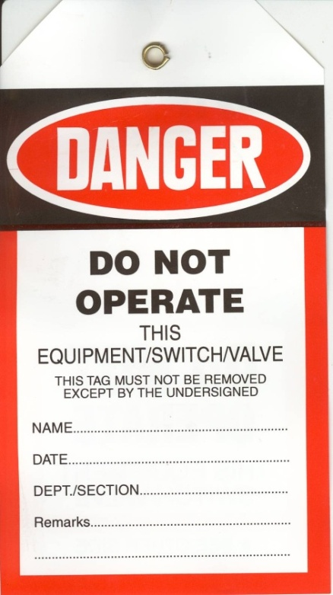
8. If the circuit is to be modified the student must:
a. Switch the circuit off,
b. Disconnect the project from the supply,
c. Attach the DANGER TAG to the plug top,
d. Report to the lecturer for instructions,
In the lecturer's presence the student is to:-
e. TEST and VERIFY for ZERO VOLTAGE.
f. Restart the DANGER TAG procedure from step 2 above.

9. When the student is satisfied that the project has been completed the student is to:-
a. Switch the project off,
b. Remove the plug,
c. Replace the DANGER TAG on the plug top,
d. Report to the lecturer for instructions,

In the lecturer's presence the student is to:-
e. TEST and VERIFY for ZERO VOLTAGE.
The lecturer is then to instruct the student to:-
f. Disassemble the project
g. Remove the DANGER TAG and store the equipment in its designated place.
LABORATORY SAFETY

Students working in laboratories at North Metropolitan TAFE Balga Campus do so, on condition that they agree to abide by the following safety instructions. Failure to observe the safety instructions will result in IMMEDIATE SUSPENSION.
- No circuit is to be plugged in or switched on without the specific permission of the lecturer in charge of the class. A circuit must be switched off and tested for ZERO VOLTS before any supply leads are removed. The DANGER TAG PROCEDURE must be used at all times.

- Do not leave any circuit switched on any longer than necessary for testing. Do not leave any circuit switched on unattended.

- Check each item of equipment before using. Report any broken, damaged or unserviceable equipment to your Lecturer.

- All wiring must be disconnected at the end of each practical class or as each project is completed.

- Make all connections in a safe manner with an appropriate connecting device. Unshielded 4mm banana plugs are not to be used for wiring.

- Switch off, remove the plug from the socket and attach your DANGER TAG to the plug top before working on any project. It is not sufficient to simply turn the switch off.

- When disconnecting your wiring from a connection made under a screw, undo the screw to remove the wiring, do not cut the wire off.

- Observe the correct colour code for all wiring projects.

- Test your circuit for short circuits with your multimeter before asking your Lecturer to switch circuit on. Test the Tester before and after EACH test.

- Skylarking and horseplay is not permitted at any time.

- Proper clothing and safety footwear must be worn at all times. Thongs, sandals and singlets are not permitted. Hard capped safety boots or safety shoes MUST be worn AT ALL TIMES at North Metropolitan TAFE Balga Campus.

- Where an activity sheet is issued for a project, complete each step in the Procedure before moving to the next step. Advise your Lecturer when you have completed the activity.

- Draw ALL DIAGRAMS in PENCIL so that they can be easily changed or corrected. Mark off each connection on your diagram as it is made.

- Check the range before taking a reading with a multimeter.

- Make sure that it is YOUR plug before inserting plug into an outlet.

- Always switch multimeter OFF, or to the highest possible AC VOLTS range when you have finished using it.

- Report any unexpected situations or events to your Lecturer.

Student’s Signature :___________________ Date :___/___/_____

ISOLATION PROCEEDURE

The procedure for isolating a complete circuit consists of several basic operations:-

- NOTIFY / Advise the owner or manager that you intend to isolate the circuit.

- IDENTIFY circuit /equipment / appliance or machine and turn off. Lock it off with a padlock if possible.

- ISOLATE the supply by withdrawing the fuses (remove fuse wire/cartridge) or switching the circuit breaker to the off position. Lock it in the OFF position.

- TAG Attach your “Danger Tag” to the fuses or circuit breaker to warn others that the circuit must not be re-energised.

- CHECK your test instrument (multimeter on voltage setting) on a known voltage source to see that it is working properly (i.e. Reads the expected voltage).

- CHECK/TEST for zero volts at the point at which you are to begin work. Test between all actives. From all actives to neutral and from all actives to earth.

- CHECK /Re-check your test instrument to see that it is still working properly.

- CHECK / Double check all conductors using another voltage tester, such as a volt stick.

The Acronym for this is “NIITCCCC” as in Nietzsche the advocate for “voluntary euthanasia”
The facts are that if you don’t isolate correctly you create your own reality which may ultimately take your life

TEST BEFORE YOU TOUCH

CHECK THE CHECKER

THIS MAY SAVE YOUR LIFE

Treat all conductors as live until you are convinced they are de-energised.
JOB SAFETY ANALYSIS WORKSHEET

JSA No.: ____________________

Risk: H = High  S= Significant  M = Medium  L = Low  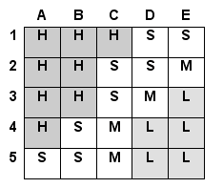 | Probability:  A – common or repeating occurrence  B – known to occur or “It has happened”  C – could occur, “I’ve heard of it happening”  D – not likely to occur  E – practically impossible | Consequences:  People:  1 – fatality or permanent disability  2 – lost time injury or illness  3 – medical treatment  4 – first aid treatment  5 – incident report only  Environment:  1 – toxic release off site with detrimental effect  2 – off site release with no detrimental effect  3 – off site release contained with outside assistance  4 – on site release immediately contained  5 – no environmental impact

STEP NO | JOB STEP  List the steps required to perform the task in the sequence they are carried out. | POTENTIAL HAZARD  Against each step list the  potential risk/ hazards that could cause injury / damage when the task step is performed. | Probability | Consequence | Risk Rank  L  S  M  H | REQUIRED HAZARD CONTROL  For each hazard  identified list the control measures required to eliminate or minimise the risk  of injury. | RESPONSIBILITY  - Nominate the person  who will be required to action the control measures
Job Safety Analysis Work Team Sign-on/ Review Register

Personnel are required to sign this register to indicate they have read, understand and will adhere to the requirements of the JSA

This JSA covers: |  |  |  | JSA No
Name | Employee Signature | Date | Name | Employee Signature | Date

Safe working practices on low voltage installations and equipment.
Extract from AS/NZS 4836:2011
S E C T I O N 2
P R I N C I P L E S OF R I S K M A N A G E M E N T A N D A S S E S S M E N T O F R I S K

2.1 GENERAL

To work on or near any electrical installations and equipment, it is first necessary to determine whether it is safe to do so. This can be done before starting work by applying a risk management system at each and every work site.
The first aim shall be to eliminate the risk.
If risk assessment indicates that risks cannot be sufficiently controlled to enable the work to be done safely, then the work shall not proceed.
Risk control principles and procedures for electrical work are covered in Section 3.

NOTES:
1 AS/NZS 31000 provides guidance on the establishment and implementation of the risk management process.
2 AS/NZS 4804 provides guidance on the development and implementation of occupational health and safety management systems.
3 Regulatory authorities in Australian states and territories and in New Zealand may have requirements for work in these areas (see Appendix C)

2.2 PRINCIPLES

The principles of risk management comprise—
(a) identifying the hazards;
(b) assessing and prioritizing the risks; and
(c) applying control measures to the identified risks.

2.3 IDENTIFY THE HAZARDS

2.3.1 General
Identify all the hazards and environmental considerations (e.g. position of exposed
energized conductors or live conductive parts, cramped conditions, moving equipment such as cranes or transfer cars, hot or wet conditions and hazardous areas).
Do not operate switches under load unless they are designed for the purpose.

NOTE: All other non-electrical sources of energy (e.g. counterweights on machines and stored
hydraulic and pneumatic energy) should be considered. AS 4024.1 provides guidance on the
safeguarding of machinery.


WARNING: ALL ELECTRICAL CONDUCTORS AND PARTS,
INCLUDING NEUTRAL AND EARTHING CONDUCTORS,
SHALL BE TREATED AS ENERGIZED UNTIL PROVEN
DE-ENERGIZED.

* TEST BEFORE YOU TOUCH
2.3.2 Electric shock
There are many sources of electric shock. Some of these are as follows:
(a) Voltages between phases, and between phases and neutral.
(b) Voltages between phases and earth (including metalwork, damp situations, other conductive surfaces and persons nearby).
(c) Voltages across open switch contacts.
(d) Voltages across undischarged capacitors, e.g EMI filters.
(e) Voltages on disconnected conductors (particularly neutrals).
(f) Voltages caused by static electricity.
(g) In multiple earthed neutral (MEN) electrical installations or systems, the rise in the earth potential in an electrical installation due to a high resistance return path to the supply neutral.
(h) Induced voltages.
(i) Voltages across secondary terminals of transformers, including current transformers.
(j) Voltages between different earthing systems.
(k) Incorrect wiring connections.
(l) Faulty electrical equipment or wiring, which may result in the frame of the electrical equipment being energized.
(m) Voltages from other sources of supply, e.g. illegal connections, uninterruptible power supplies, motor generators, inverters, solar panels and wind generators.
(n) Lightning.
(o) Breaking of the continuity of the incoming water supply.
(p) Voltages triggered inadvertently through the operation of float switches, thermostats, time switches and photo-electric cells, etc.
(q) Penetration with tools or fixings of structures containing concealed conductors.

2.3.3 Arc, blast and flash injuries
Persons working on or near energized conductors of electrical equipment should be aware that fault currents of up to 20 times the rated current of the supply transformer can flow for short times during arc fault conditions.

WARNING: ARCS THAT ARE PRODUCED UNDER THESE CONDITIONS HAVE THE ENERGY TO CAUSE AN EXPLOSION, MELT METALLIC SWITCHBOARD CUBICLES AND EQUIPMENT, CAUSE SEVERE BURNS AND FLASH BURNS TO THE FACE, EYES AND BODY AND INJURY THROUGH IMPACT FROM FLYING DEBRIS OR DISLODGED COMPONENTS. CIRCUIT PROTECTION DEVICES MIGHT NOT OPERATE TO SAFEGUARD THE WORKER IN SUCH CIRCUMSTANCES.

2.3.4 Hazardous areas
Many gases, vapours and dusts are combustible and potentially explosive. Risk of injury from explosion and fire and associated equipment damage exists in these areas. Potential sources of ignition include:
(a) Clothing made from wool, wool blends, nylons (unless treated with an antistatic process) and polyvinyl materials (especially those with a nylon base). It is possible for these materials to generate an electrical spark sufficient to ignite a flammable gas or vapour mixture.
(b) Personal effects, e.g. jewellery, watches, cigarette lighters, matches, battery-operated items such as hearing aids, mobile telephones, pagers, electronic car keys, key ring torches and transistor radios.
(c) Electric tools, test equipment and instruments, e.g. mains and battery-powered
appliances such as inspection hand lamps, drills and torches.
(d) Actions such as—
(i) any form of hot work including welding or brazing;
(ii) use of a hacksaw;
(iii) drilling or grinding of any type;
(iv) impact of a hammer or chisel onto concrete or metal;
(v) rubbing or movement of plastics; or
(vi) use of test equipment.
The items listed in Items (a), (b) and (c) above should not be taken or worn into a hazardous area, and the actions listed in (d) should not be undertaken unless—
(A) the items listed in Items (a), (b) and (c) are certified and authorised for use in the areas into which they are to be taken; or
(B) the area has been determined to be safe by a competent person (i.e. an explosive atmosphere does not exist).

NOTE: AS/NZS 2381.1, AS/NZS 61241.14, AS/NZS 60079.14 and AS/NZS 60079.17 specify
requirements for the selection, installation and maintenance of electrical equipment in hazardous areas. The AS/NZS 3800 series specifies requirements for the repair of electrical equipment to be used in explosive atmospheres.

2.3.5 Other factors
Risks can be increased by—
(a) Cramped working conditions.
(b) Confined spaces.
(c) Multiple sources of supply.
(d) Damp situations.
(e) Environmental factors, e.g. heat, cold, vibration and noise.
(f) Height (working at heights and danger of falling objects).
(g) Operational pressures to carry out work or to restore electricity supply.
(h) Unstable work area.
(i) Conductors, cables or equipment under tension or likely to fall.
(j) Proximity of other work functions and other mobile plant and equipment.
(k) Working below ground.
(l) Corrosive and toxic materials.
(m) Radiation, e.g. microwave antennas, radio towers, mobile phone antennas, radar.
(n) Material containing asbestos.
(o) Hazardous substances (e.g. PCBs; see Clause 3.9.10).
(p) Other energy sources (e.g. stored, mechanical, pneumatic, hydraulic and
gravitational).
(q) Accumulation of conductive dust.
(r) Inappropriate practices and procedures.
(s) Working in isolation from others.

2.4 ASSESSING AND PRIORITIZING THE RISKS
All work shall be planned and organized to minimize the risks associated with the work. An assessment shall be carried out at the work site before starting work to assess all risks that might have the potential to cause harm or damage.
If any person is required to work within 3 m of energized exposed conductors or parts, a competent person shall identify appropriate risk treatments (see Figure 2.1). Safety shall not be compromised because of operational pressures to carry out the work.

NOTES:
1 In some cases the identification and possibility of encroaching within 3 m of low-voltage
energized exposed conductors or parts will be obvious, e.g. overhead lines and cables and
crane collector rails. In other cases it will not be immediately obvious, e.g. power tools
drilling into structures (see Clause 5.3). Work equipment can extend into the 3 m distance,
e.g. ladders (see Clause 5.4), elevating work platforms and scaffolding (see Clause 5.5).
2 Appendix A provides a typical form for use in the assessment of risk.
Where hazards exist, the risks shall be prioritized and appropriate control measures
implemented in accordance with Clause 3.1.

WARNING: ALL WORKERS SHALL BE MADE AWARE OF
THE HAZARDS OF THE TASKS AND THE CONTROL
MEASURES REQUIRED TO MITIGATE THEM.

Practical Electrical Circuits and Protection

Parts of a Circuit

1. Electric current can only flow in a closed circuit. Any electrical circuit must have at least three basic parts - these parts are:

a. A voltage source such as a battery, a generator or an alternator. This provides the electromotive force (emf) necessary to force current to flow in the circuit.

b. Conductors to provide a path for the current. The path must always be continuous for current to flow. The most common type of conductor is insulated copper wire.

c. A load such as a lamp, motor, heating element, solenoid or coil. The load is usually some device designed to convert electrical energy into some other form of energy. A load can consist of several components connected in ‘parallel’.

2. The individual parts of an electrical circuit are usually represented by symbols. A typical basic circuit is shown below.
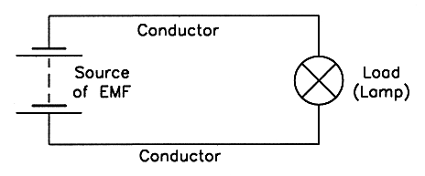

3. An electrical circuit MUST have the three parts listed above, but most have additional components such as a switch to control the circuit and a fuse to protect it.

A fuse is designed to automatically disconnect the voltage source from a load under certain fault conditions.

A fuse is connected in ‘series’ with the circuit it protects. A series circuit which incorporates a switch and a fuse is shown below.
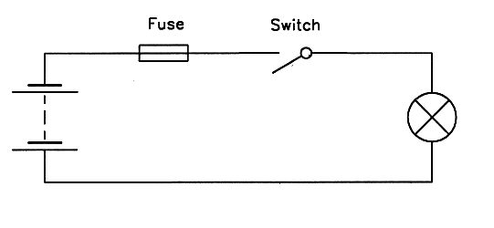

Electromotive Force

An electromotive force (emf) is a force which causes electrons ('electricity') to flow in a conductor. This electrical force is also described as a POTENTIAL DIFFERENCE or a VOLTAGE DROP between two points. Electromotive force or potential difference is measured in VOLTS, and the unit symbol for volts is V. The quantity symbol for electromotive force is E. The quantity symbol for potential difference is V or U.

Electric Current

Electric current is the flow of electrons in a material. The base unit of electric current flow is the AMPERE, and the unit symbol is A. The quantity symbol for electric current flow is I. One ampere is the current which will flow in a circuit with a resistance of one ohm if the applied voltage is one volt.

Resistance

Electrical resistance is the opposition to the flow of current in any material (solids, liquids or gases). Resistance to current flow is measured in OHMS, and the unit symbol is the Greek 'omega' (Ω). The quantity symbol is R.

Metric Prefixes

15. The metric prefixes mean 'multiply the unit by a power of 10'. In electrical engineering applications the preferred metric prefixes are those which are a multiple of 3. The specific powers of 10 referred to in the most common prefixes are:

Common Metric Prefixes

Term | Symbol | Multiply by | Example
tera | T | 1 000 000 000 000 (10¹²) | 4 TB = 4 000 000 000 000 bytes
giga | G | 1 000 000 000 (10⁹) | 3 GW = 3 000 000 000 watts
mega | M | 1 000 000 (10⁶) | 62 MΩ = 62 000 000 ohms
kilo | k | 1 000 (10³) | 22 kV = 22 000 volts
Base Unit |  | 1 (10⁰)
milli | m | 0.001 (10⁻³) | 8 mA = 0.008 amps
micro | µ | 0.000 001 (10⁻⁶) | 1 µF = 0.000 001 farads
nano | n | 0.000 000 001 (10⁻⁹) | 5 nA = 0.000 000 005 amps
pico | p | 0.000 000 000 001 (10⁻¹²) | 2 pA = 0.000 000 000 002 amps

16. Examples of the most commonly used prefixes in electrical and electronic work are:

5 MΩ means 5 times 1 000 000 ohms or 5 000 000 ohms.
3 mA means 3 times 0.001 amps or 0.003 amps.
9 mm means 9 times 0.001 metres or 0.009 metres.
2 kV means 2 times 1000 volts or 2000 volts.
6 nV means 6 times 0.000 000 001 volts or 0.000 000 006 volts.
7 µA means 7 times 0.000 001 amps or 0.000 007 amps.

AC and DC Supplies

Alternating Current - AC – Available at Socket Outlets and generators.
Direct Current - DC – Available from Primary / Secondary cells and rectified AC.
Single Phase Electrical Loads
Examples of single phase electrical loads are plug in domestic /commercial appliances, such as;
Toasters, microwaves, washing machines, clothes dryers, refrigerators, electric kettles, electric drills, etc.
Electrical Circuit Protection Devices
Fuse
A fuse is a device which has a short length of wire of known current carrying capacity (called the fusible element), enclosed in a suitable insulated carrier (known as the fuse carrier or fuse wedge) - See AS/NZS 3000 (Wiring Rules) Clause 1.4.57.

The fuse is connected in series with the supply line, so that if the current flow in the circuit exceeds a critical value the fusible element will melt, thus interrupting the supply of current to the circuit.

Clause 2.5 of the AS/NZS 3000 Wiring Rules contains the requirements relating to the devices for protection against overcurrent, current rating and types of protective device.

In general, the protective device must interrupt overload currents flowing in the circuit before such currents cause a temperature rise detrimental to insulation, joints, terminations or surroundings of the conductors.

Symbol

Circuit Breaker
A circuit breaker is a switch which automatically opens a circuit under pre-determined fault conditions (see Wiring Rules Clause 1.4.26).

The operating mechanism can be thermal, magnetic or a combination of both, but in all cases the circuit breaker must be capable of interrupting any current up to and including the prospective short circuit current at the point where the device is installed (see Clause 2.5.2).

Small moulded case circuit breakers (MCCB's) are sealed and are not usually repairable. The symbol for a circuit breaker is shown below:

Symbol
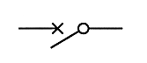

Residual Current Devices (RCDs)

A residual current device (RCD) or 'safety switch' is a means of providing protection from electric shock if a person touches a live terminal while in electrical contact with earth.
RCDs can be installed as the main switch for an installation, or they can be incorporated in extension sets which have multiple socket-outlets. Installation of an RCD does not remove the need to earth single insulated appliances.

The symbol for a residual current device is shown below:
An RCD is designed to interrupt the supply to the protected circuit if the current in the incoming active conductor is not the same as the current in the associated neutral conductor.
RCDs are mandatory for the protection of all general purpose socket outlet circuits and lighting circuits in domestic installations (see AS/NZS 3000 Clause 2.6.3).

Go to worksheet 1 and answer all questions

NB: Worksheets are now located at the back of this resource book.

Ohm’s Law
In any direct current electrical circuit there is a specific relationship between the voltage, the resistance and the current flow. This relationship is often expressed as 'Ohm's Law' which states that:
"The current flowing in a D.C. circuit or any part of a circuit is directly proportional to the applied voltage and inversely proportional to the resistance of a circuit".

This means that if the voltage across a particular component is increased the current flow will increase (a DIRECTLY proportional relationship), and if the resistance of the circuit is decreased the current flow will increase (an INVERSELY proportional relationship).
Thus the current in any D.C. circuit can be determined by dividing the voltage by the resistance.
Ohm's Law can be expressed as a mathematical relationship or equation:
Potential Difference V
Current = -------------------------- or I = ---
Resistance R

Constant Resistance Constant Voltage
I I

I is directionally proportional to V I is inversely proportional to R

When the resistance in a circuit stays constant, current will change proportionately with the applied voltage. That is, value of current is directly proportional to applied voltage.
If the voltage doubles the current flow doubles and if voltage halves the current flow halves for a constant value of resistance.

When the applied voltage stays constant, current changes are inversely proportional to changes in resistance.

That is if resistance doubles, the current flow halves and if resistance halves, the current flow doubles when the applied voltage is constant.

Ohm’s Law (cont’d.)

The equation for Ohm's Law can be transposed to find any value if the other two are known, so the three ways which Ohm's Law can be expressed are:
(Current) (Voltage) (Resistance)

V V
I = --- V = I x R R = ---
R I

A memory aid which is frequently used to show these relationships is:

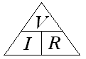

Note: Cover the letter required to be solved and see the mathematical expression which can be used to find it.

Solving Ohm's Law Problems

An Ohm's Law problem is one in which two circuit values are known and the third is to be found.

Most Ohm's Law problems can be solved using the same basic sequence.

Example

Find the current flowing in a circuit in which a voltage of 24 volts D.C. is connected to a resistance of 8 ohms.
Steps for Solution

a. Read the question carefully and

make sure you know what value is to be
found.

b. Draw a circuit diagram and insert
the known values in BASIC units (e.g.
amps, not milliamps if applicable).
V
c. Select the correct equation for I = ---
the problem. R

24
d. Substitute the known valued in the I = ---
equation (in BASIC units). 8

e. Solve the problem using arithmetic. I = 3

f. Express the answer in convenient
units (using multiples or sub-multiples I = 3 A
where required). =======

g. Check your answer - does it LOOK
correct?

All Ohm's Law problems can be solved in the above sequence, but in circuits involving more than one component, care must be taken to use the correct values in each calculation.

It is often useful to add the calculated values to the diagram as they are determined.

Go to worksheet 2 and answer all questions
Electrical Power

Power is the rate at which work is done or the rate at which energy is converted from one form to another. All electrical devices have a power 'rating' which must not be exceeded under normal operational conditions - if the power rating is exceeded the device will overheat and permanent damage may result.

Power (P) is expressed in watts (W). 1 watt = 1 joule per second.

Since the power dissipated by a resistor is critical to safe operation, it is often necessary to calculate the actual power dissipation for a given fixed or variable resistor to ensure that it is not exceeded. The actual power dissipation on D.C. can be calculated using any one of the three basic power equations:

V²
P = V x I P = I² x R P = ---
R

Example 1: Calculate the power dissipated by a resistor if the current through it is 10 amps and the applied voltage is 100 volts.

P = V x I
= 100 x 10
= 1000 watts

Example 2: Calculate the power dissipated by a 100 ohm resistor if the applied voltage is 20 volts.

V²
P = ---
R

20²
= ---
100

= 4 watts

Example 3: Calculate the power dissipated by a 5 ohm resistor if the current through it is
10 amps.
P = I² x R
= 10² x 5
= 500 watts

Example 4: A particular 240 volt heating element has a power rating of 1200 watts. How much current would be drawn by the element?
P
I = --- (by transposition)
V

1200
= -------
240

= 5 amps.

It is important to be aware that the power dissipated by a resistor increases in proportion to the square of the current – i.e. if the current is doubled the power dissipated is quadrupled

Example 5: Voltage - 12V Current – 3A Resistance - 4Ω
P = I²R P = 3² x 4 P = 9 x 4 P = 36 W
If we double the current value to 6A
P = I²R P = 6² x 4 P = 36 x 4 P = 144 W

Example 6:
V² 12² 144
P = ----- P = ------- P = --------- P = 36 W
R 4 4
If we double the voltage to 24V
V² 24² 576
P = ------ P = ------- P = --------- P = 144 W
R 4 4

Example 7:
P = V x I P = 12 x 3 P = 36 W
If we double the current to 6A
P = V x I P = 12 x 6 P = 72 W
This value is only doubling the power not quadrupling. This is because we know from basic ohms law that voltage and current are directly proportional. Therefore if we are to use this formula we must also double the voltage.
P = V x I P = 24 x 6 P = 144 W
Formula Circle

- The relationships between voltage, current, resistance and power can be summarised in the following Formula Circle:

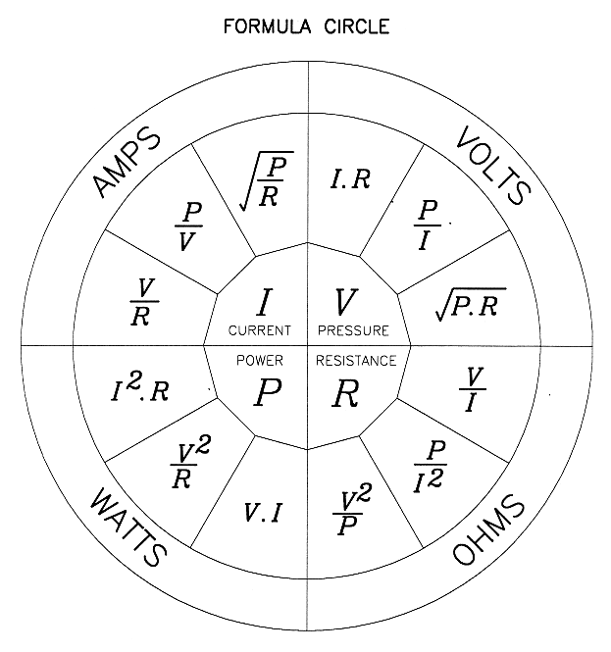

Go to worksheet 3 and answer all questions

Resistance Measurements

The resistance measuring instruments you are likely to use most frequently in the electrical industry are:

a. Multimeters - to measure voltage, current and resistance.
b. Insulation Resistance testers – to test the insulation resistance of circuits
c. Bridge meggers (Wheatstone bridge) – to accurately test circuit resistance
d. Multi-function Testers – Testing instrument used for testing of installations, can measure Insulation Resistance between conductors @ 250V, 500V & 1000V, Continuity of Earthing Conductors (very low resistance) and the presence of voltage
e. Earth Fault-Loop Impedance Testers – used for measuring the AC resistance (impedance) of earthing conductors.

Two general forms of resistance measuring instrument are available - analogue and digital. An analogue instrument has a moving pointer and a graduated scale, and a digital instrument gives a direct numerical read-out.

All types of digital instruments and those instruments which are used to indicate resistance, require a battery to operate. Most analogue ammeters and voltmeters do not require a battery as they simply work by indicating the current flowing through them.

All battery operated instruments should be turned off when not in use to avoid draining the battery too soon. Many digital instruments have an “Auto-off” feature.

The general rule for testing the resistance of an electrical circuit is to ensure the power supply is disconnected and no other component is connected in parallel with the circuit to be tested i.e. no parallel paths.

The reason is that resistance testers, including insulation resistance testers, could be damaged beyond repair if connected to an external power supply.

Connecting a multimeter to high energy systems such as mains powered systems, while set on the Ohms or Amps range could cause catastrophic damage to the meter and may result in injury or death to the operator. Always test an existing circuit for voltage before connecting a meter to read resistance.
Ohmmeters
Ohmmeters have a small internal battery so that when the probes are connected across a resistance of some consequence, it will cause a small current to flow in the circuit. This current reflects the amount of resistance the component or circuit being tested contains.
If the battery voltage falls below a certain level, an inaccurate reading may be obtained.

Most ohmmeters (including analogue multimeters with ohms ranges) have a reverse scale - the lowest value is at the RIGHT end of the scale and highest value is at the LEFT.
Scales on ohmmeters are usually non-linear, meaning that the distance between divisions is not equal. Stand-alone ohmmeters are not always available so it is more usual to use a multimeter with resistance ranges for general resistance measurement.

Parallax Error

When taking a reading from an Analogue meter it is essential that you position your head directly in line with the needle so as to avoid Parallax error.
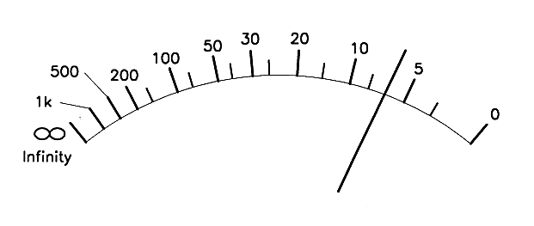
The following precautions must be taken when measuring resistance with an ohmmeter or multimeter:

a. Make sure that the supply has been disconnected from the component to be measured.
b. Use the 'Ohms Adjust' knob to set the instrument to full scale deflection (FSD) with the test probes short circuited. If the pointer on the instrument cannot be adjusted to zero ohms it indicates that the internal battery needs replacing.
c. Make sure that there are no other components in parallel with the one being measured.
d. Switch the instrument off after use.
Most Ohmmeters or multimeters that can read Ohms will have some form of range adjustment. Analogue meters should have the “multiplier” dial set so that the reading taken is from as close as possible to the middle or zero end of the scale.

Digital instruments can “auto-range” but it is sometimes prudent to select the range manually by cycling through the ranges available.

Multimeters

A multimeter is an instrument which has various functions and ranges so that it can be used for measuring various values.

The most common functions are a.c. and d.c. currents and voltages and also resistance, some may have features such as a buzzer for checking circuit continuity and diode, capacitance and transistor testing.

Multimeters are connected in series for current ranges and parallel for voltage ranges. You must take care to select the correct function and range on the selector mechanism.

Multimeters should be switched off or to the highest available a.c. range when they are not in use.

Circuit Continuity

Continuity is a term used to describe the condition in which a conductor is continuous from one end to the other.
The most common method of checking continuity is to use a resistance measuring instrument such as a multimeter; if a zero or low resistance is indicated the circuit is usually continuous i.e. both ends being tested are connected to one another.

A reading of infinity between the two ends of the conductor indicates that the conductor is open circuited.
Before checking for continuity, you must ensure the supply has been isolated first and then either one or both ends have been disconnected from other parts of the circuit being tested to avoid any parallel paths giving rise to a false reading.

Insulation Resistance Testers (Meggers)
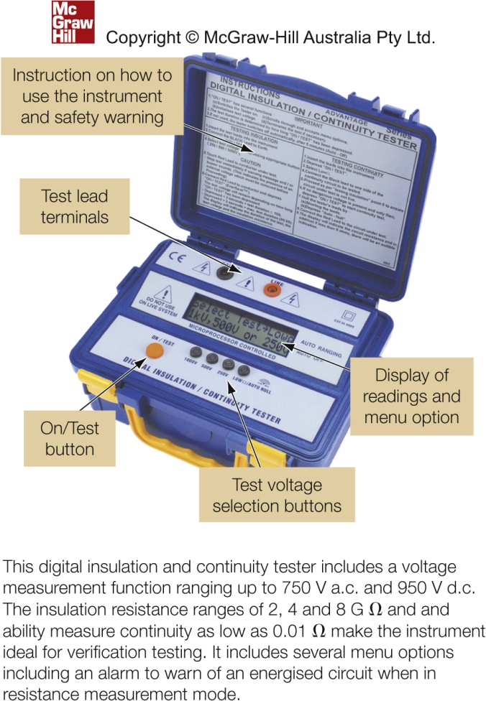

The purpose of an insulation resistance tester is to ensure that the live parts (Active and neutral conductor) do not come in contact with exposed parts or earth, of an electrical installation.
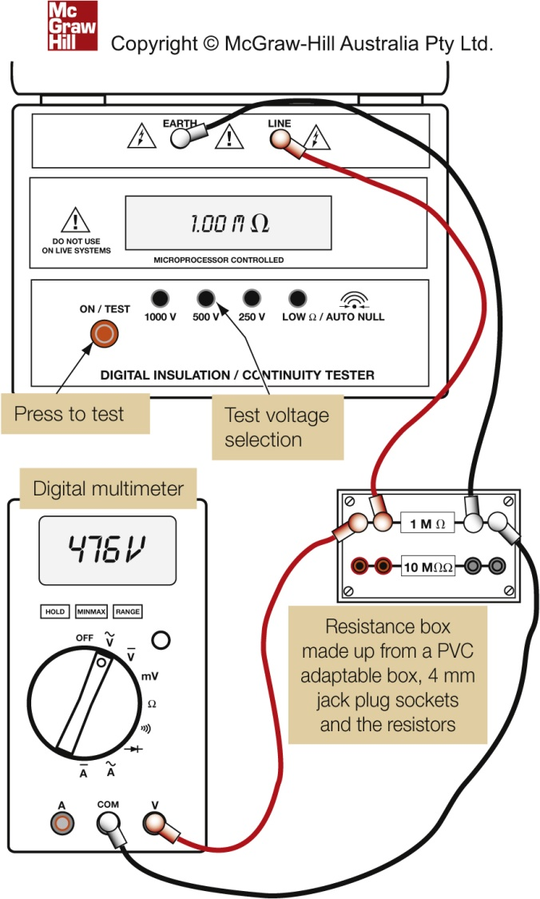
The insulation between any live part and earth, or any exposed metal frame of a single insulated appliance or installation must be capable of withstanding a direct current at 500 volts (see AS/NZS3000:2007 clause no. 8.3.6.1.)

Insulation resistance testers are available in hand driven generator or battery operated electronic push button types, and with a range of output voltages typically between 250 V d.c. to 1000 V d.c.
The scale on an insulation resistance tester is usually calibrated in Meg-ohms (MΩ) from zero to infinity (∞)

Calibration checks for IR Testers

Insulation resistance tester must maintain a consistent terminal voltage for valid test results.
AS/NZS 3000 Wiring Rules states that an IR tester must maintain its terminate voltage within +20% and -10% of the nominal open circuit voltage of 500 V d.c. when measuring a resistance of 1MΩ.
(see AS/NZS3000:2007 clause 8.3.6.1)

Care and Storage of Instruments

Electrical measuring instruments contain delicate components that can be easily damaged by rough handling, excessive temperatures or using them on incorrect anges.

When they are not in use you should switch them off (if they are battery operated) and store them with any connecting leads neatly wrapped.

You should avoid storing them with other equipment on top of them.

It is a bad practice to tap the glass on any measuring instrument because the glass can be dislodged.

If you are to transport an analogue multimeter, setting it to the highest available current range will provide maximum damping for the pointer, however, setting it to the highest current range also means that there is a very low resistance between the connecting leads, so you must take care to select the appropriate function and range before you use it.

If the instrument is to be stored you should switch it off or set it to the highest available a.c. voltage range.

All clips, probes and leads should be maintained in safe working order.
If any connecting lead becomes damaged you should have it replaced immediately.

Testing an appliance

The insulation resistance of an appliance must be in a satisfactory condition before it can be connected to mains voltage supply. The minimum insulation resistance allowed between all active conductors and its exposed parts or earth is 1MΩ.

If the appliance incorporates a sheathed heating elements, such as a pie oven, food warmer or kettle the minimum permissible insulation resistance is much lower at 0.01MΩ (10,000Ω).

To properly test the insulation resistance of a 240V appliance, an insulation resistance tester must be used. The insulation resistance tester must be able to apply a test voltage of 500Vdc, for this reason an ordinary multi-meter cannot perform this task.

If an appliance is in good functioning order, a relatively low resistance should exist between the active and neutral conductors. The value of this resistance will depend on the nature of the appliance. For example, a 2.4kW heating element will have a resistance of 24Ω.

The resistance of heating type appliances can be determined using Ohm’s Law. This is done by locating the rating plate on the appliance.

The wattage and voltage needs to be determined so that its resistance can be calculated.

The resistance of the appliance is measured in ohms and it should be close to the value calculated. If say it differs by more than 10% it may indicate that the appliance is faulty.

Note: The resistance between the terminals of appliances, which incorporate a motor, transformer or other coil type devices, cannot be calculated from the voltage and power rating. Measured values of less than 10Ω are usually acceptable. Resistance of the internal circuit of appliances should only be measured with an ohmmeter.

DO NOT USE insulation resistance testing function to read the appliances resistance as it is not the appropriate ohm’s (Ω) scale and the high output voltage of the tester may damage control components in the appliance.

Activity 1 — Appliance testing

Your lecturer will provide you with a number of cord-connected appliances of which may or may not be satisfactory for connection to the mains supply. Test each of the appliances to determine whether they are of safe and suitable condition to be connected into the mains supply. Record your results in Table 5 below.

Table 5
 | Class 1 appliance |  | Class 1 appliance |  | Class 1 appliance |  | Class 2 Appliance
Appliance name:
Test  procedure | Value required | Test result | Value required | Test result | Value required | Test result | Value required | Test result
Visual Inspection of cord and casing
Continuity of Protective Earthing Conductor
Continuity of
Element
(Or Internal circuitry)
Function of control switch
(if applicable)
Insulation Resistance
Test @ 500Vdc Between Both Supply Pins and Earth Pin
Tag fitted
Is Appliance suitable to be put into service?  If not, why not? | YES | NO | YES | NO | YES | NO | YES | NO

Go to worksheet 4 and answer all questions

Flexible cords

Flexible cords (and plugs) provide a safe and convenient method of connecting appliances and electrical equipment to the supply. However, flexible cords can be the weakest link in both safety and reliability, if installed or used inappropriately.

A flexible cord is designed to be flexible so that the conductors will not break when subjected to continuous bending and flexing, its conductors are made up of many strands of copper wire, with each strand being no more than 0.31mm in diameter.
According to AS/NZS 3000:2007, a flexible cord cannot have more than five(5) cores with each core having a cross-sectional area (CSA) no greater than 4mm².

A cable constructed to afford flexibility like that of a flexible cord but has conductors of which are either greater than 4mm2 or contains more than five cores are known simply as flexible cables.

An example of a flexible cable is the cable used on a welding machine to connect to the welding electrode holder or the cable used for the pendant controller on a crane or hoist.

Flexible cords must have a current carrying capacity not less than the rating of the appliance to which they are connected. A guide to selecting the correct conductor size in flexible cords is as follows:

Table 1 — Current rating

Rating of appliance (A) | Minimum conductor size in flexible cord (mm2)
3 | 0.5
7.5 | 0.75
10 | 1.0
16 | 1.5
20 | 2.5
25 | 4.0

The most common flexible cords are insulated and sheathed with Elastomer or PVC.
Small appliances such as clothes irons, and toasters have cords with an overall textile braiding. There are other special types of flexible cords such as one that has a metallic screening between the sheathing and the cores. The following table provides a guide to the selection of the most common type of flexible cords.

Table 2 — Cable use

Cable type | CSA | Approved use
Parallel two core – unsheathed (known as "Figure 8") | 0.5mm2 | Hand held double-insulated  appliances rated at not more than 3A.
 | 0.75mm2 | Double insulated appliance  where the cord is not used roughly. Not permitted in the vicinity of dampness.
Light duty — sheathed | ≥0.75mm2 | Double insulated appliances and non-double-insulated  appliances where the cord is not used roughly. Can be used in the vicinity of dampness.
Ordinary duty — sheathed | ≥1.0mm2 | Appliances that are not double  insulated where the cord may be used roughly. Can be used in the vicinity of dampness. Flexible cord extensions.
Heavy duty — sheathed | ≥1.5mm2 | Appliances that are not double insulated where the cord may be used roughly. Can be used in the vicinity of dampness. Flexible cord extensions.
Textile braided overall | ≥0.75mm2 | Double insulated appliances and non-double-insulated  appliances where the cord is not used roughly but not permitted in the vicinity of dampness.

Selecting the appropriate cable for use in a flexible cord

Factors that must be considered when selecting a cord for a particular application are:
• Current the cord is expected to carry will determine conductor size

• Number of cores determined by earthing or double insulation requirements

• Conditions of use

Working with flexible cords and plugs
Colour coding

Each terminal of a plug top, extension socket or appliance is intended to be connected to a particular conductor that is the active conductor, neutral conductor and earthing conductor. To make this easy and help avoid mistakes, flexible cords are colour coded to an international standard. This also makes visual checking easy. The colour code from the standard is:
Active — brown
Neutral — blue
Earth — green/yellow
This code should be adhered to whenever the flexible cord has the individual cores coloured in this way. Some flexible cords were manufactured many years ago with red and black cores. In this case, the conventional arrangement for the colour code is:
Active — red
Neutral — black
Earth — green/yellow
Cables coloured green, or green/yellow must be used only as earthing conductors.

Securing the cord

Flexible cords must be fitted to devices so that any pull on the cord does not exert any strain on the terminal connections. This is usually done by a tortuous path that the cord or cores must follow to the terminals in the device to be connected. The strain of pulling on the cord is taken up in the curves formed in the cord path and not the terminals. Another method is by a cord grip sleeve and cable clamp. All of these methods are generally built into a device intended to be cord connected.

Refer to AS/NZS 300:2007 – Clause number 3.7.2.8 (b).

Earthing

Class 1 appliances must be earthed and are provided with a terminal specifically for this purpose. Class 1 appliances generally have only (1) layer of insulation to prevent contact with live parts. They have outer metal parts that may become live under abnormal conditions.

The reason for earthing is to ensure the fuse or circuit breaker protecting the appliance circuit cuts the power off within a very short period of time event of a fault causing the metal frame of an appliance to become live. For the circuit protection device to work quickly the initial fault current must be much larger than the protection device rating. This means the earthing system, (that is conductors and connections), must have a very low resistance.

The resistance of the protective earth conductor between the earth pin of the plug and the metal frame of an appliance shall not be more than 1.0Ω
Source: AS/NZS 3760:2010 (incorporating Amendments 1 &2)

To ensure the earthing connection has an extremely low resistance the following points should be observed.

- Connect earthing conductors with the appropriate terminal device;
A crimp lug, "Ross-Courtney" ring or similar where clamping terminals are not provided.
- Make sure the earthing conductor is in contact with the bare metal of the appliance enclosure or connected to a terminal that is.
- Make sure the earth screw tightly clamps the earthing connection.
- Protect earthing connections exposed to corrosion by painting with an exterior grade paint to exclude moisture.
- Ensure the securing nut or screw cannot work loose by use of a star washer, spring washer, lock washer or “double nutting”. A Self-tapping screw is not an acceptable means of securing an earthing conductor to metal parts.

Class 2 appliances have “Double Insulation” where the outer casing of the appliance is made from non-conductive material. In the event of the failure of the primary insulation surrounding its conductors there is a further layer of insulation to prevent direct contact with the live conductors occurring.

These appliances are marked with an international symbol for double insulation and must not be earthed.

Plugs and sockets

There are many types of plug tops, the most common being the 10A three-pin plug.
This plug top has three flat pins — the active pin, the neutral pin, and the largest pin, the earth.
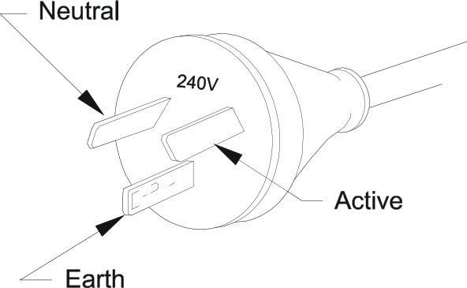

The plug is suitable for cord connected appliances rated at not more than ten amperes and intended for supply from a standard socket outlet. (A socket outlet is known commonly as a power point).

Factors that determine the design of plugs (and sockets) are:

• Voltage rating

• Current rating

• Protection rating

• Pin configuration

Voltage and current rating:

A plug must have a voltage and current rating not less than that of the appliance it supplies, and its intended socket.

Plugs and sockets are designed with various pin styles and configurations to prevent an appliance being supplied from an inappropriately rated socket. For example, a 15A three (flat) pin plug will not fit into a 10A three (flat) pin socket.

Other devices commonly used in the connection of appliances and equipment by flexible cords are the extension socket and the appliance plug. The extension socket is the socket device on an extension cord in to which a plug is inserted. The appliance plug is a socket device used with cord sets for connecting some type of appliances.

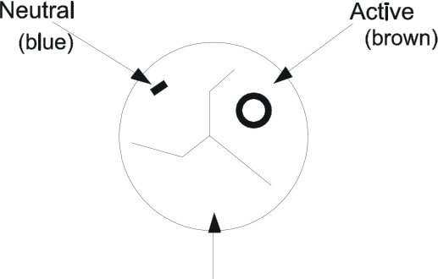
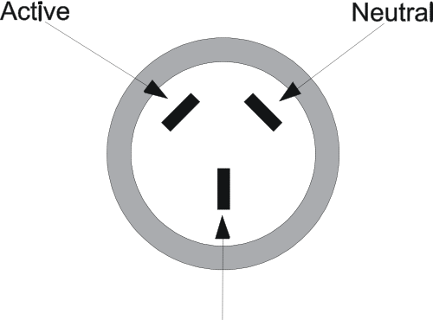



Socket connections (rear view) Socket connections (front view)
Joints in flexible cords and cables

The only suitable means of joining flexible cords or cable is by an approved coupling or connecting device. Flexible cords and cables cannot be connected by any other means eg. by Blue-point connectors or soldering and taping the joints.

Protection rating:

A plug must be suitable for the environment in which it is to be used. Electrical equipment including plugs and sockets are given an ingress protection (IP) rating, which indicates where it can be used. The IP rating indicates the level of protection against the entry of moisture and foreign bodies into a plug enclosure. For example, a plug for use out in the weather would require a rating of IP53. Plug tops typically selected for use in industry, damp areas, and construction sites would require a rating of IP56 (often referred to as "hose proof). Refer to the Australian Standard AS 1939 for details of this protection rating.

IP Rating Charts

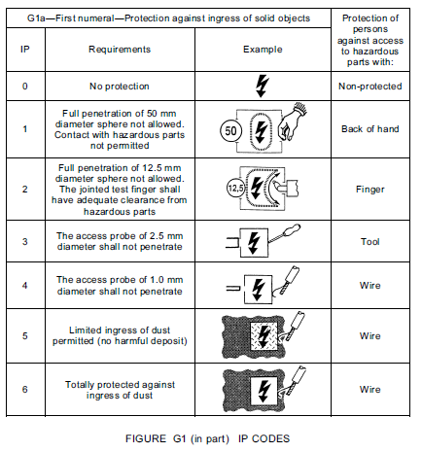 | 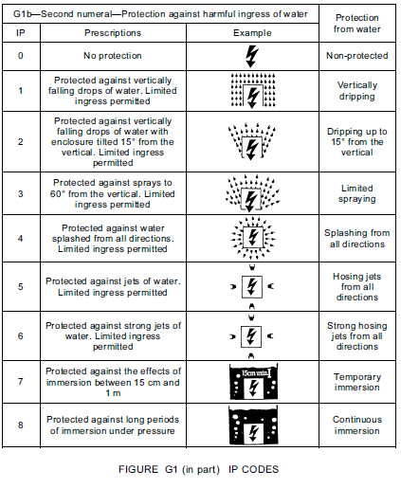

© SAI Global – Standards Australia – reproduced under Section VB Copyright

Go to worksheet 5 and answer all questions

Activity 2 — Construct an Extension cord

Use a short length of flexible cable and appropriate connectors to construct a light duty extension cord suitable for use on 240V having a maximum current rating of 10Amps.

Instructions:
- Cut a short length of the required cable from its drum.
- Determine the end of the cable which suits the plug top and that of the extension socket. Tie a loose knot in the middle of the cord to retain the knurled nut and plug top outer cover.
- Slip the knurled nut and plug top outer cover over the end to be used for the plug top.
- Strip the required length of sheath off the outside of the flexible cable.
- Strip the required amount off the ends of each conductor.
- Strip the insulation from the cores and then twist the strands by hand to form a tightly bound conductor.
- Observing the correct polarity, secure each conductor on to their respective terminals.
- Wind the conductors around the tortuous path provided on the plug base.
- Before sliding the outer cover over the plug base, see your lecturer to check your work. Work the cover on slowly, taking care not to damage the insulation surrounding the conductors.
- Tighten the knurled nut, by hand, to firmly secure the cable within the plug top.

Follow the manufacturers’ instructions when stripping the cable.

Don’t forget to slide the cord grip and plug top cover on the cord before you start connecting.
Note: Ensure correct polarity by observing the colour coding of the cables.

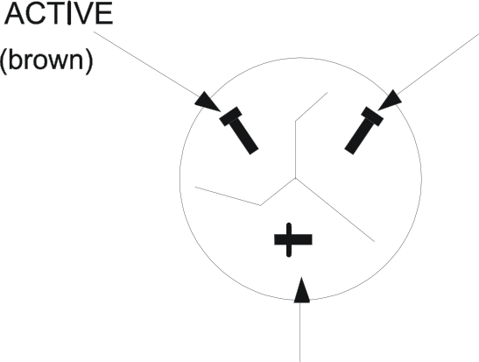


Activity 2 (cont’d)

- Proceed to fit the extension socket on to the other end of the cable (you can untie the knot you previously made in the cable now). Be careful to again strip the cable according to the instructions provided by the manufacturer.
- Continue as before with the plug top stopping before fitting the outer cover so your lecturer can check your work.
- Once fitted, have your lecturer inspect the completed cord.
- Test the cord on the Safe-T-Checker.
- Full dismantle the cord and place all parts back in the appropriate containers.
- Cut stripped ends back to the outer sheath on your piece of cable and clean up your workspace.

Task | Plug end | Socket end
1. Determine which ends of the flexible cable has its conductors in the same order as required for the plug top and extension socket.
1. Remove the correct amount of outer sheath without damaging the insulation of the internal cores.
2. Remove the correct amount of insulation from the end of the internal cores, without damaging the conductor strands.
3. Twist and compact the conductor strands ready for terminating.
4. Terminate the conductors observing the correct polarity.
5. Engage the conductors in position to take a “tortuous path”.
6. Fit outer cover of the plug top.
7. Secure the cord grip to the outer cover.
8. Repeat steps
9. Test the extension cord with the “Safe-T-Checker”.
10. Record Test results.

Activity 3 — Identify various plug and socket patterns

Using manufacturers’ catalogues, identify the current rating, and voltage rating of the plug socket patterns
Note that some of the patterns are for multiphase applications, and do not suit 240V single-phase appliances. You should be able to recognise both single and multiphase patterns in order to decide on the suitability of existing outlets for various connection purposes.

Draw the patterns below:

1. Single phase 240V - 15amp

2. Single phase 240V – 20amp

3. Single phase 240V – 10amp – Special purpose

4. Extra Low Voltage 10amp

5. Three-phase and neutral- 415V – 20amp

Replacing the flexible cord on an appliance

Before selecting the flexible cord, it is necessary to ensure that it is suitable for the environment in which it is used. Most flexible cords in common use are manufactured with PVC or Elastomer insulation and sheathing. Flexible cords are available with sheaths made of materials such as butyl rubber and silicone, which are suitable where, increased flexibility or resistance to severe environmental factors is needed.

Where solvents may be present, PVC sheathed cords are unsuitable. ‘Figure 8’ flexible cords do not have a protective sheath and must not be used where the cord is at risk of mechanical damage. Also, ‘Figure eight’ flex can only be used to supply double insulated appliances as no earthing conductor is incorporated in this cord.

The cord will need to comprise of conductors each having a suitable Cross-Sectional Area (CSA) capable of carrying the current required to operate the appliance as intended.

The plug top selected will need to have a pin configuration to satisfy the current rating of the appliance and an IP rating having regard to the environment in which it is intended to operate within. For some particular flexible cables, a plug top designed specifically to accommodate the cable must be used.

All appliances will have a method of securing the cord to the appliance, this must be done in a way as to relieve any strain on the electrical connections from a pulling force on the cord and to prevent any damage occurring to the insulation layers or the inner copper conductors. Tying a knot is not a suitable method of anchoring a cord to an appliance.

Cords should always be replaced in accordance with the manufacturers’ instructions.

Go to worksheet 6 and answer all questions

Worksheet 1 - Practical Electrical Circuits and Protection
- What are three BASIC parts of any electrical circuit?

- Prior to working on any electrical equipment what should you first do?

- What is the purpose of a FUSE in an electrical circuit?

- What is the purpose of a 'circuit breaker' in an electrical circuit?

- What are the three steps of the principles of risk management?

- Are fuses and circuit breakers connected in series or parallel with the protected components in a circuit?

- What is the approximate resistance of an ‘open circuit’?

- What is the approximate resistance of a ‘short circuit’?

- What does an RCD provide protection against?

Worksheet 2 – Ohm’s Law

Note: You should always draw a diagram of the circuit.

- How much current would flow in a circuit in which a 6 ohm resistor was connected to a 24 volt supply?

- If 24 amps flowed in a circuit when a potential difference of 12 volts was applied to it, what would be the resistance of the circuit?

- What voltage would have to be applied to a 100 ohm resistor to cause a current of 0.25 amps to flow through it?

Worksheet 3 - Electrical Power

- What is the basic unit of electrical power?

- Calculate the power consumed by an electrical appliance that has a current draw of 10 amps and is connected to a 230 volt supply?

- Calculate the power consumed by an electrical appliance that has a resistance of 50 ohms and is connected to a 230 volt supply?

- Calculate the current drawn by an electrical appliance that has a power rating of 1.6kW and is connected to a 230 volt supply?

Worksheet 4 - Resistance Measurement

1. What is the name of the electrical measuring instrument used to measure the RESISTANCE of a circuit?

2. What are the names given to the upper and lower limits of the indicating scale on a typical OHMMETER?

3. What common type of analogue measuring instrument has an internal battery?

4. What is the purpose of the 'ZERO ADJUST' control on a typical portable ohmmeter?

5. What two precautions must ALWAYS be taken when using a multimeter or ohmmeter to measure an unknown resistance in a circuit?

6. At what voltage must the insulation resistance to earth be measured in a 230 volt electric toaster?

7. What is the minimum permissible insulation resistance to earth in a 230 volt appliance?

8. Describe a method of overcoming Parallax error.

9. Name the instrument used for testing between conductors to ensure the integrity of their insulation is maintained.
Worksheet 5 – Flexible Cords

Select the type and size of flexible cord suitable for the given applications and give reasons for your selection.

1. The flexible cord for a domestic washing machine rated at 7A.

2. A flexible extension cord to be used for commercial work.

3. The cord for a 2.4kW water heater. (Note: Water heater load current)

4. The flexible cord for an office photocopier rated at 10A.

5. What IP Rating would be required for a plug top situated in an environment where fine dusts are present and where it may be occasionally sprayed with water?

Worksheet 6 – Documentation.

Refer to As/NZS 3760:2010 Section 2.5.1 and answer the following questions.

Q1. What records should be kept?

Q2. For what length of time should records be kept?

Q3. What is the inspection interval for Class I equipment used in Motels?

Q4. What is the inspection interval for Class II equipment used in assembly areas?

This is the end of this workbook.

