

**UEENEEP026A**

**Conduct in-service safety testing of electrical cord connected equipment and cord assemblies.**

A training course conducted at North Metropolitan TAFE - Balga Campus.

**Testing and Tagging of Portable Equipment**

**Introduction**

This booklet contains resource material that will help you in your studies on the practices of testing and tagging of portable electrical equipment in accordance with UEENEEP008B *Conduct in-service safety testing of electrical cord assemblies and cord connected equipment*.

# Elements and Performance Criteria

| ELEMENT | | PERFORMANCE CRITERIA | |
| --- | --- | --- | --- |
| 1 | Prepare to test cord connected apparatus and cord assemblies | 1.1 | OHS procedures for a given work area are identified, obtained and understood. |
|  |  | 1.2 | OHS risk control work preparation measures and procedures are followed. |
|  |  | 1.3 | Advice is sought from an appropriate person to minimise disruption to the work place. |
|  |  | 1.4 | Cord connected apparatus and cord assemblies to be tested are obtained. |
|  |  | 1.5 | Portable apparatus testing device is checked for correct operation and safety. |
| 2 | Test cord connected apparatus and cord assemblies | 2.1 | OHS risk control work measures and procedures are followed. |
|  |  | 2.2 | Measures are followed to ensure that cord connected apparatus and cord assemblies to be tested are not connected to the electrical supply. |
|  |  | 2.3 | Knowledge of electrical safety requirements and parameters are applied to safety testing to ensure correct interpretation of test results. |
|  |  | 2.4 | Visual checks of the cord connected apparatus and cord assemblies are carried out in accordance with established procedures to detect any abnormal or obvious damage or fault. |
|  |  | 2.5 | Approval is obtained in accordance with established procedures from appropriate personnel, before any contingencies are implemented. |
|  |  | 2.6 | Established PAT routines are followed to test cord connected apparatus and cord assemblies. |
|  |  | 2.7 | Unsafe cord connected apparatus and cord assemblies are identified from test results |
|  |  | 2.8 | Testing is undertaken effectively with minimum waste of energy and damage to apparatus. |
| 3 | Tag tested cord connected apparatus and cord assemblies and document testing activities | 3.1 | OHS work completion risk control measures and procedures are followed. |
|  |  | 3.2 | Work site is cleaned and made safe in accordance with established procedures. |
|  |  | 3.3 | Cord connected apparatus and cord assemblies are tagged according to their safety status. |
|  |  | 3.4 | Arrangements are made for unsafe cord connected apparatus and cord assemblies to be repaired by a recognised competent person. |
|  |  | 3.5 | Safety testing activities are documented in accordance with requirements and established routines procedures. |

**In-service Safety Inspection & Testing of Electrical Appliances**

**The Need for In-service Testing**

In-service testing is necessary for the safety of persons using the equipment and for the proper discharge of obligations of employers and employees, as listed in legislation covering occupational health and safety matters.

**Requirements Necessary for the Safety of Persons Using Electrical Equipment**

1. Equipment needs to be designed and manufactured to appropriate safety standards.
2. Equipment, without being dismantled, needs to be subjected to routine inspection and testing to detect obvious damage, wear or other conditions which render it unsafe.
3. Equipment identified as faulty needs to be withdrawn from service and referred for repair or disposal by expert personnel.
4. Appropriate equipment needs to be used for each particular application.
5. In specific cases, e.g. for use in confined spaces, equipment needs to be used in accordance with appropriate set of rules linking the type of work with the class of equipment and environmental safety facilities.

The course will concentrate on points 2 & 3.

The inspection and testing of equipment is covered by the **Australian/New Zealand Standard 3760: 2010 In-service safety inspection and testing of electrical equipment**. It states that the testing of electrical equipment shall be carried out by a **Competent person**.

To test electrical appliances it is necessary to have knowledge of and an understanding of the terminology used in the Electrical industry. This section is a very quick introduction to basic electrical principles, circuit protection, electrical safety, inspection and testing to the current edition of AS/NZS 3760 and applicable Western Australian regulations.

**Basic Electrical Principles**

**AC and DC Power**

The use of electrical energy in the last 150 years has changed all facets of the way we live and work. No longer do we need to rely on candles or oil lamps for lighting, cooking over a camp fire at home or even using a steam powered computer anymore. Homes and industry rely on supply of cheap AC (alternating current) power to provide lighting, heating cooling and a source of mechanical power. As motorists travelling between home and work, we on rely DC (direct current) power stored in the battery, to start the car. These two power sources, AC & DC, are so heavily relied on that when the car does not start or Western Power has another Black Out, it is treated by some as the end of civilisation.

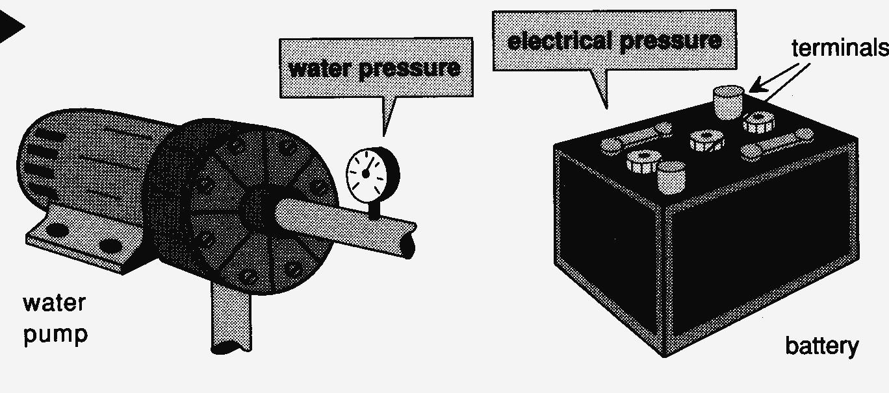

**Voltage**

Voltage is the measurement of electrical pressure. The electrical pressure of the AC power supply used in Perth homes is 230 volts and the majority of cars use a 12 volt battery to power the electrical components of the vehicle.

Quantity symbol E or V, Unit symbol V.

**Electrical Current**

Electrical current is the flow of electrons. Just as we can measure the amount of water flowing (current) through a pipe, we can measure the amount of electrical current through a conductor. The unit for electrical current is the ampere or amp for short. Just like water, we need pressure (a voltage) to get a flow of current.

Quantity symbol I, Unit symbol A.

**Resistance**

For current to flow there must be path for the electrons. Some materials allow the current to flow easily, these are called conductors, some materials restrict the flow to very low values, these are called insulators and there is another group of materials called semiconductors.

Common conductors are; silver, copper, aluminium, gold, iron and lead. Mica, glass, PVC plastic, rubber and oil impregnated paper are used as insulators. The modern electronic industry uses semiconductors manufactured from silicon and germanium to power the likes of televisions, radios, computers and many other modern industrial and domestic appliances.

About 200 years ago Georg Ohm discovered a relationship between voltage, current and resistance. He found that if the voltage remained consist in a circuit, than the current flow would be inversely proportional to the resistance. This means that where there is a breakdown in the insulation, a very low resistance short circuit between conductors, a very high value of current will flow. Conversely when there is a break in the conductors, such as an open circuit, no electrical current will flow.

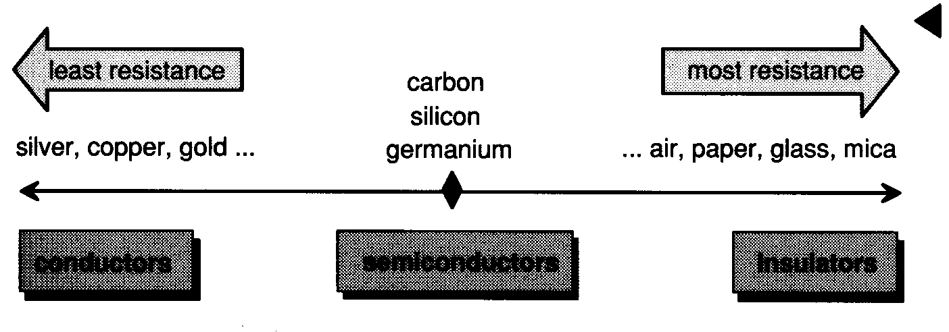

The resistance of an electrical circuit is measured in ohms. Typical values of resistance for conductors used in electrical appliances are low, between zero ohms and 100 ohms. When measuring the insulation resistance of an appliance, we are looking for values that exceed one million ohms (1 MΩ).

Quantity symbol R, Unit symbol Ω.

**Circuit Protection**

Circuit protection is designed to limit the effects of fault current on electrical equipment and/or people and livestock. The common types of over current protection are fuses and circuit breakers.

**Fuses**

Fuses work on the basis than when a circuit draws too much current caused by a short circuit or an overload, the fuse element overheats and burns out. The burnt out fuse element opens the electrical circuit and the current flow stops. When the problem that caused the fuse to blow is rectified then the fuse can be replaced.

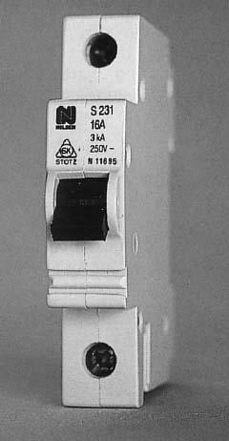

**Circuit breakers**

Circuit breakers are switches that automatically turn the current off when there is a fault. Circuit breakers are a popular type of over current protection device, because they are easy to restore power after the circuit breaker has opened the circuit.

**Residual Current Devices**

Residual Current Devices (RCDs), safety switches are circuit breakers designed to protect people against the possibility of receiving a fatal electric shock. RCDs monitor the amount of current flowing to the load and the amount of current returning from the load to the supply.

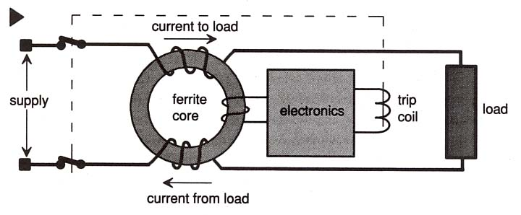

When the currents are equal, the toroid ferrite core will remain demagnetised. If there is a leakage of current to earth, the ferrite core will magnetise, because the current to the load will be more than the current leaving the load. The magnetised core will produce a small voltage that will power the electronics of the trip circuit, which disconnect the load from the supply. The type of RCDs installed in Perth homes only require a difference of 30 mA between the current to the load and the current returning to the supply for the device to operate. RCDs are now mandatary installed in all new homes.

**Earthing**

Earthing of electrical installations and Class 1 appliances using an earth wire (green/yellow) is a common method used to protect people and equipment from the harmful and often fatal effects of electric current when there is a break down in electrical insulation. If a live wire inside an appliance is touching the metal case, you could get an electric shock if you touch the case. To limit the effects of the shock and to switch the power off automatically, the cases of Class 1 appliances are connected to the general mass of earth via an earth wire.

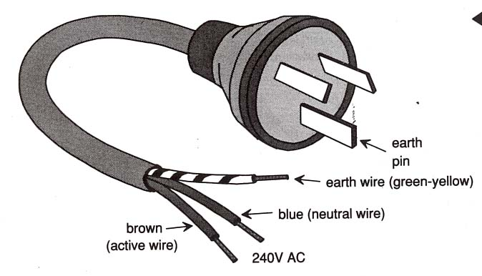 The earth wire (green/yellow in colour) is incorporated in the flexible cord with the power conductors connected to the earth pin of the plug top. When inspecting and testing Class 1 appliances, the tester needs to pay special attention to the condition of the flexible cord and the plug to make sure that the appliance has a functioning earth wire.

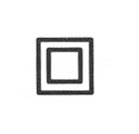

Double insulated appliances (class II) are usually made from plastic and are marked with the words *Double Insulated* or with the symbol (square in a square), are never earthed. Double insulated appliances also require vigilance when inspecting and testing.

A cracked case or a frayed flexible cord, can render the appliance hazardous.

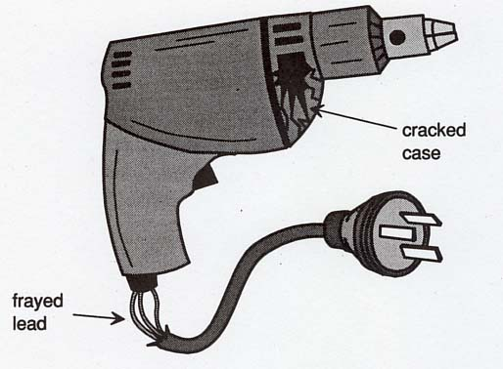

**Electrical Safety**

Safety rules are mostly a matter of commonsense. Safe work habits can be developed and used so that in time they will tend to become automatic.

Electrical energy is a useful source of power but can be dangerous when carelessly handled or misused. Some important points to be observed are:

• Make sure all appliances are serviceable before connecting them to the power.

• Regard all equipment as being alive until testing has proved otherwise.

• When removing the power from equipment to work on it, take precautions to ensure that no-one will be able to turn the power on again until work is completed.

• Isolate switches or fuses, and place danger tags on the related equipment for others to read.

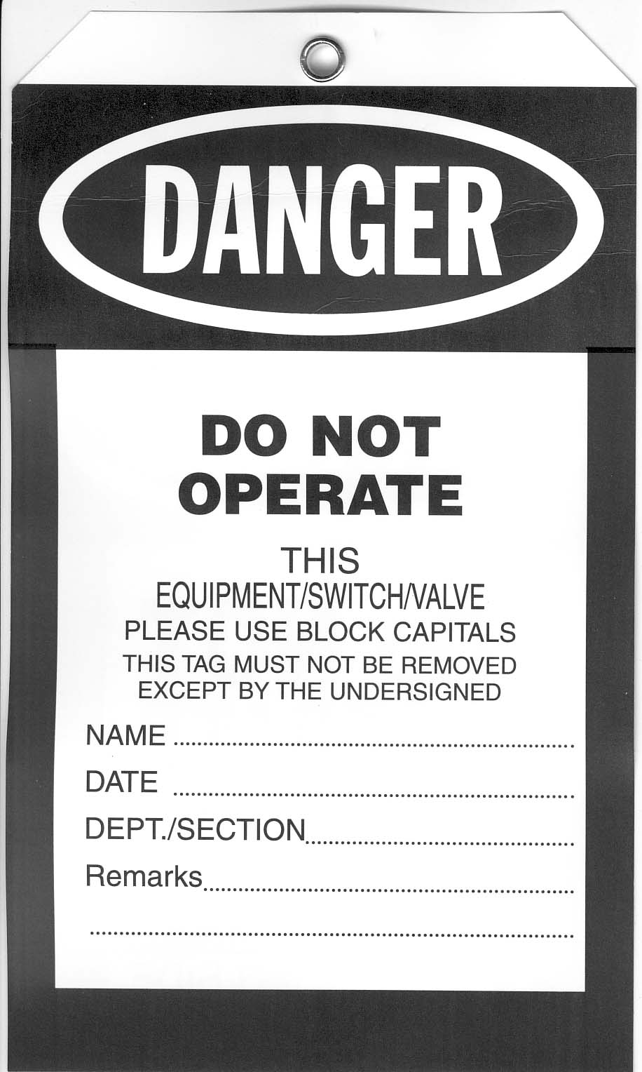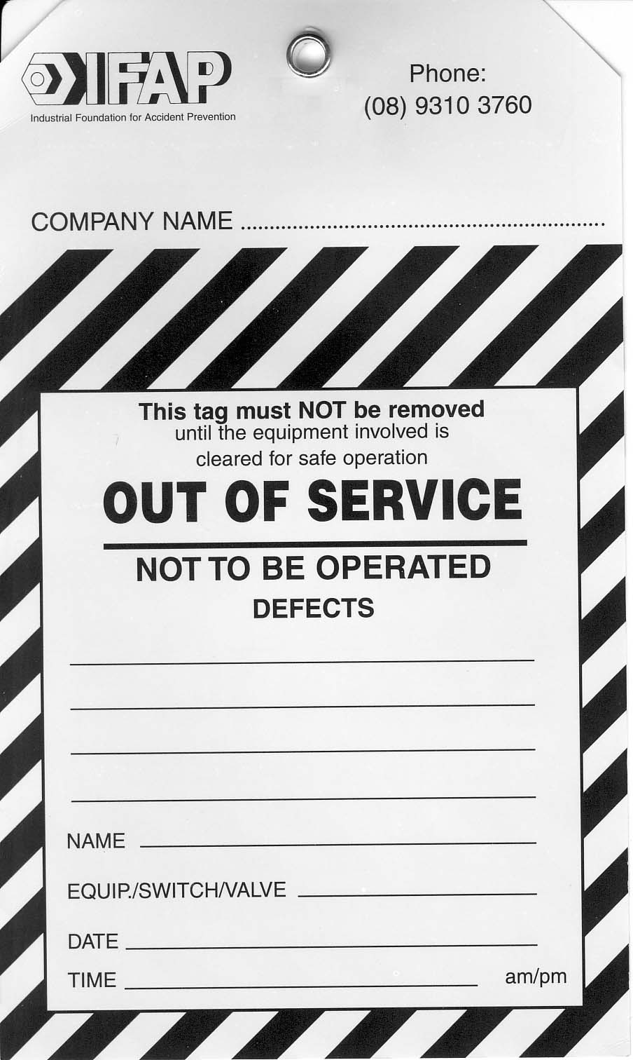• **When removing these danger tags,** check to see thatno ­one else has placed another danger tag on or under your tag.

• If a local isolating switch is provided, make sure it is used. Place a danger tag on it also, before commencing work.

# Use of Safety Tags

The use of Safety Tags to warn others of a potential hazard has been common practice in work places through out Australia for many years. AS/NZS 4836: 2001 *Safe Working on low-voltage Electrical Installation* and the WA Office of Energy Safety *Code of Practice – Safe electrical work on low voltage electrical installations* made reference to the use of Danger Tags and Out-of-Service Tags when working on electrical equipment.

**Danger Tags**

Personal Danger Tags are placed at points of isolation such as switches, fuses or circuit breakers, by persons required to work on or service equipment that may create a hazard if reactivated. Personal Danger Tags have to be removed by the person who attached it when he/she has finished work on that particular piece of equipment. If the work is not finished at the end of a work shift, the Danger Tag needs to be removed and a new Danger Tag reattached to the point of isolation if the same worker has continue working on the piece of equipment during his/her next shift.

## Out-of-Service Tags

Out of Service Tags are attached to equipment that is found to be defective. Equipment that is tagged *Out of Service* must immediately be withdrawn from service and either repaired or suitably disposed of.

### Effects of an electric shock

In spite of all precautions, accidents do happen, and electric currents can pass through the body. Electrical energy can be dangerous and the extent of the damage done to the body depends on the path it takes through the body and the amount of current flowing.

#### Path of current

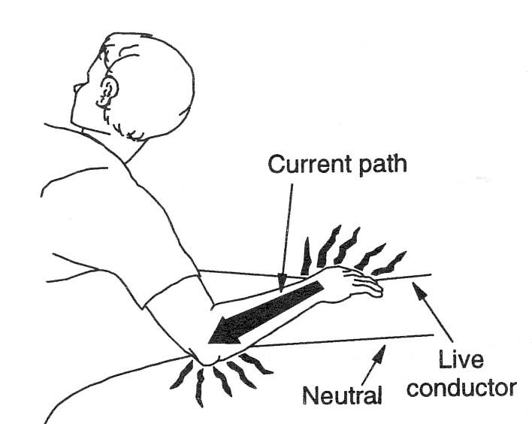There are two major types of current path through the human body. In this diagram, the path is from the hand through the arm, then back to the other conductor. No vital organs are in the path.

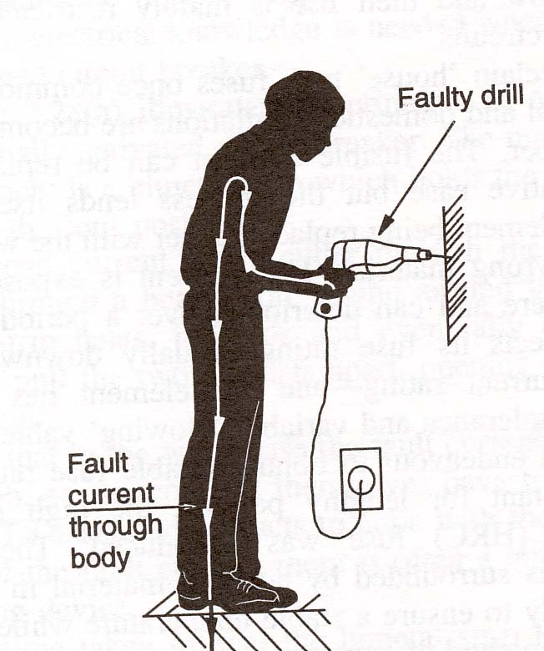

In this second diagram, a faulty drill and with no protective earth wire can cause the current to flow through the worker's body to earth. The current passes through the heart and lungs on its way to earth. It is a potentially more dan­gerous situation. A person can survive quite large elec­tric shocks provided it does not pass through the vital organs of the body. The shock can be extremely painful and can cause burning of the skin and even create holes where the current enters and leaves.

# Amount of electric current

The amount of current that can cause an electric shock varies widely from person to person. The principal factor that governs whether the shock is mild or severe depends on the resistance of that body at any given voltage. A 1 mA current can cause extreme pain to an infant, while it is only an uncomfortable feeling to an adult. A 10 mA current can be fatal to infants and adults if it flows through the chest and/or the brain. Electrocution victims have survived much higher currents when the path of electricity is not through these areas.

On a 230 volt domestic supply the adult human body in normal circumstances exhibits a resistance of about 1000 Ω to a current flow from hand to earth. This means that a current can reach a value of 200 mA or more.

## Duration of an electrical shock

It becomes difficult to predict what the effects of elec­trocution would be, because the path and the amount of current are involved, and also the time the electrical shock is applied is an important factor. Small amounts of electric current flowing for long periods can be just as lethal as large currents of short duration.

For electrical workers, one of the most common paths is from one hand to the other where the current flows through the heart and lungs. A form of muscular paralysis sets in and the person is usually unable to let go of the live conductors. The heart rhythm is inter­rupted and can stop pumping blood around the body. Severe brain damage can occur in three to four minutes unless speedy action is taken.

**Inspection and Tests**

The AS/NZS 3760/2010 has four distinct parts to its inspection and testing procedure. They are;

1. a visual inspection of the equipment and its flexible cord,
2. an electrical test of the equipment,
3. a tagging procedure, and most important, and
4. the documentation.

**Visual Inspection**

A visual inspection is as important as an electrical test. In many cases it is the damage to the equipment, its electrical cord or plug top that renders that piece of equipment electrically dangerous.

Check for obvious damage or defects to the appliance. Inspect connections, switches, the flexible cord and the plug top.

Check that the controls of the appliance are in good working order.

Check that all covers, guards and the like are secured in a manner intended by the manufacturer or supplier.

If the plug top is not moulded to the cord it has to be clear backed. Clear backed plug tops allow easy inspection of the internal electrical connection.

Check the flexible cord for cuts, abrasions and that, internal conductors are not exposed (check that the internal conductors are not exposed at the plug top and at the connection point of the appliance). The use of electrical tape to cover damage to the cord is not acceptable.

Note: Running the cord through the hand will often detect internal damage.

IF ANY DAMAGE OR DEFECT IS FOUND, THE APPLIANCE SHOULD BE IMMEDIATELY WITHDRAWN FROM SERVICE, LABELLED AS UNSERVICEABLE AND SENT FOR REPAIR.

**Electrical Testing**

Electrical testing needs to ensure that the portable equipment will operate as intended and not place the operator at risk of an electric shock. Testing of earthing continuity, Insulation resistance and correct operation will ensure that the machine is safe to operate.

The AS/NZS 3760: 2010 Standard lays out procedures to perform these tests. The use of the PAC 3760 Tester will test for earthing continuity (on a class 1 appliance), insulation resistance and leakage current without the need to use other specialised electrical test equipment

**Using the PAC 3760 Tester**

* Plug the PAC 3760 tester into a power outlet.
* Determine the class of the appliance to be tested (Class 1, earthed appliances or Class 11, double insulated appliances).
* Plug the appliance into the front panel socket of the PAC 3760 tester, and clip the black test lead to the exposed metal work on the appliance.
* Choose (1 ) or ( 2 ) for an insulation test or ( 3 ) or ( 4 ) for a *power on* leakage test.

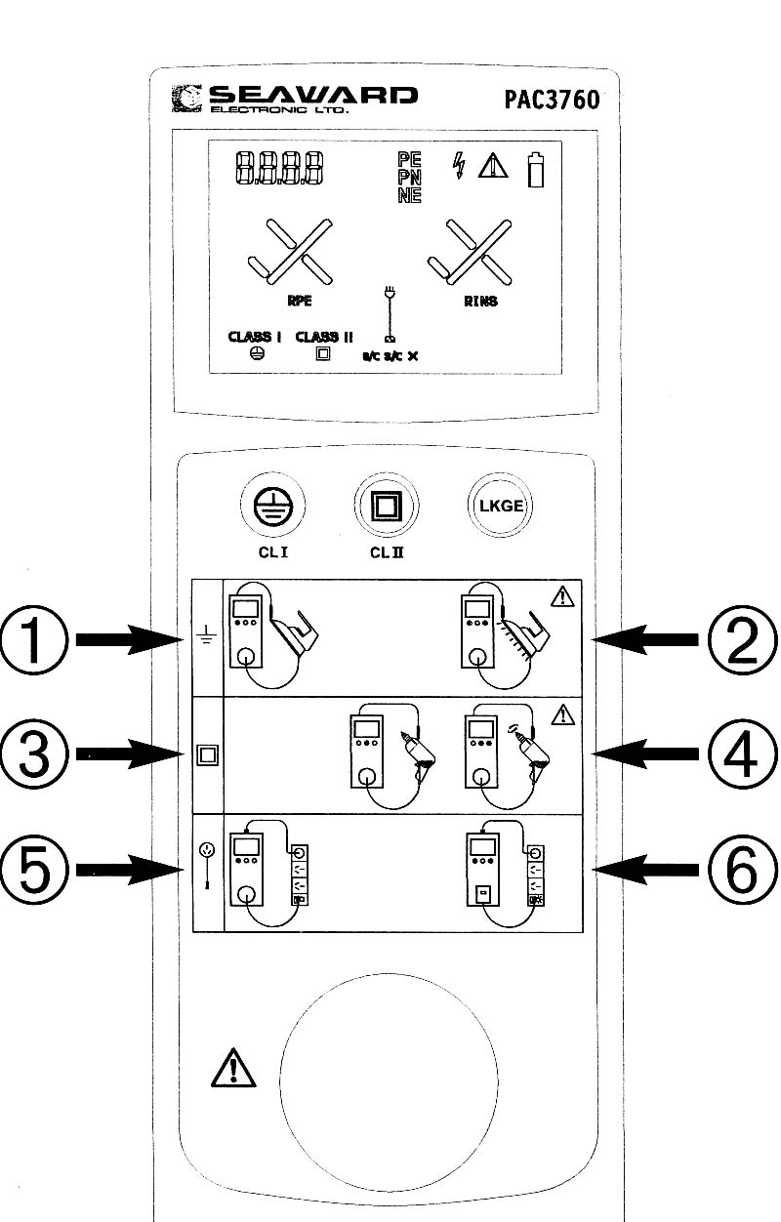(1) **Class 1 test with insulation test**

* Press the CL 1 button once.
* A pass is indicated by two ticks √ √ and “PASS”
* A fail is indicated by any cross X and “FAIL”

(2) **Class 11 test with insulation test**

* Press the CL 11 button once.
* A pass is indicated by one tick √ and “PASS”
* A fail is indicated by a cross X and “FAIL”

(3)  **Class 1 test with ‘power-on’ leakage test**

* Press the CL1 button and ‘LKGE’ button simultaneously, once.
* Wait for a √ and Δ. This indicates that power can now be applied using ‘LKGE’ button.
* Pressing the ‘LKGE’ button causes the front panel to indicate that mains power is connected to the appliance under test.

**BEWARE OF MOVING PARTS OR HOT PARTS ON THE APPLIANCE**

* Power is applied for 30 seconds unless the user presses the ‘LKGE’ button and the power to the appliance is then switched off.
* The front panel of the tester will indicate that the power is switched off.
* A pass is indicated by two ticks √ √ and “PASS”.
* A fail is indicated by a cross X and “FAIL”.

(4) **Class 11 test using ‘power-on’ leakage test**

* Press the CL11 button and ‘LKGE’ button simultaneously, once.
* Wait for the Δ. This indicates that power can now be applied using ‘LKGE’ button.
* Pressing the ‘LKGE’ button causes the front panel to indicate that mains power is connected to the appliance under test.

**BEWARE OF MOVING PARTS OR HOT PARTS ON THE APPLIANCE**

* Power is applied for 30 seconds unless the user presses the ‘LKGE’ button and the power to the appliance is then switched off.
* The front panel of the tester will indicate that the power is switched off.
* A pass is indicated by a tick √ and “PASS”.
* A fail is indicated by a cross X and “FAIL”.

1. **Testing of Extension cords and Power boards**

* Connect the extension cord plug into the front panel socket and connect the **RED** adapter lead between the IEC inlet receptacle, on top of the panel, and the extension cord or the power board socket.
* Press the CL 1 button once.
* A pass is indicated by two ticks √ √ and “PASS”
* A fail is indicated by any cross X and “FAIL”

Test operation of the appliance

After using the PAC 3760 tester on the appliance and the results show that it is electrically safe to operate, it usually good work practice to test run the equipment. By test running the appliance, the operator can check that it is operating correctly.

IF ANY ELECTRICAL DAMAGE OR DEFECT IS FOUND, THE APPLIANCE SHOULD BE IMMEDIATELY WITHDRAWN FROM SERVICE, LABELLED AS UNSERVICEABLE AND SENT FOR REPAIR.

**Tagging Procedure**

Once the appliance has been inspected and tested it has to be tagged either as suitable to re-enter service or to be withdrawn from service to be repaired or disposed of.

**Unserviceable appliances**

The AS/NZS 3670: 2010 states that where in-service inspection or testing identifies equipment that is not safe to operate, the appliance shall be:

Withdrawn from service immediately, have a label (Out of Service Tag) attached to it warning against further use, and sent for repair, disposal, or destruction by an authorised repair agent or service personnel.

**Serviceable appliances**

The AS/NZS 3670:*2010 s*tates that where in-service inspection and testing shows that equipment is safe to operate, the appliance shall be fitted with a durable, non-reusable, non- metallic tag. The tag may be colour coded to identify the period in which the test was performed, shall include:

1. the name of the person or company who performed the tests, and
2. the test or retest date.

**Documentation**

Record keeping of test and inspection results is an important part of in-service testing. Good record keeping, can show reoccurring problems with appliances, show if electrical equipment is abused and protect individuals and the university from litigation.

The documentation should contain:

1. A register of all equipment,
2. A record of formal inspection and tests,
3. A repair register, and
4. A record of all faulty equipment showing details of services or corrective actions.

Refer to AS/NZS 3760:2010 In- Service Testing and Inspection Intervals for electrical equipment .

Table 4 Page 20 -21

**The legal limits of what you can do as a Competent Tester**

Once you have completed this course and assessed as competent, you will be able to test the appliances as a part of your job. Unfortunately there are legal limits. You are **NOT** permitted to electrically maintain or repair any damage to the appliance or test and tag equipment that is intended to use on a Mine site.

**Electricity (Licensing) Regulations (1991)**

Clause 19 (1) of the Electricity (Licensing) Regulations (1991) states:

Subject to this regulation, a person who carries out any electrical work commits an offence unless the carrying out of that work by that person is authorised by a licence or permit.

Clause 19 (2) Sub-regulation (1) does not apply -

(h)         to the affixing of a plug, electrical appliance plug or cord extension socket to a flexible cord used or intended to be used to connect an electrical appliance to a plug socket outlet through which electricity is supplied or to be supplied at a nominal pressure not exceeding 1 000 volts alternating current or 1 500 volts direct current

A non licensed person must undertake appropriate training at a Registered Training Organisation (RTO) of their choice. When the off-the-job work and the on-the-job training are completed, the RTO will issue a certificate. This document can be used when seeking employment involving plug and cord-related servicing and repair work (*Electrical Focus no.43:August 2008*).

Clause 65- General penalty

A person who fails to do anything that a person is required to do under these regulations or does anything that that person is prohibited from doing under these regulations commits an offence and is liable, where no other penalty is prescribed, to a fine -

1. in the case of an individual, of $5 000;
2. in the case of a corporation, of $20 000.

**Occupational Safety and Health Regulation (1996)**

The **Occupational Safety and Health Regulations (1996)** states that electrical equipment used on a construction or demolition site as outlined in standard AS/NZS 3012 must have the tester’s name on the tag of the appliance.

Clause 3.62 - Tester to record information on tag.

A competent person who conducts under clause 3.5, 3.6 or 3.7 of AS/NZS 3012 a test on an item of portable electrical equipment or a portable residual current device that is intended for use at a workplace must ensure that, in addition to the information referred to in clause 3.8.3 of that Standard, the tag bears-

(a) the person’s name; and

(b) if the person holds and electrical worker’s licence issued under *Electricity (Licensing) Regulations 1991,* the person’s licence number.

Penalty:

(a) for the first offence, $2 000and

(b) for a subsequent offence. $2 500.

**Mines Safety and Inspection Regulations (1995) Part 5 Electricity in Mines**

**Clause 5.9** states that: Electrical work to be carried out by licensed persons

Each responsible person at a mine must ensure that a person is not engaged or permitted to carry out electrical work at the mine unless the person is authorised to carry out that work by a licence or permit under the Electricity (Licensing) Regulations (1991).

Penalty: See regulation 17.1

**Clause 5.27(2)(b)** states that: The maintenance system must include - quarterly examination, testing and tagging of any portable apparatus that is normally used in heavy operating environments such as workshops, mining areas, processing areas, construction sites and similar places;

**Clause 5.27(3)** states that: A tag referred to in sub-regulation (2)(b) must identify the date of examination and testing and the person who carried out the examination and testing.

Penalty: See regulation 17.1

**Clause 17.1** General penalty

The penalty for an offence committed by a person against a provision of these regulations that refers to this regulation is –

(a) if the offence was committed by the person as an employee –

(i) for the first offence, a fine of $5 000; and

(ii) for a subsequent offence, a fine of $6 250;

(b) if paragraph (a) does not apply –

(i) in the case of an individual –

(I) for the first offence, a fine of $25 000; and

(II) for a subsequent offence, a fine of $31 250; or

(ii) in the case of a corporation –

(I) for the first offence, a fine of $50 000; and

(II) for a subsequent offence, a fine of $62 500.

**Appendix B - Definitions**

**Appliance, portable**

A consuming device, that can be moved while in operation, other that a lamp, in which electrical energy is converted into heat, motion or any other form of energy.

**Class 1 equipment**

Equipment in which protection against electric shock does not rely on basic insulation only, but includes an additional safety precaution, in that conductive accessible parts are connected to the protective earthing conductor in the fixed wiring of the installation in such a way that those accessible parts cannot become ‘Live’ in the event of failure of the basic insulation. Equipment intended for use with a flexible cord includes a protective earthing conductor as part of the flexible cord.

**Class 11 equipment (double insulated equipment)**

Equipment in which protection against electric shock does not rely on basic insulation only, but in which additional safety precautions such as double insulation or reinforced insulation. This equipment is generally manufactured with a non-conductive (insulated) enclosure, and is marked with the words ‘DOUBLE INSULATED’ or a square within a square.

**Exposed metal**

A conductive part of electrical equipment, which is not a live part but can become live if basic insulation fails and can be touched with ‘jointed test finger’.

The term *exposed metal* does not apply to parts that are separated from live parts by double insulation.

**Flexible supply cord (lead)**

A flexible cable or cord whose purpose is to supply power to the appliance. One end is connected to a plug top and the other end is connected to the appliance or to a socket outlet designed to connect to the appliance.

**EPOD**

Electric power outlet device – power board, used to connect a number of appliances to the one power point.

**MOV**

Metal oxide varistor – a device used to protect electrical appliances from high voltage surges.