**UEE11 Electrotechnology Training Package**



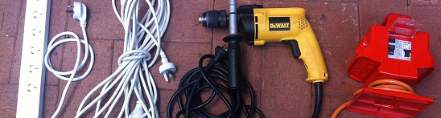**UEENEEP026A**

**Conduct in-service safety testing of electrical cord connected equipment and cord assemblies**

Student Guide

**Student name: ________________________________________**

**Electrical Department**

Version 1: 19/05/16

© North Metropolitan TAFE

**ACKNOWLEDGEMENTS**

This workbook was compiled by lecturing staff of the Electrical Trades Business Unit at South Metropolitan TAFE.

It is intended for use by North Metropolitan TAFE students only.

**COPYRIGHT DISCLAIMER**

Some of the material and graphics in this workbook has been reproduced by North Metropolitan TAFE for educational purposes under Part VB of the Copyright Act 1968 from the following texts:

Photos © Ian Evans

**All rights reserved**

No part of this publication may be reproduced, stored in a retrieval system or transmitted in any form or by any means, electronic, mechanical, photocopying, or otherwise, nor the making of copies for hire or resale to third parties or other institutions affiliated or not without the prior written permission of South Metropolitan TAFE.

Requests and inquiries concerning reproduction and rights should be directed in the first instance to the Manager Publications and Distributions.

Manager Publications and Distributions

North Metropolitan TAFE

P.O. Box 1336

MIDLAND WA 6936

Telephone: +61 08 9267 7649

Facsimile: +61 08 9267 7516

**DISCLAIMER:**

While every precaution has been made to supply complete and accurate information, Polytechnic West assumes no responsibility to any person or entity with respect to any liability, loss or damage caused or alleged to be caused directly or indirectly by the instructions contained in or accompanying this publication or by any computer software or hardware described therein.

Printed by North Metropolitan TAFE Printing Service

**Introduction to Testing and Tagging**

Duty of care legislation in WA requires that workers in a workplace are not exposed to hazards. By following the AS/NZS3760:2010 and the Worksafe guidelines that provide us with best practice procedures in regards to appliance testing so that we can fulfil these requirements.

Western Australian legislation provides us with the requirements for testing and tagging of electrical equipment in the work place.

**Occupational Safety and Health Act 1984:**

General provisions relating to occupational safety and health Part III General workplace duties Division 2 s. 19

The Occupational Safety and Health Act 1984 require electrical equipment at workplaces to be safe and not expose workers to hazards.

**Occupational Safety and Health Regulations 1996:**

The Occupational Safety and Health Regulations 1996, requires the person having control of a workplace or access to that workplace, to ensure that all portable plug-in electrical equipment and residual current devices at the workplace are safe and appropriately inspected, tested and maintained by a competent person.

To achieve these goals we follow the requirements set down in Australian Standards and industry guidelines.

**AS/NZS 3760:2010** **In-service safety inspection and testing of electrical equipment:**

AS/NZS 3760 will enable persons responsible for the safety of electrical equipment in the workplace to instigate an inspection and testing programme to achieve that aim. It also enables persons undertaking the inspection and testing to carry out the task in a safe and effective manner.

**AS/NZS 3012:2010 Electrical installations—Construction and demolition sites:**

This Standard sets out minimum requirements for the design, construction and testing of electrical installations that supply electricity to appliances and equipment on construction and demolition sites, and for the in-service testing of portable, transportable and fixed electrical equipment used on construction and demolition sites.

**Guide to testing and tagging portable electrical equipment and residual current devices at workplaces.**

This industry guideline produced by Worksafe is to assist people in meeting occupational safety and health obligations for testing and tagging electrical equipment.

**Competent Person**

The AS/NZS3760 requires that a competent person will:

* 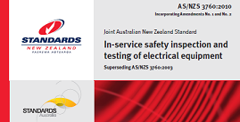Be able to use test equipment safely and effectively.
* Have an understanding of the dangers of electricity, leading to an appreciation of the need for inspection and testing.
* Have an understanding of the construction of Class I and Class II equipment, and of the terms: basic insulation, supplementary insulation, reinforced insulation and double insulation, protective earth and earth continuity, insulation resistance and earth leakage current.
* Have an understanding of the application and requirements of the AS/NZS3760.
* Have an understanding of the relevant legislative requirements appropriate Western Australia.

The ‘Guide to testing and tagging portable electrical equipment and residual current devices at workplaces’ published by Worksafe WA require these key competencies:

* 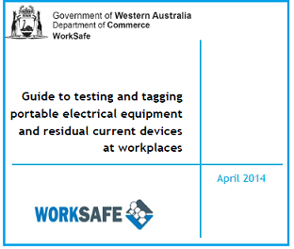Being able to distinguish between electrical equipment that is double insulated and electrical equipment that is protectively earthed, and identify the appropriate test for each type.
* Understanding the limitations of his or her training and not attempting to test electrical equipment he or she has not been trained to do.
* Understanding how the OSH regulations and relevant guidance material apply to electrical equipment used at the workplace.
* Knowing how to use the relevant testing instruments properly, interpret and record results for compliance with the OSH regulations.
* Working to the requirements of AS3012:2003.
* Knowing about, and being able to carry out, a visual examination of electrical equipment.
* Being able to carry out the earthing continuity tests on electrical equipment.
* Being able to carry out the insulation resistance or earth leakage tests on electrical equipment.

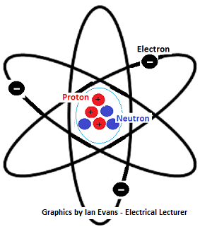**Introduction to electricity, AC and DC;**

The atom is the building block of matter which makes up our universe.

The atom itself is made up of neutrons that have a neutral charge, protons that have a positive charge and electrons that have a negative charge.

The electrons spin around the nucleus in a similar way that the planets of our solar system travel around our sun.

If the number of protons equal the number of electrons then the overall charge is neutral.

In nature a range of phenomenon like lightning occur when the process of movement within the atmosphere between air and moisture cause an excess or deficiency of electrons that create a build up of static electricity. This build up is then discharged in the form of lightning.

Electricity that we use daily in our homes and businesses is the flow of electrons in a conductor.

To create this electron flow we need to apply a potential difference in charge across a circuit.

This potential difference can be achieved by a number of ways:

**Friction**

This is the cause of static electricity and lightning.

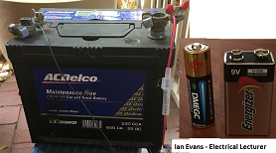

**Chemical**

You will be very familiar with this in the form of batteries. These can be non rechargeable batteries that you use for a calculator or torch to the larger 12 V rechargeable battery that starts you car.

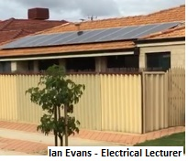

**Light**

You have probably seen many solar panels on roofs in our suburbs that convert photons of light into electricity.

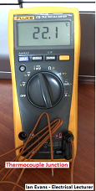**Heat**

We can produce a small voltage from heating the junction of two dissimilar metals. You may not be familiar with this process but you would have seen the result of devices that give you a temperature reading using this concept.

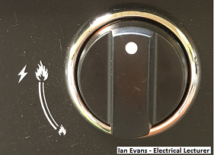**Pressure**

If you used an automatic ignitor on your gas BBQ you are using this concept in the form of a quartz crystal and the piezo effect.

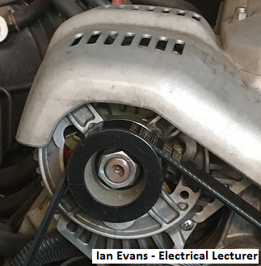

**Magnetism**

This is most common way where we have a rotating magnetic field that cuts through the stationary winding on an alternator that then produces a voltage.

A motor car has an alternator that is driven by the engine to produce a voltage. On an industrial scale we have power station that have various prime movers like gas turbines or coal fired steam turbine that are all used to turn a rotating magnetic field that induces currents in stationary windings of alternators.

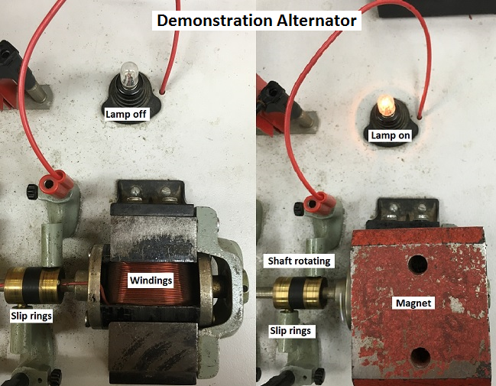

Unlike the more common large alternator with stationary windings and a rotating field our small scale demonstration alternator has a stationary field with a rotating winding.

We drive our winding through the magnetic field and the lamp, which is connected by the slip rings and brushes, lights up.

There are two forms on electricity that we use for powering our electrical equipment

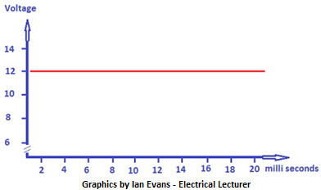**DC or direct current.**

This is what is delivered from a battery. If we graph the voltage over time of our 12 V car battery we will see a steady value.

The current that flows as a result of the applied voltage is also a steady value.

**AC or alternating current.**

This is what is produced from an alternator whether it is the alternator of your car or the alternator that supplies the grid that feeds your home and workplace.

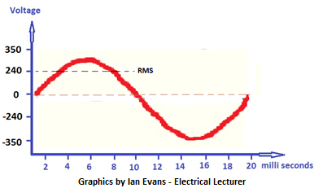This voltage output is alternating between positive and negative and this cycle occurs fifty times every second which is why it is call it a 50 hertz supply.

As this waveform alternates from zero to a positive peak and then to zero and a negative peak we us a value that is called the root mean squared or simply RMS.

A 240 V RMS ac has the same heating effect as 240 V dc.

This waveform is called a sine wave and is used because its nature means that if we put a sign wave into a power transformer we will get a sign wave back out usually at a lower voltage when we have a step down transformer.

The current that flows as a result of the applied voltage is also a corresponding sine wave.

**Electrical Units**

|  |  |
| --- | --- |
| Voltage is measured in Volts and has the unit symbol | **V** |
| Current flow is measured in Amperes and has the symbol unit symbol | **A** |
| Resistance is measured in Ohms and has the unit symbol | **Ω** |
| Power is measured in Watts and has the units symbol | **W** |

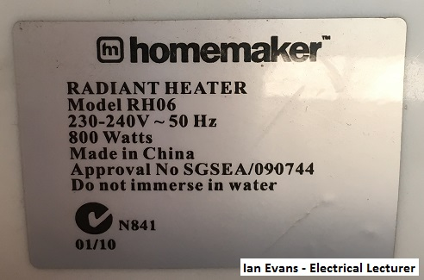

The nameplate of an Appliance gives us the operating voltage, frequency and the power rating.

The power is an indication of the expected current draw.

Although not accurate for a motor the current draw for most appliances can be calculated by dividing the voltage into the power.

In this case of a heater where we have 800 W at 240 V:

800 / 240 = 3.3 A

This is also the case of most power boards that are rated at 2400 W or 2.4 kW.

2400 / 240 = 10 A.

Our power boards referred to as EPODs usually have a maximum load of 10 A. Power boards must display the maximum load.

Electrical units are often express as multiples and submultiples.

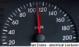You will be familiar with the term kilometres or km when referring to distance travelled in a car.

One Km = 1000 metres. The k represents 1000.

You may have heard the reference to millibar when listening to the weather report when they talk about air pressure.

One millibar = One bar divided by a 1000. The m represents divide by 1000

We will need to understand the following when we are using our PAT.

|  |  |  |  |
| --- | --- | --- | --- |
| Prefix | Symbol | Factor | Action |
| mega | M | 10 6 | Multiply by 1 000 000 |
| kilo | k | 10 3 | Multiply by 1 000 |
| milli | m | 10 -3 | Divide by 1 000 |

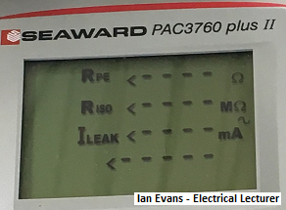Our PAT will give us the following readings from our appliance tests.

RPE _ _ _ _ **Ω**

This will be the resistance of the protective earth conductor in ohms.

RISO _ _ _ _ **MΩ**

This will be the insulation resistance in mega ohms. (M= Multiply by 1 000 000)

ILEAK _ _ _ _ **mA**

This is the leakage current measured in milli amps. (m = Divide by 1000)

**Conductors and Insulators**

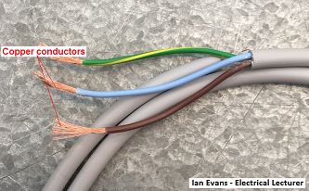A conductor is a material that allows the movement of electrons from one atom to another.

Common conducting material is the copper wire commonly found in the flexible cord of an appliance.

Other conducting material includes most types of metals including aluminium, mild steel, galvanised steel and brass just to name a few.

The metal frame of an electric kettle is a conductor.

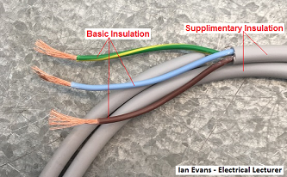Insulating material prevent the movement of electrons in the material.

Basic insulation

This is the insulation applied to live parts to provide basic protection against electric shock.

Supplementary insulation

This is an independent insulation, applied in addition to the basic insulation, in order to ensure protection against electric shock in the event of a failure of the basic insulation.

Double insulation

This is an insulation system that comprises of both the basic insulation and the supplementary insulation.

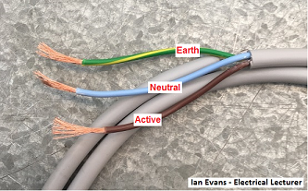

The colour coding of the basic insulation for flexible cords is:

* Active - Brown
* Neutral – Light Blue
* Earth – Green / Yellow

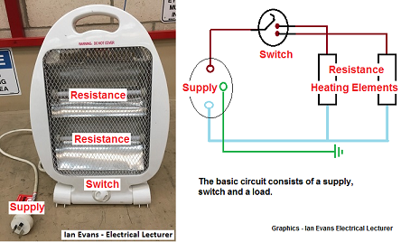

**Circuit Protection**

Circuit protection is designed to limit the effects of overload and fault current on electrical equipment or people.

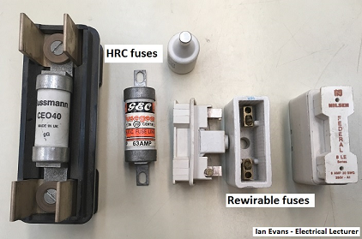The common types of overload protection are fuses and circuit breakers.

**Fuses**

Fuses work on the basis than when a circuit draws too much current due to an overload or short-circuit, the fuse element overheats and open circuits.

The burnt out fuse element opens the electrical circuit and the current flow stops. When the problem that caused the fuse to blow is rectified then the fuse can be replaced.

Rewirable fuses are no longer installed in electrical installations in Australia.

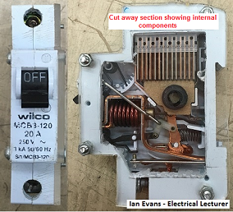

**Circuit breakers**

Circuit breakers are switches that automatically turn the current off when there is a short-circuit or an overload.

Circuit breakers are a popular type of over-current protection device, because they are easy to reset after the circuit breaker has opened the circuit.

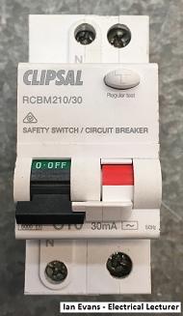**Residual Current Devices**

Residual Current Devices (RCDs, also known as safety switches) are devices designed to protect people against the possibility of receiving a fatal electric shock.

RCDs monitor the amount of current flowing from the supply to the load and the amount of current returning from the load to the supply.

### When the currents are equal, the toroid ferrite core will remain demagnetised.

### If there is a leakage of current to earth, the ferrite core will magnetise, because the current through the RCD to the load will be more than the current returning through the RCD from the load.

### The magnetised core will produce a small voltage that will power the electronics of the trip circuit, which disconnect the load from the supply.

### The type of RCDs installed in Perth homes only require a difference of 30 mA between the current to the load and the current returning to the supply, for the device to operate. It is mandatory for RCDs to be installed in all new homes in Australia.

### 

### 

### Portable RCD power board

### Earthing

### The basic concept of earthing is to ensure that anything conductive that a person can touch or comes into contact with is maintained at the same potential as the ground or earth.

### In Australia we use the MEN earthing system of linking the earth bar to the neutral bar to enhance the earthing system.

### When people complain about feeling tinging sensations when touching water taps there is probably a fault in the installation as these conductive parts are no longer at an earth potential.

### People and equipment must be protected from the harmful and possibly fatal effects of electric current when there is a break down in electrical insulation.

### Earthing of electrical installations and Class I appliances using an earth wire (green/yellow) is an essential component in achieving this protection.

### If a live wire inside an appliance is touching the metal case, you could get an electric shock when you touch the case.

### To limit the effects of the shock and to switch the power off automatically, the exposed metal parts of any Class I appliances are connected to the general mass of earth via the earth wire.

The earth wire (green/yellow in colour) is incorporated in the flexible cord with the power conductors.

It is connected to the earth pin of the plug top.

When inspecting and testing Class I appliances, the tester needs to pay special attention to the condition of the flexible cord and the plug to make sure that the appliance has a functioning earth wire.

### 

### The standard extension cord and appliance cords have 10 A plug tops. Some appliances like portable welders are rated at 15 A or even 20 A. The difference between the plug tops for these higher rated appliances is the size of the earth pin as shown in this photo below.

### 

### An appliance with a 15 A plug top requires a dedicated circuit with a matching socket outlet that has an earth receptacle that is large enough for the plug top to fit.

### To bypass this safety requirement of requiring a dedicated circuit for an appliance with a higher current rating some people have been known to file the earth pin down so that it fits a normal 10 A socket.

### This practice is illegal and dangerous as it will overload the circuit.

### If you see any sign of damage to an earth pin then the appliance should fail immediately.

### Class I and Class II Appliances

### When using our portable appliance tester we are required to determine if an appliance is class I or class II.

### Class I Appliance.jpgIt is very important that we do not make a mistake as testing a class I as a class II could mean passing an appliance as safe when it has a dangerous fault.

### Class I

### A class I appliance has basic insulation and is protected by a protective earth conductor that is connected to any exposed metal parts.

### If a live wire was to dislodge and touch the conductive frame of an appliance it will cause the circuit protection to operate and isolate the supply.

### Class II.jpg

### Class II

### A Class II appliance is referred to as a double insulated appliance. It is protected by the basic insulation and also the supplementary insulation.

### Some appliances are manufactured with reinforced insulation. This is a single insulation system that provides the same degree of protection as double insulation.

### The symbol for double insulation is a box inside a box. Or it can be labelled as ‘Double Insulation’.

**Electrical Safety**

Safety rules are mostly a matter of common sense. Safe work habits can be developed and used so that in time they will tend to become automatic.

Electrical energy is a useful source of power but can be dangerous when carelessly handled or misused. Some important points to be observed are:

* Make sure all appliances are serviceable before connecting them to the power.
* Regard all equipment as being alive until testing has proved otherwise.
* When removing the power from equipment to work on it, take precautions to ensure that no-one will be able to turn the power on again until work is completed.

### 

### Lockout bags can be used to carry out isolations for appliances if required. The simplest isolation for an appliance is to put the plug top in your pocket.

**Use of Safety Tags**

The use of Safety Tags to warn others of a potential hazard has been common practice in work places throughout Australia for many years.

AS/NZS 4836:2011 Safe working on or near low-voltage electrical installations and equipment makes reference to the use of Danger Tags and Out-of-Service Tags when working on electrical equipment.

**Danger Tags**

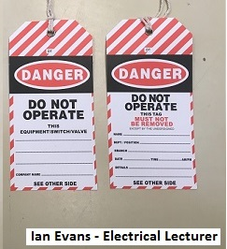

Personal Danger Tags are placed at points of isolation such as switches, fuses or circuit breakers, by persons required to work on or service equipment that may create a hazard if reactivated.

Personal Danger Tags have to be removed by the person who attached them when he/she has finished work on that particular piece of equipment.

If the work is not finished at the end of a work shift, the Danger Tag needs to be removed and a new Danger Tag reattached to the point of isolation when the worker resumes working on the piece of equipment during his/her next shift.

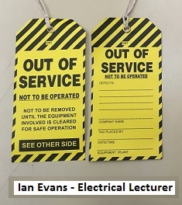**Out-of-Service Tags**

Out of Service Tags are attached to equipment that is found to be defective.

Equipment that is tagged Out of Service must immediately be withdrawn from service and either repaired or suitably disposed of.

**Effects of an electric shock**

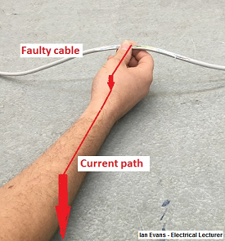In spite of all precautions, accidents do happen, and electric currents can pass through the body.

Electrical energy can be dangerous and the extent of the damage done to the body depends on several factors, including the amount of current flowing, the duration of current flow and the path it takes through the body.

There are two major types of current path through the human body.

In this image, the path is from the hand through the arm, then back to the other conductor.

No vital organs are in the path.

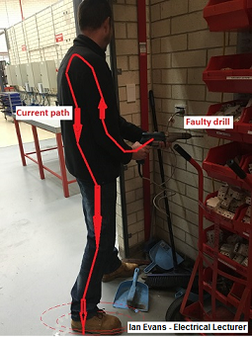In this second image, a faulty drill with no protective earth wire can cause the current to flow through the worker's body to earth.

The current passes through the heart and lungs on its way to earth.

It is potentially a more dan­gerous situation.

A person can survive quite large elec­tric shocks, provided the current does not pass through the vital organs of the body.

The shock can however be extremely painful and can cause burning of the skin and tissues, even creating holes where the current enters and leaves the body.

**Effects of an electric current**

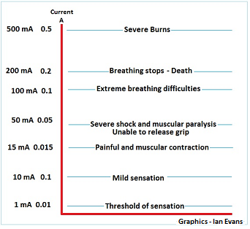The amount of current that can cause an electric shock varies from person to person. The principal factor that governs whether the shock is mild or severe depends on the resistance of that body at any given voltage.

A 1 mA current can cause extreme pain to an infant, while it is only an uncomfortable feeling to an adult.

A 10 mA current can be fatal to infants and adults if it flows through the chest and/or the brain. Electrocution victims have survived much higher currents when the path of electricity is not through these areas.

On a 230 volt domestic supply the adult human body in normal circumstances exhibits a resistance of about 1000 Ω to a current flow from hand to earth.

This means that a current can reach a value of 200 mA or more.

**Duration of an electrical shock**

The duration of an electrical shock is an important factor.

Small amounts of electric current flowing for long periods can be just as lethal as large currents of short duration.

For electrical workers, one of the most common paths is from one hand to the other, where the current flows through the heart and lungs.

A form of muscular paralysis sets in and the person is usually unable to let go of the live conductors.

The heart rhythm is inter­rupted and can stop pumping blood around the body.

Severe brain damage can occur in three to four minutes unless speedy action is taken.

**Voltage levels:**

The AS/NZS3000:2007 specifies the following voltage levels.

* Extra low voltage 0 V – 50 Vac : 0 V – 120 Vdc
* Low voltage 50 V – 1000 Vac : 120 V – 1500 Vdc
* High voltage Above low voltage

**Risk Management**

As a competent person for the purpose of testing and tagging you should be fully aware of the potential risks that working with electricity poses.

Working in a workshop with other workers can also be an issue in regards to their safety as well as yours.

Risk management should be applied on a day to day basis when working in industry.

The principles of risk management are:

* Identify any hazards
* Assess and prioritise any risks
* 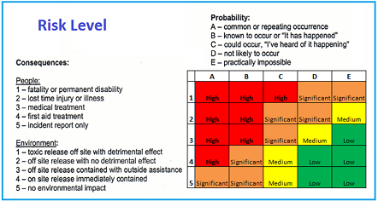Apply control measures to those risks

A best practice work procedure includes a written job safe procedure or analysis. (JSA)

We plan each job and record each step. We then record any hazards that we can identify with each step.

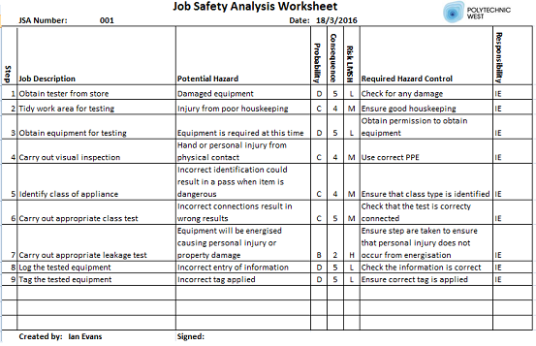We use the risk level matrix shown here to determine the level of risk associated with each hazard.

We then apply control measures to minimise any risks to ourselves or any other workers.

In this example shown we have identified a High risk potential hazard associated with carrying out a leakage current test. This is where an appliance is energised when being tested. We have the potential to injure ourselves or others around us if a portable drill was to start up and move on the bench causing an injury. We must plan ahead for this scenario to avoid any possible injuries or damage.

**Testing to the AS/NZS3760:2010**

The AS/NZS3760:2010 provides us with guidance to carry out in service safety inspection and testing of electrical equipment.

* Appliances placed into service for the first time.
* Appliances already in-service.
* Appliance that have been serviced or repaired.
* Appliances that are returning to service from a second-hand sale.
* Appliances that are available for hire.
* Residual current devices (RCDs)**.**
* Portable inverters that generate or produce low voltage.

Typical examples of equipment covered by the AS/NZS3760:

* Portable equipment, hand-held equipment and stationary equipment.
* Cord sets, cord extension sets and power boards.
* Flexible cords connected to fixed equipment in hostile environments.
* Portable power supplies.
* Battery chargers.
* Portable and transportable heavy duty tools such as high pressure washers and concrete grinders.

New equipment is not required to be tested but should be registered and tagged with the following information.

* New to service
* Date of entry to service
* Date of next test
* Statement. This appliance has not been tested to AS/NZS3760

Equipment that does not require testing

Electrical equipment (such as suspended light fittings), installed at a height of 2.5 m or greater above the ground, floor or platform, where there is not a reasonable chance of a person touching the equipment and, at the same time, coming into contact with earth or any conducting medium which may be in electrical contact with earth or through which a circuit may be completed to earth.

**Inspection and Tests**

AS/NZS 3760:2010 has four distinct parts to its inspection and testing procedure:

* + A visual inspection of the equipment and its flexible cord
  + An electrical test of the equipment
  + A tagging procedure
  + The documentation

**Visual Inspection**

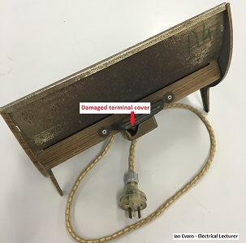A visual inspection is as important as an electrical test.

In many cases it is the damage to the equipment casing, its electrical cord, or plug top that renders that piece of equipment electrically dangerous.

Check for obvious damage or defects to the appliance. Inspect connections, switches, the flexible cord and the plug top.

Check that the controls of the appliance are in good working order.

Check that all covers, guards and the like are secured in a manner intended by the manufacturer or supplier.

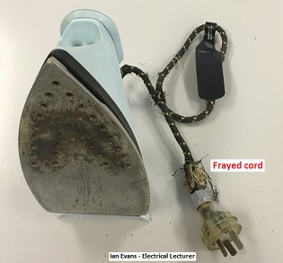

If the plug top is not moulded to the cord it has to be clear-backed (transparent). Clear-backed plug tops allow easy inspection of the internal electrical connections.

Check the flexible cord for cuts, abrasions and ensure that internal conductors are not exposed, either at the plug top or at the point where they enter the appliance.

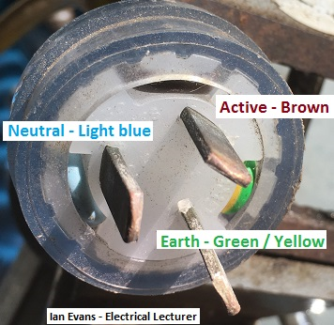The use of electrical tape to cover damage to the cord is not acceptable.

Note: Running the cord through the hand will often detect internal damage.

If the plug top is transparent you can visually check for correct polarity.

**IF ANY DAMAGE OR DEFECT IS FOUND, THE APPLIANCE SHOULD BE IMMEDIATELY WITHDRAWN FROM SERVICE, LABELLED AS UNSERVICEABLE AND SENT FOR REPAIR.**

**Testing**

**Earth continuity**

For class I appliances the resistance of the protective earthing conductor must be tested and the result must be less than 1Ω.

Some PATs make available two types of tests.

* Earth resistance test – The PAT will use a small current to determine the resistance.
* Earth bond test - The PAT will apply a heavy current to stress the earth connection.

**Testing of the insulation**

AS/NZS3760 requires one of the following two tests to ensure that there is no breakdown of the insulation of the appliance.

**Insulation Resistance**

The circuit is stressed at 500 V dc to see if there is any leakage current detected in the earth bond conductor. The appliance must be turned on for this test.

EPODs with surge protection can fail this test as the MOVs will activate as they are designed to do. A leakage current test should be performed for these items.

**Leakage current**

The appliance is energised and the PAT will determine s there is any leakage current in the earth bond conductor.

It must be less than:

* 5 mA for a class 1 appliance
* 1 mA for a class II appliance

The appliance must be turned on for this test and extreme care must be exercised as the appliance will turn on.

Because of the high risk of injury for this step we recommend the use of a risk assessment process that includes a JSA.

Some appliances that require energising for the switch to operate will require leakage testing.

Although one or the other test is required best practice is to perform both tests.

**Polarity**

Polarity of the plug top can be carried visually if it is the transparent type. The PAT will test for correct polarity.

**Test functional operation of the appliance**

After using the PAT on the appliance and if the results show that it is electrically safe, it is usually good work practice to test run the equipment to check that it is operating correctly.

**IF ANY ELECTRICAL DAMAGE OR DEFECT IS FOUND, THE APPLIANCE SHOULD BE IMMEDIATELY WITHDRAWN FROM SERVICE, LABELLED AS UNSERVICEABLE AND SENT FOR** **REPAIR.**

**Tagging Procedure**

Once the appliance has been inspected and tested it has to be tagged either as suitable to re-enter service, or to be withdrawn from service to be repaired or disposed of.

**Unserviceable appliances**

AS/NZS 3760:2010 states that where in-service inspection or testing identifies equipment that is not safe to operate, the appliance shall:

* Be withdrawn from service immediately and
* 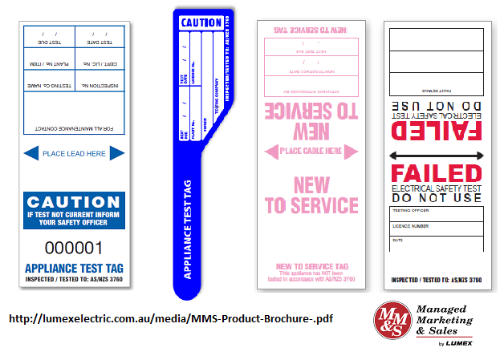Have a label (Out of Service Tag) attached to it warning against further use and
* Be sent for repair, disposal, or destruction by an authorised repair agent or service personnel.

**Serviceable appliances**

AS/NZS 3760:2010 *s*tates that where in-service inspection and testing shows that equipment is safe to operate, the appliance shall be fitted with a durable, non-reusable, non-metallic tag. The tag may be colour-coded to identify the period in which the test was performed and shall include at a minimum:

* The name of the person or company who performed the tests
* The test or inspection date and a retest date
* A reference that the appliance has been tested to AS/NZS3760

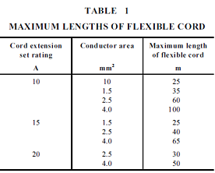**Maximum lengths of extension cords**

AS/NZS3199:2007 provides us with guidance on the maximum lengths of extension cords.

Extension cords should always be uncoiled or unreeled before use.

Failure to do this will result is overheating and damage the insulation.

**Documentation**

Record keeping of inspection and test results is an important part of in-service testing. Good record keeping can show reoccurring problems with appliances and whether electrical equipment is being abused. It can also protect individuals and companies from litigation.

The documentation should contain:

* A register of all equipment
* A record of formal inspection and tests
* A “repair” register: Remedial action and date
* A record of all faulty equipment showing details of corrective actions.

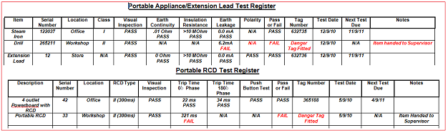

Records should be kept for seven years.

**Testing and tagging intervals:**

Table 4 of AS/NZS 3760:2010 provide minimum testing and inspection intervals that take into account the various types of workplaces.

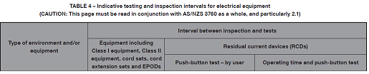

A risk assessment process should be undertaken to ensure that the particular risks are identified for your workplace as per clause 2.1 Frequency of inspection and tests of AS/NZS3760:2010.

**The legal limits of what you can do as a ‘Competent Person’**

Once you have completed this course and been assessed as competent, you will be able to test appliances as a part of your job.

There are legal limits however.

* You are **NOT** permitted to electrically maintain or repair any damage to the appliance, as this course does not cover the knowledge and skills necessary to service and repair appliances.

It is also your responsibility to maintain your competency. Once you have received your initial training you will need to put these skills and knowledge into practice ensuring that you are following your company workplace procedures as well.

If for some reason you are not involved with hands on practice in testing and tagging for a significant time period or you feel that you are not longer fully confident carrying out this task you should approach your employer and discus the need for a refresher course.

**Networking**

There is no reason for you to receive your initial training in testing and tagging and then return to your workplace and carry out your appliance testing duties in isolation.

Network with fellow workers from your organisation who are involved with similar duties as yourself.

Keep in touch with people you have met in these training sessions.

Talk to any electricians whether they are employed by your company or are contracted for various jobs.

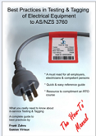**Further recommended reading**

‘Best Practices in Testing and Tagging of Electrical Equipment to AS/NZS3760’ is a comprehensive text book that is recommended for you to read.

Especially Section 6 Problem appliances: Hints and tips.

**It can be purchased on line from:**

[**https://www.testandtagsupplies.com.au**](https://www.testandtagsupplies.com.au)

**Construction and Demolition Sites**

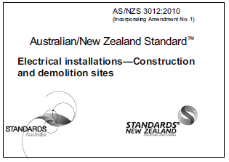We also need to understand the requirements of portable appliances testing and tagging on building and construction sites as per the AS/NZS3012:2010.

Table 1 provides information for maximum lengths of flexible cords and cables.

Clause 3.6.1 requires electrical equipment on site, including power tools, flexible cords, cord extension sets and portable socket-outlet assemblies to be tested and inspected in accordance with the methods of AS/NZS 3760, before being put into service and thereafter at intervals not exceeding those listed in Table 7.

Appendix F provides guidance on the use of colour coded appliance tags:

* Red December–February
* Green March–May
* Blue June–August
* Yellow September–November

Occupational Safety and Health Regulations (1996)

The Occupational Safety and Health Regulations (1996) states that electrical equipment used on a construction or demolition site as outlined in standard AS/NZS 3012 must have the tester’s name on the tag of the appliance.

Clause 3.62 - Tester to record information on tag.

A competent person who conducts under clause 3.5, 3.6 or 3.7 of AS/NZS 3012 a test on an item of portable electrical equipment or a portable residual current device that is intended for use at a workplace must ensure that, in addition to the information referred to in clause 3.8.3 of that Standard, the tag bears-

1. in the case of a test that need not be carried out under an electrical worker’s licence or permit under the Electricity (Licensing) Regulations 1991 —
2. the person’s name; and
3. if the person holds an electrical worker’s licence or permit — the person’s licence or permit number.

Penalty:

(a) for the first offence, $2 000 and

(b) for a subsequent offence, $2 500.

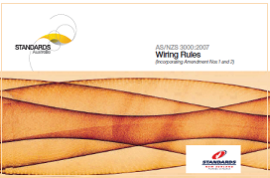**Definitions**

**AS/NZS 3000:2007 1.4.6 Appliance**

A consuming device, other than a lamp, in which electricity is converted into heat, motion or any other form of energy, or is substantially changed in its electrical character.

**AS/NZS 3760:2010 1.4.2 Class I equipment (basic insulated, protectively earthed equipment)**

Equipment in which protection against electric shock does not rely on basic insulation only, but includes an level of protection, in that conductive accessible parts are connected to the protective earthing conductor in the fixed wiring of the installation in such a way that those accessible parts cannot become ‘Live’ in the event of failure of the basic insulation...

**AS/NZS 3760:2010 1.4.3 Class II equipment (double insulated equipment)**

Equipment in which protection against electric shock does not rely on basic insulation only, but in which an extra layer of **insulation** (called “**supplementary insulation**”) is provided to give **double insulation**, there being no provision for protective earthing or reliance upon installation conditions. This equipment is generally manufactured with a non-conductive (insulated) enclosure, and is marked either with the words “DOUBLE INSULATED” or with the following symbol:

*The above definitions are extracts from the Australian Standards*

**EPOD**

Electric power outlet device – power board, used to connect a number of appliances to the one power point.

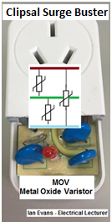

**MOV**

Metal oxide varistor – a device used to protect electrical appliances from high voltage surges.

These specially designed resistors will lower their resistance in the presence of a voltage surge that can be caused by a range of things like motors being switched off or a voltage spike that can be caused by power line faults or lightning.