**Assignment**

|  |  |
| --- | --- |
| **Name** | **AHAHAHAHAHAHAHAAAASASAHAH** |
| **Lecturer** |  |
| **Date of issue** |  |
| **Due date** |  |

***Complete the attached problems.***

***You must show formulae used to calculate answers.***

***You must draw the phasor diagrams.***

***You must show all answers with correct units of measurement.***

|  |
| --- |
| ***f = 100Hz*** |
| ***Va = 230v*** |
| ***C = 3.3µF*** |
| ***L = 2.5H*** |
| ***R = 1800Ω*** |

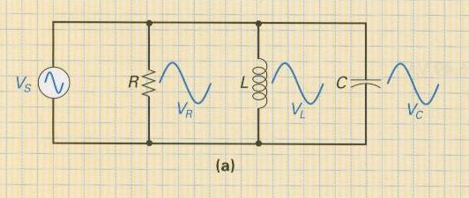

|  |
| --- |
| XL |
| XC |
| Draw current phasor diagram. |
| IR |
| IL |
| IC |
| IX |
| IT |
| Z |
| Phase angle |
| Power factor |

|  |
| --- |
| ***f = 50Hz*** |
| ***Vs = 230v*** |
| ***C = 68uF*** |
| ***L = 82mH*** |
| ***R = 32Ω*** |



|  |
| --- |
| XL |
| XC |
| Draw current phasor diagram. |
| IR |
| IL |
| IC |
| IX |
| IT |
| Z |
| Phase angle |
| Power factor |

|  |
| --- |
| ***f = 1kHz*** |
| ***Vs = 230V*** |
| ***C = 6.3uF*** |
| ***L = 3mH*** |
| ***R = 35Ω*** |



|  |
| --- |
| XL |
| XC |
| Draw current phasor diagram. |
| IR |
| IL |
| IC |
| IX |
| IT |
| Z |
| Phase angle |
| Power factor |

|  |
| --- |
| ***f = 50Hz*** |
| ***Va = 240V*** |
| ***C = 2.2uF*** |
| ***L = 2.7H*** |
| ***R = 820Ω*** |



|  |
| --- |
| XL |
| XC |
| Draw current phasor diagram. |
| IR |
| IL |
| IC |
| IX |
| IT |
| Z |
| Phase angle |
| Power factor |

|  |
| --- |
| ***f = 1.5kHz*** |
| ***Va = 230V*** |
| ***C = 15nF*** |
| ***L = 330mH*** |
| ***R = 3.3kΩ*** |



|  |
| --- |
| XL |
| XC |
| Draw current phasor diagram. |
| IR |
| IL |
| IC |
| IX |
| IT |
| Z |
| Phase angle |
| Power factor |