**METER SCALE READING No 1**

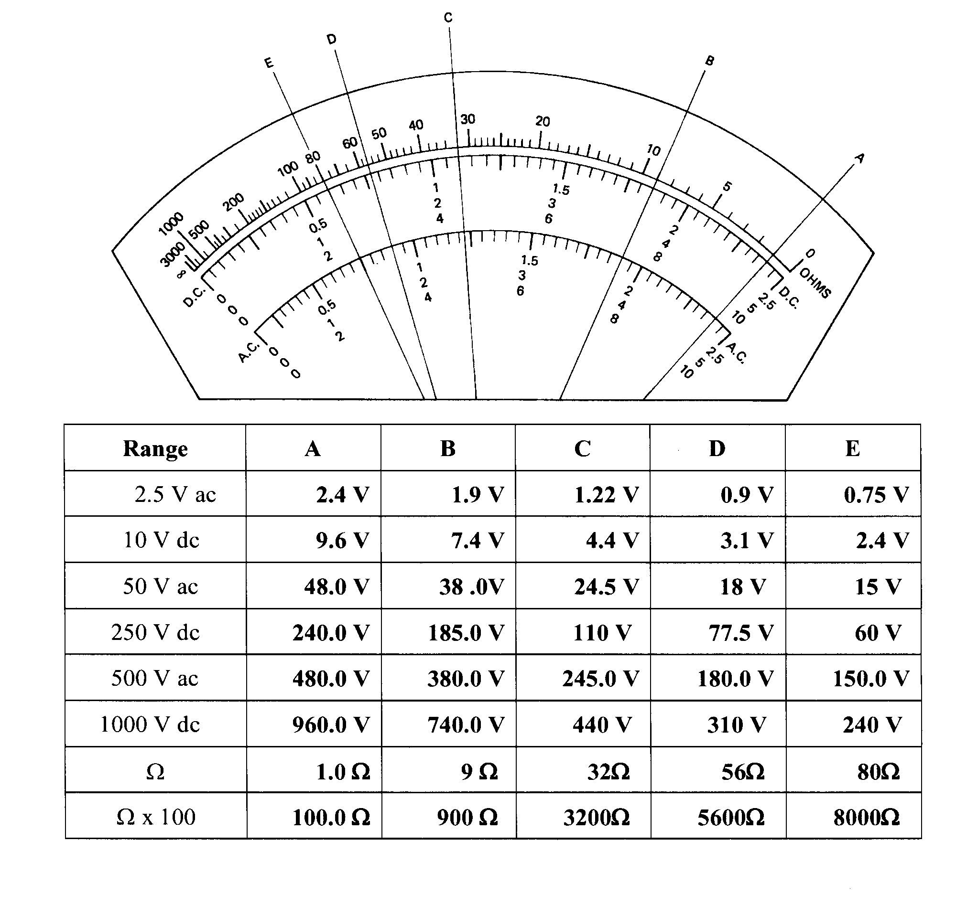**ANSWERS**