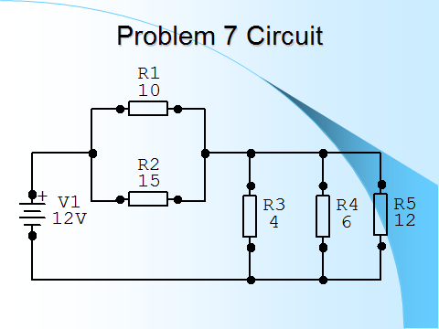

**FIND -** RT =, IT =, I in R1,R2,R3,R4 &R5, VD over R1 & R2, R3,R4,R5, WATTAGE usage of R1 & R2, R3,R4,R5

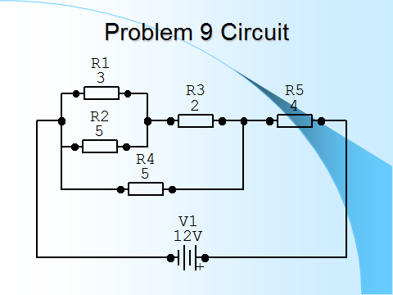

**FIND -** RT =, IT =, I in R1,R2,R3,R4 &R5, VD over R1 & R2, R3,R4,R5, WATTAGE usage of R1 & R2, R3,R4,R5

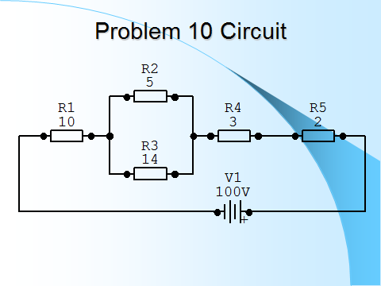

**FIND -** RT =, IT =, I in R1,R2,R3,R4 &R5, VD over R1 & R2, R3,R4,R5, WATTAGE usage of R1 & R2, R3,R4,R5