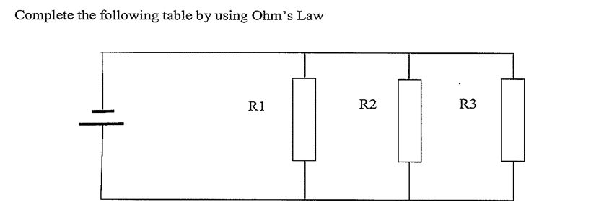

|  |  |  |  |  |  |  |  |  |  |
| --- | --- | --- | --- | --- | --- | --- | --- | --- | --- |
|  | **VS** | **R1** | **R2** | **R3** | **RT** | **IR1** | **IR2** | **IR3** | **IT** |
| 1 | 25 V | 15 Ω | 25 Ω |  |  |  |  |  |  |
| 2 | 100 V | 25 Ω | 50 Ω |  |  |  |  |  |  |
| 3 | 10 V | 35 Ω | 50 Ω |  | 11.35 Ω |  |  |  |  |
| 4 | 10 V |  | 150 Ω | 250 Ω |  |  | 66.6 mA |  | 156 mA |
| 5 | 100 V |  |  |  |  | 100 mA | 200 mA |  | 600 mA |
| 6 |  | 1 kΩ | 2 kΩ | 3k5Ω |  |  |  |  | 178 mA |
| 7 | 50 V | 10 kΩ | 15 kΩ |  |  |  |  |  | 10 mA |
| 8 | 55 V | 25 kΩ | 15 kΩ |  |  | 2m2A |  | 4m4A | 10m25A |
| 9 | 100V |  |  |  |  | 35 mA | 25 mA | 40 mA |  |